Apprenticeship Mentor Template Guidance

Creating Your Document
To create your own document using the template visit the apprenticeships google drive link and click on the ‘template’ folder (you will need to be logged in as a SHU member of staff to do this – username@my.shu.ac.uk).

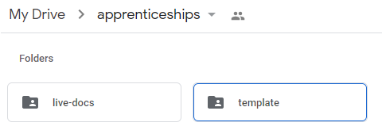

Inside this folder you will find a sample template. Do not edit this document
Right click on the document entitled ‘Template’ and from the options displayed select ‘Make a copy’
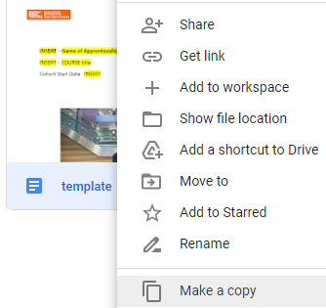

Renaming the copy
You can rename the new file by right clicking on the document and selecting ‘Rename’.
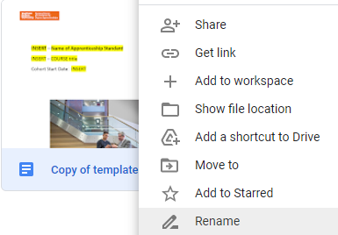

Use the name of your course as the file title.

Editing Your document
Ensuring that you have selected the appropriate document you can now open the file and make the appropriate changes.

Publishing Your Finished Document
To publish your new document return to the apprenticeships google drive link and click on the ‘template’ folder. The document you have been working on should be visible.
Right click on it and from the menu shown select ‘Move to’
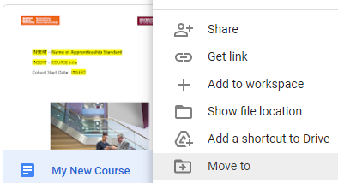

Using the back arrow shown in the pop up displayed select the ‘live-docs’ folder
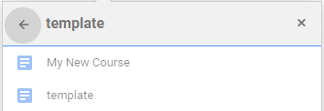
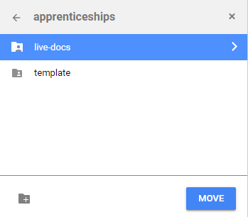

Select ‘move’ to select the folder and ‘Move Here’ to place your document in the correct location.

Finally…
Open up the Apprenticeship spreadsheet and click on the ‘Refresh Stored Data’ button.
Once this step has been completed the document will be available in the apprenticeship standards document viewer.
For technical support please contact Neil Mayne.

