

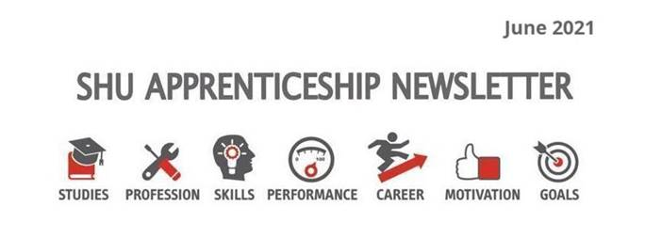

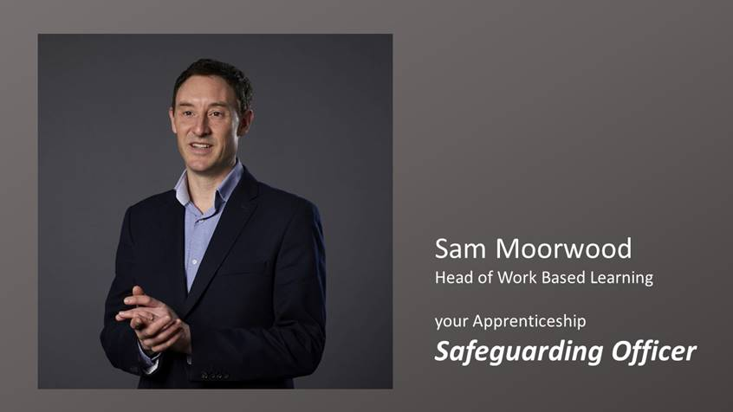

Phew... relief - I have just checked that the SHU staff Apprenticeship Event on Tuesday will be finished before the kick-off (England -v- Germany). In this month’s letter:
- Equality in Sport
- Equality Impact Assessment for your Apprenticeship Project
- Research and Apprenticeships
- Apprentice of the Year – Final call
- Careers management resources
- Summer enrichment activities with the SU
- Megan introduces our positive role model case study: Ian McGregor

On the subject of sport, I was interested, but concerned to review this academic-review-of-sport-in-uk-confirms-racial-inequalities-still-exist. SHU is driving the equality research agenda, but clearly some difficult findings.
How is Equality, Diversity and Inclusion (EDI) relevant to Apprenticeships?
EDI is embedded in all SHU courses and your WBL Coach will help you to build on that. Here are some relevant EDI resources. Consider doing an Equality Impact Assessment of your next work-based project. We have got a group trialling the method right now. Drop me line for more detail.
Our WBL Coach Megan Hartley Clarke introduces this month’s case study, including an exciting national nomination to celebrate this month’s EDI theme. Read on.



Andy Womble - Apprenticeship Research

On the Subject of Research our teaching staff and WBL Coaches will be coming together in our staff event to think about the research we have done and still want to do in relation to Apprenticeship courses and participants.
We are a National Centre for Excellence in Degree Apprenticeships (NCEDA). If you have done any interesting or impactful work-based research do talk to your Academic Adviser, or module leader about options for publication to celebrate and share your work.

Updates

Awards Applications: Final call for applications to the Sheffield City Region Apprentice of the Year Awards by midnight on Wednesday

Careers and employability: Careers Connect reopened from 15 June for 1:1 appointments with our Employability Advisers
Here is more info on Career Management for Apprentices

Summer Events with the Student’s Union: https://www.hallamstudentsunion.com/whatson/

Megan Hartley Clark, Work Based Learning Coach:
As an Apprentice at Sheffield Hallam University you are expected to exemplify the values we uphold in respect of equality, lead the way in celebrating diversity and champion inclusive practice both at the University and in your job role.
Iain McGregor, an apprentice on the Senior Leader Master’s programme, is leading some great Diversity and Inclusion work at Nottingham University Hospital and has been nominated for an award for ‘positive role model’ in this year’s National Diversity Awards (in association with ITV). The shortlist will be announced in September. Here is Ian's story:

Iain: Leadership, aspirations, equality
“I had been wanted to undertake a leadership programme at Master’s level for some time, but could never find the right programme that would allow me to reflect on my leadership within healthcare and also challenge the boundaries of my knowledge and learning from a nursing perspective. I visited Sheffield Hallam on an open evening to explore the options and I was advised that the Senior Leader Master’s Degree Apprenticeship was an option available so applied for a place.
My main role is a Duty Matron – I am part of a small team who support capacity and flow through our hospitals services from the emergency department, admission and discharge. We are one of the main contacts for escalations within the trust and work with multiple teams and specialities to ensure that the patients receive the care and treatment they require in the right place at the right time. We also form part of the emergency planning and resilience response for incidents and matters that occur on a day to day basis, so that we can continue providing safe and effective services to our patients and staff. I also chair the LGBTQIA+ Staff Support Network alongside my main role (in a voluntary capacity), this network brings together staff who have an interest in the equality, diversity and inclusion agenda specifically for LGBTQIA+ individuals (both staff and patients). We meet regularly to discuss practice developments for both staff and patients on how we can improve inclusive practices and support across the organisation. We have held a number of successful virtual events over the last year – despite the pandemic – and are continuing to grow our membership numbers each month. When I first became involved in the network, the meetings were only attended by a few individuals and we were in a transient state.
Both teams (Duty Matron & LGBTQIA+ Staff Support Network) are small but extremely supportive of each other. My personal contribution to the Duty Matron team is being present and supportive to my colleagues as well as sharing best practice when it comes to ED&I matters – we are often the first contact out of hours for wards and services to ask such questions, so keeping the team up to date is key for us. As the chair of the network, I have committed a number of hours to re-establishing the network as well as bringing my own passion and drive for better support for both staff and patients. I work rotational shifts between days and nights, so will often stay after nights to meet and catch up with individuals or get up early to make sure that plans and meetings are going ahead.
I have so many personal aspirations relating to work based activity. I would love to be in a role that I am really able to showcase the positivity that comes from engaging the staff teams with practice development. Equality, diversity and inclusion will never be far away from what I do as it’s such an integral part of my passion. My career path has been wide and varied to date and although I had always maintained that I would eventually aim to be a Chief Nurse one day".

Footnote:
Copyright Sheffield Hallam University
AIIR is a set of web resources developed to work alongside your apprenticeship programme, it includes: Onboarding Succeeding in your off-the-job training Well-being and support Equality, diversity and inclusion British values and Prevent Careers information, advice and guidance

