|  |
| --- |
|  |
| **Apprenticeship Delivery Guide** |
| A Handbook for Apprenticeship Course Leaders, Work Based Learning Coaches and the Delivery Team |
|  |
|  |
|  |

|  |
| --- |
| Version: Approved by AWBL Steering Group March 2020, Published April 2020 |

**Apprenticeship Delivery Guide**

A Handbook for Apprenticeship Course Leaders, Work Based Learning Coaches and the Delivery Team

**Page Section Contents**

2 1 Introduction - Purpose of the Handbook

3 2 SHU Apprenticeship Delivery standards

5 3 Planning for Delivery

7 4 Agreeing workload and Cohorts for WBL Coaches

8 5 On-boarding - Skills Scan, RPL and the Commitment Statement

11 6 Welcome Evenings (and Information Evenings)

12 7 Apprenticeship Essentials for Course Induction

15 8 SHU Standards During Delivery

17 9 Apprenticeship Progress Reviews

23 10 Monthly Apprentice Progress Meetings (B-R-A-G Tracking and Actions)

25 11 EPA Gateway Sign-offs and Assessment Boards (Apprenticeship) - *Process*

31 12 Withdrawal of Apprentices

32 13 Safeguarding Matters and Wellbeing

34 14 Additional Learning Needs

35 15 Apprenticeship Essentials - Compliance within Curriculum

37 16 Assessment Practice for Work Based Learning

39 17 ACLs and Academic Advisers in Apprenticeship Delivery

41 18 20% Off-The-Job-Training

43 19 Gateway Period and End Point Assessment - *Delivery*

45 20 Course Review, Assessment Boards (Apprenticeship) - *Quality*

47 21 Employer Feedback

48 22 Celebrating Success

Appendix 1 Delivery Standards for Apprenticeships at SHU

Appendix 2 Apprenticeship Course Leader Role Description

Appendix 3 Work Based Learning Coach Job role

Appendix 4 Apprentice Progress Review Template

Appendix 5 Template for 20% Off-The-Job-Training Calculation

Appendix 6 Peer Observation Template

Appendix 7 Attendance Monitoring Baseline Process

Appendix 8 Template for Apprenticeship Case Studies

Appendix 9 Apprenticeship Withdrawal Form

Appendix 10 Standard Letter / Email for Triggering Withdrawal Process

Appendix 11 Assessment Board (Apprenticeship) Agenda (as at Feb 2020)

Appendix 12 KSB Milestones

Appendix 13 Academic Adviser Model for Apprenticeships

**Apprenticeship Delivery Guide**

A Handbook for Apprenticeship Course Leaders, Work Based Learning Coaches and the Delivery Team

**1. Introduction - Purpose of the Delivery Guide**

1.1 This document is written with reference to the Apprenticeship Course Leader Role (Appendix 2) and the Work Based Learning Coach Job Description (Appendix 3). These roles are critical to delivering impactful apprenticeship provision at Sheffield Hallam University (SHU).

1.2 The following objectives are measured and reported at the relevant Assessment Boards (Apprenticeship) and/or collectively to the University's Apprenticeship Delivery Group to implement the delivery of an efficient and high quality apprenticeship portfolio:

* Apprentice satisfaction and impact on programme
* Employer satisfaction and organisational impact
* Timely and overall achievement rates for Apprentices at EPA
* Strong outcomes, progression and destinations for Apprentices
* Rewarding and continuous improvement for apprenticeship course teams

1.3 This document outlines the respective tasks and collaborative work required between the primary members of the delivery team: Apprentice Course Leader (ACL), Module Leaders (ML), Academic Advisers (AAs), Work Based Learning (WBL) Coaches, as well as key student support and operational contributors. Impactful delivery calls for strong communication and determined actions to meet employer needs and properly support learning and progress for each apprentice. This document identifies respective roles and responsibilities for models of best practice, calling for strong collaborative delivery for "high quality apprenticeships", from first enquiry through to EPA and beyond:

*A challenging and stretching training and learning programme developed and delivered with the active involvement of the employer(s), which uses a range of effective on and off the job training methods as well as work itself...*

*(Institute for Apprenticeships and Technical Education) -* <https://www.instituteforapprenticeships.org/quality/what-is-a-quality-apprenticeship/>

Also see: Quality Assurance Agency Guide: <https://www.qaa.ac.uk/docs/qaa/quality-code/quality-assuring-higher-education-in-apprenticeships.pdf?sfvrsn=6e4cff81_26>

For Higher Apprenticeships the OfSTED Education Inspection Framework applies: <https://www.gov.uk/government/publications/education-inspection-framework>

The ESFA Funding Rules impact on both operational and delivery activities: <https://www.gov.uk/guidance/apprenticeship-funding-rules>

2 **SHU Apprenticeship Delivery Standards**

These standards work alongside existing SHU quality frameworks and policy to set a baseline for course teams to collaboratively support and challenge apprenticeship learners from their commitment statement through to their End Point Assessment. These standards complement the Apprenticeship Course Leader Role and WBL Coach roles.

* **Planning for Delivery**: The Course Delivery Team must work together so that curriculum delivery includes strong work based learning that supports the setting of targets and monitoring progress from the apprentice's starting point through to End Point Assessment, further implemented through Progress Reviews, as managed by the WBL Coach.
* **WBL Coach Cohort Allocations**: Coaches are recruited, trained and allocated workloads to reflect levels of expertise and capability to support apprentices' progress, taking into account staff, apprentice and employer experience across the apprenticeship portfolio.
* **On-Boarding (Skills Scan, RPL and the Commitment Statement)**: Course Leaders and WBL Coaches work collaboratively to support the On-boarding process, check the apprentice and employer needs and adjust the learning plan (including Recognised Prior Learning) at the start of each apprenticeship and making adjustments during delivery where necessary.
* **Welcome/Information Evenings**: The Apprenticeship Delivery Team will attend and support employers and apprentices to understand their obligations and expectations, as well as setting out the University's role and key points of the Apprenticeship Standard.
* **Apprenticeship Essentials for Course Induction:**  ACLs arrange/deliver an Apprenticeship-focused induction, supported by the WBL Coach to cover the apprenticeship specific aspects of delivery as well as core SHU induction material.
* **During Delivery:** The ACL coordinates module learning and assessment activities to reflect the needs of the apprentices on their standard so that knowledge skills and behaviours are embedded in delivery and WBL opportunities are maximised. WBL Coaching is integrated to curriculum so coaches can optimise effective progress reviews and SMART target setting.
* **Apprentice Progress Reviews:** WBL Coaches are responsible for scheduling and conducting tripartite progress reviews, engaging employers and supporting progress to achieving timely progress towards Knowledge, Skills and Behaviours in readiness for End Point Assessment. Targets are set and supported by in-curricula work based learning and assessment approaches, coordinated and reviewed by the Course Leader.
* **Monthly ACL & WBL Coach Meetings (B-R-A-G Tracking & Actions):** ACLs and WBL Coaches meet on a monthly basis to review individual and cohort progress using the standard meeting template. This meeting is used to and identify causes for concern to be escalated, and interventions tracked, as well as recognising achievements and agreeing EPA readiness.
* **Safeguarding Matters:** ACLs and WBL Coaches are aware of SHU's obligations to protect vulnerable adults from any threats to their well-being and any safeguarding matters. Key stakeholders including ACL, Academic Advisers, Student support, WBL Coach should be informed of any change in circumstances or well-being issues. Communication to employers must be coordinated with BESE, having regard to confidentiality and GDPR.
* **Apprenticeship Essentials in Curriculum:** The ACL is accountable for implementing certain compliance activities in and around curriculum including: implementing attendance monitoring; organising delivery of the timetabled and scheduled learning activities that make up the Universities contribution to 20% Off The Job Training; identifying and developing opportunities to emphasise British Values, Equality and Diversity; observing that apprentices are undertaking substantially new learning. The WBL Coach will support all these activities.
* **Assessment Practice:** The ACL has oversight of course assessment, including embedding and enhancing a WBL approach to assessment and related delivery activities. This includes developing activity flows between Assessment tasks and the Apprenticeship Progress Reviews.
* **Course Leader Role in Delivering Elements of Curriculum:** ACLs take an active role in delivering parts of curriculum to enhance their knowledge of each cohort and accessibility for the apprentice learners to gain support and provide feedback on delivery.
* **Gateway Period and End Point Assessment:** ACLs ensure that timely and sustained support is available during the gateway period into EPA to maximise apprenticeship completions by the Planned End Date for each cohort and individual. The WBL Coach plays a key role advising on readiness and driving up EPA success for both integrated and independent EPA.
* **Course Review - Apprenticeship Course Improvement Plans and Assessment Boards (Apprenticeship):** Employer and apprentice feedback will inform holistic course review, supported by WBL Coach input. ACLs will use Course Review to ensure a focus on the enhancement of WBL opportunities and look directly at achievement of the whole apprentice programme up to and including End Point Assessment.
* **Employer Feedback:** Employer feedback is taken as seriously as learner feedback and is used responsively during delivery and formally at course review to ensure delivery is sector and employer focussed and maximises the opportunities for employers to realise impact during and after the apprenticeship.
* **Celebrating Success:** The ACL and the WBL Coach both actively champion apprenticeships and work to instil a culture of commitment and ambition in the apprentice and employer community identifying achievements and looking for opportunities to celebrate success.

**3 Planning for Delivery**

3.1 As apprenticeship numbers grow it is critical that Departmental leaders appoint and support ACLs and that BESE are able to identify WBL Coaches in a timely manner, in anticipation of growing apprenticeship numbers.

*Selecting the Apprenticeship Course Leader (ACL):*

3.2 The allocation of ACLs will be in annual Departmental planning activity. Departmental Work Planners will obviously need to consider and support the ACL's capabilities. The ACL will need to recognise that the Higher Education award is a part of the Apprenticeship Programme and that successful delivery depends on an integrated approach to on the job and off the job learning through an integrated work based learning approach. Whilst the ACL can rely on the WBL Coach to support the apprentice and integrate that activity with the curriculum, the ACL will also need put in place curriculum interventions and practices that support the delivery team to drive the levels of integrated WBL right up to EPA. Examples of this are set out in the Best Practice Guide to WBL Assessment (available on the [Teaching and Assessment Essentials (WBL Assessment)](https://blogs.shu.ac.uk/wblapprenticeships/wbl-assessment/?doing_wp_cron=1580810195.0425050258636474609375) SHU Blog Page.

*Bringing in the WBL Coach:*

3.3 Where provision is growing the course team should discuss with the Head of WBL the need and timing of new coaching provision and whether this would be best met with a Full time role, part time role or zero hour contract(s) (i.e. An Associate WBL Coach). Appointing to these roles in anticipation of growth will be based on Business Development projections as reported to the Apprenticeship Delivery Group (ADG) and/or University Recruitment Committee. The capacity and sector knowledge of a coach should be considered as part of decision making. This will be informed by the WBL Department within BESE. Recruitment of new WBL Coaches will be determined through the annual planning process taking into account projected recruitment across the Apprenticeship Portfolio. The ACL and/or apprenticeship lead for the Department will be expected to encourage interest and support the recruitment panel and selection of a preferred candidate. Induction for new members of staff will be jointly arranged by Head of WBL (or WBL Manager) and the Apprenticeship Lead/Course Leader in the academic Department.

*Planning the Year*

3.4 The ACL and WBL Coach should discuss how Assessment tasks might support, or drive Apprenticeship Progress Reviews and how reviews might feed into any assessments at each level of study. With this in mind an indicative schedule of reviews with target dates should be set before each year commences. This should be sent to the employer and the apprentice early to get dates in the diary.

**Figure 1 Illustration of Year Plan for Apprenticeship Progress Reviews (APRs)**

On-boarding: Individual Training Needs (pre-start)

Prior Learning

Skills Scan

Agree early actions, targets e.g. project planning, literacy and numeracy development

Workplace Review

Response to skills scan

Theme: e.g. British Values

(Month 1-3)

Virtual Review

Theme: e.g. 20% OTJT, link to reflective Assignment

(Month 10-12)

Workshop Review:

KSB peer review and target setting

Theme: e.g. Welfare

(Month 4-6)

Workplace Review:

SMART planning Theme: e.g. EDI

(Month 7-9)

Notes:

* Any APR may link to Assessment so that APRs and curriculum are mutually supportive
* Section 7 sets out the Apprenticeship Essentials themes
* Section 15 offers tools for the integration of Apprenticeship Essentials into curriculum, including the role of on-line Apprenticeship Impact Information Sheets (AIIR) in between reviews
* Methods of review and timing are interchangeable. Assume **minimum 2 workplace reviews**, or substitute Zoom reviews as contingency if normal working practices are not possible.

**4 Agreeing Workload and Cohorts for WBL Coaches**

4.1 The allocation of cohorts for each WBL Coach will be discussed by the Apprenticeship Lead(s) and ACL(s) in consultation with the WBL Manager and team. The decision will ultimately rest with the Head of Work Based Learning in BESE who is responsible for identifying and resourcing the coaching needs of the whole portfolio and according to the agreed *Establishment*. Where-ever possible the approach will align with the preferences of the ACL and WBL Coach.

4.2 Ideally an apprentice will keep the same WBL Coach for the duration of their apprenticeship. Once a WBL Coach has been allocated a cohort, then the Coach should normally continue to support each apprentice in that cohort right up to the EPA (and repeat EPAs if necessary). The Coach should only take on new cohorts where capacity allows or in limited circumstances to cover temporary, short periods of resource shortfall (allowing for a temporary reduction in frequency of reviews).

4.3 Allocation of cohorts should be based on a reasonable balanced application of the following (non-exhaustive) considerations:

* Existing capacity and capability of the WBL Coach, including any preferences expressed by the coach during discussions on allocations.
* The coach's sector knowledge and employer familiarity and overall ability to represent the university in a positive light with employers
* Cultural and operational alignment to the employer
* Levels of expertise required for a specialism of a particular route, or cohort, depending on the level of study and in some cases the prominence of the business relationship.
* Ability of the WBL Coach to manage known risks within or across a cohort of apprentices
* Balance of travel requirements for each coach
* Not least, the diversity of experience and job satisfaction for the WBL Coach

**5 On-boarding - Skills Scan, RPL and the Commitment Statement**

5.1 As part of the validation process, the course design team will embed Knowledge, Skills and Behaviours set out in the relevant Apprenticeship Standard within modules and produce a mapping grid to show this. This [*mapping* document](https://sheffieldhallam.sharepoint.com/:x:/r/sites/3050/cda/_layouts/15/Doc.aspx?sourcedoc=%7b61CE0602-A8AA-49AD-B0DB-1BC0C51EDA98%7d&file=Mapping%20Template%20v2.%20June%202018.xlsx&cid=03dc818f-1b3b-4627-be55-f7490edc78ee) becomes part of a Commitment Statement for each apprentice including the projection of timing and amount for "20% Off-The Job-Training" (OTJT), which includes Scheduled Teaching, but also time spend learning in the place of work - this cumulative amount must be at least 20% of the apprentice's contracted working hours as an average calculated over the duration of the apprenticeship measured up to the practical Gateway (see Section 19).

5.2 There is also a predictive calculation of how the 20% OTJT will be achieved shown in a pie chart (see Appendix 5 - <https://blogs.shu.ac.uk/wblapprenticeships/should-we-do-this-apprenticeship/>). This chart is also required at the point of programme approval, so it can be appended to the Commitment Statement for all learners.

5.3 The secretary to the Approval Panel (the Apprenticeship and Work Based Framework Standing Panel) will confirm approval and then pass documents to the BESE Operations Team, to be included in the commitment statement prior to the start of the Apprenticeship. The Mapping Document and 20% schedule provide the ACL, the WBL Coach, the apprentice and employer (represented by a "Mentor"), a good overview of the apprenticeship journey.

5.4 The BESE Operations Team can provide a detailed and thorough process diagram to explain the Apprenticeship On-Boarding Process. Figure 2 below sets out the basic process.

5.5 Through the on-boarding process the WBL Coach will be familiar with each learner's starting point. This is based on the combined review of any prior qualifications together with a "Skills Scan" - this is an initial self-evaluation of the learner's existing knowledge, skills and behaviours (with reference to the intended Apprenticeship Standard). The Apprentice Applicant is asked to share the output of the Skills Scan with their employer.

5.6 The WBL Coach then conducts an *Suitability Discussion*, typically by telephone, where additional *Information Advice and Guidance* is offered ,e.g. in relation to job role and career aspirations as well as English and Maths qualifications. From this Suitability Discussion the outcome of the Skills Scan, combined with prior qualifications is established as the learner's starting point and the basis for evaluating progress against KSB milestones throughout the Apprenticeship journey. The KSB Milestones (see Appendix 12) enable clear judgements as to EPA readiness as the Apprentice passes through the Apprenticeship Gateway.

5.7 The WBL Coach is able to refer more complex cases to an academic and subsequently to the Head of WBL to agree any changes to be reflected in:

* The commitment statement and any adjustments made to the programme content and/or duration.
* Proportionate adjustment to funding if necessary.

5.8 This part of the On-boarding process including the triggers and impact of Recognised Prior Learning are set out in more detail in Figure 3.

**Figure 2 Overview of On-boarding Process for Apprenticeships**

(Below is for indication - Contact BESE Operations Team for process advice)

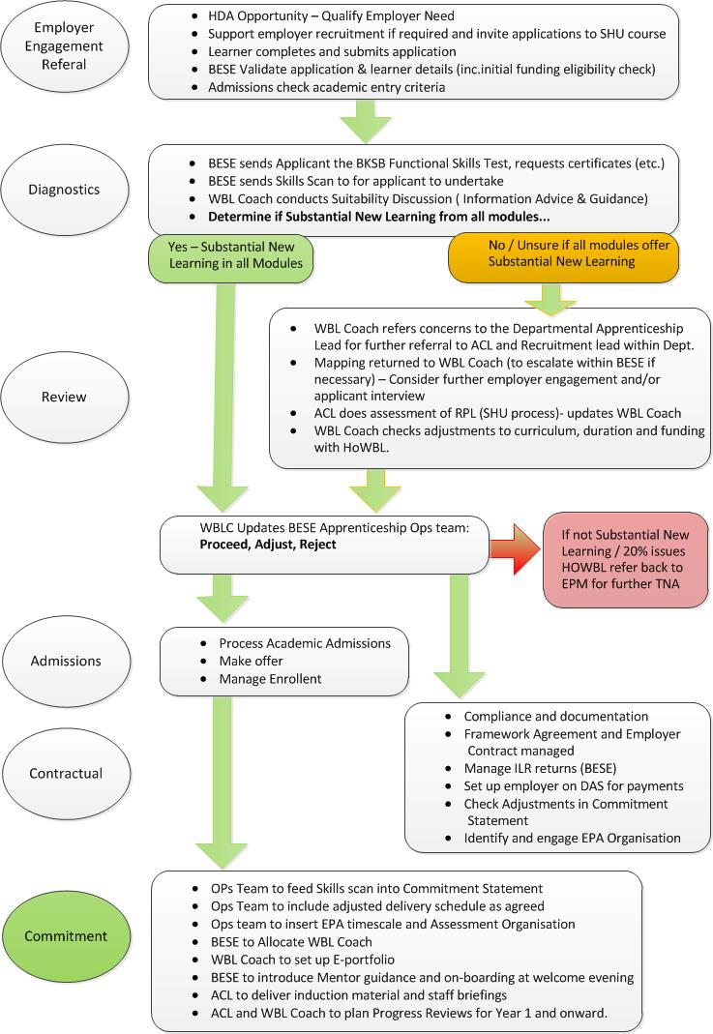

**Figure 3 Recognised Prior Learning and Adjustments to Programme and Funding**

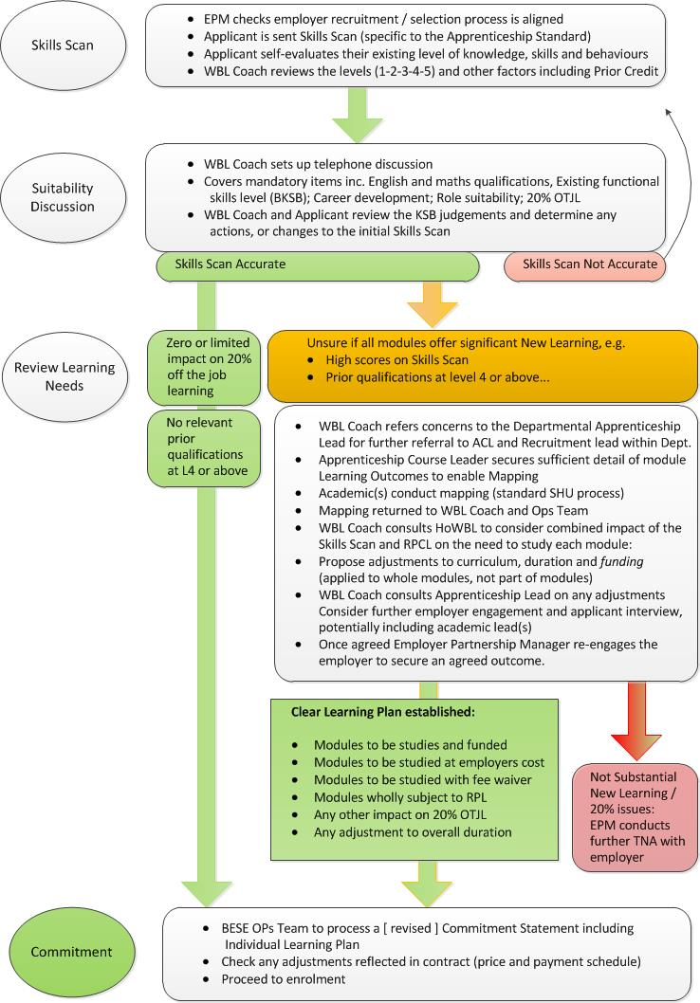

**6 Welcome Evenings (and Information Evenings)**

6.1 Welcome Evenings are typically held several weeks before provision starts (before the first day of teaching). These are coordinated by BESE but all course teams/subject areas are expected to send a delegate, typically the apprenticeship academic lead, and/or ACLs. BESE will send out holding invitations to all relevant academic staff and WBL Coaches as early as possible and update SHU staff on likely attendees (both apprentices and their mentors from the employing organisation) as the date approaches. BESE will invite all new apprentices and their employer, as well as apprentices and employers who have not attended previous welcome evenings. The same approach is taken to Information Evenings, typically held once towards the end of Semester 1, again in Spring and then potentially in early Summer depending on demand and start of new provision outside the standard academic cycle. Generic presentations will be led by BESE covering for example:

* The University - its mission and facilities
* Apprenticeship Essentials (See figure 4 below)
* The University' Apprenticeship Ambassador Scheme
* Free on line resource and other support for mentors (the employer)

6.2 **In addition**, Academic Apprenticeship Leads and ACLs have worked with WBL Coaches to facilitate round table discussions for groups split by subject cohorts. ACLs are expected to take an active part in these events and it is good practice to organise separate course focussed activities before or after the event. For example, tours of relevant teaching space and possible taster sessions. These should be led entirely by course teams (as required) and may be supported by WBL Coaches. Welcome Evenings will, when necessary, be hosted as virtual events

6.3 BESE will circulate the Welcome Evening Slides to all Apprentices and Employers (mentors) who were invited.

6.4 BESE collects forms from Apprentices and mentors including:

* Confirmation of attendance
* Feedback on the event
* Names of mentor to be connected to free on-line mentor resource
* Names and emails of apprentices and/or mentors who wish to be part of the Apprenticeship Ambassador scheme with SHU

**7 Apprenticeship Essentials in Course Induction**

7.1 Induction should be planned and delivered by the Course Team (Apprenticeship Course Leader in particular). As well as normal induction activities, such as introducing Academic Advisers, Student Support staff, submissions process, Hallam Help messaging (etc.), ACLs should coordinate the delivery and/or provision or offer holistic Apprenticeship Information Advice and Guidance (IAG).

Course Induction should re-emphasise the *Apprenticeship Essentials* that have been introduced to Apprentices and Employers that attended the Welcome Evening, as well as emphasising how they will be covered and integrated into future curriculum activities, APRs and through on-line Apprenticeship Information and Impact Resources (AIIR):

**Figure 4 Apprenticeship Essentials**

**Apprenticeship Essentials:**

* What is an Apprenticeship? (Information, Advice and Guidance)
* The Commitment Statement
* 20% Off-The-Job-Training - meaning, obligations and methods
* Equality, Diversity & Inclusion
* British Values and Prevent Duty
* Safeguarding
* Support, Welfare (Safeguarding), Additional Learning Needs
* Career Development
* English and Maths qualifications,
* Development of functional skills: literary, numeracy, IT
* E-portfolios & Evidence for EPA (Getting the most from your coach)

7.2 The latest evolution of Apprenticeship Delivery at SHU is seeking full integration of Apprenticeship Essentials through:

|  |
| --- |
| * Curriculum delivery and assessment |
| * Apprenticeship Progress Reviews (Using theme -specific annex) |
| * On-line Apprenticeship Impact & Information Resources (AIIR) |

7.3 This approach seeks to deliver the Apprenticeship Essentials as integral and/or added value, rather than bolt on messaging. See the "Developing an Apprenticeship Course" page of the [Apprenticeship Teaching and Assessment Essentials](https://blogs.shu.ac.uk/wblapprenticeships/developing-an-apprenticeship-course/readiness-checklist/?doing_wp_cron=1580811870.8959798812866210937500) Website for developmental tools and initial exemplars. The AIIR themes mentioned above are set out in Section 15.

7.4 **ADDITIONAL LEARNING NEEDS:** It is important to highlight the opportunity for identifying, assessing and accessing support for *additional learning needs* through the SHU assessment centre and a SHU learning contract, supported by ESFA funding. The Apprentice might encounter real or perceived barriers to engaging with the processes and seeking support, for example, there may be complications in the work place which affect the Apprentices' confidence to engage with the help and support available from SHU. There is a role for the ACL to emphasise the importance of the support and the WBL Coach to work with Student Support team to unlock any barriers, working in confidence with the learner.

*(Note: LLDD = Learner with Learning Difficulties and disabilities). See Section 14 for further information on Additional Learning Needs*

7.5Table 1 below (in combination with standard induction information) may be overwhelming for the new apprentice. Clear use of the Apprentice's course handbook and signposting will be required and course teams will need to know when to return to specifics and emphasise / further clarify these aspects of the apprenticeship frequently and regularly. If these messages are only left to the ACL and the WBL Coach the status and value of the apprenticeship will not be sufficiently reinforced. The Apprenticeship Essentials need to be reinforced in assessments and through lecture and seminar dialogue and sign-posting throughout the Apprenticeship, so that the purpose of Apprenticeship Progress Reviews is clear and the importance of EPA Readiness (in all its forms) is central to the Apprenticeship Course. The ACL and other members of academic staff should recognise that the curriculum and work place must offer integrated learning and work collaboratively to *emphasise the value of Apprenticeship identity.*

**Table 1 Induction Essentials and Guidance on Roles**

|  |  |  |  |
| --- | --- | --- | --- |
| **Induction Content** | **ACL Role** | **WBL Coach** | **Sources of Info / materials** |
| Standard Induction delivery as per any other course | ACL to coordinate with Student Academic Services | Attendance as part of induction, ongoing training | [Hallam Welcome Blog](https://blogs.shu.ac.uk/hallamwelcome/resources/?doing_wp_cron=1573121395.4795949459075927734375)  [Library Access for Distance Learners](https://libguides.shu.ac.uk/distancelearners/registration)  [Additional Learning Needs](https://www.shu.ac.uk/current-students/student-support/disability-support)  [Register for Linked-in-Learning](https://www.shu.ac.uk/digital-skills/linkedin-learning)  standard slides: [TAE](https://blogs.shu.ac.uk/wblapprenticeships/resources-opportunities/) |
| The Course ethos, Structure, curriculum etc. | Lead Role | Attendance as part of induction, ongoing training | Apprenticeship Docs, approved at AWBL Panel + On-Line Catalogue |
| The Apprenticeship Standard | Introduce KSBs,  Gateway, EPA basics | Pick up themes in later parts | [IFA&TE](https://www.instituteforapprenticeships.org/apprenticeship-standards/) |
| The Commitment Statement | 3-way obligations, KSBs, 20% OTJT | Pick up themes in later parts | Available from BESE:  [apprenticeships@shu.ac.uk](mailto:apprenticeships@shu.ac.uk) |
| The Apprenticeship journey, including Gateway to EPA | Apprenticeship Status, nature of WBL | Apprenticeship Progress Reviews | BESE standard slides in [Teaching and Assessment Essentials webpage](https://blogs.shu.ac.uk/wblapprenticeships/resources-opportunities/) |
| The SHU WBL Coach | Introduce. | Explain role | This Guide and BESE standard slides: [TAE](https://blogs.shu.ac.uk/wblapprenticeships/resources-opportunities/) |
| The integration of WBL in curriculum. | PPD, Projects, WBL Assessment, …peer learning, etc. | Support discussion | BESE standard slides: [TAE](https://blogs.shu.ac.uk/wblapprenticeships/resources-opportunities/): *what makes a good project*  [+ Student Project Guide](https://sheffieldhallam.sharepoint.com/sites/3050/SitePages/AWBL%20Documents.aspx) |
| Role of Academic Adviser | Introduce AA function | How the Coach and AA work | See support triangles in standard slides [TAE](https://blogs.shu.ac.uk/wblapprenticeships/resources-opportunities/). |
| Credit bearing assessment | Explain experiential assessment tasks | Link to *Apprentice Progress Reviews* | Course Docs  [See WBL Assessment Best Practice Guidance](https://blogs.shu.ac.uk/wblapprenticeships/wbl-assessment/?doing_wp_cron=1580810195.0425050258636474609375) |
| The Employer Mentor | Emphasise critical importance | Welcome/Info. evenings, on-line /other support | [Mentor Support Resource](https://v3.pebblepad.co.uk/v3portfolio/hallam/Asset/View/yRr9jHnfs8wgpctZmHM4Z3n3kh)  [Apprentice Progress Review Form](https://blogs.shu.ac.uk/wblapprenticeships/delivery-guide/) |
| Apprenticeship Progress Reviews | Emphasise as part of delivery | 12 weeks, tri-partite, KSBs | Progress Review Form  [TAE - Appendix 8](https://blogs.shu.ac.uk/wblapprenticeships/delivery-guide/) |
| Apprenticeship Essentials | Emphasise- these matter as much as assessment | Attendance, 20% OTJT, safeguarding British Values (etc.) | [TAE Standard Slides](https://blogs.shu.ac.uk/wblapprenticeships/resources-opportunities/)  See Sections 7 and 15  [TAE- Embedding Essentials](https://blogs.shu.ac.uk/wblapprenticeships/developing-an-apprenticeship-course/readiness-checklist/) |
| E-portfolios | PPD, Project, other modules for KSBs, Experiential for EPA | Purpose, structure function, curating evidence | Workshop Slides required  Refer to timetable inc. Gateway Support, [MAYTAS](https://blogs.shu.ac.uk/wblapprenticeships/mytas/) |
| EPA | Methods, timing, PSRBs, Support | Critical employer role | [IfA&TE standards](https://www.instituteforapprenticeships.org/apprenticeship-standards/) |
| Careers Info Advice and Guidance | Standard induction ref to Careers Connect | Beyond EPA: Apprentice focus  in Careers 360 | [Careers360 for Apprentices](https://www.abintegro.com/Resources/CustomPage/11948)  [Careers Connect](https://www.shu.ac.uk/current-students/student-support/disability-support)  [TAE Standard Slides](https://blogs.shu.ac.uk/wblapprenticeships/resources-opportunities/) |
| Impact and Celebration | Consider case studies to inspire. /award opportunity | Introduce Ambassador Scheme | Ambassador Contact: [martin.flynn@shu.ac.uk](mailto:martin.flynn@shu.ac.uk)  [SHU Inspirational Student](https://blogs.shu.ac.uk/isa/awards/) |

**8 SHU Standards During Delivery**

*Apprentice Attendance Monitoring and Intervention*

8.1 Under the University's Attendance Monitoring Policy and Baseline Process for actions at Apprenticeship Course Level (See Appendix 7), the Departments and Course Teams must complete registers of every apprentice's attendance, for every taught session. Any issues should be escalated in accordance with the University's policy and so feed into the ACL and WBL Coach monthly meeting (see section 11) and also the (tripartite) Apprenticeship Progress Reviews so that issues can be raised with the apprentice and their employer and suitable interventions agreed. Departments are required to implement the University's Attendance Monitoring process, and the baseline process for Apprenticeships. For further information on emerging available smart technology through the JISC Learner Analytics project, please contact Student Experience Evaluation and Research ([STEER](https://blogs.shu.ac.uk/steer/about/?doing_wp_cron=1573222508.4912660121917724609375)). Staff involved in the implementation of the Attendance Monitoring App for Apprenticeships include: Paul Dewsnap, Carlyn Fearn, Melissa Jacobi, Sam Giove, Sam Moorwood.

*Apprenticeship Course Leader in Curriculum*

8.2 Subject to Departmental work planning activities, it makes good sense for the ACL to take a strong role during the first WBL reflective module and where capacity allows taking part in delivery and/or assessment at a later stage of the Apprenticeship to be familiar with the members of each cohort and have a hands on sense of their experience and later, their timely readiness for EPA. The ACL can set an example to other module leaders in best practice for WBL Assessment, agile tutor behaviours and explicit reinforcement of Apprenticeship Essentials including the requirement to log 20% Off- The-Job-Training, discussions around British Values, Equality and Diversity etc. Further detail is offered in Section 18,

*WBL Coach in Delivery*

8.3 Prior to the start of teaching the ACL should work with course team and the WBL Coach to identify key lectures, or delivered sessions which would befit from the coach's attendance/contribution and or would be of benefit to the coach as a stakeholder and adviser on the curriculum and assessment delivery. Strong contenders (but not exclusively) will be key lectures for Personal Professional Development Modules, Project Based modules but also subject specific modules which relate well to core knowledge skills and behaviours in the *Standard*. In addition look for modules where the assessment in some way helps learners to prepare for EPA (possibly through some form of mock activity for example). Where the EPA involves the delivery of a specific project within an Integrated EPA, the design of a preparatory "Gateway module" in advance will offer direction for the apprentice with suitable points of employer engagement linked to Progress Reviews and Sign-off at Assessment Boards (Apprenticeship).

8.4 Some of the sessions in which the Coach supports delivery might also form an opportunity to instigate or conclude an Apprenticeship Progress Review, ensuring that the employer's input is also secured. The following table might help with pre-delivery planning to ensure the WBL Coach effectiveness is maximised to enhance the apprenticeship journey:

**Table 2: Checklist /Options for WBL Coach Attendance /Contribution in Taught Sessions:**

|  |  |  |  |  |  |  |  |  |  |
| --- | --- | --- | --- | --- | --- | --- | --- | --- | --- |
| Date and duration | Lecture/ Seminar Heading | Overall purpose of session | Reason(s) for WBL Coach attendance: | | | | | | |
| Key KSB relationship? | E-portfolio training / support | Supporting APRs | For WBL Coach development | Gateway Sign off | EPA support / Practice | Other (e.g. compliance IAG) |
|  |  |  |  |  |  |  |  |  |  |
|  |  |  |  |  |  |  |  |  |  |
|  |  |  |  |  |  |  |  |  |  |
| …insert rows… |  |  |  |  |  |  |  |  |  |

8.5 The latest evolution of Apprenticeship Delivery at SHU is seeking full integration of Apprenticeship Essentials through:

|  |
| --- |
| * Curriculum delivery and assessment |
| * Apprenticeship Progress Reviews (Using theme-specific Annex) |
| * On-line: Apprenticeship Impact & Information Resources (AIIR) |

This integration seeks to deliver the Apprenticeship Essentials as added value, rather than bolt on messaging. See the Apprenticeship Teaching and Assessment Essentials Website for developmental tools, initial exemplars and tools [[Teaching and Assessment Essentials webpage](https://blogs.shu.ac.uk/wblapprenticeships/resources-opportunities/)]

**9 Apprenticeship Progress Reviews**

9.1 **Apprenticeship Progress Reviews (APRs)** should be scheduled at the outset of the programme. There will be a tolerance of two weeks either side of the planned review date. These reviews are primarily the responsibility of the Work Based Learning Coach. Apprenticeship Progress Reviews are the most important part of the WBL Coach Role (see Appendix 3). The most up to date template is found on the Apprenticeship Teaching and Assessment Essentials web-page [https://blogs.shu.ac.uk/wblapprenticeships/delivery-guide/.](https://blogs.shu.ac.uk/wblapprenticeships/delivery-guide/)

9.2 APRs should be tripartite and so include genuine and evidenced employer engagement. In all cases the WBL Coach should ensure the employer is engaged in the review and the event is planned in advance in a way that facilitates the employer mentor's direct engagement as frequently and pro-actively as possible.

9.3 SHU's approach includes baseline standards for Apprentice Progress Reviews, set out on Figure 6 below.

9.4 APRs need to be planned in advance. Changes are by exception only, including for example, where curriculum drivers for review need to be taken into account. For Apprentices who are at risk (Red status) then additional *work-place* reviews should be considered.

9.5 Once a review has been completed and confirmed by the Apprentice and the work place mentor the Coach will finalise the review and ensure it is uploaded to the E-Track System in MAYTAS. The coach must update the Overall Tracker KPIs for the Apprentice and Overall B-R-A-G status for the Apprentice (see Paragraph 9.9 below). At that point any decision to escalate any matter should be noted in readiness for the Monthly meeting with the ACL.

9.6 Any concerns that might be classed as a safeguarding matter should be escalated to the WBL Manager and to the Nominated Apprenticeship lead without delay. The nominated Safeguarding Officer for Apprenticeships is the Head of Work Based Learning, Sam Moorwood. Meetings between the WBL Manager and WBL Coaches on a 1:1 basis and also the WBL Coach Team Meetings act as back-up mechanisms for escalating concerns, but the earliest communication should be made. See Section 13.

9.7 ACLs and WBL Coaches should discuss how curriculum activities, potentially including assessment, should support the role of the coach in carrying out APRs and in turn how an APR can feed into assessment, for example promoting engagement with specific KSBs in the work place at specific times in the assessment journey. The ACL should support the WBL Coach to work in an integrated way with the relevant module leaders to implement any good practice.

**Figure 5 Apprenticeship Progress Reviews - Schedule of Baseline Process**

|  |  |  |  |
| --- | --- | --- | --- |
| **Review Timing** | **Review Mode** | **Review Focus** | **Ongoing Student Communications +**  **Curriculum Link** |
| Pre-Enrolment | Forms and telephone interview | Skills Scan + Careers IA&G |  |
| Year 1:  The [TAE web-page](https://blogs.shu.ac.uk/wblapprenticeships/developing-an-apprenticeship-course/readiness-checklist/?doing_wp_cron=1580811870.8959798812866210937500) provides ACLs and WBL Coaches with tools to embed the Apprenticeship Essentials themes through 3 coordinated channels:   * Curriculum Delivery * Apprentice Progress Review (themed annex) * Apprenticeship information and Impact Sheets (AIIR)   Therefore, each Review Focus will cover at least one of the following themes using a theme-specific annex:   * British Values / Prevent * Welfare and Safeguarding * Equality, Diversity, Inclusion * 20% OTJT * Careers Progression * Skills Scan * English/Maths development * Working with your coach   (E-portfolios and Evidence)  Where appropriate these channels will link into assessment | | | |
| Week 1-12 | Workplace,  fully tripartite |  |  |
| Week 13-24 | Employer input then Workshop at SHU |  |  |
| Week 25-37 | Work place,  fully tripartite |  |  |
| Week 38 -50 | Zoom (virtual)  potential curriculum link |  |  |
| Year 2: | | | |
| Week 1-12 | Workplace,  fully tripartite |  |  |
| Week 13-24 | Employer input then Workshop at SHU |  |  |
| Week 25-37 | Work place,  fully tripartite |  |  |
| Week 38 -50 | Zoom (virtual)  potential curriculum link |  |  |
| Year 3 | | | |
| Week 1-12 | Workplace,  fully tripartite |  |  |
| Week 13-24 | Employer input then Workshop at SHU |  |  |
| Week 25-37 | Work place,  fully tripartite |  |  |
| Week 38 -50 | Zoom (virtual)  potential curriculum link |  | EPA Readiness |
| Gateway into EPA | | | |
| Gateway Review |  |  |  |
| 20% Workshop |  |  |  |
| E-portfolio Workshop |  |  |  |

**Figure 6 Baseline Standards for Apprentice Progress Reviews**

* Reviews are based on discussion and action plans to support development from starting point towards timely completion of End Point Assessment
* Reviews are conducted transparently, supportively and are action-focussed
* A first review that responds to any matters raised in the On-boarding process (Skills Scan) for an Individualised Learning Plan
* Agreeing the next review before closing a review, within 12 weeks and in accordance with a schedule for the year (See Figure 1 in Section 3)
* Development review and target setting in relation to curriculum assessments
* Normally 2 reviews in the work place each year, depending on (BRAG) status (i.e. Red may need more)
* Clear opportunity and guidance to access learning needs and disability support
* A standardised template, used with flexible, interactive communication
* Based on clear information including ratified and provisional grades, attendance data and other feedback where available
* Building in the views of the Academic Adviser and interventions agreed with the Apprenticeship Course Leader
* Respecting matters of confidentiality, sensitivity and GDPR
* Clear focus for each review, to incorporate Apprenticeship Essentials and linking to Apprenticeship Information and Impact Resources*
* Using curriculum and experiential learning to review the full range of KSBs each year
* Genuine engagement with and by the employer's mentor, organised by the WBL Coach in advance (or by the employer if they wish)
* Swift follow up where any one of the parties was absent
* Continuation of reviews after the final credits in the gateway period
* Focus on attendance evidence, patterns, impact & intervention - every review.
* Confirmation that the Apprentice is receiving, logging and able to evidence 20% Off-The-Job-Training at each review, using E-Track in MAYTAS.
* Evidence consistently & expediently uploaded to e-portfolios by the apprentice
* The above captured in an E-portfolio that is accessible by the apprentice, the employer, the WBL Coach, the Course Leader and any other SHU staff
* Clear SMART targets to help the apprentice reach their potential
* A reset of the action plan to support progress towards timely completion
* Timely Careers Information, Advice & Guidance to help the Apprentice prepare for the next stage

*Apprenticeship Information and Impact Resources (AIIR) provide flexible on-line support for Apprentices to engage with *Apprenticeship Essentials* including: Wellbeing and Safeguarding considerations; British Values and the Prevent Duty; Equality, Diversity and Inclusion; 20% Off-The-Job-Training etc. See Section 7 and 15.

9.8 Preparation for reviews and working with stakeholders is important to conducting effective review by keeping the University joined up:

*Pre-visit Actions (best practice checklist)*

* Check status in E-Track (MAYTAS) and review last action plan
* Review any items noted in the last Monthly meeting with the ACL
* Check access to evidence of progress - E-portfolio completion, work based achievements and standard administration documents, such as H&S documentation.
* Review records such as module results, attendance, and punctuality.
* Understand any links to curriculum that should focus discussion or actions, for example Project progress and recent/pending WBL Assessment tasks and deadlines.
* Clarify any input from the Academic Advisor (AA), requesting anything that the tutor wants to pass on, particularly in final review of each year. (Further information on the role of the AA:  [“Higher and Degree Apprenticeship - Academic Advisers”)](https://blogs.shu.ac.uk/wblapprenticeships/delivery-guide/)
* Check SITS records/Student CRM regarding Interactions with Student Support Services
* Ensure the employer is proactively engaged in advance, with a clear time, location and agenda (as agreed at the end of the last review)
* Check the status of the 20% O-T-J-T log and send any reminders or cautions to the Apprentice clearly flagging issues in advance with the mentor.
* Check any recent or upcoming Apprenticeship Impact and Information Sheets
* Identify the ***Review Annex*** (Apprenticeship Essentials focus) and prepare

*During the Apprentice Progress Review: B-R-A-G Status (Blue, Red, Amber, Green)*

9.9 During the Review the WBL Coach will work to the Baseline standards (Figure 6 above) to consider the key elements of the Apprenticeship and determine a B-R-A-G status to report to be agreed with the Apprentice and the employer's mentor, The approach to B-R-A-G requires the parties to discuss an evidence-based determination of the Apprentice's key indicators and overall status as set out below..

*After the Apprenticeship Delivery Reviews -* ***Quality Assurance***

9.10 Problems and causes for celebration, or intervention are agreed with the Apprenticeship Course Leader in the Apprenticeship Course Monthly Meeting (see Section 10).

.

9.11 Every six weeks the WBL Manager will identify a selection of reviews, for good coverage, and some randomised selection to conduct quality assurance. The APR forms will be evaluated against the baseline standards in Figure 6 and with reference to Intent, Implementation and Impact. Individual APR forms are marked up for critical discussion. Common themes are summarised for wider discussion, initially with the Head of WBL, but not excluding other parties, such as the Director of Business Engagement and Growth and ACLs.

* 1. **Dissemination of Quality Assurance outputs –** after each Progress Review QA session the Work Based Learning Manager will produce a QA overview identifying the sample and collating the feedback – this will identify particular themes and also proposed immediate actions. This will be followed by:
* Specific feedback given to WBC’s during the following month in 1:1 meetings – including individual action plans for improvement.
* A slide deck to be shared at the next team meeting, showing common themes and actions taken.
* All the above, as well as overviews of Development Events (supported by the Head of WBL) will be brought together into a single QA file.

**SIGNIFICANT RISKS AND BARRIERS TO TIMELY ACHIEVEMENT (Red)**

THE LEARNER WILL NOT ACHIEVE BY THE EXPECTED END DATE WITHOUT INTERVENTION.

The quality or level of progress is significantly below important aspects(s) of described skill, knowledge or behavioural area(s). This could impact on the ability of the learner to achieve milestones in their Commitment Statement and ultimately prevent timely completion of the Apprenticeship (End Point Assessment for Standards).   
The employer and or provider will need to spend more time and effort supporting development of the noted area(s), be it knowledge, skills or behaviours as well as opportunities to demonstrate technical competencies. The Apprentice will need to respond to existing or new support in order to address the gap in progress. An action plan should be agreed and monitored frequently and regularly with all parties. Set specific improvement targets to focus on, using a SMART approach. Agree future reviews as fully tripartite in the work place until progress issues resolved.  
  
**SOME RISKS TO GOOD AND TIMELY PROGRESS (Amber)**

LEARNER MAY NOT ACHIEVE BY EXPECTED END DATE WITHOUT FURTHER INTERVENTION / SUPPORT.

This level means that the Apprentice, the employer and provider need to keep a watchful eye, but not to a large extent. The red colour is when you need to intervene in the situation. Specific actions should be agreed to target progress to green status across all areas.  
An amber situation might result in lower quality of learning, or a known, but manageable delay in meeting learning milestones agreed in the Apprentice's Commitment Statement.

Any problems with the Apprentice's experiences in work, or understanding in the educational setting can be fixed through good communication and some redirection of effort. In these cases a greater quality of outcome should be achievable and efforts should also manage any risk of slipping into a red situation. Set a mixture of improvement and stretch targets using a SMART approach.  
  
**MAKING GOOD AND TIMELY PROGRESS (Green)**

THE LEARNER IS ON TRACK TO ACHIEVE BY THE EXPECTED END DATE

The Apprentice and their support network do not need to have any concern about the rate and direction of progress with regards to the knowledge, skill or behaviour in question. For technical competencies the necessary experiences and learning are taking place in line with anticipated timescales in the Commitment Statement. The Apprentices should feel appropriately confident about achieving the necessary learning to meet this aspect of the Apprenticeship as required by the Specification / Gateway Programme / End Point Assessment, in a timely manner. It is always worth keeping an eye on the accuracy of the green, making sure it’s a true green. Set stretch targets using a SMART methodology, and recognise impact in the work place.

**BEYOND EXPECTATIONS (Blue)**

THE LEARNER IS ON TRACK TO EXCEL BY EXPECTED END DATE

The Apprentice and their support network are consistently positive about the rate and direction of progress with regards to the knowledge, skill or behaviour with potential for a distinction at EPA. Academic progress is at least a merit, with potential for a distinction, all technical competencies, necessary experiences and learning are taking place at or beyond the right pace and often ahead of anticipated timescales in the Commitment Statement. The Apprentice should feel appropriately confident about achieving the necessary learning to meet this aspect of the Apprenticeship Framework or standard as required by the Apprenticeship (Specification / Gateway Programme / End Point Assessment). Set stretch targets and look for opportunities to celebrate the apprentice's success and impact in the workplace.

**10 Monthly Course Progress Meetings** *(B-R-A-G Tracking and Actions)*

10.1 WBL Coaches set up monthly review meetings with the Apprenticeship Course Leader to monitor Apprentice and cohort progress and resolve any progress, or delivery issues. ACL will chair the meeting and determine actions and interventions at course and individual learner level. A standing agenda is shown in Figure 8 below.

10.2 The assessment of B-R-A-G for the cohort should be agreed by the ACL and WBL Coach taking into account:

* Overall typical progress of learners against KSBs (information supplied by WBL Coach)
* Employer Rating (WBL Coach, with ACL input where involved)
* Attendance (ACL)
* 20% OTJT (WBL Coach)
* Academic Attainment /Progression (ACL)
* Any impact of Academic Conduct (plagiarism) (ACL)
* Additional Learning Needs impact at individual learners level
* Other components E.g. English/Maths/other gateway requirement, such as NVQ - (Collaborative ACL input for subcontracted provision)

10.3 For subcontracted provision with collaborative partners, SHU operates monthly *updates* using a standardised tracker system. The meetings involve:

* From SHU: Collaborative Course Leader and Apprenticeship Lead; Rep from BESE Partnerships (usually Head of Education Partnerships and Skills) and Contracts team, WBL Coach if required;
* From the partner: The Apprenticeship Lead, Course Leader and/or their coach/assessor

The template below should be used by the ACL and WBL Coach to capture concise minutes and agreed actions at monthly meetings. The notes should capture key interventions and overall progress for each cohort of learners, including any withdrawals, or progression to EPA - See section 20 which covers Assessment Boards (Apprenticeship).

10.4 This Monthly Course Progress Meeting will be critical in escalating any issues to the Assessment Board (Apprenticeship). Not all monthly meetings will align to boards but those that fall prior to the AB (A) should be used for the ACL and WBL Coach to agree what matters need to be reviewed and escalated at the AB (A).

10.5 The Standing Agenda in Figure 8 below is used to collate key information, by Head of WBL to form a report to the Apprenticeship Delivery Group. Significant issues can be escalated further to the Apprenticeship and Work Based Learning Steering Group. The line of reporting is shown in the Apprenticeship Governance Diagram in Figure 9, p27.

**Figure 7 Monthly Apprenticeship Course Meetings Agenda (and ADG Report)**

(Revised June 2020 to respond to MAYTAS data availability)

|  |  |  |  |  |  |
| --- | --- | --- | --- | --- | --- |
| Apprenticeship: | insert | | | | |
| Course: | insert | | | | |
| Cohorts discussed (including current level(s) of study) | Insert | | | | |
| Course Leader: |  | | | | |
| WBL Coach name: |  | | | | |
| Date Meeting **held** - |  | ACL Confirmation this is an agreed record: | | |  |
| Date **Next** Meeting **Agreed** - |  | | | | |
| Reason if not completed & action: |  | | | | |
| Agenda Item | Notes relating to interventions  (include items from Operations Group including agreed withdrawals/ BiL Forms | | | Actions  (who and when) | |
| 1 **Review of MAYTAS Data**  (Attach/highlight data) | Blue: No……… % …….. Change (+/-) ……..  Green: No……… % …….. Change (+/-) ……..  Amber: No……… % …….. Change (+/-) ……..  Red: No……… % …….. Change (+/-) …….. | | |  | |
| 1.1 EPA Achievement data | (inc. discussion of predicted achievements | | |  | |
| 1.2 Attendance / engagement i |  | | |  | |
| 1.3 Off-The-Job-Training |  | | |  | |
| 1.4 Employer Rating |  | | |  | |
| 1.5 Progress -BRAG & Milestones |  | | |  | |
| **2. WBL Coach APR activities** | (Timely and complete?) | | |  | |
| **3. Course /curriculum** |  | | |  | |
| 3.1 Developments to note |  | | |  | |
| 3.2 Recent module delivery  - Impact for Apprentices |  | | |  | |
| 3.3 Ongoing module delivery  - Links to Training Plans |  | | |  | |
| 3.4 Upcoming module delivery  - Opportunities for KSBs |  | | |  | |
| 4. **Events** |  | | |  | |
| 5. **Causes for celebration** |  | | |  | |
| 5.1 Employer feedback |  | | |  | |
| 5.2 Apprentice Feedback |  | | |  | |
| 5.3 Case Studies / nominations and progress check |  | | |  | |
| **6. Gateway Sign-offs (agreed in meeting to go to Assessment Board (Apprenticeship):** | | | | | |
|  | Employer | | Date employer confirmed gateway requirements | | |
|  | insert | | insert | | |
|  | insert | | insert | | |
| Next Apprenticeship DAB |  | | | | |
| Date of EPA |  | | | | |
| EPA Organisation |  | | | | |

**11 EPA Gateway Sign-offs and Assessment Board (Apprenticeship) - *Process***

11.1 Figure 8 below illustrates the governance framework for Apprenticeship delivery. Within this Governance Framework SHU has developed its institutional infrastructure and job roles and training to ensure it can work with End Point Assessment organisations to support Apprentices who are on Standards with an ***Independent*** End Point Assessment (conducted by a third party EPA Organisation after the on-programme credits)

11.2 Alongside this SHU is responsible for undertaking the End Point Assessment where apprentices are on Standards that have an **Integrated** EPA, as set out in each Apprenticeship Standard Assessment Plan. In these cases SHU must apply to join the Register of End Point Assessment Organisations for every Integrated Standard that it delivers. The application is written by the Course Team, with support from BESE and once approved by the Apprenticeship Work Based Learning Framework Panel (at the point of course design and approval) it is then submitted to the ESFA by BESE.

11.3 Figure 9, further below provides an overview of how SHU must support its Apprentices during the programme, through the Gateway and into the End Point Assessment for both **Independent** and **Integrated** End Point Assessment types.

11.4 Apprentice or employer issues are logged in each monthly meeting. A simple template is provided above, Figure 7 on P23. This provides a section for the WBL Coach and ACL to log progression to Gateway for individual, or cohorts. Any issues logged in relation to individual risks, or collectively for a cohort or specific group of learners with shared characteristics or backgrounds, will be returned by the WBL Coach to Head of WBL and reported at the Apprenticeship Delivery Group as necessary to determine further intervention to support the course delivery team. The Heads of Department will attend, or delegate attendance to ADG and higher governance at the AWBL Steering Group, and check the minutes so they are informed of progress and withdrawals from their courses. These will also be reported at Assessment Boards (Apprenticeship).

11.5 The Assessment Board (Apprenticeship) is of particular importance to underpin and review the quality and efficiency of the Apprenticeship portfolio at SHU. These Assessment Boards have a specific agenda. Details can be obtained from Stephen Bolton (BESE). An interim template can be found here: [TAE site - compliant Learner management](https://blogs.shu.ac.uk/wblapprenticeships/compliant-learner-management/). Further advice on delivery Gateway modules and preparing learners for EPA is in Section 20.

11.6 This section on Gateway *Process* should be read in conjunction with other sections of this document, but with particular reference to Section 19 on EPA Gateway Period and End Point Assessment - *Delivery.*

**Figure 8: Governance Structure and Escalation Flow for Apprenticeships**



**Figure 9 Managing Apprenticeship Progress to Gateway and End Point Assessment**

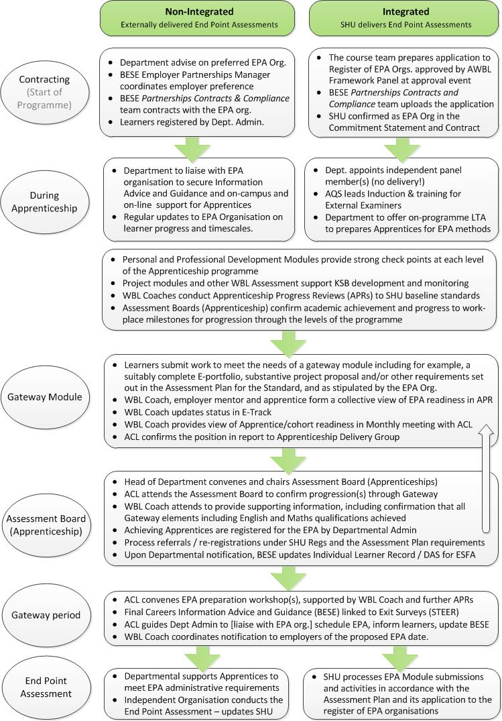

11.7 The University currently uses a Blue-Red-Amber-Green coding to identify general progress.

* Blue: Beyond Expectations
* Green: Good Progress towards timely completion
* Amber: Some issues needing agreed action
* Red: Significant Concerns requiring intervention

The above categories of progress are explained in Section 9, Page 21.

11.8 The B-R-A-G approach is used to monitor the following areas, recorded in the MAYTAS Apprenticeship Tracking system, to determine appropriate interventions and set challenging targets:

* *Up to date on reviews (% within 2-weeks of targeted date)*
* *Academic Progress by Apprentices*
* *Apprentices' Attendance*
* *Satisfactory 20% off the job learning achieved and logged*
* *Other Gateway requirements (Including English and Maths)*
* *Engagement of Work Mentor*
* ***Overall Progress to KSB Milestones*** (See Appendix 12)

*i.e. progress to EPA is evidenced in the E-portfolio*

11.9 The Trackers are maintained by WBL Coaches in E-Track (MAYTAS).

11.10 Causes for concern which should be communicated to other staff in the University. Figure 10 below provides a qualitative framework for identifying issues for escalation and possible routes for action.

11.11 Where a learner shows a red status against any of the above this matter should be discussed at the next possible monthly meeting (at the latest) and escalated in accordance with advice in this guidance. For sustained issues, beyond the initial intervention, a decision may trigger the withdrawal process. The factors and interpretation is outlined out in section 12 to follow.

11.12 In addition, Figure 11 shows the *process* for escalation of apprenticeship progress barriers, with particular emphasis on insufficient 20% OTJT intervention.

11.13 The Withdrawal process is set out in Section 12, including reference to internal withdrawal forms and an adaptable template for employer communications.

**Figure 10 Escalation of Apprenticeship Issues**

|  |  |  |  |
| --- | --- | --- | --- |
| **Indicators** |  | **Intervention Level** | **Actions -**  **WBL Coach to coordinate:** |
| **Grades:**  Observe grades, overall credit success and any outstanding modules (refer, defer, resit)  **Submissions:**  Be aware of any late, or missing submissions  **Attendance:**  Be aware of any reoccurring, or persistent attendance or punctuality issues (work or university)  **Employer engagement:**  Be aware of the mentor's engagement in Apprenticeship Progress Reviews (attendance, comments and action planning)  **20% Off-The-Job-Training (OTJT):**  Discuss reality of identifying, conducting, or logging 20% OTJT  **KSB Progress & planning**  Check for persistent problems with specific KSBs, or overall slow progress in EPA readiness |  | **Critical** **Persistent Red**  Problems too widespread, or intense - completion of apprenticeship seems definitely unlikely  *- action: termination of apprenticeship by agreed date and commence support to next training option*  **Serious** - **Recent/ongoing Red**  Problems are widespread or significant problems in key areas that need significant intervention to resolve  *Action: Set SMART interventions, monitor closely and escalate to senior staff for support*  **Moderate** - **Amber**  Manage at course level using SMART approaches but keep all other stakeholders informed, e.g. wellbeing support, academic advisers. Increase intensity of review.  **Low**: **Amber**  Mange at delivery level through consistent target setting, informing other stakeholders as necessary, or through routine updates. Consider early, focussed Progress-way review *in the work place.*  **No Issues - Green or Blue**  Manage reviews and academic progress as normal | Monthly Delivery Team / Departmental Operations meetings to recommend any withdrawals to Head of Department.  Trigger Withdrawal Process (see section 12) and standard letter in Appendix 10  Log in Monthly meeting and agree intervention.  Update WBL Manger,  actively supporting Coach to deliver/ monitor actions  - Review at Dept. Ops Meeting  Inform ACL at monthly meeting. Escalate to WBL Coach Manger. Informal other stakeholders via Departmental Operations Meetings  Manage by WBL Coach, update ACL at monthly meetings. Involve other stakeholders if relevant to their role, e.g.   * Academic Adviser * Academic Administrator * The Employer * EP Manager |

Figure 11 (below) shows the process for escalation of apprenticeship progress barriers including insufficient 20% off the job learning.

**Figure 11: Apprenticeship Escalation Process E.g. 20% Off-The-Job-Training**

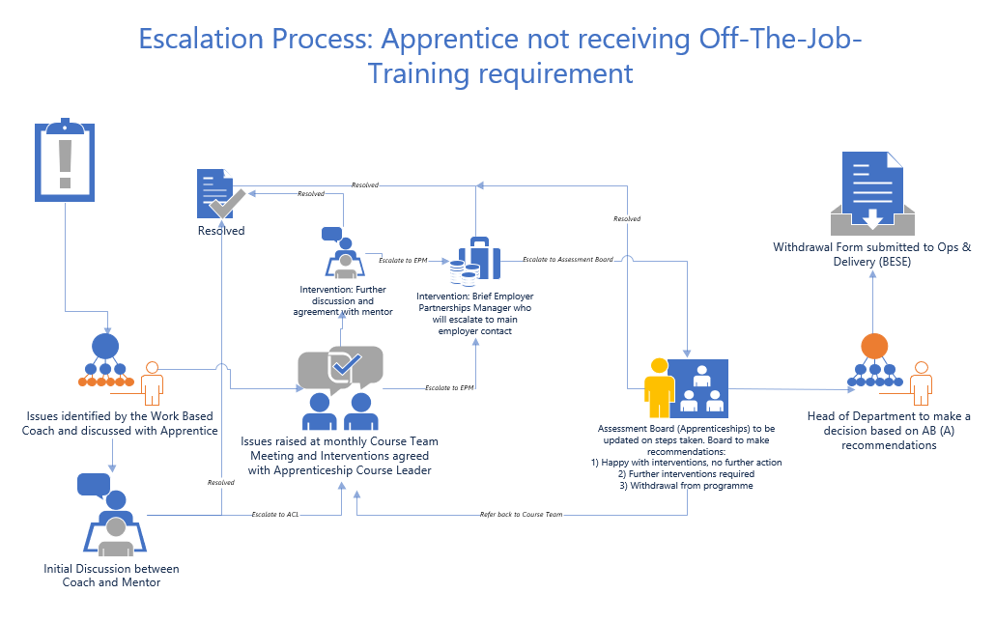

**12. Withdrawal of Apprentices**

12.1 Where an Apprentice continues to demonstrate significant concerns to the extent that they are no longer seriously pursuing the objectives and commitments made at the outset and targets subsequently set in Apprenticeship Progress Reviews, then the University will instigate a three step process.

12.2 This process may be adjusted depending on how the apprentice and their employer respond, as follows:

**Step 1:** **Monthly Meeting to Confirm Withdrawal Letter Action**

* Following the escalation process, the WBL Coach consults with the WBL Manager and if necessary Head of Work Based Learning to confirm a view that withdrawal process should be triggered by the standard formal letter (and email).
* This is confirmed in monthly meeting with ACL or sooner
* The matter is reported to the Departmental Operations Meeting, or equivalent to obtain Head of Department confirmation
* The matter is escalated to the Assessment Board (Apprenticeships)
* See Appendix 9 for Withdrawal Form.
* See Appendix 10 for standard withdrawal letter

The letter may trigger a break in study if appropriate, or alternatively set a limited action period and effectively give notification of termination

**Step 2: Employer Partnership Manager Meeting with Employer**

* A meeting is convened by the sector specific Employer Partnership Manager (EPM) to discuss next steps and communicate further about the employer contract and funding and any other training needs. This will be a final check point prior to implementing the withdrawal.

**Step 3: Implement the Withdrawal**

* Following the meeting the EPM reports back to Head of Department, ACL, WBL Manager, the BESE Contract Team and the Departmental Operations Meeting to Action outcomes.
* Following a meeting to discuss options a learner may elect to complete a learner withdrawal form. General Advice and Process information on student-led withdrawals can be found here: <https://portal.shu.ac.uk/departments/registryservices/services/sup_stu/pages/studentledwithdrawal.aspx>
* The WBL Coach will complete an Apprenticeship Withdrawal Form to be signed by the ACL at the Monthly Meeting (See Appendix 9)
* The outcome / next action is confirmed at the Assessment Board (Apprenticeship) or if already noted at a previous board the confirmation will be by Chairs Action by the Head of Department.

**13 Safeguarding Matters and Wellbeing**

13.1 During each *Apprentice Progress Review* the WBL coach ensures the apprentice has the opportunity to raise any matters relating to their welfare, prevent duty, health and safety or other safeguarding issues in the workplace, or relating to their apprenticeship generally. Where such issues are raised (or identified) the Coach will ensure an action is agreed, or referred back to the other stakeholder in the University and followed up in accordance with the Apprenticeship Safeguarding Practice Note found at: <https://blogs.shu.ac.uk/wblapprenticeships/compliant-learner-management/>

13.2 The Apprentice support network needs to bridge the SHU environment and the work place and so the WBL Coach becomes the primary contact point and often may need to make referrals, as illustrated in Figure 12 below.

**Figure 12: Apprenticeship Support Network**

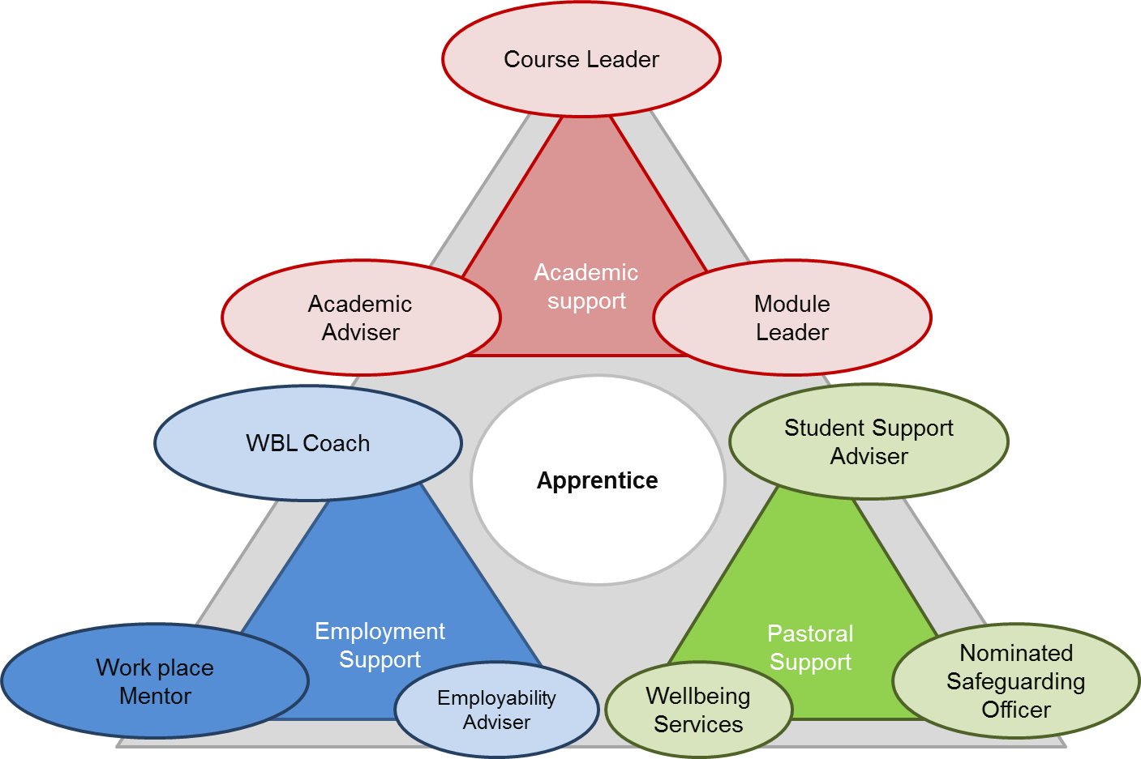

13.3 Wellbeing (including 20% Off-The -Job-Training and Safeguarding) is identified as a theme for "Apprenticeship Essentials" (see sections 7 and 15) and so there are opportunities for Apprentices to remain informed and to actively engage with those themes through:

|  |
| --- |
| * Curriculum delivery and assessment |
| * Apprenticeship Progress Reviews (Using theme-specific Annex) |
| * On-line: Apprenticeship Impact & Information Resources (AIIR) |

13.4 Employers have a primary duty under health and safety legislation but the University also owes a duty of care. Safeguarding typically related to children, but any adult can become a *vulnerable adult* and so the WBL Coach should use reasonable diligence to observe any concerns and/or listen to those raised by the apprentice or other relevant person.

13.5 The monthly meeting between the WBL Coach and the Apprenticeship Course Leader offers a timely opportunity to review any wellbeing and safeguarding matters that might need escalating as concerns, having regard to any sensitivities, or confidentiality and GDPR restrictions. Safeguarding is the priority. Additionally, WBL Coach team-meetings are a further (fortnightly) opportunity to escalate concerns to the WBL Coach Team Leader and Head of WBL as the Appointed Person.

**Figure 13 Communication Channels for Escalating Safeguarding Issues (From SHU Safeguarding for Apprenticeship Provision)**



**Subcontractor Monthly Meetings**

Learner monitoring and interventions and escalation of any issues

The Designated Safeguarding Officer for Apprenticeships is the Head of Work Based Learning

14 **Additional Learning Needs**

14.1 Learning support is available for apprentices who disclose a learning difficulty or disability. Support will include provision of a learning contract, setting out adjustments to learning, teaching and assessment, e.g. extended deadlines. It may also include provision of support workers, e.g. note taker or specialist mentor, supportive software, or hardware provision.

14.2 Apprentices who disclose a learning difficulty or disability through the university application process are automatically provided with details about how to set up support through the Disabled Student Support team (DSS). So long as they have registered with DSS and provided written evidence of their disability, DSS can set up support from the start of their course.

14.3 For a number of reasons, apprentices may not enquire about disability support until after their course has started, or there may be a need to carry out further assessment to the evidence submitted, or otherwise. In this case, they should be signposted to Disabled Student Support as soon as possible.

14.4 Disability Advisers in DSS will assess the details of the support package needed by the apprentice. If an apprentice requires help at work on account of a learning difficulty/disability, they should be signposted to the [Access to Work](https://www.gov.uk/access-to-work) scheme.

14.5 If an apprentice has disclosed a disability, this should be picked up as part of the Apprentice Progress Review and the impact on their learning discussed:

* If no support is in place, or a learning contract needs to be reviewed, the apprentice should be referred to DSS.
* If a support worker has been recommended the WBLC should ascertain if the apprentice is booking the number of sessions recommended in their Study Needs Assessment. If they are not attending, or only attending spasmodically, the WBLC should liaise with BESE Admin to enable adjustment of the MAYTAS claim to ESFA. Where an apprentice is attending one to one support with an external support provider (Study Skills tutors and Mentors) the WBLC should liaise with DSS to obtain feedback about the impact of the support.

14.6 Further guidance on well-being, mental health support and safeguarding is available:

Disabled Student Support:

<https://www.shu.ac.uk/current-students/student-support/disability-support>

Student Wellbeing Guidance for staff:

<https://portal.shu.ac.uk/departments/wellbeing/pages/supporting-student-wellbeing.aspx>

Student Wellbeing Advice Page:

<https://www.shu.ac.uk/current-students/student-support/student-wellbeing>

Supporting Students in Distress: <https://blogs.shu.ac.uk/shudistress/?doing_wp_cron=1556175956.9806680679321289062500>

**15 Apprenticeship Essentials - Compliance within Curriculum**

15.1Apprenticeship Essentials are set out as a list for induction in Section 7, figure 4. The University has taken that list and devised 6 broad themes to cover the Apprenticeship Essentials. In summary, the themes have been developed as follows:

**Table 3 Apprenticeship Essentials - Themes**

|  |  |
| --- | --- |
| **Main Themes** | **Sub-themes** |
| Well-being and Support  (Safeguarding) | Getting Help (and Safeguarding) |
| Staying Safe on-line |
| 20% Off-The-Job-Training |
| Your community and Enrichment |
| Workplace Welfare |
| Academic Support |
| On-Boarding | Commitment - Employer Engagement |
| Transition - Preparing for HE |
| Starting Point - Your "Skills Scan" |
| Journey - Roadmap to EPA |
| Evidence - Demonstrating your KSBs |
| Impact - Projects in the Workplace |
| Careers Information  Advice & Guidance | The Right Apprenticeship - Revisiting Skills Scan |
| Personal and Professional Development |
| Careers Guidance (link) |
| Careers 360 for Apprentices |
| Book an adviser workshop |
| Alumni Support |
| Equality Diversity  and Inclusion | SHU Equality Objectives (Student Charter) |
| Disability Team |
| Unconscious Bias (Linked in Learning) |
| Race Equality Charter |
| Athena Swan |
| Working Families |
| British Values  and Prevent | British Values - What are they? |
| BV in your Apprenticeship |
| Prevent - what does it mean? |
| Self-Development (Actions) |
| Discussion - for your Progress Review |
| Concerned? - Options for Support |

15.2 To provide development and engagement for those themes the University will cover these through induction and then offer three methods of ongoing engagement:

|  |
| --- |
| * Curriculum delivery and assessment |
| * Apprenticeship Progress Reviews (Using theme-specific Annex) |
| * On-line: Apprenticeship Impact & Information Resources (AIIR) |

15.3 At the outset of each Apprenticeship programme the ACL should work with module leaders and the WBL Coach (the delivery team) to develop the overall delivery scheme, identifying how and when the above approach will be implemented. The following presentation can be found in the Teaching and Assessment Essentials Website: Embedding Apprenticeship Essentials, alongside planning resources to assist in this activity: <https://blogs.shu.ac.uk/wblapprenticeships/developing-an-apprenticeship-course/readiness-checklist/>

15.4 The ACL is also accountable for implementing and seeking best practice and embed Apprenticeship Essentials through apprenticeship course delivery. Table 4 below summarises these activities and the roles during delivery. This table should be read in conjunction with the wider guidance and toolkit for "Embedding Apprenticeship Essentials (see above link)

**Table 4 Compliance Activates led by ACL - Summary of Responsibilities**

|  |  |  |  |
| --- | --- | --- | --- |
| **Area** | **ACL Role** | **WBL Coach Role** | **Other Operational Role(s)** |
| Attendance monitoring and intervention | Follow SHU policy, to implement attendance monitoring working with faculty *academic administration* | Obtain and observe attendance patterns and raise issues in APR. Escalate known issues to the ACL. | ACL to escalate persistent non-attendance issues to Student Support Services and potentially to Employer Partnership Managers |
| English and Maths Progress | Ensure English / Maths progression supported in all curriculum in additional to any qualifications required | Chase any certificates and/or qualification progress where needed, Focussed reviews on general development. | Liaise with WBL Manager, who works with BESE Ops team to track and liaise with the Functional Skills provider (Sheffield College). |
| 20% off the job learning | Ensure Commitment Statement completed. Ensure projects and other assessments flag OTJT activities.  + Reporting at AB (A). | Reviews and in-class workshops to support apprentices to identify/plan for 20%. Maintain tracker and interventions.  + Reporting at AB (A). | BESE to release themed *Apprenticeship Impact Information Resource*  Escalate any non-compliance at AB(A) (see section 11) |
| British Values  + Prevent Duty | Ensure course design, review and assessment activities identify areas of professional and ethical development. | Cover in reviews. E.g. One *focussed APR* Annex per year and through *Apprenticeship Impact Information Resources* | All Apprenticeship Essentials to be communicated in class, at reviews and through themed *AIIR* |
| Equality Diversity and Inclusion | Ensure course design review and assessment review activities identify areas of professional and ethical development relating to equality | Cover in reviews. E.g. One *focussed APR* Annex per year and through *Apprenticeship Impact Information Resource* | BESE to monitor performance of different groups through Apprenticeship System and report any concerning outcomes or trends. |
| Safeguarding and wellbeing | Communicate meanings and options for support, e.g. inductions. Ensure learners are familiar. Observe commitments in any learning contracts. | Through APRs, ensure apprentice understands meaning and support/ reporting options. E-portfolio to reinforce during delivery. Raise issues ASAP and at WBL team meetings. | HoWBL is designated safeguarding officer for apprenticeships.  Report updates to Safeguarding Steering Group, Maintain Safeguarding Practice note. |
| Adjusting RPL  (Also see Section 4 - On-boarding.) | ACL to oversee learner progress through curriculum assessments and towards gateway requirements and KSBs required for EPA. | Identify any unnecessary or additional learning requirements as the course progresses. If initial on-boarding was not accurate then adjusted in the ILP. | Funding adjusted by the BESE Ops team.  The cost of retakes needs to be communicated and invoiced to employers ASAP (not charging the learner). |
| Enrichment & celebrating success | Identify nominations, then support apprentice /employer applications for SHU & external awards | Identify nominations by deadline required, then support apprentice /employer applications  (see Section 22) | BESE to set in place process for nominations and support.  Promote to employers. |

Table 4 should be reviewed in conjunction with the wider guidance and toolkit for "Embedding Apprenticeship Essentials": <https://blogs.shu.ac.uk/wblapprenticeships/developing-an-apprenticeship-course/readiness-checklist/>

**16 Assessment Practice for Work Based Learning**

16.1 For guidance on how to develop and embed WBL in assessment and curriculum delivery see the BESE Assessment review activity embedded in the [ACIP process](https://sheffieldhallam.sharepoint.com/sites/3050/SitePages/Apprenticeship%20CIP.aspx). This [WBL Assessment Best Practice Guide](https://blogs.shu.ac.uk/wblapprenticeships/wbl-assessment/?doing_wp_cron=1580810195.0425050258636474609375) illustrates how assessment can reinforce development of KSBs through direct LTA activities but also through critical review and action planning. LTA can relate directly to Apprentice Progress Reviews, either by promoting or requiring preparation for Apprentice Progress Reviews, or using the outcomes and discussions from three way discussions and content of E-portfolios as assessment focal points. These activities should re-inforce a positive status of apprentice and raise awareness of progress and requirements for EPA.

16.2 The University is developing a Staff Development offer for new and existing colleagues to help develop WBL capability including an understanding of the nature of courses like degree apprenticeships. This will cover: how to devise appropriate assessment vehicles; how to support compliance through adapting curriculum delivery; and importantly, the art of story-telling and agility in the class room and on-line. These methods will collectively enhance the apprentice experience including time-effective achievement of learning outcomes, removal of unnecessary contact hours and greater impact for the employer. The outcomes must be improved satisfaction and improved timely completion rates through success at EPA.

Further information on [Staff Development Opportunities](https://blogs.shu.ac.uk/wblapprenticeships/nceda/) is in the tab relating to the National Centre for Excellence in Degree Apprenticeships.

External facing information about NCEDA can be found here: <http://www.scci.org.uk/2018/11/jake-berry-mp-opens-sheffield-hallams-new-national-centre-of-excellence-for-degree-apprenticeships/>

**17 ACLs and Academic Advisers in Apprenticeship Delivery**

17.1 SHU has a preferred Delivery Model for Apprenticeship courses (see [Apprenticeship and Work Based Learning Framework](https://sheffieldhallam.sharepoint.com/sites/3050/SitePages/AWBL%20Documents.aspx)). Variability is inevitable due to the different formats and durations in each [Apprenticeship Standard](https://www.instituteforapprenticeships.org/apprenticeship-standards/) and Assessment Plan. The SHU AWBL delivery model requires a minimum amount of flexible work based learning modules, where the learner can determine their own focus to some extent, including modules for:

1. **Personal and Professional Development (PPD)** (20 credits per level); and
2. **Project-based learning** (typically 40 credits per level minimum).

In addition, other introductory, discipline focussed, or subject specialist modules will also contain WBL approaches to learning teaching and assessment, as set out in the SHU [WBL Assessment Best Practice Guide](https://blogs.shu.ac.uk/wblapprenticeships/wbl-assessment/?doing_wp_cron=1580810195.0425050258636474609375).

17.2 The Course Leader will find great advantage by participating in delivery of the PDP modules and also Project modules, at level 4 and ideally (subject to capacity) engaging in delivery at later stages to keep in contact with the apprentices and understand their progress and ongoing challenges. If the Apprenticeship Course Leader has a specific specialist area that they are well placed to delivery (outside the core WBL modules), then it would make sense to use one of the relevant assessments in that module to link directly to one of the Apprenticeship Progress Reviews, including a component of SMART planning to feed into the next review. This can be done as an appendix to a submission so does not need to involve a major re-write of the assessment brief.

17.3 The Academic Advising Framework (2018), and Academic Advising Policy (2019) states that *all* students should be allocated a named Academic Adviser (AA), have *contact* a minimum of three times a year and provide a reference for students upon completion. The allocated AA will support academic progression, personal development and professional development. HDA students are also able to access the Student Support Adviser drop in sessions which take place on a daily basis at both Collegiate and City Campus.

17.4 For Apprentices the AA should be provided with a copy of the Apprentice's *Skills Scan,* completed as part of the On-Boarding process for information. The AA role will focus on:

* understanding the requirements of university study
* identify patterns in their feedback
* signposting to additional support if required (eg: Student Support Adviser, Skills Centre or Disabled Student Support)
* their personal development, making specific reference to the *behaviours* set out in the apprenticeship standard and
* professional development, with a wider remit than EPA readiness, discussing possibilities for development outside the Apprenticeship.

17.5 The Course Leader needs to be clear with Apprentices that the AA role is a separate role from the WBL Coach. The costing model for Apprenticeship delivery envisages a specific involvement for AAs Advisers, agreed by the Apprenticeship and Work Based learning Steering Group (see Appendix 13). Implementation is by one of two options:

**AA Option 1:**

The first is to adapt an existing module to explicitly 'house' academic advising, for example a Reflective Practice module. In this situation course teams could modify Module Descriptors and delivery to explicitly incorporate academic advising activity as part of the module. Where this model is used the Module Leader or member of the module teaching team would be identified as the named Academic Adviser for students taking that module.

**AA Option 2:**

The second option would be to implement academic advising outside a module. Minimum requirements for academic advising outside the curriculum are outlined in Appendix 13, with links to the monthly apprentice progress meetings conducted by the WBL Coach and Course Leader, as well as Apprenticeship Progress Reviews.

17.6 Section 10 provides guidance on how to plan a year to ensure Apprenticeship Essentials (and compliance) are embedded in curriculum with integration to Apprenticeship Progress Reviews (APR). The PPD (also referred to as Reflective Practice) modules are the ideal vehicle for much of the delivery of Apprenticeship Essentials.

17.7 SHU has recently (Spring 2019) been inspected by OfSTED for part of its Apprenticeship Provision. Part of this inspection considered the extent to which the University uses peer observed teaching to enhance its practice. ACLs should liaise with the Departmental Subject Group Leads to ensure the University's [policy](https://extra.shu.ac.uk/sas/quality/AcademicPoliciesDocuments/Peer%20Review%20and%20Enhancement%20Policy%20final.pdf) for annual peer review and enhancement is applied clearly and recorded for impact on learning journey. Please see current University advice here: [https://blogs.shu.ac.uk/talent/observation-of-practice/](https://blogs.shu.ac.uk/talent/observation-of-practice/?doing_wp_cron=1557748110.0477409362792968750000). Logs and outcomes of Peer Review activity will need to be available for future OfSTED inspections.

17.8 In addition a template is provided in Appendix 6, taken from the above internal and HEA informed guidance, with minor adaptation to achieve effective Peer Observations of teaching on Apprenticeship courses.

17.9 All Apprenticeship Course Leaders should work closely be part of the Apprenticeship and Work Based Learning Task Group for updates on operational and funding impacts as well as new resources and case studies. Development of Practice is offered through staff development opportunities, events and workshops run as part of the AWBL Guild community of Practice. Clare Barnett can add you to the meeting invitation and you will receive minutes, updates and resources as part of circulations of that group. Email Clare Barnet and copy to [Apprenticeships@shu.ac.uk](mailto:Apprenticeships@shu.ac.uk)

**18 20% Off -The- Job-Training**

***The basic Idea***

18.1 The ESFA funding rules specify that all apprentices must be given 20% **Off -The- Job-Training**. *What does this mean?*

18.2 In short an Apprentice must work at least 30 hours in a working week in an appropriate job role. Over the course of an apprenticeship (up to the practical gateway) the apprentice must on average spend 20% of their contracted working hours in "Off-The-Job-Training" (OTJT) i.e. typically about 7 hours a week on average, measured over the duration of the apprenticeship. This rule is in place to protect and support the apprentice and ensure a high quality apprenticeship can lead to success for the learner.

18.3 Practical Completion (or the passage through "gateway") is generally understood to be the point at which the programme of learning has been completed and the Apprentice is ready, they have met all the Gateway Requirements set out in the Apprenticeship Assessment Plan and so they are effectively, making final preparations for their End Point Assessment event.

All this is explained in the Government Guidance found here: <https://www.gov.uk/government/publications/apprenticeships-off-the-job-training>

In addition further SHU resources are here: [Teaching and Assessment Essentials webpage](https://blogs.shu.ac.uk/wblapprenticeships/resources-opportunities/)

***The commitment to 20% OTJT***

18.4 At the start of every apprenticeship there must be a three way "Commitment Statement" in place. These are administered by BESE alongside the employer contract. The Commitment Statement includes a series of obligations, commitment and expectations between the apprentice, their employer and the Apprentice training provider (SHU). This includes a summary of how the 20% off the job learning is planned. A schedule and Pie chart are set up by the course leader (working with BESE) to show the different ways to get 20% OTJT against an overall target (see Appendix5 - or: <https://blogs.shu.ac.uk/wblapprenticeships/should-we-do-this-apprenticeship/>). This information is appended to the Commitment Statement on release by BESE Operations team.

***A work-based curriculum should proactively drive this process...***

18.5 The approval process for each new SHU Apprenticeship provision includes a requirement for the course design team to create a mapping grid ([*mapping* document](https://sheffieldhallam.sharepoint.com/:x:/r/sites/3050/cda/_layouts/15/Doc.aspx?sourcedoc=%7b61CE0602-A8AA-49AD-B0DB-1BC0C51EDA98%7d&file=Mapping%20Template%20v2.%20June%202018.xlsx&cid=03dc818f-1b3b-4627-be55-f7490edc78ee))to show how the taught element will contribute to 20% OTJT and map the modules to the knowledge, skills and behaviours in the relevant apprenticeship standard. Work Based Learning Assessments should secure the intentions in the mapping exercise.

18.6 Reflective modules are a vehicle for reviewing knowledge skills and behaviours and putting actions in place, potentially within assessment vehicles. In addition Project-based modules require purposeful and impactful project learning in the workplace, which counts as 20% OTJT. SHU is required to monitor and intervene to support 20% OTJT.

***Monitoring, Supporting and Intervening***

18.7 Amongst the obligations on SHU, we are required to deliver our part of 20% OTJT (basically thought of as the curriculum). We must support the employer and apprentice to identify and achieve the rest. SHU's Work Based Learning Coach schedules *Apprenticeship Progress Reviews* (tripartite). Part of the review is to monitor and action plan the achievement of OTJT. 2 E-Track (in MAYTAS) must be used to support ESFA funding reports and enable proactive intervention agreed by the Apprenticeship Course Leader and WBL Coach initially. There is a process of escalation set out in Figure 11, Section 11.

***Employer Commitment and Communications***

18.8 The requirement to enable and record 20% Off the Job Training is communicated to employers and apprentices in specific ways:

* Initial Training Needs Analysis
* In the Commitment Statement
* Recruitment Evenings
* Welcome Evenings
* Induction Apprenticeship Progress Reviews
* On-line Mentor Support Resource and supplementary training agreed with each employer
* During curriculum delivery, particularly in Personal and Professional Development modules
* Through Apprentice Progress Reviews
* Through further intervention if necessary

18.9 The ACL should work with their apprenticeship lead in Faculty and with the Head of WBL in BESE to ensure that all members of the delivery team are able to actively communicate an support the identification of 20% Off-The-Job-Training and engage in planned and opportunistic dialogue to support learners to achieve this and record this. This communication should be part of ongoing teaching and learning dialogue and also embedded in WBL learning teaching and assessment activities. The WBL Coach will then be responsible for monitoring and setting appropriate targets, with reference to those actions that are required in curriculum and assessment tasks.

**19 Gateway Period and End Point Assessment (EPA) *- Delivery***

19.1 Previous section 11 provides advice on the Process for Gateway and EPA. This section 19 provides best practice guidance and requirements in relation to *Delivery*. The delivery of an *Apprenticeship Standard* should be done with the end in mind. The Departmental Delivery Team is accountable for the delivery of the whole apprenticeship. The conclusion of any credit bearing component, does not end this accountability. Success is based on completion of the entire Apprenticeship up to and including EPA.

19.2 The ACL and the WBL Coach therefore need a strong knowledge of the relevant Apprenticeship Standard, keen familiarity with the range of knowledge skills and behaviours and the overall requirements, including matters such as duration, entry requirements and specific methods for the EPA, including who does it, when and how. The Apprenticeship Standards, including the critical Assessment Plans can be found here: <https://www.instituteforapprenticeships.org/apprenticeship-standards/>

19.3 The operation of each EPA is highly dependent on the rules set out in the Apprenticeship Standard and related (EPA) **Assessment Plan**. The ACL should work with the Apprenticeship Lead in their area and the course delivery team to develop a clear strategy of support during the gateway period leading up to the EPA. This applies for integrated and non-integrated Apprenticeships, though the approach will vary. An action plan might include (for example):

* + - Clear submission requirements and enhanced feedback from Gateway Module
    - Portfolio evidence review / Defending your evidence workshop
    - Presenting your case study / project workshop
    - Specific support from the EPA Organisation on expectations
    - Note: The Apprenticeship costing model allows for the WBL Coach to continue Apprenticeship Progress Reviews during the gateway period

19.4 ACLs should work with the EPA Organisation to develop a shared understanding of how the EPA will work and ensure clear communications and guidance is given to learners and employers early in the apprenticeship and with regular information release.

*Gateway Modules*

19.5 All Apprenticeship Courses (whether integrated, or non-integrated) should be able to identify a *Gateway Module* to implement formal checks on readiness and activities to ensure Gateway requirements are met. These might include specific submission requirements, e.g.:

* An assessed reflection or critique on all or parts of a completed E-portfolio;
* Pro-forma confirming employer sign off for EPA, as set out in the Assessment Plan;
* A pass/fail element of a module to confirm the completeness of a vocational portfolio, or technical requirements have been met (as appropriate to the Standard)
* The submission of a project proposal / Case Study (ies) if required by the Standard
* Final action plan to address/strengthen evidence gaps if permitted
* Confirmation of English and Maths certificates (and other gateway components).

19.6 Gateway module mechanisms should be developed to meet the needs of the Apprenticeship Standard and for Integrated Degree Apprenticeships should be in line with the operational intent and planning set out in the SHU application to join the **Register of End Point Assessment Organisations** (contact BESE for advice on Integrated End Point Assessments). Therefore the Apprentice's readiness and sign-off will again depend on the detail for Gateway, found in the Apprenticeship Assessment plan. Where readiness is captured in module assessment activities, those outcomes can inform decisions to progress learners to gateway. Readiness is agreed at Monthly Meetings between the ACL and the WBL Coach (See Agenda in Figure 7, Section 10). These decisions are formally ratified at Assessment Boards (Apprenticeship) (see Figure 10 in Section 11 and Section 20).

19.7 The Monthly Meeting agenda *includes* the **Gateway Readiness Form** to be completed at Monthly Reviews to inform planning and contractual implementation to set up End Point Assessments for Integrated Delivery, or by the external EPA organisation.

19.8 The practical arrangements for organising and setting up EPA whether integrated or non-integrated rest with the Departmental Administration Team (Section 11 covers roles).

19.9 Whilst the above support roles are important in facilitating a smooth journey to EPA and maximising chances of success, it is worth re-emphasising that the Departmental Delivery Team is accountable for the delivery of the whole apprenticeship. The conclusion of any credit bearing component, does not end this accountability. Success is based on completion rates for the Apprenticeship.

19.10 For Integrated End Point Assessments further work is underway through a practice group to identify good practice for EPA set up, including:

* Implementing the EPA module and the terms in the Application to join the Register (reflecting the Assessment Plan)
* Employment Status for Independent Panel Members
* Good practice for Gateway Modules
* Training and time allowances for Assessors
* Inclusion in Assessment Boards (Apprenticeship)
* Developing/owning banks of questions
* Reviewing E-portfolios
* Quality Assurance of Assessment and Assessors - (moderation, de-brief)
* Planning and Sequencing
* Risk Management

Contact the Head of Work Based Learning for updates or to attend the group: PA: Jane Ashcroft. Or contact Colm Cambell, or Linda Hall in AQS.

**20 Course Review - Assessment Boards (Apprenticeship) - *Quality***

20.1 As well as the Department Assessment Board responsibilities, there are additional responsibilities relating to students on Apprenticeships. These are the responsibility of Assessment Boards (Apprenticeship). The additional responsibilities are:-

* To monitor progress against the relevant apprenticeship framework or standard in accordance with Education and Skills Funding Agency (ESFA) funding and monitoring rules. This includes:-
  + - Off-The-Job-Training
    - Attendance
    - Employer engagement
    - Progress of evidence of knowledge, skills and behaviour
    - Gateway requirements.
* To identify students who require intervention in order to close their achievement gap for referral to the relevant department/committee.
* To ratify individual students who meet the prescribed KSB criteria to progress to Gateway leading to the End Point Assessment (EPA).
* To monitor the EPA status of non-integrated apprenticeships.
* To identify issues in the attainment of apprenticeship students compared to non-apprenticeship students and consider relative performance of different groups of learners across cohorts of apprentices as compared to national benchmarks

20.2 The Standing Agenda for Assessment Boards (Apprenticeship) includes additional questions pertaining to the Apprenticeship Journey, which will be answered jointly by the Apprenticeship Course Leader and WBL Coach based on the outcomes of previous Monthly Meeting.

The agenda for Assessment Boards (Apprenticeship) is in Appendix 11, or on the Teaching and Assessment Essentials SHU Blog page: <https://blogs.shu.ac.uk/wblapprenticeships/compliant-learner-management/>

20.3 Further advice on Judging Readiness is found here in Appendix 12 (KSB Milestones): [Teaching and Assessment Essentials webpage](https://blogs.shu.ac.uk/wblapprenticeships/resources-opportunities/).

*Monitoring of Apprentices against Apprenticeship Standards or Frameworks*

20.4For each course, Work- based coaches and Course Leader (where applicable) to report any issues on:

**Off the job learning**

* + Confirm how many apprentices have received 20% OTJT
  + Confirm how many apprentices can evidence satisfactory progress against their log What are the reasons for those that are not satisfactory?

**Employer engagement**

* + What % of employers have engaged well in the majority of Apprenticeship Progress Reviews (75% minimum for Green status). (50-75% Amber)
  + Which employers have not engaged and what interventions have been agreed with the ACL?
  + What are/will be the impacts of those interventions?

**Attendance**

* + Please report the Attendance statistics

**Knowledge, skills and behaviour**

* + For Apprentices not Green or Blue, what interventions have been agreed and/or implemented, with the ACL.
  + What is the summary and relevant interventions for learner now passed their Planned End Dates?  (% and actions).

**21 Employer Feedback**

21.1 The ESFA runs a generic employer feedback survey and published results on line: <https://findapprenticeshiptraining.apprenticeships.education.gov.uk/Provider/10005790?keyword=Sheffield%20Hallam>

21.2 In addition, the Apprenticeship Progress Review Form promotes broad employer feedback on the Apprentice's performance and impact in the work place. There is also opportunity for the employer to provide feedback on the course in general (with a score of 1-10) and WBL Coaches are encouraged to return comments to ACLs so that delivery can be actively monitored and improved on a responsive basis. Monthly meetings will be a regular chance to note employer feedback including the average Employer Satisfaction Rating and any outlying concerns. The ACL can then seek enhancement with the course delivery team and share concerns and actions with the Departmental Operations Meeting, or equivalent.

21.3 The approach to obtaining and acting on employer feedback is strengthened under revised templates Apprenticeship Progress Reviews, Monthly internal meeting agenda and through the Standing agenda for Departmental Assessment Boards. Accuracy and regularity of reporting will be enhanced through the Implementation of the new Learner Management System (MAYTAS).

21.4 Careful consideration should be given to differentiate between feedback and complaints. Where there is a clear voice expressing strong level of dissatisfaction, then this is probably a complaint, but this might best be determined in the monthly meeting (unless more urgent) and by checking with the individual(s) concerned. If a complaint has been made, then it is imported to establish whether it is a complaint from the student (apprentice) or their employer (or both) and instigate the correct process (or processes) in a timely manner. Information on complaints processes can be found through the links below:

**Student complaints:** <https://students.shu.ac.uk/regulations/appeals_and_complaints/index.html>

**Employer complaints:** <https://www.shu.ac.uk/business/develop-your-people/degree-apprenticeships/useful-resources>

21.5 For additional qualitative and evaluative feedback, the ACL should work with module leaders to also seek ways of pulling employer feedback and actively identifying impact and performance changes into submitted work, whether formative or summative assessment. Positive critical reflection or honest and open critique within assessment vehicles or as part of seminar, or general surveys in curriculum can form valuable tools for delivery enhancement within curriculum and inform course review. The apprentices should be encouraged through assessment to identify opportunities for impact and performance improvement and actively log these within or in preparation for assessment and to generate evidence for E-portfolios. This leads us on to the final section of this guidance…

**22 Celebrating Success**

22.1 The Course Leader and WBL Coach should be champions for the standard within the university when engaging with other academics and professional services staff as well as to enhance the engagement and ambassadorship of each apprentice and their employer. Areas for engagement include:

* Supporting the development of case studies and nominations/applications for Apprentice of the Year Awards - <https://appawards.co.uk/> See Appendix 8 for case study template, which is aligned to nominations/applications for national awards.
* Engaging with Business Development and Marketing activities as required.
* Championing Apprenticeships through dialogue, LTA delivery and assessment design.
* Sharing with the team on a regular basis and as part of delivery culture.
* Including the employer in good news and added value activities, as well as the essentials like course review at assessment Boards (Apprenticeship)
* Embedding good practice - attending and contributing to The Work Based Learning Guild and AWBL Task Group meetings (contact [apprenticeships@shu.ac.uk](mailto:apprenticeships@shu.ac.uk)).
* Implementation of APR Annex and the AIIR on the theme of Community and Enrichment (see Sections 7 and 15 on Apprenticeship Essentials)

22.2 BESE can offer further guidance on supporting apprentices/employers to identify nominations and submit effective applications for Apprenticeship Awards in a timely manner. The approach will be driven by WBL Coaches, ACLs and Module Leaders running final year reflective and Gateway modules to identify and support each application, however there is scope to consider whether assessment vehicles, or aspects of delivery can be used to help Apprentices shape applications in advance - for example reflective exercises that ask the apprentice to work with the employer to answer a set of questions that would align to the application forms. Assessments can be designed to encourage content and structure that demonstrates impact in accordance with the template for nominations in Appendix 8.

22.3 Apprentices and their employers can be encouraged to join the SHU **Apprenticeship Ambassador Scheme**. This can support marketing, schools outreach and reporting and work to heighten awareness and support for the apprenticeship brand. Contact [apprenticeships@shu.ac.uk](mailto:apprenticeships@shu.ac.uk)

22.4 SHU has recently revamped its internal **Inspirational Student Award.** Aspiring and impactful apprentices will find a good fit with one or more categories and this application can gain strong reward and recognition for employability and also act as a springboard to regional and national Apprenticeship award nominations and applications. Contact Ian Saunders in BESE, or drop a line to **! Inspirational Student Awards**

Nomination link:            <https://go.shu.ac.uk/nominate>

Categories:                   <https://blogs.shu.ac.uk/isa/awards/>

**Appendices**

Appendix 1 Delivery Standards for Apprenticeships at SHU

[Standards, Highlighted on TAE](https://blogs.shu.ac.uk/wblapprenticeships/delivery-guide/)

Appendix 2 Apprenticeship Course Leader Role Description

[Apprenticeship Course Leader Role](https://blogs.shu.ac.uk/cle/files/2019/03/HDA-CL-role-outline-V2-FINAL.pdf)

Appendix 3 Work Based Learning Coach Job role

<https://blogs.shu.ac.uk/wblapprenticeships/delivery-guide/>

Appendix 4 Apprentice Progress Review Template

<https://blogs.shu.ac.uk/wblapprenticeships/delivery-guide/>

Appendix 5 Template for 20% Off-The-Job-Training Calculation

<https://blogs.shu.ac.uk/wblapprenticeships/should-we-do-this-apprenticeship/>

Appendix 6 Peer Observation Template

<https://blogs.shu.ac.uk/wblapprenticeships/delivery-guide/>

Appendix 7 Attendance Monitoring Baseline Process

<https://blogs.shu.ac.uk/wblapprenticeships/delivery-guide/>

Appendix 8 Template for Apprenticeship Case Studies

<https://blogs.shu.ac.uk/wblapprenticeships/delivery-guide/>

Appendix 9 Apprenticeship Withdrawal Form

<https://blogs.shu.ac.uk/wblapprenticeships/delivery-guide/>

Appendix 10 Standard Letter / Email for Triggering Withdrawal Process

<https://blogs.shu.ac.uk/wblapprenticeships/delivery-guide/>

Appendix 11 Assessment Board (Apprenticeship) Agenda (as at Feb 2020)

<https://blogs.shu.ac.uk/wblapprenticeships/delivery-guide>

Appendix 12 Apprenticeship Milestones

<https://blogs.shu.ac.uk/wblapprenticeships/delivery-guide/>

Appendix 13 Academic Adviser Model for Apprenticeships

<https://blogs.shu.ac.uk/wblapprenticeships/delivery-guide/>