**Thinking of creating a new Higher /Degree Apprenticeship at SHU?**

*Fast Facts:*

* As a starting point you will need to understand which ***Apprenticeship Standards*** are available and whether they are *approved for delivery with an approved funding cap*. Access the standards here: <https://www.instituteforapprenticeships.org/apprenticeship-standards/>. Be aware- the process for approval of the standard by the Institute for Apprenticeships and Technical Education (IfATE) consists of several stages before employer funding can be drawn down from the Education and Skills Funding Agency (ESFA). Ensure your College/Department lead supports you here.
* The SHU ***Apprenticeship Delivery Guide*** will help you understand how SHU has developed its approach and embedded an integrated approach to Apprenticeship Essentials: <https://blogs.shu.ac.uk/wblapprenticeships/delivery-guide/>
* Apprenticeship awards are considered for approval by the A***pprenticeships and Work Based Learning Framework (AWBLF) Standing Panel***. NB. College Planning Approval is required before a proposal can progress to validation. There is an Apprenticeship specific approach to running a cost model (Please contact Kay Simpson, or your College finance lead). Be familiar with the principles of the Apprenticeship and Work Based Learning Framework. Use the Apprenticeship Course Descriptor template, Apprenticeship Modules & adaptable student support guides: <https://sheffieldhallam.sharepoint.com/sites/3050/SitePages/Apprenticeships-and-Work-Based-Learning.aspx>
* Following confirmation of planning approval by the relevant College planning authority, a short *preliminary meeting* will be arranged by the AWBLF Standing Panel Secretary as early as possible to start the course planning and design process. Attendees at this preliminary meeting should include the Academic Lead for the proposal, the Chair of the AWBLF Standing Panel, Head of Work Based Learning and the Secretary to the Panel. Contact Linda Hall, or Colm Campbell in AQS.
* As part of the validation process, the Panel will review how your course design will deliver the specific Apprenticeship Standard. Your team needs to map the content of the modules for the new award to the Knowledge, Skills and Behaviours (KSB's) as set out the Apprenticeship Standard: <https://sheffieldhallam.sharepoint.com/sites/3050/SitePages/Apprenticeships-and-Work-Based-Learning.aspx>

This then becomes part of the Apprenticeship "Commitment Statement", which is a three way agreement between the University, the employer and the apprentice. It is the start of the learning journey and informs the Apprentice's E-portfolio. You will also need to calculate the basis for [20% Off-The-Job-Training](https://blogs.shu.ac.uk/wblapprenticeships/apprenticeship-fundamentals/?doing_wp_cron=1581677491.8742620944976806640625) in readiness for your approval event. Contact AQS for the pie chart template.

* Upon approval, Course Information is sent to the marketing team (learners and employers). Your College/Departmental Business Development Lead should contact Phil Clarke, Head of Business Engagement (BESE) for *early* advice on how to recruit apprentices working with *employers*.
* In addition, you should review the SHU [*Teaching Essentials Toolkit*](https://blogs.shu.ac.uk/wblapprenticeships/?doing_wp_cron=1571060228.9137070178985595703125) for ideas and advice on how to develop and deliver an Apprenticeship award. Pay attention to the need for an E-portfolio approach, the model for "Apprenticeship Progress Reviews" and to monitor 20% Off-The-Job-Training. BESE are implementing MAYTAS to meet these activities…

*How will you recruit a Work Based Learning Coach*?... Contact Andy Womble in BESE.

* Who is your Operational lead in Department/College? (Contact Stephen Bolton in BESE). Also, there is a community of academic practitioners. To join the Apprenticeship and Work Based Guild Group contact Clare Barnett: [c.barnett@shu.ac.uk](mailto:c.barnett@shu.ac.uk)

The slides and notes below are a good place to start discussions.

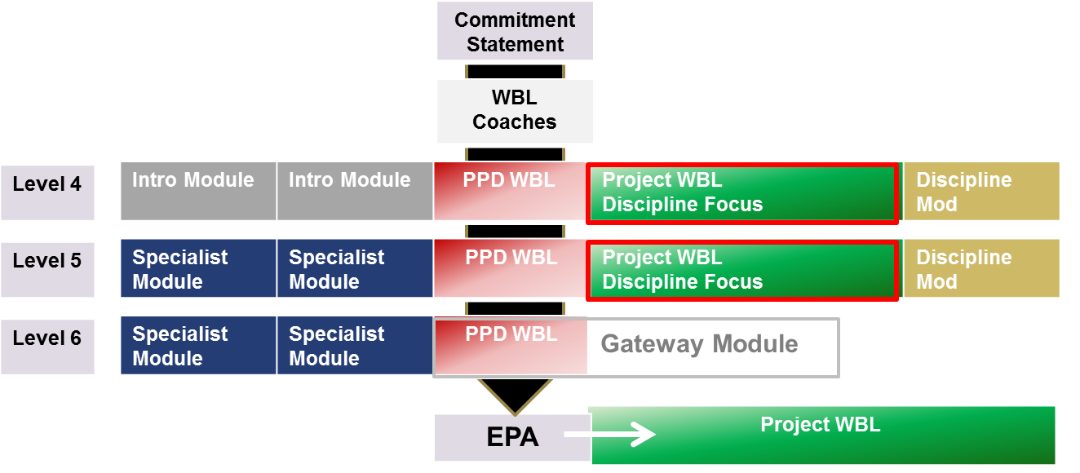

Core WBL content offers a contextualised journey to the learner, supporting their journey from the Commitment Statement to the EPA. Check the Assessment Plan to see how the EPA will work and what sort of gateway module you need to design.

The Award Title of "Professional Practice in…" is a normal requirement of the Panel.

(nb. the diagram illustrates a typical degree apprenticeship. A Level 7 Apprenticeship would look different)

How will a WBL curriculum drive 20% OTJT?

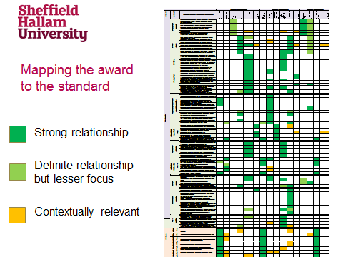

The mapping template ensures the AWBLF Panel can *endorse* the use of the SHU award as an Apprenticeship, if the modules align to the Knowledge, Skills, Behaviours set out in the Apprenticeship Standard, published by the IfATE.

There is space to set out employer activities and EPA preparation and so this becomes part of the three way commitment statement.

The AWBLF Panel Secretary will send a blank template for the design team to populate with a bespoke commentary on how the course delivery will support the learner, including conducting three way review and achieving 20% off the job training through an E-portfolio approach (currently implementing MAYTAS).

Other specific requirements might include an application to join the Register of End Point Assessment Organisations and up-front calculation of 20% Off-The Job-Training

To join a community of practitioners and get more insight and support contact Clare Barnet. to AWBL and/or the WBL Guild Group

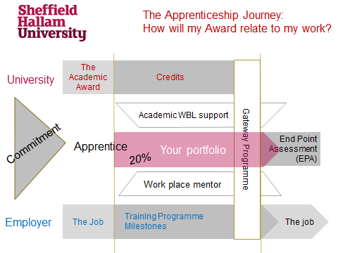

Please d Contact Jane Ashcroft [j.ashcroft@su.ac.uk](mailto:j.ashcroft@su.ac.uk) in BESE to arrange a meeting with Head of Work Based Learning.

Kind regards,

Linda Hall Senior Quality Officer in Academic Quality Standards

Sam Moorwood, Head of Work Based Learning (BESE)