 



Mentoring Guidance

for the Employer

(Template v1.3 May 2018)

Directorate of Education and Employer Partnerships

DEEP Telephone 0114 225 3433

Email: Apprenticeships@shu.ac.uk

Contents

Introduction: 3

Higher and Degree Apprenticeships 3

The Sheffield Hallam University Course 4

Key Features of the Apprenticeship Journey 7

What is Mentoring? 13

I’m a Mentor. What’s in it for me? 13

A mentor should be: 13

The mentoring process 14

Skills and qualities used within the process 14

Overview of your Mentor input and Opportunities 15

Your own Training and Development as a Mentor 16

Appendix 1: Higher/Further Education - Learning Mentor (LM) 18

Appendix 2: INSERT APPRENTICESHIP END POINT ASSESSMENT 20

Appendix 3: Three-Way Review Template and Guidance 21

Appendix 4: Higher / Degree Standard for your Apprentice 24

Appendix 5: Assessment plan for your Apprentice 25

Appendix 7: What is 20% off the job learning? 26

# Introduction:

Welcome. This document is designed to provide an overview of the Apprentice experience both studying as a learner with Sheffield Hallam University and as an employee with your organisation. For you as a mentor, the guidance will provide a focus on the Sheffield Hallam University course structure, content and ethos. We are offering initial guidance on how you can progress as a mentor to ensure you provide the best support possible to your mentee (Apprentice) seeking to reach and successfully complete the End Point Assessment for their Apprenticeship. We will also explain the options for you to gain a qualification and optional development of your expertise that might appeal to you for your own professional development which in turn can support your business objectives.

**Sheffield Hallam University**

Insert Credentials for Delivery based on Department and Programme

**The Employer**

Statement about the employer's objectives for skills and training and business.

## Higher and Degree Apprenticeships

Apprenticeships are work-based training programmes that are designed to help employers train people for specific job roles. Apprentices at all levels have a full time job including work-based training whilst also studying part time for a qualification.

**What is a Higher Apprenticeship?**

A Higher Apprenticeship covers delivery from levels 4 to 7 by any Higher Education or Further Education institution. Higher Apprentices at Sheffield Hallam study part time at levels 4 and 5 for a Foundation Degree, whilst undertaking on-the-job vocational learning and development with their employer.

**What is a Degree Apprenticeship?**

A Degree Apprenticeship describes delivery at levels up to and including 6 and/or 7 by Higher Education institutions only. Degree Apprentices at Sheffield Hallam typically study part time at levels 4, 5 and 6 for a Bachelor’s Degree, whilst undertaking on-the-job vocational learning and development with their employer. Depending on the programme, these take between 3 and 5 years to complete. Specific information on your Apprentice's course is provided below…

# The Sheffield Hallam University Course

*Insert Course Headline Information.# E.g. for Quantity Surveying:*

The BSc (Honours) Quantity Surveying is designed to meet the requirements of the Approved Degree Appretniceship of "Consultant (Professional) Quantity Surveyor" (please see Appendix 1). The Apprenticeship is an innovative work-based learning solution that is designed to meet the needs of the employer and the learner, putting them at the heart of the programme. Alongside core topic areas, the programme allows for completion of major in-company projects designed to deliver return on investment for the employing organisation. Module content for the BSc (Honours) Quantity Surveying is shown below.

**Duration**

The course is delivered over 5 years.

**Delivery method**

Students attend on day-release to be taught alongside part-time and full-time students; however there will be additional workshop/visits for students and employers to assist with preparation for professional qualifications.

**Course description**

The course prepares students for professional careers in the construction industry by providing the technical knowledge, initiative, and interpersonal skills the industry demands. The courses are intended to take advantage of students' employment; to develop their potential and utilise their existing knowledge. Working experiences will feed into a number of modules and the theoretical stance taught academically should be applicable to most students' working environment. It is expected that a student will be able to take the knowledge gained at Sheffield Hallam University and make use of it in the workplace.

Our courses are a mixture of lectures, class-based seminars, practical work and site visits. Students are expected to engage with the subject matter and question staff and each other. Full-time, part-time and Apprenticeship students will be mixed in different activities and support each other throughout.

There is an average of three hours additional study per hour of attendance, which means that to achieve their potential, students need to spend sufficient time completing coursework and preparing for exams.

Our teaching staff have extensive industry experience from across the range of professional disciplines associated with the construction industry. We invite visiting lecturers and employers from consultancy companies and large contractors to reinforce the practical nature of the course.

**Assessment for the degree**

The Sheffield Hallam University degree award will incorporate a mix of innovative and traditional assessment types. Assessment for learning will ensure that learners are able to integrate academic learning and on-the-job training. There will be some exams, report writing, reflective assignments, portfolio development work, Work Based Projects with critical review and presentations. Assessments will also include some group work.

**Professional recognition**

Both awards are accredited by CIOB and RICS. In addition, the Apprenticeship standard provides a distinctive pathway to full professional membership to CIOB for the Construction Project Management Apprentices and to RICS for the Consultant (Professional) Quantity Surveying Construction Quantity Surveying Apprentices.

**End-point assessment (EPA)**

Ultimately the EPA will check that the employee is ready to join the profession with full occupational competence. The University award will work with employers to help the learner to prepare for the EPA. Please see Appendix 2 for the End Point Assessment. The End Point Assessment is undertaken by in independent Third Party. Your Provider can explain more and help you select the right organisation [REVIEW IF INTEGRATED EPA].

**BSc (Honours) Quantity Surveying**

| Year | Modules | Description |
| --- | --- | --- |
| Year 1 | Introduction to the Built Environment | An introduction to the roles of the different disciplines within Quantity Surveying, professional bodies and academic practises. A work based learning modules which begins preparation for the professional body end point assessment. |
| Understanding Building Technology | An introduction to construction technology, focussing on domestic and small scale developments. This requires the student to be able to identify, describe and converse with the terminology of building. |
| Materials Science | Lab-based work where common construction materials are tested and the results recorded and analysed; introduces aspects of quality management to construction |
| Year 2 | Introduction to Measurement | An introduction to the purpose and practice of measurement to create the foundations for more detailed building and civil engineering measurement over the rest of the course. |
| Law & Economics for the Built Environment | The principles behind the economy and the laws governing our industry. |
| Development Project | A project based on an existing case study building and a proposed development. Students are required to assimilate knowledge from other modules to develop a design proposal |
| Year 3 | Contractual Procedures | Analysing and evaluating various procurement strategies and tendering procedures available and reviewing Standard Forms of Contract. |
| Measurement of Building Works | An in depth understanding of measuring building works across a broad cross section of construction elements in line with NRM2. |
| Evaluating Construction Technology | A more in depth view of the technology and techniques of building. Includes a research project of the student's choice |
| Health & Safety at Work | Essential material regarding H&S; the legislation and implications of health and safety in modern practise. |

|  |  |  |
| --- | --- | --- |
| Year 4 | Collaborative Project | A multi-disciplinary approach to construction to encourage the development of team working skills, leadership / management and the ethos of BIM collaboration. The module focusses on a case study development in the workplace. |
| Cost Management | Essential knowledge to apply construction costing techniques within the design and construction stages of a project, including estimating, cost planning, cost modelling and costing risk. |
| Quantity Surveying Practice & Contract Management | Involves critical analysis and evaluation of complex contractual /contract administration and dispute resolution issues and proposing effective solutions. |
| Strategic Facilities Management | Students study the implications of construction on a building's use and management. Requires analysis of various business methodologies, such as outsourcing vs in-house. |
| Year 5 | Quantity Surveying Professional Studies | A chance to reflect upon key thematic issues encountered within the profession by drawing on work experiences Additionally time will be spent on building advanced costing skills. |
| Advanced Measurement | Consideration of measurement using NRM2 and CESMM4, as well as software packages to carry out detailed measurement |
| Dissertation | Students are able to devise and investigate a research question related to the workplace. This is a double module, assessed through written submissions and verbal interrogation reflecting higher levels of research and study. |

# Key Features of the Apprenticeship Journey

**The Commitment Statement:**

* At the heart of your employee's Apprenticeship is a three-way Commitment Statement, which outlines the mutual responsibilities of the Apprentice, their employer, and the university. It emphasises both WBL and mentoring as a key requirement of the curriculum design.
* You should see this right at the start of the Apprenticeship and may have signed the document yourself (though the signature might have been someone in HR, or your training department)
* Commitment Statements are needed to demonstrate commitment and are necessary to obtain funding, but they should be treated as a live document and an adaptable road map. The Apprenticeship course at Sheffield Hallam University provides explicit checkpoints and opportunities to review and update the learning milestones with the End Point Assessment in mind.

The following statements *typify* parts of a SHU Commitment Statement, but will be updated to reflect any changes to the funding rules or to achieve general improvements - you should refer to the Commitment Statement which will expand on the following types of commitments:

* **The Apprentice shall >**
  + Attend training sessions, either on- or off-the-job, as and when required
  + Liaise with the Course Leader and the Employer, as applicable, in relation to any reviews, monitoring, or audits required for the Apprenticeship, including providing information for, and access to, all documentation relevant to the Apprenticeship on request
* **The Employer shall >**
  + Provide a safe and supportive environment for the work-based elements of the Apprenticeship
  + Ensure that the Apprentice's roles at work allow him/her to gain the wider employment experience required by the university course and the Apprenticeship Standard
  + Ensure that the Apprentice is given sufficient time to enable him/her to complete all elements of the work-based learning elements of the university course within his/her contracted working hours and achieve 20% "off-the-job learning".
  + Allow the Apprentice to attend all agreed off-the-job learning and shall continue to pay the Apprentice during such time, where it falls within normal working hours

**The University shall >**

* + Deliver the academic learning elements of the university course and establish and/or deliver on- and off-the-job learning to meet the needs of the Apprenticeship, the Apprentice and the employer
  + Monitor the Apprentice's progress in liaison with the employer, and the course leader shall keep the employer informed of the Apprentice's progress, including any disciplinary issues
  + Monitor the quality of learning delivery to ensure that it meets the required standards, including liaising with both the employer and the Apprentice

Your role as a mentor is so important to meeting those employer obligations. Fundamentally, you are there to ensure your apprentice has a real opportunity to learn in the work place and apply what they are gaining from their study. This should bring real business/ organisational benefits for your employer. Let us know how we can help you to achieve that.

**How is the Course Structured to support the journey to the End Point Assessment?**

**E.g.**

The course is delivered over 3 years. Students attend on day-release to be taught alongside part-time and full-time students; however there will be additional workshop/visits for students and employers to assist with preparation for professional qualifications.

The diagram below shows how we have built in work based learning modules that support the Apprenticeship journey right from the first signed version of the Learning Agreement through to the End Point Assessment. This is based on Sheffield Hallam University's model for work based learning which is explained in more detail below.

**Key Diagram (for illustration - INSERT KEY DIAGRAM FOR YOUR COURSE/APPRENTICESHIP**

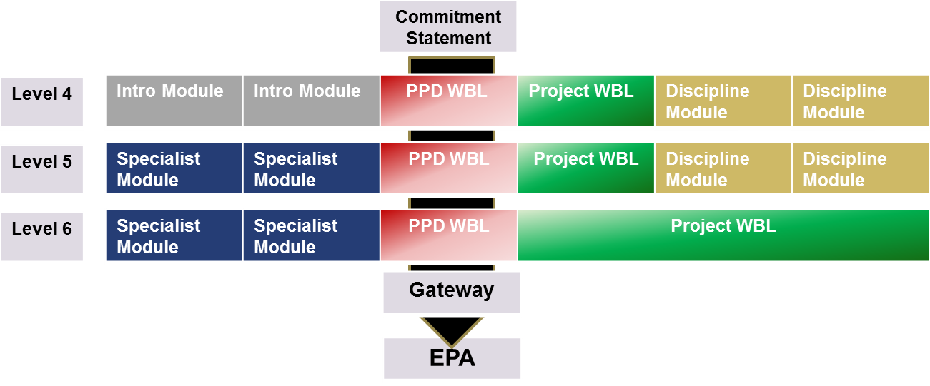

Nb. Course Delivery Structure may vary and typically ranges from 3 to 5 years.

**Work Based Learning Modules in more detail:**

* **What is work-based learning?** A relevant definition for WBL at SHU is *‘learning that takes place at, through, for and from work to meet the needs and aspirations of individuals and the organisations they work for’* (adapted from Nixon et al, 2006):
  + learning **at** work - learning that takes place in the workplace
  + learning **through** work - learning while working
  + learning **for** work - learning how to do new or existing things better
  + learning **from** work - ‘curriculum’ that grows from the experience of the learner, their work context and community of practice

Work Based Learning recognises that the workplace is a legitimate site of knowledge. Combined with the vocational nature of Apprenticeships, maximising a WBL focus is key to the successful interplay between academic and vocational learning. Within our courses we offer different types of Work Based Learning Modules:

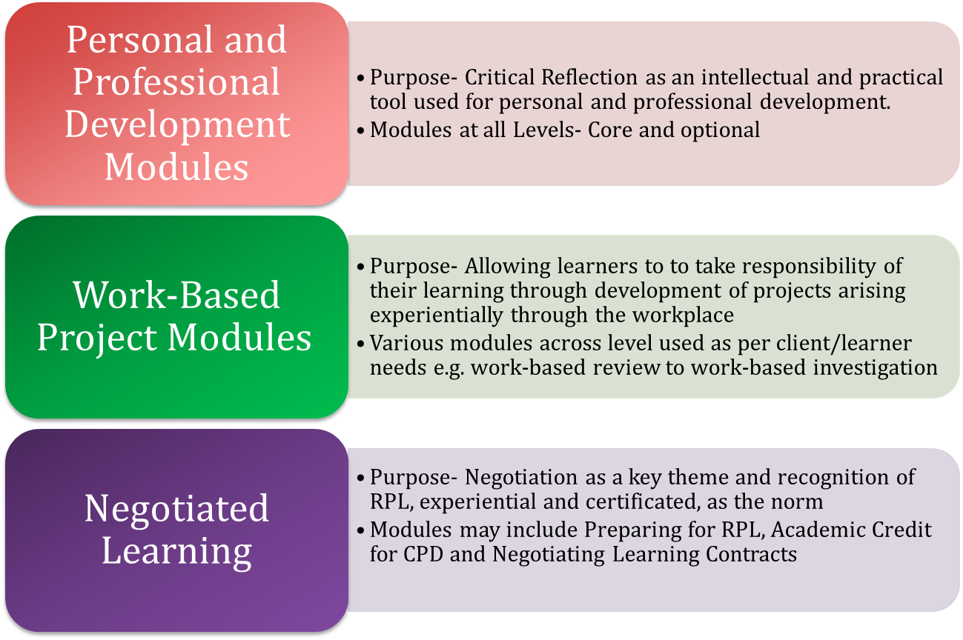

**Personal and professional development (PPD) >**Modules to support and enable learners to reflect on current practice and develop action plans for continued PPD. Modules are structured, supported and assessed in ways which reflect the variety of experience and background of work-based learners as well as the needs of their sponsoring organisations. These modules help the learner develop self-analysis and reflective practice skills to underpin learning analysis and development planning, to support life-long learning, personal growth and development.  
  
Modules can also be aligned to relevant organisation talent management frameworks, to help develop specific leadership competencies, management standards and organisational values. The use of psychometric tools can enable the learner to develop a baseline profile, which the learner can develop in other relevant modules. These modules are likely to provide strong support mechanisms in relation to the Apprentices progress towards the EPA. They can also be used to emphasise and integrate the role of the work based mentor.

**Work-based project >**Modules that allow learners to negotiate a contextual work-based project related to their role. The content of the module is formally agreed as part of the programme approval process. Projects will often be of a research and development nature. A project may be making the case for a change in practice, or alternatively the project might be concerned with the development of new product or procedures in a specific work context.  
  
The project may be technical, and the programme design may seek to address specific learning outcomes, for example in relation to vocational themes, or professional and regulatory body requirements where those apply. The Project Modules also enable the student to bring together evidence of technical and professional learning and provide a vehicle for demonstrating that at the End Point Assessment.

**The End Point Assessment**

The requirements of the End Point Assessment have been designed by a group of Employers at the outset. This End Point Assessment will be arranged by Sheffield Hallam University but undertaken by a third party organisation. (THIS DOES NOT APPLY FOR INTEGRATED EPA - INSERT APPROPRIATE TEXT FOR ITEGRATED EPAs)

The requirements for the Gateway Programme and the End Point Assessment are set out in Appendix 2, which you should regularly review with your mentee and share their progress reviews. We recommend that up to date copies of the Commitment Statement and progress reviews are shared before each mentor meeting and discussed each time to help give your meetings purpose and structure and support the Apprentices progress towards the End Point Assessment.

The University offers a standard template for a three way review which keeps all three parties engaged and updated on any issues using a Red-Amber -Green Approach. Please see Appendix 3. [OR AS ADAPTED. PLEASE CHECK AS SOME COMPONENTS ARE FOR FUNDING COMPLIANCE PURPOSES]

This does not have to replace any of your in-work appraisal processes, but you can look to combine these activities where appropriate. We recommend a discussion with your HR lead and/or Training / Apprenticeship lead.

INSERT FURTHER ADVICE IF PROTOCOL ALREADY AGREED WITH THE EMPLOYER(S)

**The Apprenticeship Journey - The Overview:**

If the information and approach to learning and training offered above is starting to make sense, then the diagram below is another way of seeing how the Three Way Agreement sits at the heart of the Apprenticeship and ties into the role of the University and the Employer - specifically your role as the Apprentice's mentor

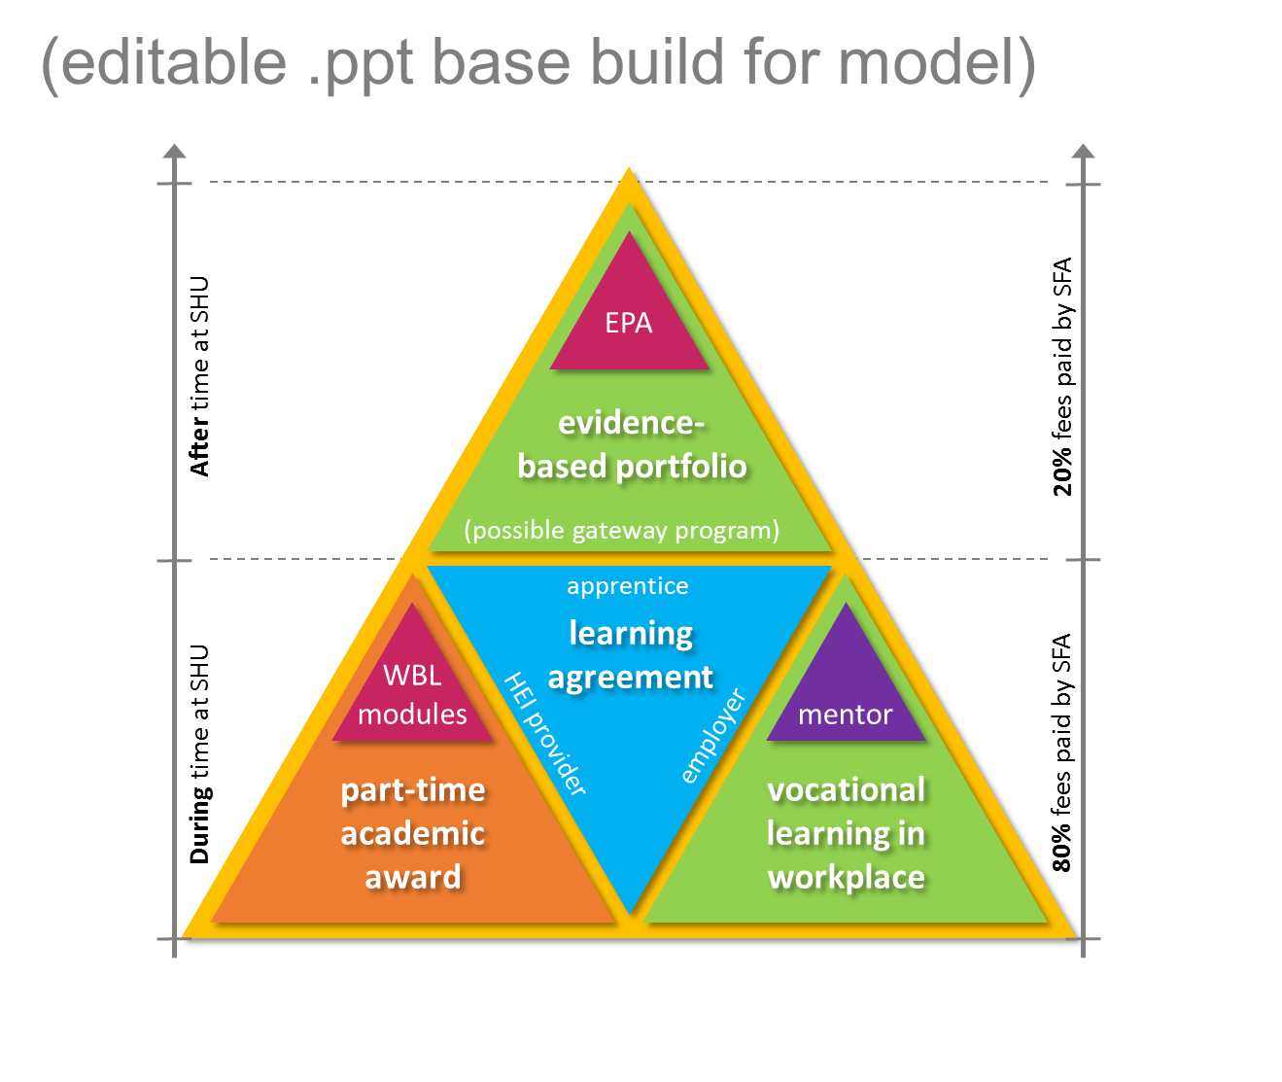

The next sections of this guide offer you further advice on mentoring and opportunities to better understand how an apprenticeship works. As well as reviewing this document in full we recommend that you sign up to the University's **FREE** **on-line mentor development resource.**

Please email a request to [Apprenticeships@shu.ac.uk](mailto:Apprenticeships@shu.ac.uk) for the attention of David Thornton.

We need your full name and email address and you will then receive a joining email.

We also offer welcome and information events and training for mentors and apprentices from across the university, so please look out for the invitations.

## What is Mentoring?

Mentoring is a one-to-one partnership between two people which focuses on personal development. Usually the relationship is between someone who is more experienced and someone who is less experienced.

Mentoring is an increasingly common way for organisations to support their employees’ learning and development (CIPD, 2015). So for professionals, mentoring a student could be an interesting and rewarding way to develop this highly regarded skill.

Whilst the employer is key to the success of the HDA programme in broad terms, the work based mentor is fundamental to the success of the learning agreement, and ultimately the Apprentice’s student experience.

The selection of a capable and compatible mentor for an Apprentice should be carefully considered, both in terms of skill and behavioural fit, particularly given the significance of the three-way learning agreement and the longevity of the relationship.

## I’m a Mentor. What’s in it for me?

**Other benefits of mentoring include:**

* An opportunity to meet other mentors and expand your professional network
* A chance to look at your role with a fresh perspective
* Gaining experience which could count towards continuing professional development (CPD) points
* An increased sense of job satisfaction as reported by previous mentors
* Opportunities to keep up to date with developments in higher education, qualification structures and the needs or experiences of students and graduates

Sheffield Hallam Mentoring Blog, 2017

## A mentor should be:

* Appreciative of the challenges facing the Apprentice - Familiar with the curriculum
* Engaged with the University and the ethos of work based learning through specific course activities
* Aware and increasingly competent of the role and skills of mentoring
* Qualified in their discipline to a suitable level [check the Assessment Plan for the Standard]
* Willing to develop their own practice and supportive of their business skills objectives

## The mentoring process

This diagram illustrates the mentoring process and the stages at which you can help your mentee progress their ideas and take action.

Figure X:

## Skills and qualities used within the process

* identifying training and development needs
* auditing existing skill levels and identifying skill gaps
* identifying the information needed that will help the mentee make an informed and realistic decision
* signposting the mentee to sources of information
* introducing them to other contacts or discussing strategies for gaining the information/contacts required

We suggest you engage with the University's FREEon-line mentor development resource and identify the areas of learning that will most help to carry out your role as mentor. Further details are found on page 16. The Development resource covers essentials including:

* The ESFA requirement that each apprentice can enjoy and evidence 20% of-the job learning within their contracted hours;
* That the Apprentice is aware of safeguarding and welfare policy and obligations that the provider and employer must follow;
* That Apprentices should be introduced to British Values and be fully aware of the "Prevent Duty" relevant to employers, employees and the provider.

## Overview of your Mentor input and Opportunities

|  |  |  |  |
| --- | --- | --- | --- |
| **Stage in Apprenticeship** | **Activity** | **Your role as Mentor** | **Outcomes for Apprentice** |
| Preparing | Matching the mentor and mentee | Consider the personality of the Apprentice and your own take on things. If compatibility is a serious issue raise this with your business. Spend time to get to know them and discuss their strengths and weaknesses and how you will be able to support. | Your Apprentice should feel comfortable with your relationship, including your joint understanding of the academic award and the requirements of the End Point Assessment. He/she should know what to expect from you as a mentor and how and when to get support. |
| Signing the Commitment Statement | Develop and Finalise the Commitment Statement | Support your Apprentice to consider the learning modules in the University course and how they relate to the job role and training opportunities. Help the Apprentice to understand and plan for the journey ahead. | Your Apprentice should appreciate their commitments and how the Agreement represents a flexible plan for ongoing review with the Course tutors and you as a mentor. The signed Statement should represent a realistic commitment for all. |
| Induction | Joint Course Induction,  Course overview etc. | You will be invited to a Course Induction, or welcome evening. This will be your chance to appreciate the structure; attendance; content and Learning Outcomes; and assessment. | Your Apprentice will see you engaging with the course and get the opportunity to meet you in the context of University facilities at SHU. They will appreciate your connection with the University. |
| Induction | Initial Mentoring Training  Co-delivered by SHU and employer | You will engage in mentor training, networking opportunities and meet other mentors to compare expectations. You will better understand the nature of your role as a mentor for a Degree Apprentice. | Following this initial training from SHU you will be able to confirm to your Apprentice the full nature of the mentoring relationship and share an understanding of the challenges and support opportunities offered by the University and business. |
| During the Apprentice: | Three way review process | The Three-way review process will include feedback from the Course tutors, you as the mentor and from the Apprentice. You will ensure good frequency and regularity of communication and raise concerns if this is not happening. Check that the learner is enabled to do 20% off-the-job learning. Support them with that. | He/she will engage in periodic review to agree ideas for development through an open and honest process. They will negotiate changes to work based opportunities to support progress. Barriers to completing the EPA will be discussed and solutions agreed. The Apprentice will be able to agree how 20% off-the-job learning is enabled and evidenced. |
| During the Apprentice: | Workplace mentoring meetings | Aim for regular communications, one hour a fortnight, including phone or virtual meetings, Use a standard template for efficacy. Seek ways to integrate the University's approach with your own appraisal process. Update the Commitment Statement and complete 3-Way Reviews | The Apprentice should be aware of their obligations to share information and prepare for each meeting (E-portfolio).  They should be clear on their actions to address gaps in knowledge, skills and behaviours through work place activities. They will know how you will support any changes and new opportunities. |
| During the Apprentice: | Dissemination activities | You may attend University-based events to observe your Apprentice delivering presentations and provide your feedback. | He/she will disseminate their learning to other students and mentors to consolidate their progress and prepare for the EPA, including through mentor feedback. |
| Gateway Period | Support Events | You will attend/review your apprentice's engagement with further support provided by the University to fine tune and complete their Portfolio and EPA requirements. It is likely you will evaluate their readiness for EPA. | The Apprentice will attend University to gain support from tutors, interact with colleagues and practice EPA technique with professional body input where appropriate. They will feel confident in your judgement regarding the EPA timing. |

## Your own Training and Development as a Mentor

The model below highlights the experiences, potential awards and funding and benefits to business growth of being a mentor at increasing levels of engagement and expertise.

The options include:

* Compulsory: Basic induction activities to prepare you as a mentor to support your apprentice through their work based and academic journey. You will gain further mentoring experience as your apprentice progresses. This will be integrated into your apprentice's course of study. This time and investment can in many instances be counted as CPD for your own personal and professional development
* The Sheffield Hallam On-line Mentor Development Resource, which will help you embed mentoring principles, knowledge, skills and their application over a five-week period, in preparation for the years of study and work based learning required of your apprentice. It covers essentials like Health and wellbeing, Prevent Duty, Safeguarding and British Values.
* The opportunity for you to conduct your mentoring under your own apprenticeship. This will be formally recognised training delivered by SHU or a partner provider and will allow your business to use its Apprenticeship Levy or co-funding from Government to pay for all, or the majority (90%+) of the costs. You will demonstrate you knowledge, skills and behaviours as a mentor through an End Point Assessment SUBJECT TO STANDARD APPROVAL BY IfA
* For a greater impact and high level recognition of your skills and knowledge you can combine your experiences to set you on the way to a Degree / Post Graduate award in *Coaching and Mentoring* (tbc). Your expertise will enable you to support other mentors and become a leader in your business environment, gaining a formal and high level Sheffield Hallam University Award through a work-based learning approach and flexible attendance at University. This route will be subject to appropriate entry criteria, but will capitalise on the experiences you gain during the time you support your Apprentice.

**Figure X: Illustration of Mentoring Training Options**

Ongoing mentoring experiences in support of your apprentice (see table above)

SHU L7 Coaching and Mentoring Award

Level 3 Mentoring Apprenticeship -

Subject to IfA Approval

On-Line Mentor Development

Mentor Induction

Develop expertise and leadership for business

Progressive approach with Funding

Added value for support role and CPD

Compliance with support role

To access the [**On-line Mentor Development Resource**](https://v3.pebblepad.co.uk/v3portfolio/hallam/Asset/View/yRr9jHnfs8wgpctZmHM4Z3n3kh)send an email to [apprenticeships@shu.ac.uk](mailto:apprenticeships@shu.ac.uk)

Ideally use subject title "**HDA mentoring Development Log in**". Tell us:

* First name
* Surname
* Your email Address
* Name of the organisation/business you work for please.

[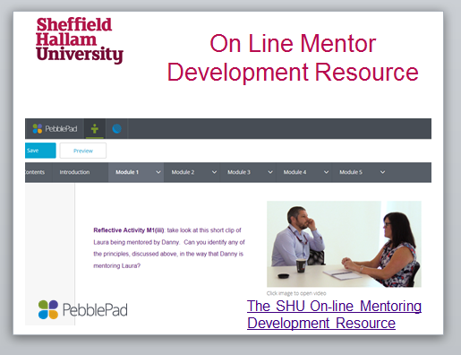](https://v3.pebblepad.co.uk/v3portfolio/hallam/Asset/View/yRr9jHnfs8wgpctZmHM4Z3n3kh)

# Appendix 1: Higher/Further Education - Learning Mentor (LM)

<https://www.gov.uk/government/uploads/system/uploads/attachment_data/file/470022/EDUCATION_AND_TRAINING_HigherFurther_Education_-_Learning_Mentor__LM_.pdf>

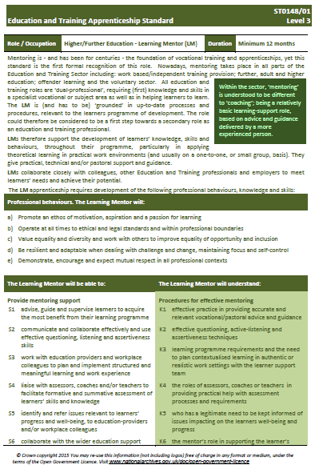

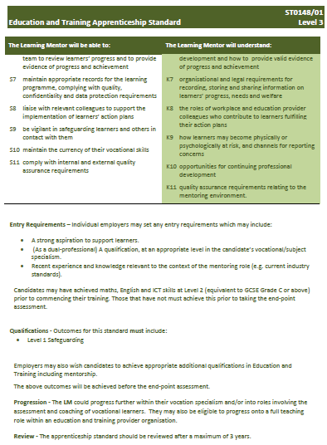

# Appendix 2: INSERT APPRENTICESHIP END POINT ASSESSMENT

AWAITED FROM JO NORTH - TRAILBLAZER LEAD

# Appendix 3: Three-Way Review Template and Guidance



cont.



**Explanation RAG Approach to Three-Way Review Process**

Red

The quality or level of progress is significantly below the described skill, knowledge or behavioral area. This could impact on the ability of the learner to achieve milestones in their learning agreement and ultimately prevent completion of the Apprenticeship (End Point Assessment for *Standards*).

The employer and or provider will need to spend more time and effort supporting development of this area, be it knowledge, skills or behaviors as well as opportunities to demonstrate technical competencies. The Apprentice will need to respond to existing or new support in order to address the gap in progress. An action plan should be agreed and factored into the learning agreement.

Amber

This means that the Apprentice, the employer and provider need to keep a watchful eye, but not to a large extent. The red color is when you need to intervene in the situation. An amber color might not warrant a specific action plan.

An amber situation might result in lower quality of learning, or a known, but manageable delay in meeting learning milestones agreed in the Apprentice's Learning Agreement. Any problems with the Apprentice's experiences in work, or understanding in the educational setting can be fixed relatively quickly through good communication and some redirection of effort. In these cases a greater quality of outcome should be achievable and efforts should also manage any risk of slipping into a *red* situation.

Green

The Apprentice and their support network do not need to have any concern about the rate and direction of progress with regards to the knowledge, skill or behavior in question. If this is a technical competence then the necessary experiences and learning are taking place in line with anticipated timescales in the Learning Agreement. The Apprentices should feel appropriately confident about achieving the necessary learning to meet this aspect of the Apprenticeship Framework or standard as required by the Apprenticeship (Specification / Gateway Programme / End Point Assessment)

It is always worth keeping an eye on the accuracy of the green, making sure it’s a true green.

# Appendix 4: Higher / Degree Standard for your Apprentice

INSERT

# Appendix 5: Assessment plan for your Apprentice

INSERT

# Appendix 7: What is 20% off the job learning?

**Resources:**

ESFA Funding Rules: <https://www.gov.uk/government/publications/apprenticeship-funding-and-performance-management-rules-2017-to-2018>

Government Guidance 20% off-the-job-learning: <https://www.gov.uk/government/publications/apprenticeship-funding-and-performance-management-rules-2017-to-2018>

**Extract from Funding Rules:**

Off-the-job training is defined as learning which is undertaken outside of the normal day-to-day working environment and leads towards the achievement of an apprenticeship. This can include training that is delivered at the apprentice’s normal place of work but must not be delivered as part of their normal working duties.

The off-the-job training must be directly relevant to the apprenticeship framework or standard and could include the following:

* The teaching of theory (for example: lectures, role playing, simulation exercises, online learning or manufacturer training),
* Practical training: shadowing, mentoring, industry visits and attendance at competitions,
* Learning support and time spent writing assessments/assignments.

Off-the-job training does not include:

* English and maths (up to level 2) which is funded separately,
* progress reviews or on-programme assessment needed for an apprenticeship framework or standard,
* training which takes place outside the apprentice’s paid working hours.

**Further Information**

Sheffield Hallam University has developed further guidance on the identification and recording of 20% off-the-job-learning. This can be emailed to you directly or accessed from our Free on-line Mentor Support resource. Contact [apprenticeships@shu.ac..uk](mailto:apprenticeships@shu.ac..uk)

This further guidance specifically relates to the way that SHU Apprenticeship Programmes are designed and delivered and so will help you and your apprentice to identify and log the evidence, whilst minimising time out from the business. We can also provide an Excel-based spreadsheet if you do not want to use your own recording system. Our Work Based Learning Tutors / Coaches will remind the apprentice that the log needs to be up to date and uploaded into the e-portfolio. For information regarding the e-portfolio your apprentice can speak to the Course Leader