Work-based learning
Student guide #2

Work-based
project

Version 1.0, March 2017
Directorate of Education & Employer Partnerships

Contents

1. Welcome 3
About this guide 3
Work-based learning at SHU 4
The WBL framework and Apprenticeships 4
2. Introduction to work-based projects 5
Choosing a work-based project 5
The politics of choice 8
Work-based projects and research 8
Being a practitioner conducting inquiry 9
3. Undertaking a work-based project 10
Stage 1: Initiating your work-based project 11
Stage 2: Planning to undertake your work-based project 12
Stage 3: Execution – analysis and sense-making 12
Stage 4: Closure – writing up your work-based project 13
4. Different ways of presenting your project 14
Project report format 14
Product with critical commentary 15
Project portfolio 16
5. Concluding remarks 17
6. Further reading 18

Welcome

About this guide
This guide is one of three designed to support you, our Sheffield Hallam University (SHU) students, undertaking your course which contains one (or more) of our key work-based learning (WBL) framework modules. It is intended to be an informative and accessible introduction to the module, and we hope it is also an inspiring starting point. As always, the emphasis is on you to develop your own autonomous learning skills and your own knowledge and abilities around a given topic.
Once you have read this guide please use the further reading section as a springboard to valuable relevant resources. It is also likely that your course and module tutors will have recommended additional reading and key texts to support your specific context and knowledge, so do remember to discuss this with them and check your online reading-lists (RLOs) too.
If you have any feedback about this guide, such as other things it could contain or better resources you have found that would help other students, please contact the Directorate of Education and Employer Partnerships (DEEP) and let us know so we can update and develop future versions of this guide. We hope you find this resource valuable.

Sam Moorwood
Head of Employer Partnerships
Directorate of Education and Employer Partnerships
s.moorwood@shu.ac.uk
0114 225 3433
March 2017

Work-based learning at SHU
A relevant definition for WBL at SHU is ‘learning that takes place at, through, for and from work to meet the needs and aspirations of individuals and the organisations they work for’ (adapted from Nixon et al, 2006):
- learning at work - learning that takes place in the workplace
- learning through work - learning while working
- learning for work - learning how to do new or existing things better
- learning from work - ‘curriculum’ that grows from the experience of the learner, their work context and community of practice
WBL recognises that the workplace is a legitimate site of knowledge. Combined with the vocational nature of courses like the government incentivised Higher and Degree Apprenticeships (HDAs), maximising a WBL focus is key to the successful interplay between academic and vocational learning in the workplace.

The WBL framework and Apprenticeships
As part of the work to support the provision of HDAs at SHU, DEEP created a framework to support the university-wide development of a wide range of different courses with a WBL focus. Not all courses that feature WBL will necessarily come under the framework, but it provides a standardised approach to assist if required. At the heart of this approach is a set of three WBL modules which can be used individually or collectively from academic levels four through to seven, according to specific course requirements. If you are reading this guide, chances are that you are on a course featuring one or more of these modules! The following diagram introduces all three modules so you can see how they fit together:

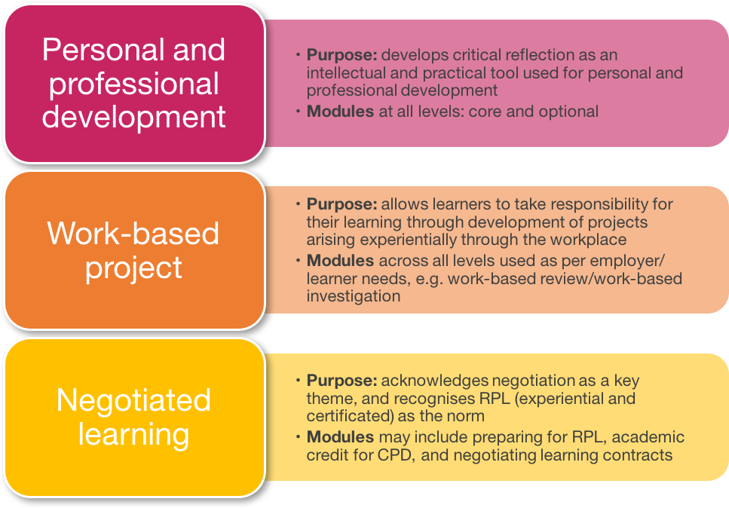
This guide

Introduction to work-based projects

This guide focuses on the work-based project (WBP). A WBP is an individual or collaborative activity that is carefully planned to achieve a particular aim. Considering Nixon et al’s (2006) four WBL learning points above, we can see that a WBP can satisfy all four points in various ways at the same time.
Your WBL programme is likely to include at least one (and possibly more than one) significant WBP. It is a particularly important part of a WBL programme as it gives you the opportunity to systematically engage with a real-life work issue and produce a report or other outcomes of relevance to you and your work situation.
A WBP is also a fantastic opportunity to spend some time working in greater depth on a work issue that requires more attention than would typically be possible. Often, a great WBP comes from finding the balance to explore something that really interests and motivates you to learn more about it and its context, and a professional challenge that would benefit from more attention.

Exhibit A: Some examples of work based projects:
- The development of a concise quick reference guide to inform urban search and rescue staff
- A review of procedures used by a construction management company to report construction defects
- A survey of staff at a College of Further Education to assess the readiness of the College to implement the Investors in People standard
- A work based handbook for managers who need to consult internal stakeholders on new procurement projects

Choosing a work-based project
In a work-based programme you have both freedom and scope to develop learning elements which are meaningful to you and your work. This is particularly important when considering the development of a WBP as the outcomes of the project should not just be of interest to you and provide evidence of your academic ability, they should also be of value to your employer or other interested work-based stakeholder (this could be a client if you are self-employed). The need to develop a project of interest and relevance to your work will require you to discuss your potential project area with others in your area of work who may be affected by your project.
For some courses, you may be required to identify a project which helps you demonstrate the achievement of specific course learning outcomes, perhaps relevant to your sector of employment. For other courses, you might be encouraged to develop your own relevant learning outcomes that the WBP effectively achieves. Either way, make sure you understand clearly from your course and/or module tutors what guidance is available to enable you to select a suitable project.
As you start to consider possible project areas, spend some time carefully considering this ten-point check list. It will help you focus in on specific elements and issues, and then ‘helicopter out’ to see the holistic situation more clearly:

- What do you want your project to achieve? Remember, a positive outcome might be understanding something more completely – don’t get caught in the trap of thinking your project is only successful if it achieves a significant and tangible change.
- What is the potential for impact on the organisation of the project process as well as the project outcome?
- What difference does it make that it is YOU undertaking the project? Ideally you want to focus on something which you are interested in, and that you know already is a significant issue you have to engage with as part of your work.
- What knowledge and skills do you need to carry out the project? If you do not already have these abilities how will you gain them?
- Who else is involved? What is in it for those stakeholders? Are they fully informed? Are they active participants?
- What help do you need from others and why would they want to help you?
- Are there individuals or groups which may see your project as threatening? If so, how are you going to deal with this?
- If your project is to have significance for your organisation do you have to convince key ‘decision makers’? If so, what sort of case do you need to put forward? What is the decision-making process?
- How might the knowledge you have created be used/disseminated and updated when your project is finished?
- Is the project feasible within the timescale and with the resources available to you? How will the timescale relate to the Sheffield Hallam University module requirements?

Exhibit B: Example use of the ten-point check list by Simon, a training officer in the fire service preparing to undertake a WBP as part of his 2nd year (level 5) Degree Apprenticeship course.
- Simon believes on the basis of his experience and discussions with colleagues that training of fire officers to rescue people trapped in road traffic accidents could be improved and he want to use his work based learning project to gather evidence to support the case for change to his employers.
- The potential impact would be a significant change to training procedures within his organization and would be likely to result in the development of new training courses for fire service personnel.
- Simon has over fifteen years of experience in the fire service and has been a trainer in the service for six years. It is part of his current work role to plan and deliver training courses.
- Simon already has a good understanding of training and of road traffic accident issues. He currently does not have knowledge or experience of research and he believes he will need to put together a credible research base in order to make a convincing case to his manager that major change to existing practice is needed. He has discussed this with his University tutor and decided to include a course unit in research methods as part of his negotiated work based programme.
- Simon plans to collect data from fellow officers who participate in courses that he currently delivers. This will require the permission of his employer and the consent of those course participants who take part. Simon will need to consider the ethical position of asking his own students to participate in his study in this way and build in specific safeguards.
- Simon needs to convince the Fire service to allow him to undertake this research and is dependent upon his fellow fire officers to provide him with information. He believes that there is a willingness to do this but he will have to make clear exactly what commitment he is seeking from others.
- Simon is seeking to bring about change to established courses and realizes that it is unlikely that his employer will agree to do this unless there is compelling evidence of the need and feasibility of change.
- The first key decision maker that Simon must influence is his immediate line manager in order to get approval to undertake the project. Ultimately he knows that for significant change to be implemented in the organisation he must make a convincing case to the committee with responsibility for learning and development in his organization.
- Simon knows that he can use existing procedures to produce and disseminate any new course that might arise from his project.
- Simon has calculated that he will need to ask for support in distributing and collecting the questionnaire to fellow fire officers. He constructed a timeline for the major stages of his project which suggests it can be accomplished in three months.

The politics of choice
Work-based students sometimes find themselves feeling like specific projects have been ‘imposed’ upon them by well-meaning managers. This can feel like a problem because – basically – employer/employee dynamics are coming up against both student learning preferences and the academic requirements of the course. A manager might think they are being helpful in giving their employee a ‘solution’ to meet perceived WBP needs, when actually it doesn’t quite fit the requirements of the course, potentially doesn’t excite the student enough to be motivated to undertake a great study, or even just addresses one of the manager’s own commitments on their ‘to do’ list! Be really careful not to fall foul of this situation before it is too late.
Potential WBPs should be discussed openly and honestly, and considered from all angles – both professional, academic and motivational. For any WBP, it’s important to cultivate a healthy three-way relationship between your main employer contacts (mentors, line managers, department head), your university contacts (course and module tutors, other student peers) and yourself as a reflective student, careful to always consider not just what you are doing but why, and what you are learning from your actions as you go. This can take time and effort, but don’t undervalue its importance in the long term.

Action: initial explorative steps
- Think of at least two project areas related to your work which you would be interested in making part of your work-based learning programme.
- For each project areas make some notes about it against the ten point check list above.

Work-based projects and research
Your WBP is a genuine piece of research for the purposes of work. That said, don’t be put off by thinking of your WBP like this – it can give some students the fear! In essence, your research can be simply understood as a planned and systematic activity which provides reliable ways of finding out about and deepening your understanding of a particular work-based issue. Research can take many forms, for example market research to inform the development of a new product, or lab based research to trial a new drug. Because conducting research is an integral part of a WBP it is often referred to as practitioner inquiry or insider research. Practitioner inquiry is a form of applied research that is undertaken by professionals/practitioners within (inside) practice contexts (in this case their work) that is intended to be of direct relevance to work and usually has direct application to practice.

Being a practitioner conducting inquiry
As a practitioner carrying out inquiry you are likely to have a dual role as both an employee and an inquirer/researcher. The influences brought to bear upon you by this dual role make it crucial that you develop your reflective practitioner capabilities regarding the design and conduct of your WBP (For more on reflective practice, please see the ‘personal and professional development’ student guide #1 which accompanies this one).
It's a bit like having two hats – your worker hat and your student hat – and recognising that they have different drivers, perspectives and priorities. Research ethics comes into play here – how you act with one hat on might differ from how you should act according to the other. For example, it is important to be aware of your own role(s) and position within the work environment. Your position in relation to other colleagues is particularly important as this may be altered by you explicitly taking on a temporary researcher role. You will need to consider the parameters of your authority and autonomy to carry out the research you propose. Being an insider may offer particular opportunities for certain inquiry/research approaches. Approaches like case study, ethnography, and action research are often highly applicable research methodologies to consider in the position of an insider researcher. Your research participants should always be informed which hat you are wearing.
That said, it is sometimes asserted that the position of an insider researcher is fundamentally compromised due to the range of influences which familiarity with the research context inevitably brings. In the face of this critique it is important to recognize that complete freedom from external influence or potential bias in social research is rarely, if ever, achieved outside of the natural sciences. This is a far bigger debate than your WBP module! What matters most here is how you as the insider researcher take steps to heighten your own awareness of the influences upon you and make them explicit as part of your research process. Through this reflexivity you can take account of your own subjectivity as a researcher. Critical reflection is about identifying and challenging your own assumptions and by so doing potentially challenging the assumptions of your research project participants. Keeping a reflective learning diary is a good tool for keeping track of your thought processes as you develop and carry out your work based project. Fundamentally, robust research design which shows that you have actively considered such issues will be a key part of your WBP.
Exhibit C: Suggested format for an entry in a reflective learning diary
1. Date:
2. Nature of learning event, who/what was involved:
3. Questions raised:
4. Outcomes of decisions/actions taken:
5. Key learning points:
6. Impact of key learning points on you/on others?

Undertaking a work-based project
The clue is in the name – your WBP is a specific project and should be carefully planned and managed as such. A project is a planned approach to working towards the successful achievement of a given outcome, usually within a given timescale, utilising specific resources. To this end, projects are often considered in lifecycle terms, with specific successive stages of initiation, planning, execution and closure. The specific terms used can differ according to the model, but the idea is usually very similar.

Exhibit D: typical project lifecycle and key elements
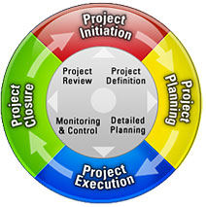
(Source: Wikimedia Commons, CC 3.0 license)

Different approaches and actions are required at each stage. Some of these are captured in the sections below, but do read more widely about how to plan and undertake your chosen WBP methodology as you develop your ideas into your specific study. It’s easy to set yourself up for a less than successful project if you don’t spend enough time thinking things through and working carefully and methodically before the execution stage. For example, two issues that tend to crop up time and again when students undertake WBPs is (1) that they do not scope their project adequately during the initiation phase at the outset – what am I specifically seeking to achieve and why? What is within the scope of my study and what is outside the scope? – and (2) that they do not create even a simple project plan to pragmatically consider the time and effort required to achieve the various project stages and actions so they can plan their commitment effectively. Too many projects get going too slowly. Clear, realistic early planning is key to your research and its impact.

Exhibit E: a simple project plan (shown here as a ‘Gantt chart’)
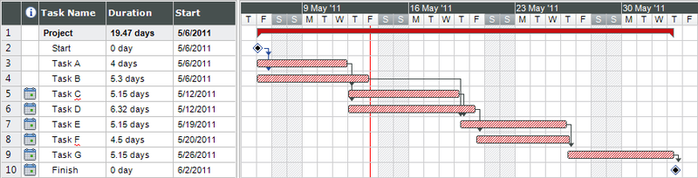
(Source: Wikimedia Commons, CC 3.0 license)

Stage 1: Initiating your work-based project
It is important that you develop a project plan which identifies:
- The focus and rationale for your project
- The methodology (or overall approach) that will influence your project design
- The aims and objectives of what you want to achieve
- The scope – what is in and what is outside of your project
- If there are specific questions that you want to address
- The information or data you need to gather
- The resources and support available to you
- Permissions required to access information
- The project outcomes and/or product
- The time frame within which this must be achieved
While these items form the core of the project there are other things that you may need to consider:
- The context in which you work and how it may influence the project
- Who you will need permission from to undertake the project – are there ethical issues you need to seek clearance for from others?
- Your role as an insider, and any conflicts of interest this might present
- Any ethical considerations relating to gathering, storing and using information or accessing data
- How you can disseminate (share) the outcomes and
- For an Apprentice, whether the project will form part of, or help you prepare for the End Point Assessment.

Stage 2: Planning to undertake your work-based project
This is the first ‘doing’ stage when your project becomes active. After careful initiation, now it is time to move towards action. The following are key questions that you need to address at this stage:
What do others say about the area of your project? –This requires an exploration and reading of supporting literature, research, sector, professional, organisational or any other relevant sources, e.g. government policies. Consider how this might inform your thinking about the project, what questions do you need to ask, how might you approach it?
What sort of information are you collecting? –This refers to the variety of data you may be collecting which can be primary data from individuals, but may also include documentary data, contextual information. Your chosen methodology will affect these choices. Some information may be qualitative (opinion based) and some data may be quantitative (typically factual and numerical).
How are you collecting your data and what is your justification for doing it this way? – For example you might be gathering data through interviews and/or questionnaires, but you might also be able to collect data from websites, or museum collections or practitioners working in a similar context elsewhere in the country.
Do you have access to the data you need? If not, who has? – if you need to use data from your organisation you may need to get special permission to do so or ethical permission in some sectors such as in health or education
How will you be ethical in your approach? – consider how you will ensure how the people who supply you with information (your informants) are able to make informed choices about their contribution to your project, how you will preserve confidentiality of people and recorded data. What ethical issues may be involved such as whose intellectual property to outcome will be, or whether there are business implications
Are you getting what you need from your data collection? – is your project activity getting you the information that you need in order to address the aims and objectives of your project? You may find that there is information that you had not previously anticipated as being significant and it is important to be able to focus on emerging issues as your project develops.
How will I manage the data? Think in advance about how you will record and analyse the data you collect. Bear in mind both the work based audience for your project work and the academic requirements of the University.

Stage 3: Execution – analysis and sense-making
This may feel like the most active stage of your WBP as you are out and about, actively gathering information and working to make sense of it. Important questions at this stage are:
How will you make sense of the data you have collected? – be systematic in how you order your findings. Develop a system for comparing and contrasting your data. Organise your thoughts and write notes to yourself. Discuss your findings with colleagues, friends and your University tutor. Align your findings with the aims and objectives of your project.
How do you present your project? – you should have some idea before you get to this stage of what form the final project will take e.g. project report, portfolio of evidence and commentary, product and commentary. Consult your work based colleagues and your university tutor as to how to present your product if necessary. It is essential to include selected evidence from your investigation in a way that shows how you came to your conclusions. Apprentices should be mindful and take advice on how the outputs and their presentation can support the achievement of their Apprenticeship End Point Assessment.
How do you share your project findings? – as this is a work based project your colleagues, workplace and community of practitioners are likely to have been involved and are likely to be interested in your outcomes. Think about opportunities to share outcomes at work.

Stage 4: Closure – writing up your work-based project
This is the point when the main project activity has finished, but you are writing up the report and preparing for submission of work to the University for assessment. At this stage it is important to reflect upon the project as a whole and ask yourself the following questions:
- Review to what extent were the objectives of the project met?
- What were the barriers and the things that helped you to achieve the aims?
- To what extent were you able to achieve your intended project?
- What worked well?
- What you might do differently next time?
- What have you learnt from undertaking the project and how might you use this new understanding in the future?
Remember that good research does not always break new ground by finding out something new. A WBP might be equally valuable in that it supports or confirms something that was suspected, or even already known. A ‘negative’ result can be as important as a positive one, so long as the project has been designed, undertaken and presented robustly and rigorously and can be demonstrated to be a successful piece of research. If you can’t make concrete conclusions you might have discovered something very important about the need for another research project and be able to identify the methodology and techniques needed.

Different ways of presenting your project
This section suggests some different ways of presenting your project. While some courses may have more flexibility in terms of presentation options, you should always discuss specific course preferences and requirements in advance with your course or module tutor. Pay particular attention to word count expectations. ‘Scaffolding’ your output by way of a well-balanced framework that gives space for all the different elements in advance is a useful approach to ensure you are setting yourself up for success.

Project report format
If your project results in one written final project report a typical accepted format is:

Title page
Title of project, your name, student number, module code, month and year of submission, project keywords
Contents page
This is usually written last when you are happy with the structure of the report
Project abstract
This is a summary of the project explaining in outline what the project is about, how it was carried out and identifying the main project outcomes.
Chapter 1: Introduction
This is where you provide the context to the project. You should identify your work context, and explain why the main theme of your project is important to this work context.
Chapter 2: Project aims and objectives
Identify the main aim of your project and identify the objectives that you need to address in order to achieve your project aim. The aims and objectives indicate what you are exploring in your project and what overarching questions you will address. If you are carrying out a research project you should include a research statement and identify the research questions which you as the practitioner researcher must address in order to deliver upon the aims and objectives of your work based project.
Chapter 3: Methodology
Describe and justify your choice of how you have approached your project. If your project is a research project you should identify and justify your chosen research approach and data collection techniques. You should also discuss your role as a practitioner researcher and explore the advantages/disadvantages of this role.
An important part of this chapter is to identify how you have systematically reached and used literature relevant to your project. This might be conventional books or journal articles but will also include a range of work based sources of information such as professional journals, magazines, company publications. Your tutor might indicate that a separate section on literature review is required.
If you have already developed a Project proposal in which you identified an approach and data collection techniques, you will be able to draft this chapter at an early stage. You should critically reflect on the methodology you have used and include a discussion of why you have chosen the particular approach and techniques. Include how you will deal with issues of a confidential or ethical nature.
You will need to revisit this chapter when you have completed your project as some of your initial plans may change.
Chapter 4: Project activity
Describe and evaluate the actions you took in order to carry out your project. What helped or hindered the activities? Avoid just recounting what you did stand back and reflect upon what you did and try to explain what worked well and why and what might have been improved. Keeping a reflective diary (see section 2 of this guide, page 9) will really help you with this process.
Chapter 5: Project findings
Present your results with a full discussion and your interpretation. It is important to analyse your findings and explain how they relate to your work context. This is a very important chapter and is likely to be the longest.
Chapter 6: Conclusions and recommendations
First go back to the aims and objectives of your project as laid out in chapter 2 and say whether or not, or the extent to which you have achieved these. Any recommendations you make must be clearly linked to your conclusions and based upon your project findings. You should make clear who the intended audiences are for the different recommendations and whether the recommendations are for action in the short, medium or long term.
References (also called bibliography)
All references at SHU must be presented using the APA 6th edition format. This is a specific version of Harvard. Full guidance on this approach can be obtained through the Learning Essentials resources on SHUspace. The list of references at the end of your report must include detailed information on all the sources referred to in your report.

Product with critical commentary
One alternative, quite different way of meeting the requirements for a work-based project is to submit a ‘product’ – an output as a consequence of your WBP – for example, a procedural handbook, business plan, new organisational tool, or other organisational artefact, along with a critical commentary which explains the purpose of the product, how it was developed and how it will be used.

Suggested structure for a critical commentary:

Introduction:
Give the work context and your position. What was the background to the creation of the product, what need/opportunity was the product a response to?
Terms of reference:
What was the specific aim of the product, what objectives did you have to address in order to produce the product?
Product Development:
How was the product developed? What research and development activity underpinned the creation of the product? What was your role, how did the product development draw upon/extend your knowledge and skills? What resources were involved?
Use of the product:
If the project includes a pilot or actual use of the product how has the use been planned how has feedback been received and how has it been evaluated? If changes have been made what are they and why are they required?
Conclusions and recommendations:
What is the outcome of your evaluation of the product and how will it inform future use/revision of the product? Reflect upon your personal and professional learning from the development and use of the product you have created.
This approach enables an artefact or product to be produced as part of your project, which is submitted with a critical commentary explaining the work context and the need for the product.
References (also called bibliography)
All references at SHU must be presented using the APA 6th edition format. This is a specific version of Harvard. Full guidance on this approach can be obtained through the Learning Essentials resources on SHUspace. The list of references at the end of your report must include detailed information on all the sources referred to in your report.

Project portfolio
One final approach is to demonstrate your project learning and output achievement by submitting a portfolio of evidence along with a critical commentary upon the evidence. You can also use this approach to draw together a number of learning activities to meet the learning outcomes of the project module. If this is an option, be really careful to check your module assessment requirements for any avoidance of doubt.
The content might be a related chain of evidence arising from development at work. For example, a performing artist might include in their portfolio a performance plan, photographs or links to a video clip of the performance and a reflective evaluation of the performance. A manager developing new operational procedures might include examples of the original procedures, notes of the research to establish comparable procedures to other companies, notes of consultation carried out inside the company, the revised procedures, and finally discussion of the process by which they were approved.
When presenting a portfolio like this, it is vital that you clearly explain the significance of the evidence you have chosen to include. Remember it is the quality of the evidence rather than the quantity that counts.
The commentary on the evidence should make clear:
- Relevant background information explaining the context of the project
- The purpose of the project and how the evidence illustrates the achievement of that purpose.
- What role you played in the production of the evidence.
- What development or research work was involved in the project?
- What were the project outcomes and how were they applied to your work?
- Any wider implications for your area of work?
References (also called bibliography)
All references at SHU must be presented using the APA 6th edition format. This is a specific version of Harvard. Full guidance on this approach can be obtained through the Learning Essentials resources on SHUspace. The list of references at the end of your report must include detailed information on all the sources referred to in your report.

If you are an Apprentice then your project approach should take into account the requirements of your End Point Assessment (EPA). Try to choose a project and approach that will offer you the most benefit in preparing for that EPA.

Concluding remarks

This module guide has provided a brief introduction to a range of important elements for undertaking work-based project. We hope you have found it useful, but as declared at the outset, it is only a starting point. Your next steps, once you have a working idea of a potential project topic or question, should be to:
- Begin reading more widely about undertaking a work-based research project
- Begin reading around your chosen research topic or question
- Discuss possible WBP options with your course and/or module tutor and your key employer contacts
- Commence a research diary to capture your early reflections
- For Apprentices understand the relevance of this project to your EPA.

The learning starts here – good luck, and remember to pick something you can enjoy!

Further reading

Remember to check your course programme and module online reading-lists (RLOs) for further resources. Find them in your Blackboard sites or search by name or module code here https://shu.rl.talis.com/
A work based learning framework reading list covering reflective practice, personal development, critical thinking, study skills and referencing skills is available here https://shu.rl.talis.com/lists/AFA12C42-34B3-8BC6-1C93-5AE63782228E.html (or search WBLF here https://shu.rl.talis.com )

In addition, you may find the following useful work-based research starting points:

Cohen, L., Manion, L., and Morrison, K. (2010) Research Methods in Education. 6th ed. London: Routledge.
Costley, C., Elliot, G.C. and Gibbs, P. (2010) Doing Work Based Research: Approaches to Enquiry for Insider-Researchers. London: Sage.
Robson, R. (2011) Real world research, Oxford: Blackwell Publishers.
Workman B and Nottingham P (2015) Work-based projects, in Helyer R (Ed.) (2015) The Work-Based Learning Student Handbook, 2nd Edition. London: Palgrave.

