Work-based learning
Student guide #1

Personal & professional development

Version 1.0, March 2017
Directorate of Education & Employer Partnerships

Contents

1. Welcome 3
About this guide 3
Work-based learning at SHU 4
The WBL framework and Apprenticeships 4
2. Introduction to personal and professional development 5
PPD in your work-based programme 5
A note on apprenticeships and end-point assessment 5
3. Appraisal of your current knowledge and skills 6
SWOT analysis 6
4. Learning and work and learning styles 9
Learning from experience 9
Reflective and reflexive practice 10
Learning styles 11
5. Planning your own PPD using a learning agreement 14
A partnership approach – the learning agreement 14
6. Concluding remarks 16
7. Further reading 17
8. Appendix: notes on reflective approaches 18

Welcome

About this guide
This guide is one of three designed to support you, our Sheffield Hallam University (SHU) students, undertaking your course which contains one (or more) of our key work-based learning (WBL) framework modules. It is intended to be an informative and accessible introduction to the module, and we hope it is also an inspiring starting point. As always, the emphasis is on you to develop your own autonomous learning skills and your own knowledge and abilities around a given topic.
Once you have read this guide please use the further reading section as a springboard to valuable relevant resources. It is also likely that your course and module tutors will have recommended additional reading and key texts to support your specific context and knowledge, so do remember to discuss this with them and check your online reading-lists (RLOs) too.
If you have any feedback about this guide, such as other things it could contain or better resources you have found that would help other students, please contact the Directorate of Education and Employer Partnerships (DEEP) and let us know so we can update and develop future versions of this guide. We hope you find this resource valuable.

Sam Moorwood
Head of Employer Partnerships
Directorate of Education and Employer Partnerships
s.moorwood@shu.ac.uk
0114 225 3433
March 2017

Work-based learning at SHU
A relevant definition for WBL at SHU is ‘learning that takes place at, through, for and from work to meet the needs and aspirations of individuals and the organisations they work for’ (adapted from Nixon et al, 2006):
- learning at work - learning that takes place in the workplace
- learning through work - learning while working
- learning for work - learning how to do new or existing things better
- learning from work - ‘curriculum’ that grows from the experience of the learner, their work context and community of practice
WBL recognises that the workplace is a legitimate site of knowledge. Combined with the vocational nature of courses like the government incentivised Higher and Degree Apprenticeships (HDAs), maximising a WBL focus is key to the successful interplay between academic and vocational learning in the workplace.

The WBL framework and Apprenticeships
As part of the work to support the provision of HDAs at SHU, DEEP created a framework to support the university-wide development of a wide range of different courses with a WBL focus. Not all courses that feature WBL will necessarily come under the framework, but it provides a standardised approach to assist if required. At the heart of this approach is a set of three WBL modules which can be used individually or collectively from academic levels four through to seven, according to specific course requirements. If you are reading this guide, chances are that you are on a course featuring one or more of these modules! The following diagram introduces all three modules so you can see how they fit together:

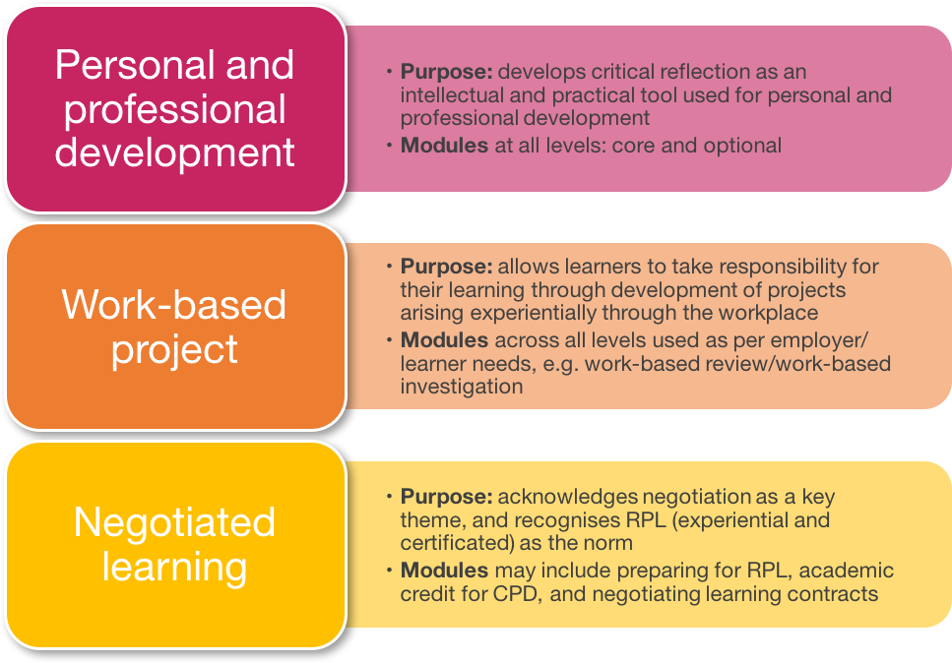
This guide

Introduction to personal and professional development

This guide focuses upon personal and professional development (PPD) as part of your university WBL programme. Both personal and professional development are important features of WBL as you are engaging with real-life issues of relevance not just to you but also to others who you work with. Turning to Nixon et al’s (2006) four points above, there can be no doubt that PPD is a route to satisfying all four perspectives.

PPD in your work-based programme
In a work-based programme you have a lot of freedom to develop a programme which is meaningful to you and your work. One major aspect of this freedom is the potential to influence and shape programme elements to facilitate your own general personal development needs and aspirations. This is in addition to providing professional development and wider impact in your current work area of practice.
Another thing to be mindful of is the relationship with any professional development planning (PDP is a common acronym) or annual appraisal requirements that your employer may have, outside of the learning programme that contains this module. If you approach things holistically, you may be able to combine and overlay different actions so that they become supportive and mutually beneficial – don’t miss a good opportunity to make your required outcomes more resource efficient!

A note on apprenticeships and end-point assessment
Having encouraged this careful holistic thinking between PPD and PDP, there is one other thing you need to be mindful of. If your university programme is an Apprenticeship, then it will lead to an End Point Assessment (EPA). This will be designed to check you have reached standards for knowledge, skills and behaviours. Your course and module tutors will let you know whether this will be:
- Integrated into your final assessment tasks in specific SHU modules; or
- arranged by SHU with another organisation, to take place after the university award and following a further period of work-based learning
One common way of achieving this assessment is through an evidence-based portfolio approach. Through specific modules and support your tutors will identify ways for you to prepare materials and evidence for your EPA. Some of that work will count towards the University Assessments and other work and evidence will be retained and set aside to help you demonstrate your competence at the EPA specifically. Your tutors will be familiar with the specific requirements of your Apprenticeship and so guide you through university assessments and towards your Apprenticeship EPA.

Appraisal of your current knowledge and skills
The starting point for your PPD is to undertake an appraisal of your current knowledge and skills. Many of us go about undertaking our work without really thinking about, in terms of the quality of our output, what we bring to the jobs we undertake, and what we might need to do to improve things. A great and recommended starting point is to undertake a self-analysis of your personal strengths, weaknesses, opportunities and threats (SWOT analysis) as outlined below.
For many people this isn’t an entirely comfortable experience – many of us tend towards job elements that we like and are good at for a range of reasons. Agreeing to be more enquiring and critical (meaning honest and questioning, rather than negative) of yourself is an important departure point for what becomes a new way of thinking and indeed being for many people. Once you have some initial ideas that you think are reasonably balanced and you are comfortable with, if possible discuss them with your manager, mentor or other trusted work-based stakeholder. Most people have performance or behavioural ‘blind spots’ that are completely unknown to them. Maturely raising and exploring them can be a tremendously powerful and rewarding experience, if you have achieved the right trusting and safe relationship to do so.

SWOT analysis
SWOT analysis is widely used as a tool to help uncover, explore and plan business activities and projects of many kinds. It can also be applied to career planning, as it focuses on internal (strengths and weaknesses) and external influences (opportunities and threats) so it provides an opportunity to examine your own personal strengths and weaknesses against relevant contextual external opportunities and threats. A SWOT analysis is typically represented as a table divided into four sections. An example follows below, along with some relevant questions for personal analysis under each section:

Exhibit A: Personal SWOT analysis with prompt questions
Strengths (internal to you)  - What are you good at? (consider identifying as knowledge, skills, behaviours)  - What do other people see as your strengths/ask your advice or help with?  - What personal contacts/networks do you have?  - What personal resources do you have access to? | Weaknesses (internal to you)  - What aspects of your work would you try and avoid due to lack of confidence?  - What do others think are your weaknesses?  - What negative work habits do you have?  - What aspect of your knowledge/skills do you think is holding you back?
Opportunities (external to you)  - Is there a need in your area of work that no one is filling?  - Are there new changes in the internal or external work environment that you might be able to take advantage of? | Threats (external to you)  - What currently holds you back at work?  - Is your job/area of work about to change?  - Could any of your weaknesses lead to threats to your career development?

Exhibit B: Example of a personal SWOT analysis undertaken by Sheila, a newly appointed project manager in a software development company
Strengths  - What are you good at? Good project management knowledge and skills and interpersonal skills  - What do other people see as your strengths/ask your advice about? Technical advice about project management  - What personal contacts/networks do you have? Just getting to know people in the company and the industry  - What personal resources do you have access to? A car. Some spare time | Weaknesses  - What aspects of your work would you try and avoid due to lack of confidence? Team Leadership  - What do others think are your weaknesses? Not sure  - What negative work habits do you have? Not as assertive as I could be  - What aspect of your knowledge/skills do you think is holding you back? Need to develop Leadership skills  - Lack of my own personal network of contacts in my company and the local industry
Opportunities  - Is there a need in your area of work that no one is filling? There seems to be a limited number of good Team leaders in the company  - Are there new changes in the internal or external work environment that you might be able to take advantage of? There seems to be a strong demand for project managers in the software development sector in my region of the country | Threats  - What currently holds you back at work? Lack of confidence in leadership role  - Is your job/area of work about to change? Likely to be increased demand for team leaders  - Could any of your weaknesses lead to threats to your career development? I may be bypassed or seen as not ambitious if I do not put myself forward for leadership roles

The personal SWOT analysis undertaken by Sheila shown above (her responses to the prompt questions are in italics) is an example of how this approach can trigger a range of different reflections and potential actions. We can keep using Sheila as an example to bring these further to life: Sheila has a good knowledge and skill base, and the time to try and develop further. As she is newly appointed she doesn't yet have a network of personal contacts and she has identified this as a weakness. When considering her weaknesses, she thinks she needs to be more assertive and to develop team leadership skills. When considering career opportunities and threats the importance of developing in the leadership area is reinforced as she identifies opportunities but does not currently feel able to take advantage of them. This suggests that Sheila should certainly consider undertaking a taught module in or around the topic of leadership or a negotiated learning module (see student guide #3 in this series) as part of her WBL programme. Also, if there was the opportunity, it could for example be well worth her considering undertaking a work-based project where she was able to assume a project leadership role within a real-life work team. Consequently, Sheila takes advice from her Course Leader and Work BAsed Learning Tutor about the flexibility within her course. She also decides to talk to her line manager about project leadership opportunities at work. She also decides she should find out more about local professional networks for her area of work.

Action #1: undertake your own initial SWOT analysis
- Use the SWOT table and suggested questions to help you. Try not to limit your analysis to the questions suggested – if something feels relevant, capture it.
- Consider what the analysis suggests you should try to do to enable your own PPD. When you feel comfortable (sometimes coming back to an activity like this after a few days gives you a fresh perspective and you might refine or change certain things) invite a trusted work-colleague, manager or mentor to discuss your thoughts and findings with you.
- Also, don’t forget to keep a record of your first SWOT analysis to facilitate your reflective practice. Next time you undertake one, have a look back at the first (afterwards!)

Learning and work and learning styles
Understanding your personal learning style will help you to plan your PPD, and work-based programme more generally, by selecting activities and approaches that complement the way that you learn. More broadly, it will probably also be quite enlightening as a way to help you understand how you adapt to and cope with change at work.

Learning from experience
Kolb’s (1984) influential experiential learning cycle forms a useful way of understanding why you are (repeatedly!) asked to reflect on your learning as you work through your WBL programme. Kolb’s definition of learning is ‘…the process whereby knowledge is created through the transformation of experience’ (1984, p.1). Kolb argues that adult learning is primarily experiential and is a lifelong process in which personal development and work, rather than formal education, provide most of the learning opportunity. According to Kolb experiential learning occurs when individuals involve themselves in new experiences in an open-minded way (have concrete experiences), then reflect on their experiences from a range of perspectives (by reflective observation). By integrating their observations into theories (abstract conceptualisations) learners can create meanings, which are then tested out in real world problem solving situations (through active experimentation). This provides the concrete experience for the next cycle of learning.
It is worth noting that this model is cyclic, and whilst all stages of the cycle are important for knowledge creation, people have different preferences and perspectives. A model like this is a tool for thought and understanding, not a rigid framework.

Exhibit C: Kolb’s learning cycle
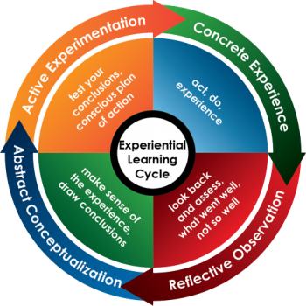
(Source: eLearning wiki, CC 4.0 license)
Action #2: take your learning further
- To find out more about experiential learning and other related theories and concepts, try the range of podcasts and screencasts available at:
http://www.haygroup.com/leadershipandtalentondemand/video/details.aspx?id=303

Reflective and reflexive practice
The process of reflection underpins WBL and aims to enable you, as a learner, to become more aware of all manner of learning opportunities through experience. At higher education levels the reflection you need to undertake upon your experience needs to be ‘critical’. Critical reflection (or reflexive practice) is about identifying and challenging your own assumptions, thinking about thinking if you like, and by so doing potentially challenging the assumptions of those you relate to. Keeping a reflective learning diary is a great tool for keeping track of your learning from experience. It is also really good to get into the habit of reflecting critically on real-life events. Critical reflection is also a key skill you will need to develop and put into practice when you undertake a work-based project as part of your university work-based programme.

Exhibit D: Suggested format for an entry in a reflective learning diary
1. Date:
2. Nature of learning event, who/what was involved:
3. Questions raised:
4. Outcomes of decisions/actions taken:
5. Key learning points:
6. Impact of key learning points on you/on others?

The work of Donald Schön (1983, 1987) focuses on the ‘reflective practitioner’ and the importance of reflection when learning at work. Schön argues that technical and textbook knowledge, though important, is insufficient to prepare individuals to be practising professionals. For this, ‘knowing how’ or what he calls ‘knowing-in-action’ must also be recognised as important. By knowing-in-action he is referring to tacit and intuitive, rather than explicit knowledge, learned through doing rather than in the classroom. Which if you think about it links well with Kolb’s experientially based theory. He gives the example of riding a bicycle. If you begin to fall off a bicycle you may well know what the right thing is to do in order to correct the bike’s motion and not fall off, though you may not be able to verbalise what this is in the moment of its happening.
This knowing-in-action is necessary for practitioners because real world problems tend to be ‘messy’ rather than well formed. Such problems may be unique to that situation and may not simply be solved by the applications of rules from the profession’s or professional’s theoretical knowledge base.
Schön describes knowing-in-action as what we draw on in dealing with the routine problems of practice. However, when something untoward happens, something surprising or unexpected, it is also possible to reflect on what’s going on in the midst of the activity itself. A consequence of this process, which he terms ‘reflection-in-action’ is that thinking can lead to a ‘…reshaping of what we are doing while we are doing it’ (1987, p.26). Reflection-in-action operates as an immediate critique of a way of doing something that gives rise to a modification in how it is done. However, for learning to be consolidated, thought and verbalisation is required and it is necessary to reflect on the reflection-in-action – thinking about thinking, as it were. This ability to use such reflection skills to analyse action both during and after the action is what Schön means by a ‘reflective practitioner’. These ideas on the reflective practitioner have been very influential, for example in the training of teachers and nurses. Their popularity is probably wider than ever today, with many business, management and other professional disciplines now placing value on reflective practice and embedding its key principles within related learning and development.
Schon, D., & Ebook Library. (2008). Reflective Practitioner How Professionals Think In Action. New York: Basic Books. Available at Adsetts Library - 658.403 SC - LEVEL 5 and as an online book.

Learning styles
One widely popular learning style model was proposed by Honey and Mumford (1982). They identified four main learning style preferences, which are explored further below in their own words.

Exhibit E: A cartoon depicting Honey & Mumford’s learning styles
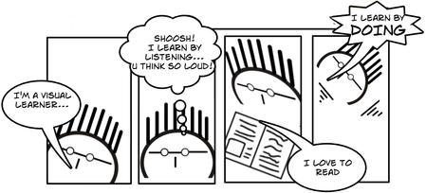
(Source: Educational Origami Wikispace, CC 2.5 license)
Activists
Activists involve themselves fully and without bias in new experiences. They enjoy the here and now, and are happy to be dominated by immediate experiences. They are open-minded, not sceptical, and this tends to make them enthusiastic about anything new. Their philosophy is: ‘I'll try anything once’. They tend to act first and consider the consequences afterwards. Their days are filled with activity. They tackle problems by brainstorming. As soon as the excitement from one activity has died down they are busy looking for the next. They tend to thrive on the challenge of new experiences but are bored with implementation and longer term consolidation. They are gregarious people constantly involving themselves with others but, in doing so, they seek to centre all activities around themselves.
Reflectors
Reflectors like to stand back to ponder experiences and observe them from many different perspectives. They collect data, both first hand and from others, and prefer to think about it thoroughly before coming to a conclusion. The thorough collection and analysis of data about experiences and events is what counts so they tend to postpone reaching definitive conclusions for as long as possible. Their philosophy is to be cautious. They are thoughtful people who like to consider all possible angles and implications before making a move. They prefer to take a back seat in meetings and discussions. They enjoy observing other people in action. They listen to others and get the drift of the discussion before making their own points. They tend to adopt a low profile and have a slightly distant, tolerant unruffled air about them. When they act it is part of a wide picture which includes the past as well as the present and others' observations as well as their own.
Theorists
Theorists adapt and integrate observations into complex but logically sound theories. They think problems through in a vertical, step-by-step logical way. They assimilate disparate facts into coherent theories. They tend to be perfectionists who won't rest easy until things are tidy and fit into a rational scheme. They like to analyse and synthesize. They are keen on basic assumptions, principles, theories models and systems thinking. Their philosophy prizes rationality and logic. ‘If it’s logical it’s good.’ Questions they frequently ask are: ‘Does it make sense?’ ‘How does this fit with that?’ ‘What are the basic assumptions?’ They tend to be detached, analytical and dedicated to rational objectivity rather than anything subjective or ambiguous. Their approach to problems is consistently logical. This is their 'mental set' and they rigidly reject anything that doesn't fit with it. They prefer to maximise certainty and feel uncomfortable with subjective judgements, lateral thinking and anything flippant.
Pragmatists
Pragmatists are keen on trying out ideas, theories and techniques to see if they work in practice. They positively search out new ideas and take the first opportunity to experiment with applications. They are the sort of people who return from courses brimming with new ideas that they want to try out in practice. They like to get on with things and act quickly and confidently on ideas that attract them. They tend to be impatient with ruminating and open-ended discussions. They are essentially practical, down to earth people who like making practical decisions and solving problems. They respond to problems and opportunities 'as a challenge'. Their philosophy is ‘There is always a better way’ and ‘If it works it's good’.

Exhibit F: Relationship between Honey & Mumford’s (1982) and Kolb’s (1984) models
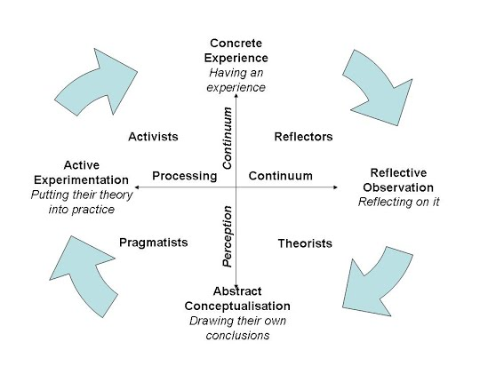
(Source: Learningandteaching.info, CC attribution non-commercial license)

Action #3: consider your own learning styles
- Based on what you have read here, does one (or perhaps two) of the styles resonate with you more than the others?
- Which model feels most relevant for you, Honey & Mumford or Kolb? Remember these are just models – tools for thinking and reflective practice!
- Do you behave differently in difference personal and professional circumstances? Why do you think this might be?
- What disadvantages can you see to your own preferred learning style(s)?

Action #4: now evaluate own learning style
Honey, P., & Mumford, A. (2001). The learning styles questionnaire : 80-item version. Maidenhead: Peter Honey. Avaialble at Adsetts Library - 658.312404 HO (LEVEL 5)
http://resources.eln.io/honey-mumford-learner-types-1986-questionnaire-online/

Planning your own PPD using a learning agreement
An important feature of PPD at university level is the ability to develop the autonomy and responsibility for your own learning. To this end, the WBL programme gives you the opportunity to actively negotiate and plan your own programme.

A partnership approach – the learning agreement
If you are on an Apprenticeship course, the learning agreement will be at the heart of your programme. It gives you the opportunity to develop your own WBL in partnership with both the university and your key work based stakeholder (usually a representative from your employer, but it could be a major client if you were self-employed).
This three-way learning agreement (also sometimes called a commitment statement) outlines the mutual responsibilities of the student/Apprentice, their employer, and the university. It emphasises both WBL and mentoring as key requirements of your learning journey. The learning agreement is fundamental to the success of your programme, as it clarifies precisely what you intend to do and within what timescale. It should be a persuasive argument to make the case for your planned programme.

The learning agreement is:
- A three-way agreement between you, your employer (or other relevant work stakeholder) and the University (the interests of all three parties must be borne in mind when you are planning your programme)
- A current statement of intent on your part
- A record that, by virtue of signature, your employer (or other work stakeholder) and the university agree to your proposed programme, to monitor and support your progress
- The product of a negotiated process between yourself, your employer (or other work stakeholder) and the university. As part of the negotiation process you may be required to modify your ideas and your proposed programme.

To complete your learning agreement, you need to ask yourself whether your learning outcomes meet your needs as the learner, the business/service needs of your workplace and the needs of the university as the academic awarding body. In order to reflect on the interests of each of these three partners in your proposed programme of work based study, you should consider the following questions concering:

Yourself:
- What do you want to get out of the programme?
- What knowledge, skills, personal satisfaction, and career development are you seeking to achieve?
- What are the practical considerations such as the timeframe in which to study?

Your work situation:
- What do you think your employer (or other work stakeholder and your work colleagues want to get out of your participation in a higher education work based learning programme?
- What are the strategic needs of your organisation, department or community of practice and how will these develop you as a worker?
- Or, if you are self-employed, how might the programme benefit your own business?
Nb. Apprentices cannot be self employed
- What planning and resources do you need to identify with your mentor and work-based stakeholders (E.g. budget holders for your training plan).

The university:
- What factors do you think the University are likely to take into account when considering whether to agree to your proposed outcomes?
- You should to consider whether the aims and learning outcomes reflect the level of the qualification you are working towards (See the Work Based Learning Framework Handbook for more information about this.

An outline learning agreement document is available from your Course Leader. This is the starting point for your own, unique, three-way agreement. For Apprenticeships, this will be a specific document provided and completed for the very start of your learning.

Concluding remarks
This module guide has provided a brief introduction to a range of important elements for successful personal and professional development. We hope you have found it useful, but as declared at the outset, it is only a starting point. Your next steps, if you haven’t started already, are to:
- Consider the four action points in this guide, using the ‘notes on reflective approaches’ table (appendix, p.18) as a further general prompt
- Begin reading more widely about work-based learning and reflective practice
- Consider your learning agreement with your course/module tutor and your employer (mentor) and create a first draft for three-way negotiation and agreement
- Commence a research diary to capture your early reflections
- Identify the structured opportunities for review of progress and plan to work towards each review point.

The learning starts here – good luck, and remember that powerful PPD is both enjoyable and slightly uncomfortable… if it isn’t then you’re potentially not pushing yourself hard enough!

Further reading

Remember to check your course programme and module online reading-lists (RLOs) for further resources. Find them in your Blackboard sites or search by name or module code here https://shu.rl.talis.com/

A work based learning framework reading list covering reflective practice, personal development, critical thinking, study skills and referencing skills is available here https://shu.rl.talis.com/lists/AFA12C42-34B3-8BC6-1C93-5AE63782228E.html (or search WBLF here https://shu.rl.talis.com )

In addition, you may find the following useful work-based research starting points:

Core Text
Helyer R (Ed.) (2015) The Work-Based Learning Student Handbook, 2nd Edition. London: Palgrave.
Please read chapters 1 to 6 which cover building your own work-based learning programme.

Background references:
Honey, P. & Mumford, A. (1982) Manual of Learning Styles. London: P. Honey.
Kolb, D. (1984) Experiential Learning. London: Prentice Hall.
Schön, D. (1983) The reflective practitioner. San Francisco: Jossey Bass.
Schön, D. (1987) Educating the reflective practitioner. San Francisco: Jossey Bass.

Appendix: notes on reflective approaches

Reflective and personal development skills | Reflective skills  for performance | Reflective practice for  professional development | Professional review  and future planning
- Understanding how we learn and the learning cycle  - Learning styles  - Experiential and work-based learning  - Skills and approaches for work-based learning  - Work-based learning in higher education  - Understanding self and impact on others  - Reflective learning | - Sense-making through reflective practice  - Reflective practice models and techniques  - Identifying and defining personal performance indicators and standards:  - Personal / role related  - Organisational  - Measuring and monitoring own personal performance  - Emotional intelligence: self-regulation; positive thinking and positioning; positive attitudes; impact on others performance  - Performance under pressure: prioritising, contingency planning, decision making and problem-solving  - Developing productive working relationships, team working and leading self and others.  - Career development and future orientation | - Identification of relevant employability skills and their role in future professional development e.g. analysis of professional standards, employer competency frameworks, transferable skills templates  - Understanding of professional career frameworks across different sectors/industries  - Strategies and models for organisational development  - Definitions and models of organisational excellence  - Industry and world professional skills agendas  - Personal and team performance management and enhancement  - Supporting, guiding and developing others to achieve professional excellence  - Goal alignment (personal, professional and organisational)  - Reconciling resource and budget constraints in the strive for excellence | - Identifying and defining personal performance indicators and standards:  - Personal / role related  - Organisational  - Measuring and monitoring own personal performance  - Self-awareness and personal development  - Personal and organisation change  - Sense-making through reflective practice  - Action planning and lifelong learning  - Career development and future orientation

