Work-based learning
Student Guide #3

Negotiated learning

Version 1.0, March 2017
Directorate of Education & Employer Partnerships

Contents

1. Welcome 3
About this guide 3
Work-based learning at SHU 4
The WBL framework and Apprenticeships 4
2. Introduction to negotiated learning 5
3. Negotiated learning as part of your future WBL programme 5
Planning your negotiated learning module 6
Learning outcomes 7
Use of resources 9
Evidence of learning achievement 9
Negotiated learning and ‘recognition of prior learning’ 11
4. Reviewing your learning 12
Demonstrating your learning 14
5. Concluding remarks 15
6. Further reading 16

Welcome

About this guide
This guide is one of three designed to support you, our Sheffield Hallam University (SHU) students, undertaking your course which contains one (or more) of our key work-based learning (WBL) framework modules. It is intended to be an informative and accessible introduction to the module, and we hope it is also an inspiring starting point. As always, the emphasis is on you to develop your own autonomous learning skills and your own knowledge and abilities around a given topic.
Once you have read this guide please use the further reading section as a springboard to valuable relevant resources. It is also likely that your course and module tutors will have recommended additional reading and key texts to support your specific context and knowledge, so do remember to discuss this with them and check your online reading-lists (RLOs) too.
If you have any feedback about this guide, such as other things it could contain or better resources you have found that would help other students, please contact the Directorate of Education and Employer Partnerships (DEEP) and let us know so we can update and develop future versions of this guide. We hope you find this resource valuable.

Sam Moorwood
Head of Employer Partnerships
Directorate of Education and Employer Partnerships
s.moorwood@shu.ac.uk
0114 225 3433
March 2017

Work-based learning at SHU
A relevant definition for WBL at SHU is ‘learning that takes place at, through, for and from work to meet the needs and aspirations of individuals and the organisations they work for’ (adapted from Nixon et al, 2006):
- learning at work - learning that takes place in the workplace
- learning through work - learning while working
- learning for work - learning how to do new or existing things better
- learning from work - ‘curriculum’ that grows from the experience of the learner, their work context and community of practice
WBL recognises that the workplace is a legitimate site of knowledge. Combined with the vocational nature of courses like the government incentivised Higher and Degree Apprenticeships (HDAs), maximising a WBL focus is key to the successful interplay between academic and vocational learning in the workplace.

The WBL framework and Apprenticeships
As part of the work to support the provision of HDAs at SHU, DEEP created a framework to support the university-wide development of a wide range of different courses with a WBL focus. Not all courses that feature WBL will necessarily come under the framework, but it provides a standardised approach to assist if required. At the heart of this approach is a set of three WBL modules which can be used individually or collectively from academic levels four through to seven, according to specific course requirements. If you are reading this guide, chances are that you are on a course featuring one or more of these modules! The following diagram introduces all three modules so you can see how they fit together:

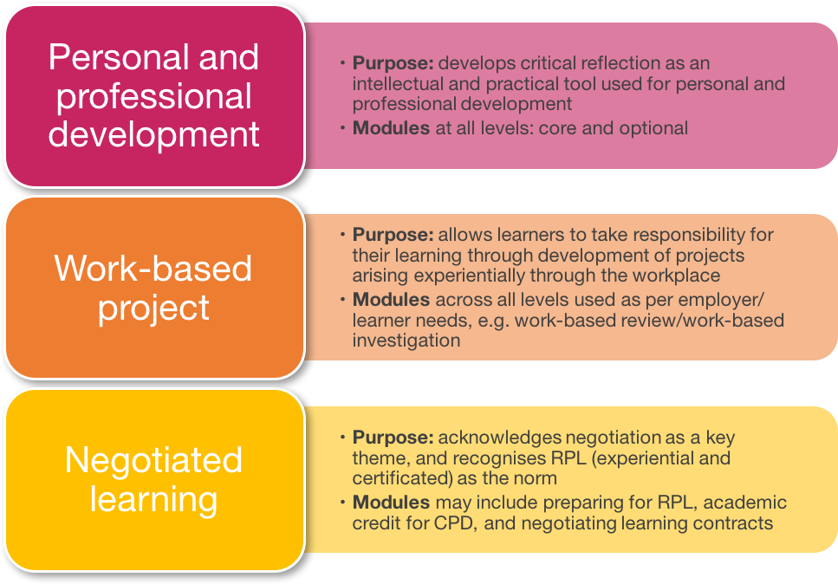
This guide

Introduction to negotiated learning
Negotiated learning (NL) modules focus on your professional practice as the core of your learning activity and are designed to enable you to gain academic credit for learning achieved through continuous professional development in the workplace. Turning to Nixon et al’s (2006) four points above, there can be no doubt that NL is a route to satisfying all four perspectives.
NL can be considered in two ways – forwards, or prospectively: as new learning comprising part of your forthcoming SHU WBL programme, and backwards, or retrospectively: as recognition of learning already achieved that can be evidenced and counted towards the requirements of your work-based qualification through the university process of ‘recognition of prior learning’ (RPL).

Negotiated learning as part of your future WBL programme
The personal and professional development module (student guide #1 in this series) introduces the use of a learning agreement as a key part of a WBL programme. It gives you as the student the opportunity to influence and develop your own work-based programme in partnership with the university and your key work-based stakeholder (usually a representative of your employer, but it could be a major client if you were self-employed).
As well as being able to negotiate your learning at an overall programme level through the learning agreement, it is also possible to negotiate your learning at a module level. This is what this guide is all about. NL modules are designed to provide an outline for you to flesh out your own continuing professional development (CPD). This means that you can define a module for yourself, which is focused on the development of new skills and knowledge that will benefit both you and your organisation. The module might include:
- Short courses organised by your employer, professional body, union or the university
- Conferences
- Work shadowing and observation
- Visits to other organisations
- Short secondments to other units/departments
- Focussed reading
These learning activities can form the basis of a ‘negotiated or NL module’ by linking them to appropriate learning outcomes and forms of assessment. You should have spotted that this can be a very shrewd and resource effective approach to take for part of your WBP programme. If you were planning to undertake specific learning events or activities at work anyway, this is an opportunity to make them count for your SHU course too. Or if you already have evidence of relevant learning, with care you can make good retrospective use of it. With this module, it’s a bit like tuning yourself in for as many opportunities as possible!

Planning your negotiated learning module
Perhaps the main challenge with this NL module is the fact that you are in the driving seat. The ownership and responsibility to shape the module and make it come together is entirely with you. This can feel odd, especially compared with other more prescriptive modules where you are told what you need to achieve and specifically how you will get there. It’s all part of becoming an autonomous learner though, so do embrace any unease or misgivings and aim to think both broadly and laterally to really make this module work for you. Don’t forget you can sound your course and/or module tutor and workplace mentor out with ideas.
Your overall programme aim gives an overview of what you would like to achieve from your WBL programme. It is equally important to be clear about what you want to achieve from each NL module that you are able to include in your WBL programme.
Professional bodies provide a range of information and templates to help their members plan their CPD. For a well-developed and widely resourced example of this see the Chartered Institute of Personnel and Development (CIPD): https://www.cipd.co.uk/cpd/examples-templates.aspx
A simple template for planning a NL is given below. When completing it you should think through precisely what you would like to achieve, the boundaries within which you have to work, the resources available to you, and the timescale involved. Use to the explanatory notes that follow to help and prompt you:

Exhibit A: Starter template for planning a negotiated learning module
1. What do I want to learn and how does it fit within my overall WBL programme? | 2. What will I need to do to achieve this learning? | 3. What support or resources will I need? | 4. What evidence of learning achievement will I be able to provide? | 5. What is the timescale?
Initial notes to become learning outcomes… | Etc…

- What do I want to learn and how does it fit within my overall WBL programme?
You need to identify what knowledge and skills you plan to gain from the learning activity. You should express these as ‘learning outcomes’ (see the next section below). You also need to explain how this learning fits into your overall programme.
- What will I need to do to achieve this learning?
Describe the activities (there will most probably be more than one, although not always) you will undertake in order to achieve the learning described in answer to question 1. For example, you might gain some of the knowledge from attending a short course offered by your company, supplemented with wider academic reading.
- What support or resources will I need?
This might include resources provided by your employer such as access to information or people, as well as resources provided by the SHU.
- What evidence of learning achievement will I be able to provide?
You should identify how you will demonstrate that you have achieved the learning outcomes described in answer to question 1. Often this will be a combination of work-based evidence (for example a work document you have produced) plus a written commentary on that evidence making it explicit to the university assessor how the evidence addresses the learning outcomes.
- What is the timescale?
You need to take into account the university timescale for modules and assessment, as well as any workplace deadlines and priorities which may be relevant.

Learning outcomes
Learning outcomes are a statement of what a learner can be expected to know, understand and be able to demonstrate, as the result of a specific learning period of activities. They are worded in a particular linguistic style, which can take a bit of getting used to, but once you get your eye in they are relatively straightforward to construct.
Success in your NL module assessment will be dependent on the achievement of your stated and agreed learning outcomes at the appropriate academic level of your course programme. A great bit of good practice to work to from the outset is that all of your learning outcomes should be ‘SMART’, which is an acronym that stands for:
Specific: are your learning outcomes specific, clear and easy to understand?
Measureable: how will you know when the learning outcome has been achieved? What evidence is needed to confirm that you have achieved the learning outcomes?
Achievable: is it within your capabilities?
Realistic: is it possible for you to perform the outcomes? How sensible is the outcome in the current work context? (do you have access to support and resources?)
Timely: is there a realistic deadline? Are there review dates?

Here’s an example. Robert is a local government manager and has decided that his aim is to develop his own management skills in order to introduce a change in working practices within his team. Robert describes his aim as:
‘To develop my change management skills and understanding of the implementation of change, in order to change working practices within the team I have responsibility for’
This is a great and aspirational start, but it isn’t quite SMART yet. So, to achieve this aim Robert identifies that he will need to gain change management knowledge and skills and greater understanding of how teams work. Robert is working towards a WBL Honours degree, so he needs to take into account the ‘generic description of learning outcomes’ for the Level 6 negotiated learning module he is developing. If he doesn’t set his learning outcomes at level 6, he risks not being able to achieve a module pass even if he satisfies the SMART objectives he has created. The generic information shoud be available at the very least as a course or programme ‘definitive document’ (def doc for short). If you are in any doubt about this, definitely make time to speak to your course or module tutor.
Consequently, after discussion with his university supervisor it is agreed that this is a substantial body of work and can constitute a 20 credit point academic level 6 module for Robert. Taking into account the overall module aim and the level and size of the module, Robert uses the SMART criteria to help him develop the following learning outcomes. Note the very particular way of structuring them. This is a technique that takes a little practice. However if they are well-constructed, you are setting yourself up for success, because there can be no doubt whether you have (or have not yet) achieved them.
- The ability to identify, analyse and evaluate professional and academic literature relating to change management theory and skills.
- The ability to identify, analyse and evaluate professional and academic literature relating to work teams.
- The ability to draw upon change and team literature to inform the development of an action plan to introduce change into a team within a local government department. The action plan should be substantially completed for workplace circulation by mid November.

Use of resources
When thinking about the NL module you need to identify the human and material resources that you will need to draw upon in order to achieve your learning outcomes. For example such resources might include:
- Your immediate manager (a time commitment from both of you)
- Visits to other departments with key learning outcomes in mind (time commitments from a range of individuals)
- Discussions with strategic people who can help you to see the wider picture (time commitments again)
- Attendance at conferences (time and resource commitments)
- Visits to other similar organisations in order to benchmark or gain a fresh perspective (time and resource commitments)
- Job shadowing opportunities to learn about the roles of other team members (time commitments)
- Attendance on training events that are internal or external to your work organisation (time and resource commitments)

Evidence of learning achievement
The evidence of the achievement of the learning outcomes of your NL module can take a variety of forms. Some examples of evidence include work-based products such as:
- A report
- Updated guidelines, policies or procedures
- A financial analysis
- A project proposal or report
- A business plan
- Development of a policy
- Needs assessment
- Teaching programme
- Strategy document
You can be creative when devising how you will evidence your learning achievement but you should also be selective about which pieces of evidence you use. Remember, the work you submit needs to be commensurate with the academic level of the NL module. You are seeking to demonstrate the quality of your learning rather than the quantity of activity that you were involved in.

The evidence you submit for assessment must be:
- Valid: your evidence must be directly related to the learning outcome(s) you are working on.
- Authentic: it must be clear that any evidence submitted is produced by you and/or relates specifically to you/work you have undertaken.
- Current: evidence should primarily be drawn from the period of activity covered by the NL module and be dated for any avoidance of doubt (If you have negotiated a retrospective contribution you will have addressed the timescale through the slightly different RPL process and module).
- Sufficient: you must submit enough evidence to cover the range of the learning outcomes of the module.
You must also be ethical in your use of evidence. You should always seek to protect any person or organisation named in your evidence by keeping them anonymous (pseudonyms can be an effective approach at both organisational and individual levels) unless you get explicit written permission to use the names of individuals or organisations that you can evidence if need be. Also, if you intend to include confidential material as evidence you must ensure consent for the use of material is obtained from all people involved and be sensitive to the implications of your evidence.
It is possible, in rare and specific circumstances, to mark your submitted material ‘commercial in confidence’ and note that it can only be seen by university assessors and external examiners. Having said that, in the spirit of your course-level three way partnership represented by your learning agreement, it might be an idea to try and avoid this sort of content if at all possible.
Below is a continuation of Robert’s example, using the template introduced above as exhibit A. Note here that Robert is drawing upon his workplace as well as the university to support his learning. All activity is due to be completed within the same semester. Each learning outcome is evidenced and the culmination is an action plan of direct relevance to work:

Exhibit B: Robert’s example use of the template to develop his NL module
1. What do I want to learn and how does it fit within my overall WBL programme? | 2. What will I need to do to achieve this learning? | 3. What support or resources will I need? | 4. What evidence of learning achievement will I be able to provide? | 5. What is the timescale?
Learning outcome 1:  The ability to identify, analyse and evaluate professional and academic literature relating to change management theory and skills | Undertake a literature search and write a literature review | 1. Access to online academic literature  2. Advice and access to any relevant literature held by my employer | A 1500 word literature review | One semester
Learning outcome 2:  The ability to identify, analyse and evaluate professional and academic literature relating to work teams | 1. Undertake a literature search and write a literature review  2. Attend in company training on team leadership | 1. Access to online academic literature  2. Advice and access to any relevant literature held by my employer | A 1500 word literature review | One semester
Learning outcome 3:  The ability to draw upon change and team literature to inform the development of an action plan to introduce change into a team within a local government department | 1. Consult with my line manager about the desired change and the rate of change  2. Draft plan for approval | 1. Line manager support.  2. University supervisor to comment on draft action plan | A 1000 word action plan | One semester

Negotiated learning and ‘recognition of prior learning’

Recognition of Prior Learning (RPL) gives you the opportunity to gain academic recognition (in the form of academic credit) for learning you have already achieved. To make a claim for RPL you need to be explicit about the learning achievement you wish to claim and then put together a portfolio which demonstrates that learning to the University. RPL claims may be made against the learning outcomes of specific university modules. Where you have learning which does not neatly correspond to a university module from a specific subject it is often more helpful to use the generic learning outcomes of the NL modules as the template against which to assemble evidence of prior learning achievement.

If you have a learning event or topic area in mind, make some time to discuss this properly with your course or module tutor. Don’t risk wasting significant time and energy preparing lengthy documents that may not be appropriate – have an open discussion to get an idea of whether your RPL proposal is likely to be accepted first.

Reviewing your learning

The first step in preparing your RPL portfolio is to write an up-to-date CV (curriculum vitae or resumé). A CV gives an overall picture of your work history and provides the introduction and context for your RPL portfolio. If you have an existing CV use it as a starting point, but it is likely to need expansion to include information about your employment (paid/unpaid) and any other activities which are relevant as sources of the learning you wish to be accredited. There is a range of great and free CV content and formatting guidance. Google Docs, for example has two templates offered as standard:

Exhibit C: Google Docs CV templates freely available online:
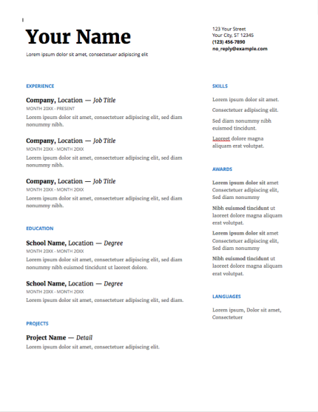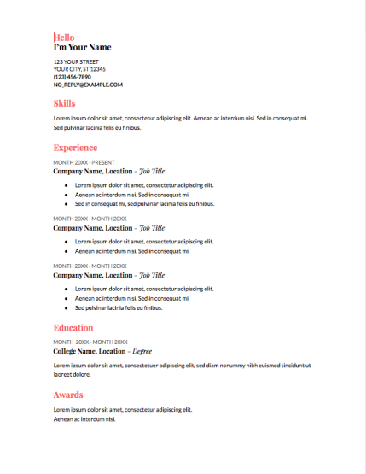

(Source: Google Docs screenshots)

Include the following in your CV, in each case starting with your most recent activity and working backwards:
- Education (post-secondary school only)
- Employment (may include in-house training and staff development courses)
- Unpaid work (may include domestic as well as voluntary work – but only include this if it will form part of your RPL claim)
- Publications if any (give full references)

Writing your CV gives you a chance to review your past work experiences. The next step in preparing a RPL portfolio is to review the job description(s) you have for your current work. Your aim is to provide a picture of your current roles, responsibilities and achievements which will contextualise your RPL claim.

For this activity, think of the term ‘job description’ as one which describes the work you do, whether it is paid or unpaid. Where available a formal job description may be a starting point. However, if you do not have a formal job description or you are not in paid employment, you should write your own job description. A formal job description may not cover all that you do and may not emphasize the knowledge and skills you have had to use in order to carry out the job. Think about what you really do in your job(s). If you were to hand over your job to someone tomorrow, how would you describe your roles and responsibilities to them so they could do what you do?

Guidelines for writing a job description to include in your RPL portfolio:
- Provide comments on each aspect of your current work role. Include a short description of each task and indicate its relative importance within the whole job. Concentrate on the knowledge and skills which are required to do each task.
- Add functions and activities not covered in your official job description.
- Give brief details (date, duration, subject) of significant courses and training programmes you have taken in relation to your job (do not go back beyond five years, since the task of writing your job description is to give a picture of your current activities).
- If you work for an organisation, it is useful to provide a chart showing your position on it (use job titles only, not individual names, for confidentiality reasons)
- Give an idea of the range of your responsibility, for example, the number of people you are responsible for or the value of any resources you control. Insert your job description(s) into your RPL Portfolio.

Your job description will help you identify many of the skills and knowledge you use on a daily basis. By reflecting on these you can begin to identify learning you can develop for accreditation.

Review your CV and job description to identify knowledge and skill areas you have developed in order to be effective in the work roles you have carried out.

These questions may help you to identify learning that you have:
- What would someone else need to know to do your job?
- Are there policies/legislation/procedures that you must be familiar with?
- Do you have to deal with specific types of problems?
- What specific responsibilities do you have?
- What areas do other people ask your advice about?

Demonstrating your learning

In each learning claim you should demonstrate that you have reflected on your experience to identify and analyse your learning. Your analysis of learning must make clear the context in which your learning occurred and the rationale for the choices and decisions made where learning was achieved by solving problems or overcoming difficulties. You also need to demonstrate progression in your learning and understanding of how your learning has implications for your future behaviour.

Each claim for learning must include the following headings and information:
- Name of the claim for learning:
When the claim is based upon meeting the learning outcomes of a specified module the name of the learning claim will be the same as the title of the module. However because the title of the module is negotiated learning, this gives you the freedom to propose a tile which you feel represent the area of learning achievement being claimed.
- Introduction:
A short paragraph introducing the area of the claim for learning. This should cover how you acquired the learning. Refer to your CV and job description to provide the context for your learning.
- Relevant courses attended and/or significant insights from literature:
List any relevant training or professional development courses attended in the last five years, (for each give date, duration, outline content and form of assessment, if any). List significant articles read which have been influential in the development of your thinking and professional practice.
- Analysis of learning and evidence:
Itemise the learning you are claiming credit for and map it against the learning outcomes of the negotiated learning module.

You must supply evidence to cover all the learning outcomes of the negotiated learning module. The evidence must meet the criteria identified under the ‘evidence of learning achivement’ section (see page 9 above) and must also be current. Where you are claiming for prior learning, supplementary evidence may be necessary to show that you are still capable of achieving the same level of learning. Evidence more than five years old should only be included if you are able to demonstrate that the learning has been in use more recently and, if appropriate, has been updated.

Attach a short commentary to each piece of evidence explaining its context and how it demonstrates a particular aspect of your learning. Remember that quantity of evidence does not equate with quantity or quality of the actual learning. It is often possible to find a piece of evidence that demonstrates several learning outcomes.

Concluding remarks
This module guide has provided a brief introduction to a range of important elements for successful planning and achievement of negotiated learning modules. We hope you have found it useful, but as declared at the outset, it is only a starting point. Your next steps, if you haven’t started already, are to:
- Consider what prospective opportunities you have for a NL module within your work-based learning programme
- Consider whether you have any retrospective opportunities for either a NL module or RPL claim within your work-based learning programme
- Begin exploring early ideas and discussing with your course and/or module tutor
- Begin working up some initial notes using the template to facilitate suitable learning outcomes with SMART objectives

The learning starts here – good luck, and remember that NL is likely going to feel quite odd at first, as you are in an entirely creative and autonomous position. Rise to the challenge – it can be an incredibly resource effective way of achieving valuable academic module credits, particularly if you have done, or plan to do, something of intrinsic course value in the workplace.

Further reading

Remember to check your course programme and module online reading-lists (RLOs) for further resources. Find them in your Blackboard sites or search by name or module code here https://shu.rl.talis.com/

A work based learning framework reading list covering reflective practice, personal development, critical thinking, study skills and referencing skills is available here https://shu.rl.talis.com/lists/AFA12C42-34B3-8BC6-1C93-5AE63782228E.html (or search WBLF here https://shu.rl.talis.com )

Core text:
Helyer, R. (Ed.) (2015) The Work-Based Learning Student Handbook, 2nd Edition. London: Palgrave.
Please read chapters 6 and 11 which cover negotiated WBL and assessment of WBL.

Background references:
Durrant, A., Rhodes, G., and Young, D. (eds) (2009) Getting started with University-level Work Based Learning, London: Middlesex University Press.
Laycock, M. and Karpel, M. (2015) Negotiation and Work-Based Learning, in Helyer R (Ed.) (2015) Facilitating Work-Based Learning: A Handbook for Tutors, pp 73-93, London: Palgrave.

