Graphical user interface showing screen shot of the Drop-off summary page.
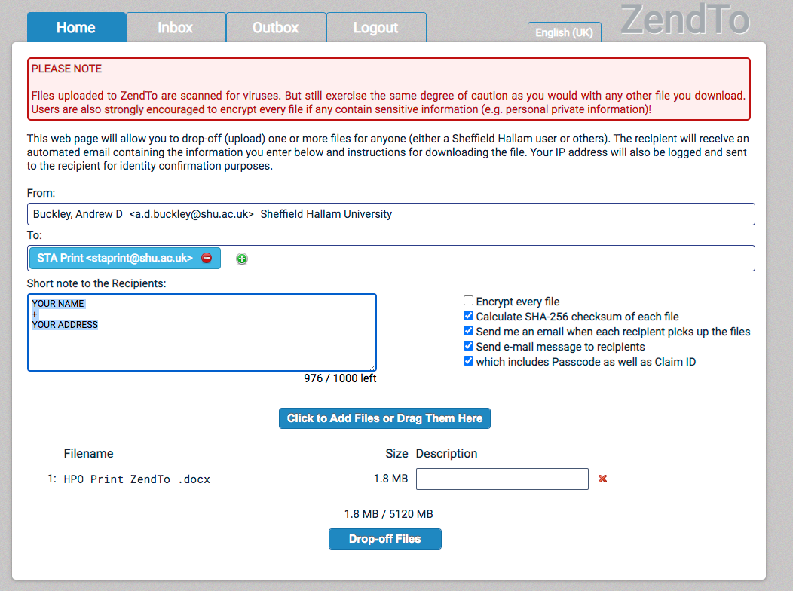

1. Goto [zendto.shu.ac.uk](http://zendto.shu.ac.uk) or scan the QR code

6. Check the drop-off summary is correct.  
You can also forward the link to others (for example if the work needs both print and digital submission)

HPO Print Output

Uploading files to ZendTo

# HPO Media Centre Room 16.-1.14, Level -1, HPO Building, City Campus

# [acmdesign@shu.ac.uk](mailto:acmdesign@shu.ac.uk)

3. Click on ‘Drop Off’

2. Login with your SHU username and password

4. Enter the following details  
Name: STA Print Email: staprint@shu.ac.uk

and click Add & Close

5. Click to browse or drag and drop files to add them to the list.

Please add your address in the comments if you require prints to be posted out.

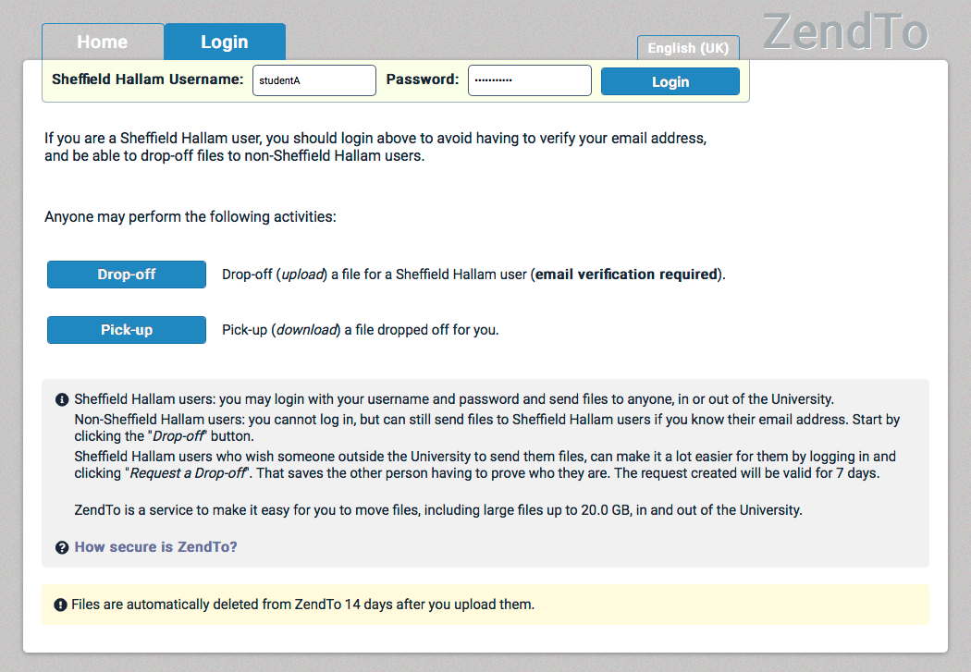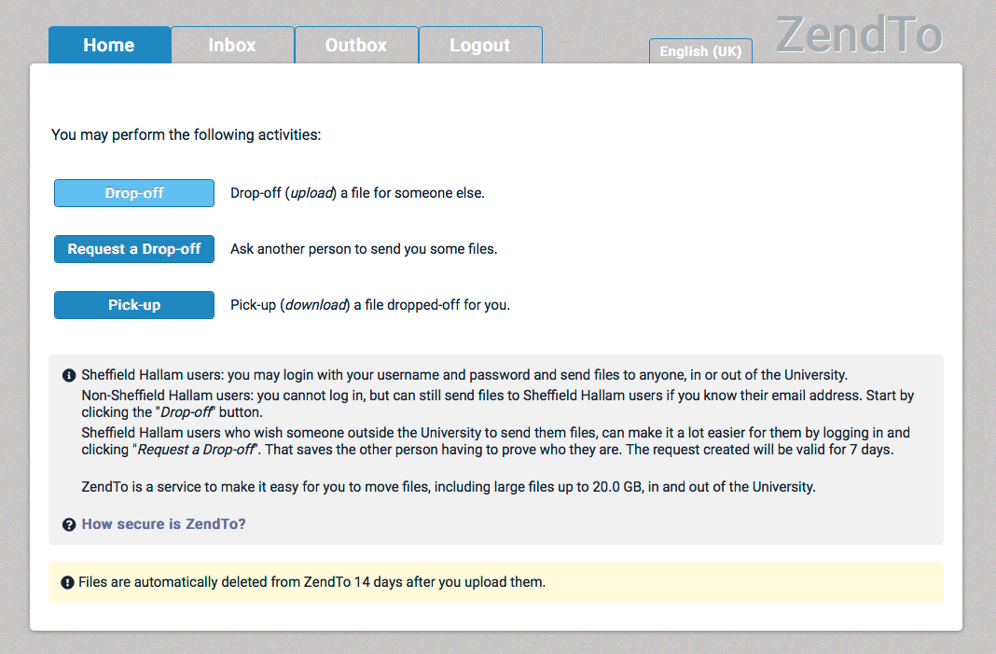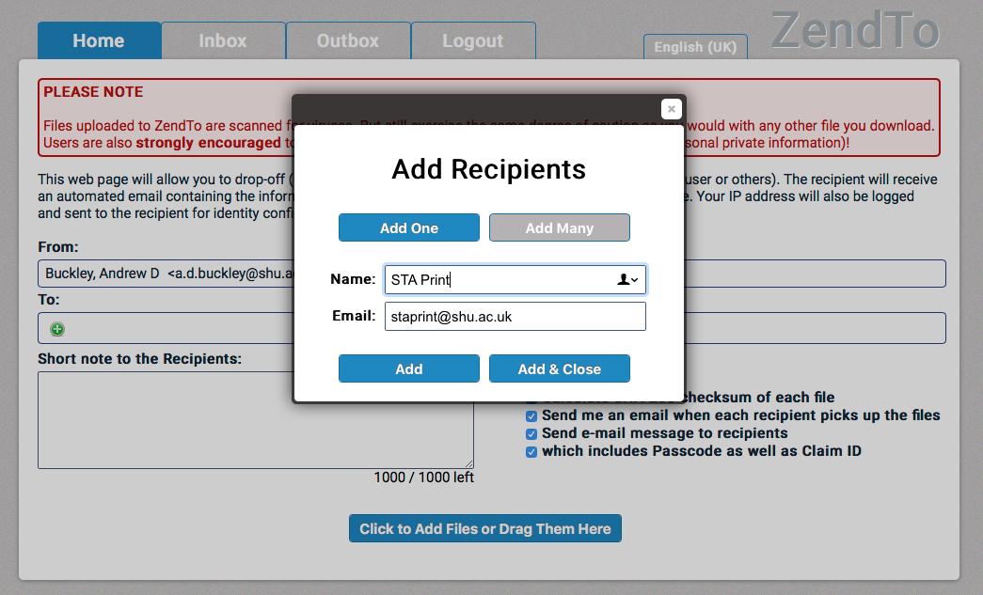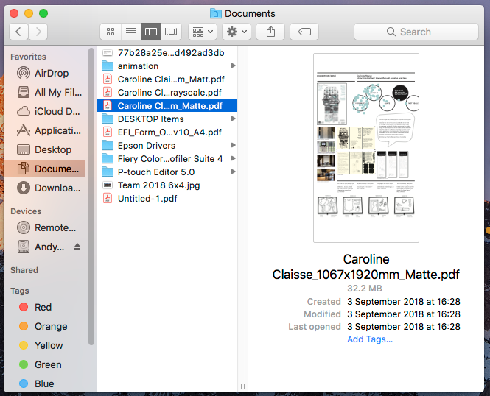

SHU ZendTo

You will receive an email notification when the file is picked up, and another when the print has been mailed out. Please note that prints on specialist media (Adhesives, Art Papers etc.) may take longer to process. Any queries can be made via email to [staprint@shu.ac.uk](mailto:staprint@shu.ac.uk).