MyTimetable, the new online timetable view

We now have a new online timetable view called MyTimetable. It provides the same information as the old online timetable but in a more user-friendly format. There is a help page linked in the top right that provides information such as how to connect to your calendar and automatic change notifications (that relate to activities due to take place in the next two weeks that you are allocated to teach), but here a few things that you may find particularly useful

Class lists
These are now linked with the activity itself. Click on the activity to open the details box then scroll down to the bottom for printable class lists. A register format is also available that doesn’t refer to Learning Contracts:
The class list also contains information on the capacity of the room:
In this example the location is Charles St-12.5.08 at City campus, capacity 50 (the total number of students is 24)

Course timetables
MyTimetable can combine timetables, allowing users to select a number of timetables (e.g. five members of staff, combinations of students and/or modules etc) so it is possible to provide a course view. This is data drawn from SITS so if a relationship isn’t yet set up you can instead select all the relevant modules to display together. You may want to remove other timetables such as your own teaching from the right-hand list first. My Timetable uses the terminology ‘Programme of Study’ to describe the level of a course. You can use the + Add timetable button to search for a Programme of Study for an academic year and bring all the relevant modules into the timetable
To find a course start typing relevant words and the list will show the Programmes of Study that fit. In this case starting to type Economics displays Programmes including BA Hon Accounting and Economics-1 (i.e., the first block):
Select the Programme you want and then add the timetable by clicking Add timetable in the bottom right of the window. This then imports all the related modules and all the activities into the timetable view:
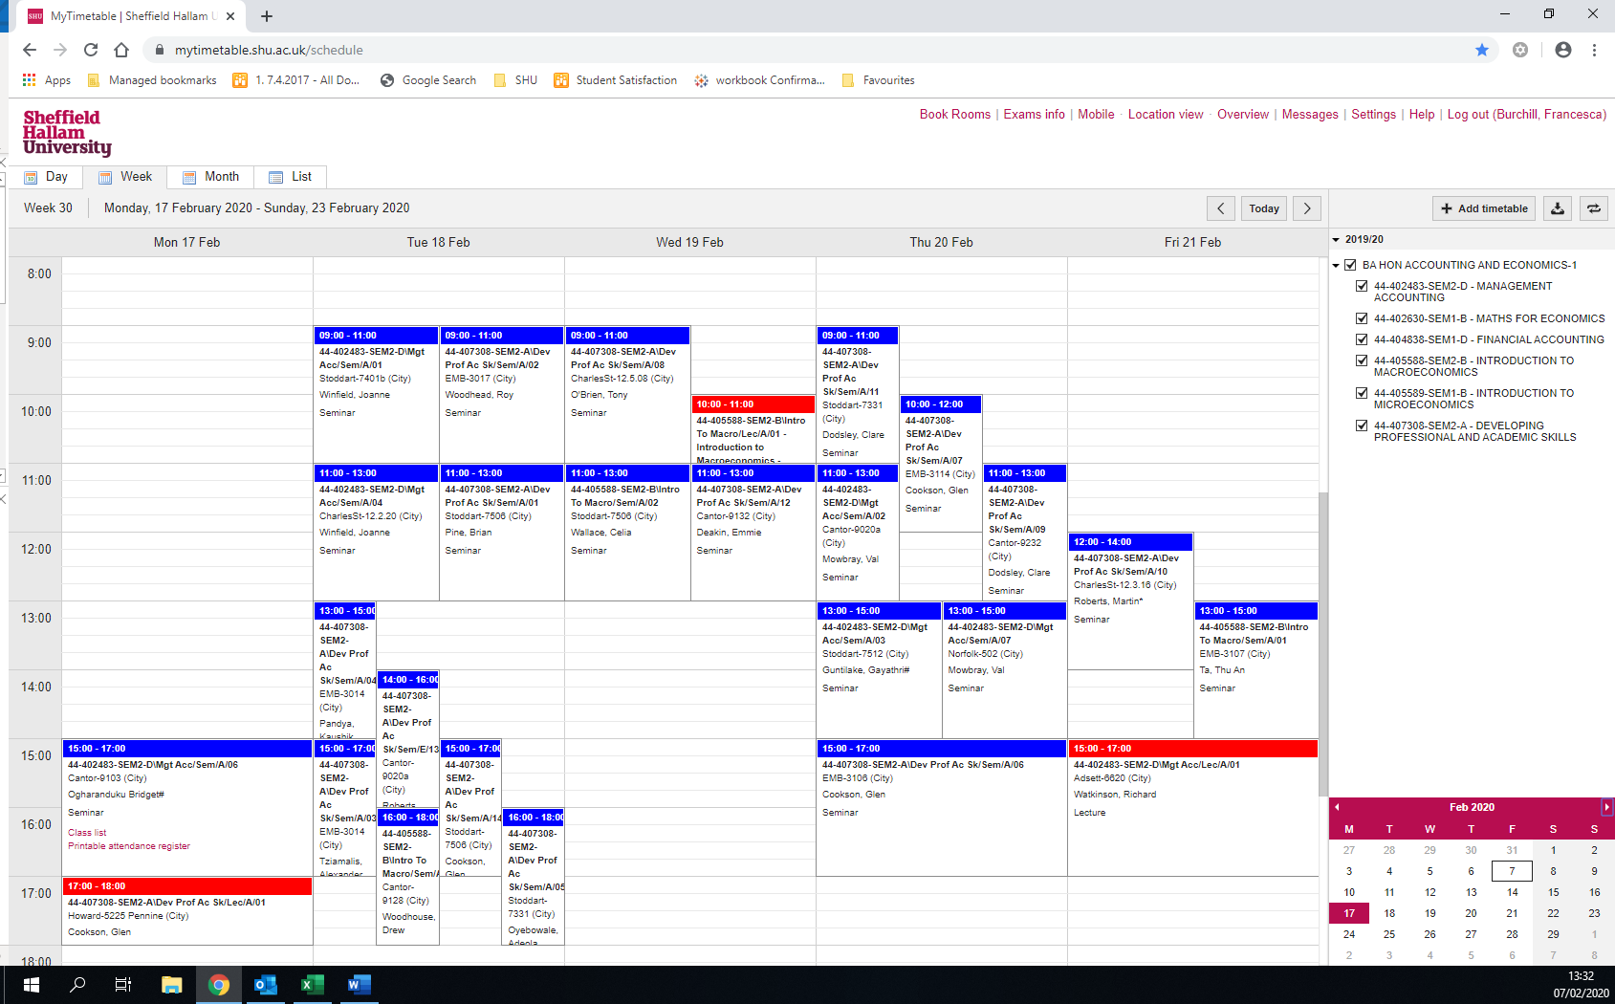

Please note that all activities related to the modules are imported. If the module is shared between courses, there isn’t a way to exclude activities taken by other students. The best way to view a student experience of a course is still to look up a relevant student and view their timetable.

Students by Programme of Study (course + block)
It may be useful to be able to find a time a small number of students are available together, e.g., for an informal meeting or tutorial session. You can search for students via Programme of Study and then select some of them to display together
Add student timetables, and use the drop-down list for Filter on programme of study, scrolling until you find the one you want:
This will now display a list of all the students that belong to that Programme of Study. Select the students you need to see from the list (you can select more than one at a time):
Click on the Add timetables button in the bottom right corner and the combined timetable for these students will display. You can see from this example that they are all available on the morning of Tuesday 11th February:

