How to update a Module Leader in SITS online

The process of updating a module leader is completed in SITS online (same access as My Student Record). You can access the system direct SITS Online or via the Staff Intranet sites and systems.
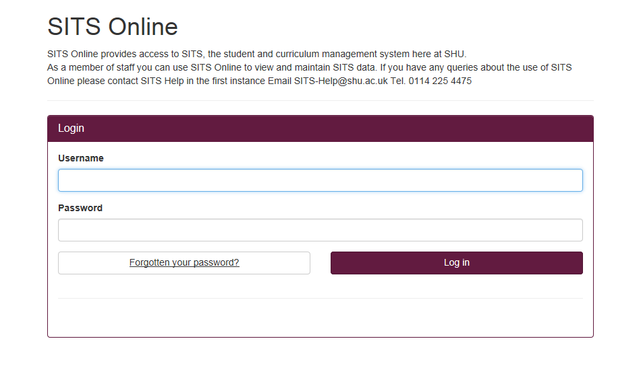

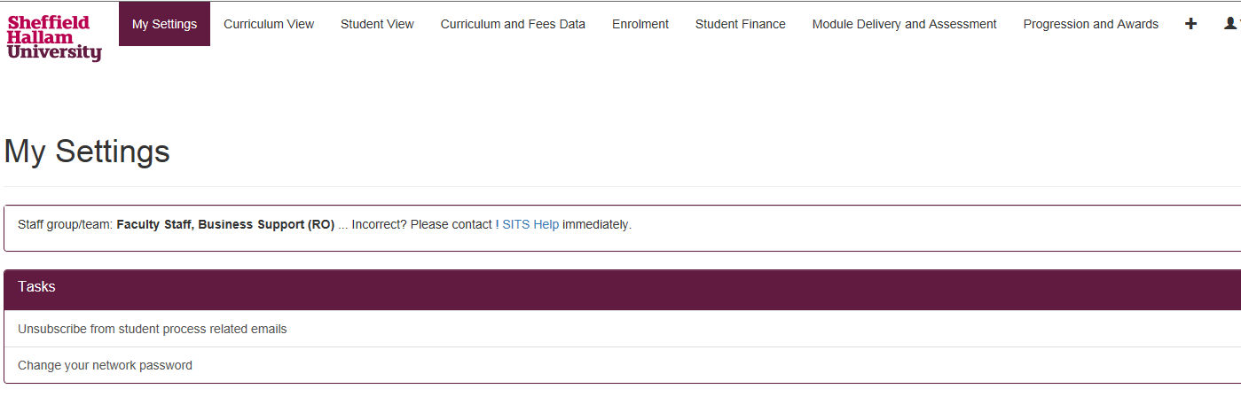
Once you have logged in, select the 'Curriculum and Fees Data' tab at the top of the screen.

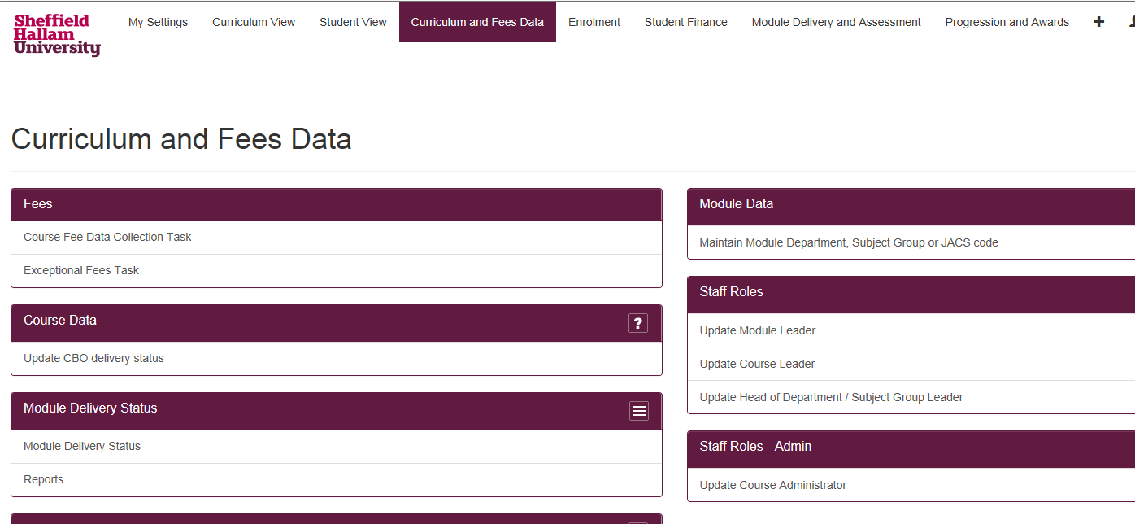
Then under 'Staff Roles' select 'Update Module Leader'. Please note that your screen will look slightly different to the one shown here depending on what level of access you have.

On the ‘Select Module’ section, insert either the module name or module number and click ‘Next’.
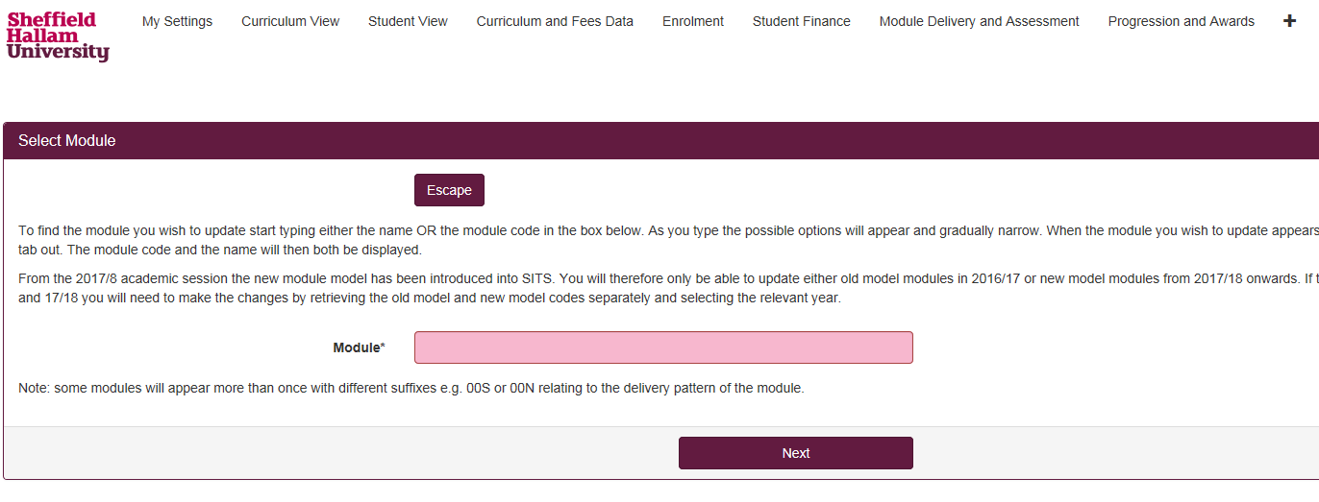

Select the academic year from the drop-down list that you want the change to relate to. If it’s a permanent change, select the current and future academic years. Click ‘Next’.

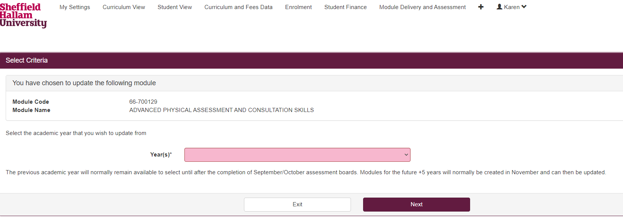

You will then be asked of the Module Leader is the same for all occurrences of the module. Select:
- Yes - The Module Leader is the same for all occurrences.
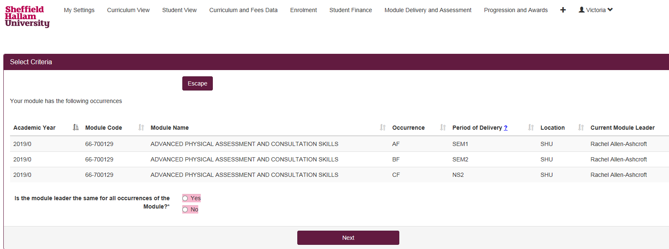
- No - You have different Module Leaders for different occurrences. Please note that two people cannot be entered in the same field. You will have to input each Module Leader against the relevant occurrence.

Start typing the name of the new Module Leader in the box and named options will appear.
A 6-digit number beginning with P will populate the box, this is the staff ID number. Select 'Store' when you have found the new Module Leader.

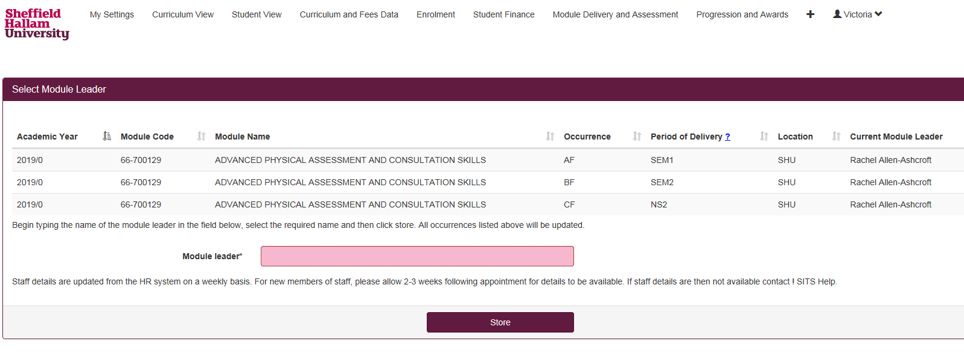

Please note:
- The updates will be visible on the various systems after 24 hours/overnight.
- If you cannot find the person you want, there might be an issue with their record (e.g., they’re a new staff member). To resolve this email the SITS team ! SITS Help
- If you see multiple staff members with the same name - check with the member of staff what their staff ID number is to ensure the correct staff member is entered. Staff numbers can be located on your SHU card.

