How to update a Course Leader in SITS online

The process of updating a course leader is completed in SITS online (same access as My Student Record). You can access the system direct SITS Online or via the Staff Intranet sites and systems.
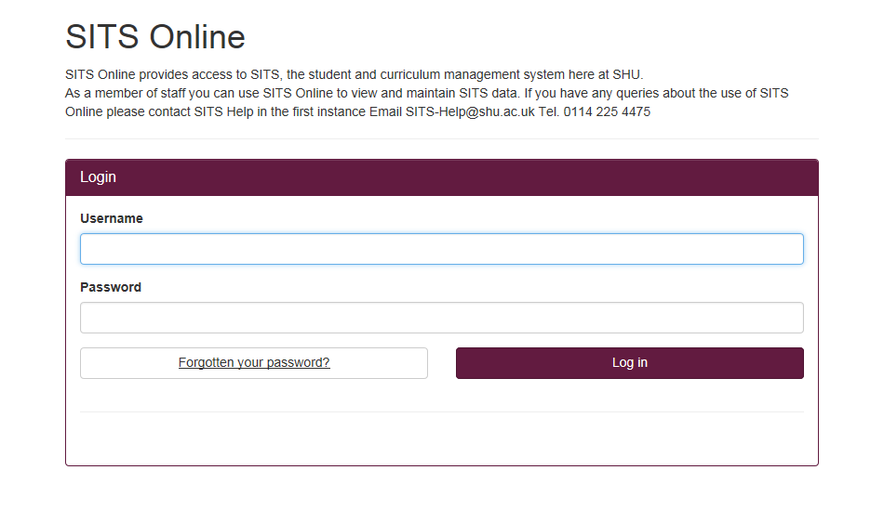

Once you have logged in, select the 'Curriculum and Fees Data' tab at the top of the screen.
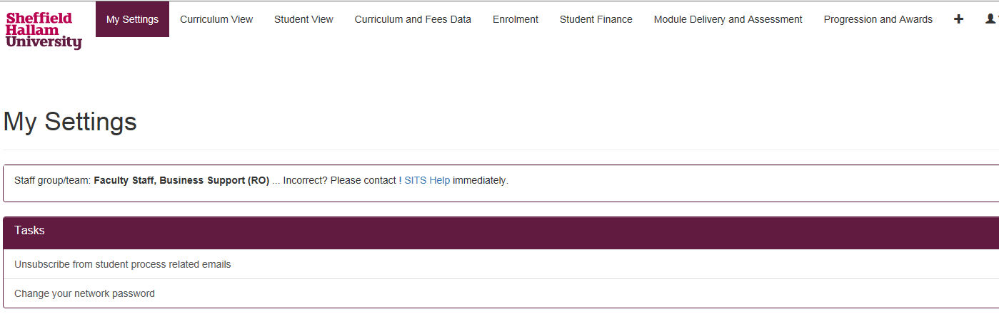

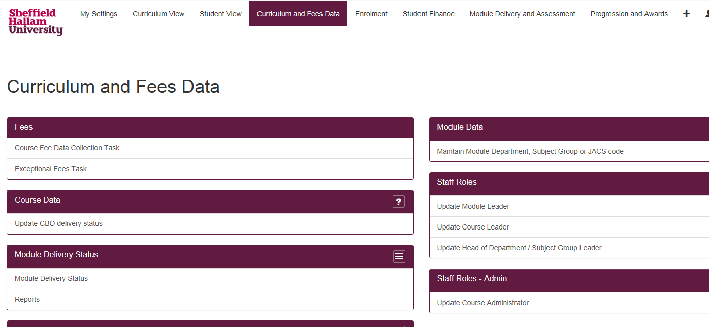
Then under 'Staff Roles' select 'Update Course Leader'. Please note that your screen may look slightly different to the one shown here depending on what level of access you have.

On the ‘Select Course’ section, insert either the course title or course code and click ‘Next’
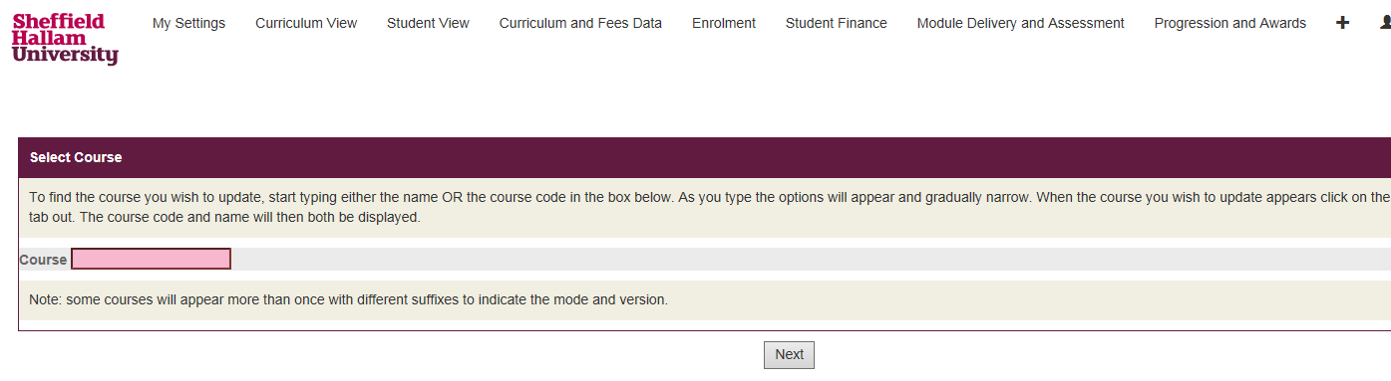

Select the current academic year that you wish to update. Please note that SITS roll forward data in November each year to the next academic year. Click ‘Next’.
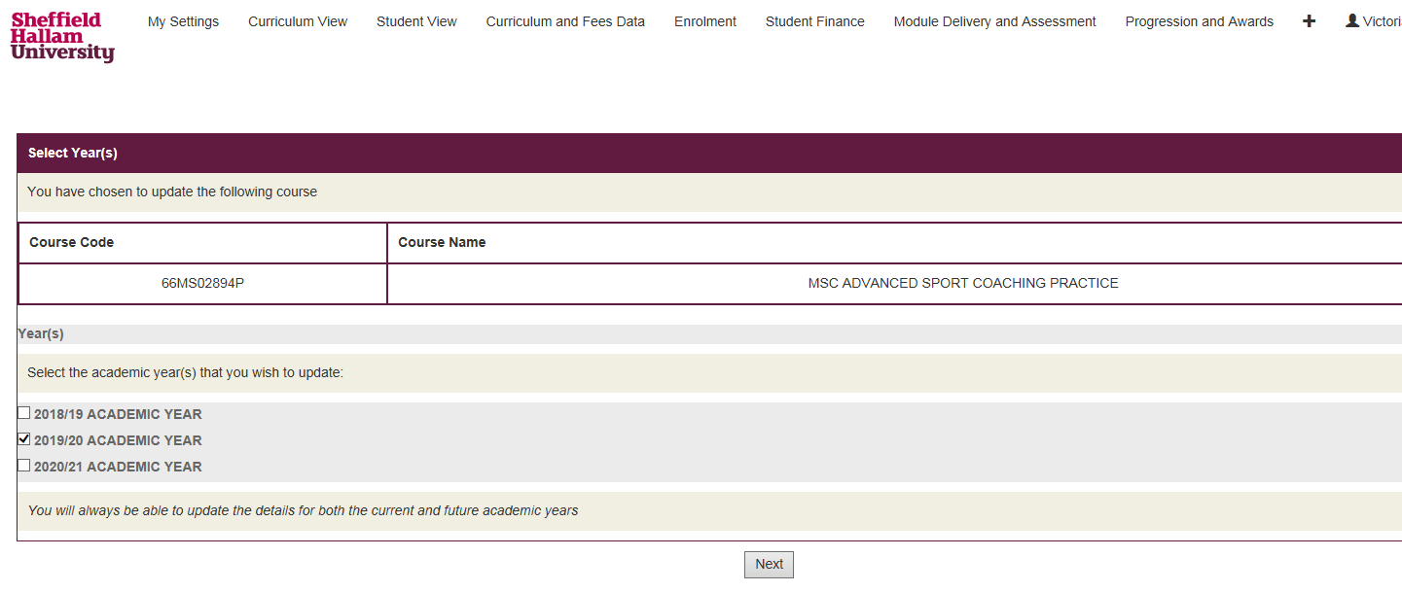

You will then be asked if the Course Leader is the same for all occurrences of the course. Select:
- Yes - The Course Leader is the same for all occurrences.
- No - You have different Course Leaders for different occurrences. Please note that two people cannot be entered in the same field. You will have to input each Course Leader against the relevant occurrence.
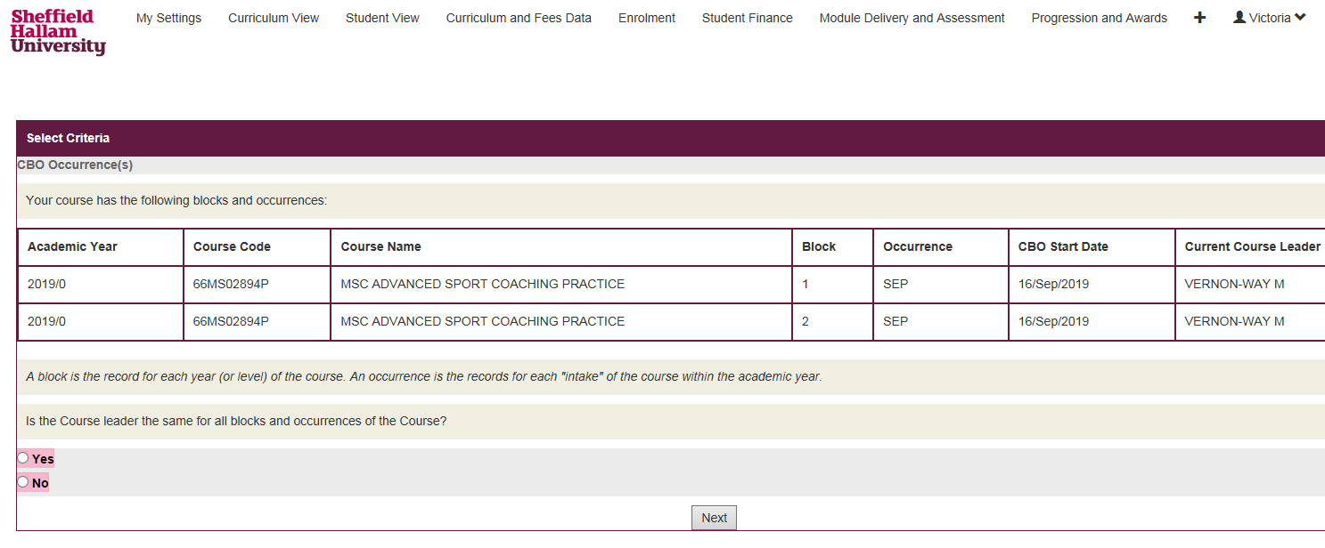

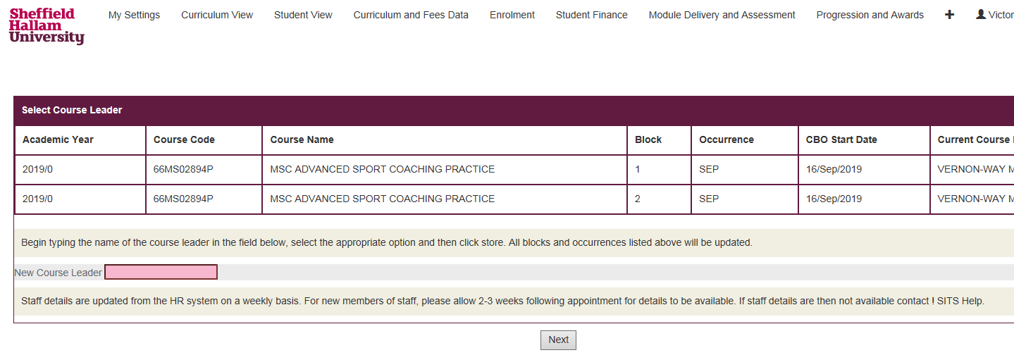
Start typing the name of the new Course Leader in the search field and named options will appear. A 6-digit number beginning with P will populate the box, this is the Course Leader’s staff ID number. Once you have selected the new Course Leader click 'Store' to save the updated record’

Click ‘Close’ to complete the update.
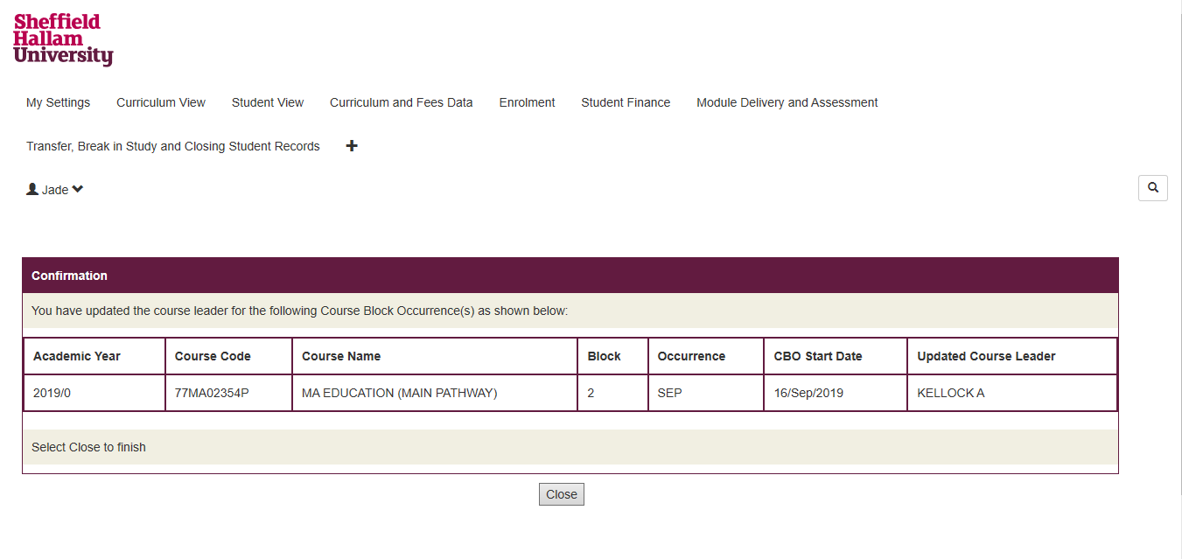

Please note:
- The updates will be visible on the various systems after 24 hours/overnight.
- If you cannot find the relevant Course Leader, there might be an issue with their record (e.g., they’re a new staff member). To resolve this email the SITS team ! SITS Help
- If you see multiple staff members with the same name - check with the member of staff what their staff ID number is to ensure the correct staff member is entered. Staff numbers can be located on your SHU Card.

