An Academic Essentials Case Study

Title | Formative Assessment in a HR Module
Brief | Small changes to boost engagement with formative tasks
Profile | Tutor names | Lynne Booth and Michelle Blackburn
 | Email address | l.m.booth@shu.ac.uk and m.blackburn@shu.ac.uk
 | College | Business, Technology and Engineering (BTE)
 | Department | Management
 | Size of cohort | Large (30+ students)
 | Technologies used | Blackboard
 | Hallam Model | Thrive

The Aim
We wanted to boost the number of students who engaged with formative assessment as the assessment required them to demonstrate new skills (blog writing) using new technology (WordPress). It also provided assurance (or fresh guidance) to the students in time for them to make improvements to their work before formal submission. This was achieved within the time allowance for the module.

Benefits
- Increased student engagement with formative assessment (increased from 50% to 85%).
- Students are better prepared for their summative assessment.
- Students receive feedback they can use in summative assessment.
- The teaching team were able to identify struggling students before summative assessment.

The Approach
Students needed to produce four subject based blogs for their summative assessment of this module. The formative task was for students to produce one sample blog from four for formative feedback by the teaching team. They were also given an opportunity to ask questions related to content on their other blogs and the assessment in general.
Experience had showed us that students engaging with the feedback had increased their marks. It also served to reduce anxiety within the Level 6 cohort.
The actions taken to encourage engagement with the formative task were as follows:
- The formative assessment had a deadline that was repeated in every seminar and lecture.
- A reminder was presented on the Blackboard site every week from the start of the academic year to the deadline for the formative task.
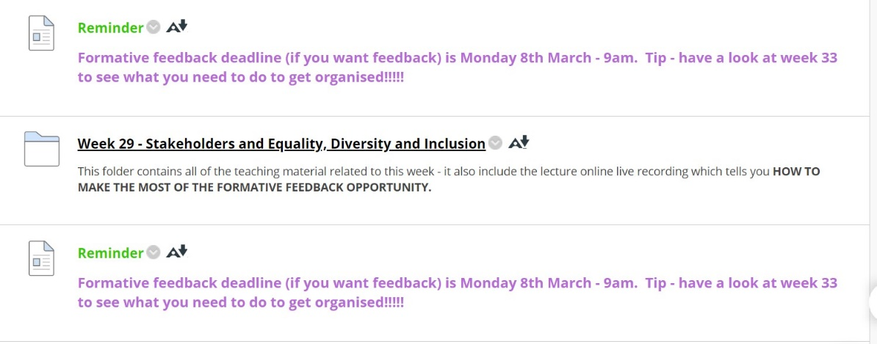
- The students were required to submit a form to a Blackboard submission point by the specified deadline.
- The form contained their blog access codes and questions related to the assessment.
- We checked in with students who had not submitted.

The Outcome / Impact
The engagement with the formative assessment increased from about 50% to 85% of the cohort due to the new formal deadline reminder and submission process. The students appreciated the fact that they were able to ask specific questions about areas of concern. Students commented that the discursive writing style of blogs is so different to the usual academic assignment submissions and this had given them confidence to know they were on the right lines in terms of both content and style. It reduced some of their anxieties about the task and reduced incremental assessment questions to the team. It also gave the students confidence to keep working on their blogs at an early stage.
Using a formal submission point it kept everything in one place, we could see at a glance who had not returned the forms and touched base with those students. The simple submission process helped both us and the students as we were able to provide feedback through the usual Blackboard processes and students knew how to readily access it.

Future Developments
This approach can be scaled up to any number of students.

Recommendations
- Put all the information in one place where students regularly access information so it cannot be missed.
- Repeat messages more than once so they cannot forget.
- Use familiar systems eg submission points.
- Ensure timing is signposted early so students know it is going to happen.
- Manage expectations by using a form – then it is clear to the students what you will and will not be offering feedback on.

Want to share your case study with the wider academic community? Send to Academic Development & Diversity and we’ll host on our Academic Essentials: Case Study page for wider publication.

