Zoom: How to download participant reports

- Sign into your Zoom account.
- Setting up your Zoom profile.
- Recommended settings for your Zoom profile.
You can also view these guidance notes via screencasts.
Participant reports provide you with a means to record who attended your teaching, learning and development sessions. To do this, click on your Zoom profile.

- Left-hand side bar you will see a list of options.
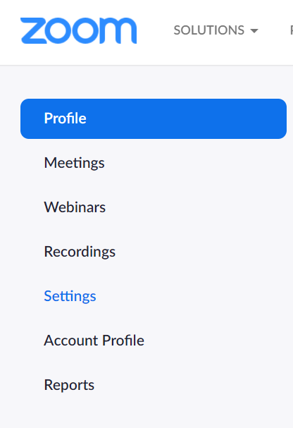
- Select Reports.
- Here you will see two menu choices.
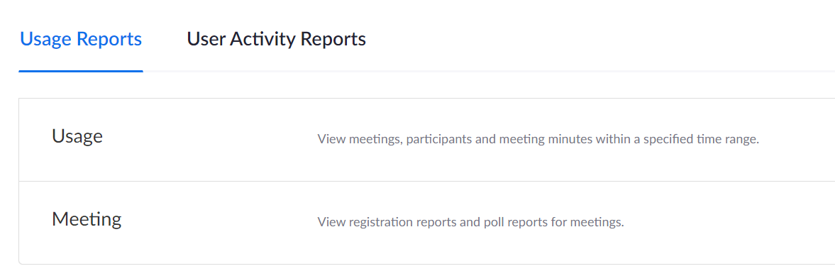
- Select ‘Usage’.
- Use the calendar function to locate the list of meetings and associated information on the relevant date/month required.
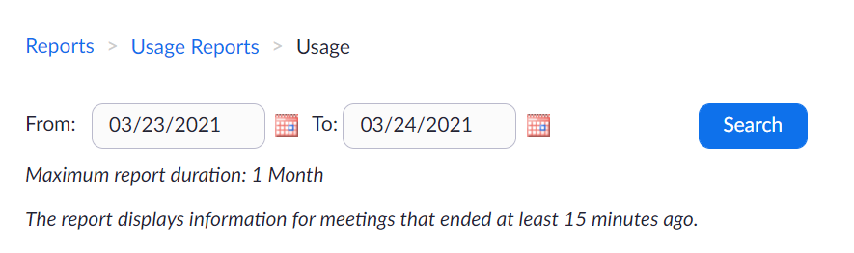
- You will be presented with a list of toggle columns.
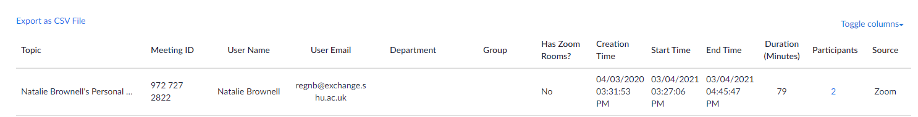
- Under the column ‘Participants’ you will see a number. This indicates how many people were engaged in that Zoom meeting.
- Click on the participant number. It will open a new view that lists the meeting participants along with their join time, leave time and how long they stayed in that meeting.
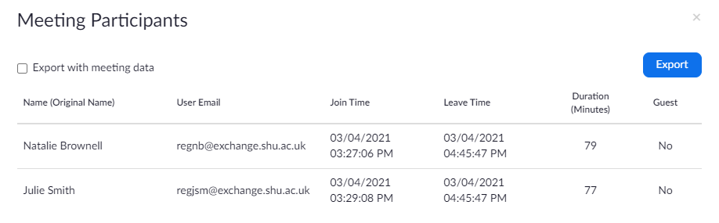
- Click the ‘export with meeting data’ box if you want all data for that meeting.
- Click the ‘export’ box to download participant data.
- At the left-hand foot of the window, you will see the excel file, ready to open.
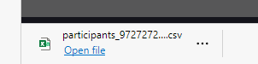
- Click ‘open file’ to download the csv file.
- Save as: under meeting name/date and format as an excel spreadsheet.
- Send your document to your colleagues/team who record learning, teaching and development sessions for statistical data input.

