Cross-disciplinary perceptions of research-informed teaching

Linking teaching, research and applied practice in higher education is a goal of many academic institutions, and there is a sector-wide expectation that academics should be both active researchers and effective teachers. Sheffield Hallam has the aim that on graduation, students should be in a position to creating knowledge, innovations and solutions that impact on people’s lives. Within the college of Health Wellbeing and the Life Sciences, by reviewing the links between research, applied practice and teaching from both the student and staff perspective, we aimed to:
- Obtain an understanding of the students' and staffs' perception of research and evidence based practice within teaching.
- Gain meaningful insights into the student experience of research and practice-informed teaching.
- Determine the importance of the research environment informing student choices to around study.

What did we do?
Online questionnaires targeted towards students and academic staff members were used to collect data around research and evidence based teaching. The research questionnaires were adapted from an original design by Healey (2005) to suit the requirements of a cross-college study and gained 418 responses. To gain a deeper understanding of the analysed data, we followed up the questionnaire with focus groups held in the departments of Nursing and Midwifery, Biosciences and Chemistry and Sport . Thematic analysis was used to identify and report on patterns within the focus group transcripts whilst maintaining the rich detail of the qualitative data.

What did we find out?
Several key themes were elicited from the surveys and focus group data.
- Research and evidence based practice are essential to students as it demonstrates that the teaching is current. All students value staff involvement in research and report that it aids in their learning. Focus group data highlights that staff being enthusiastic about research would mean they have more knowledge of the subject area and they would be passionate about what they were teaching.
Student Quote: “I think it’s important to be taught by lectures involved in research.”
Question: How important to you is it that those who teach you are involved in research or consultancy? 1 Not at all important to 5 Very important
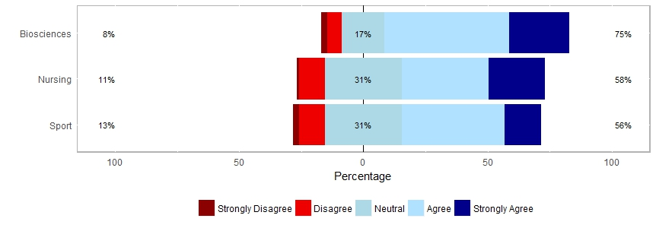
.
- Undergraduates are unaware of the research undertaken in the college before starting the course and research activity is not a strongdriver for recruitment. Many students commented that it was the course design and the interactions with staff at open days that made them apply.
Student Quote: “I didn’t know much about the academic side before I applied I looked more at the course structure.”
Question: The research undertaken in my Department/Research Centre had?
1 No influence on my decision to study at SHU to 5 a very strong influence on my decision to study at SHU.
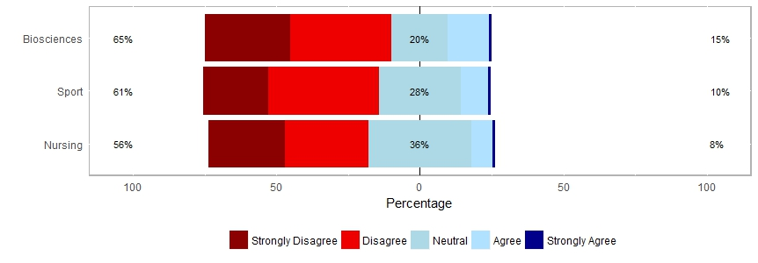
- Students felt that it was important that they were taught by lecturers involved in research. Exposure to research was felt by the students to increase understanding of the subject material. Research informed teaching was not deemed to improve problem-solving abilities in first-year cohorts however this link was seen with final year students. This is a reflection of the student experiences at the point of asking. First year students have typically experienced research in a passive manner, (in that they hear about research but do not do it). Final year students through projects and other work are more actively involved.

Question: What impact, if any, has your exposure to the research and/or consultancy in your course, Department or Research Centre had on your learning? (Check all that apply)

 | Sport | Nursing | Biosciences
Increased my understanding of the subject | 69% | 58% | 66%
Contributed to the development of my research/consultancy related skills | 44% | 53% | 39%
Improved my problem-solving abilities | 29% | 35% | 36%

- Students are aware that staff undertake research or are actively involved in discipline specific resarch and practice but do not feel a part of those communities. The vast majority said they would like to have been more involved in through their course if they had the opportunity.
Student Quote: “Through are projects I feel more involved in research I know with my project tutor what I am doing is relevant to their research so I do feel like I am helping towards something, it would be nice if we could experience that throughout the course.”
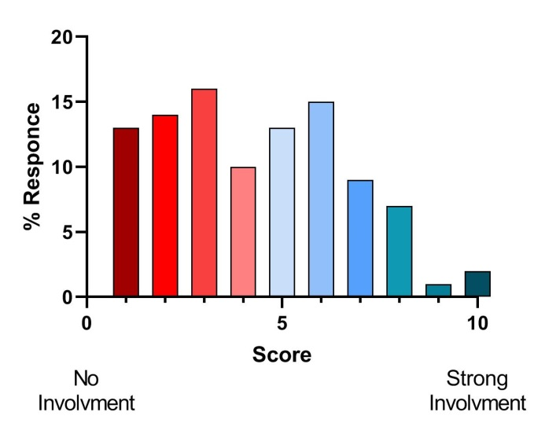

So what next?
All years expressed how they thought the teaching quality of their courses was good however they would like to have more seminars or workshops on course content linked to research and practice to feel more engaged with research. The findings in our college echo that on the broader literature; what is missing is a response. The next stage for this research is to identify how we can involve students in research at all levels and produce case studies of practice that have been shown to work.

