Presents a free online talk on Thursday 8th November at 5.30pm

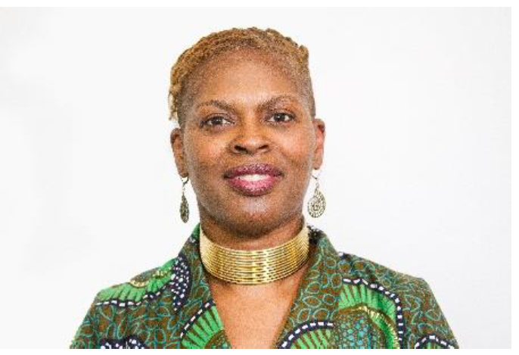
Jannett Morgan
(BA, Cert Ed., PGDipADDS, FHEA)
Director, JM Learning & Skills

Neurodiversity: why race matters

While the representation of neurodivergent students in higher education is becoming more diverse, there remains a strong association between dyslexia (for example) and being white and middle class. But talking about race is difficult, even for those of us who fight for equality. In this talk, Jannett Morgan explains the importance of an intersectional approach to neurodiversity, specifically highlighting the rarely heard experiences of students from African and Caribbean backgrounds.

Jannett Morgan Bio
Jannett is a teacher, trainer, consultant and coach with twenty years’ experience in further and higher education and more recently as a leadership and management training provider in the private sector. Jannett’s focus is on the empowerment and promotion of talented individuals from marginalised and under-represented groups. Since 1998, Jannett has supported students and employees with ‘hidden’ disabilities, mainly the neurodivergent learning differences of dyslexia and dyspraxia, working part-time as a neurodiversity tutor at several universities and as an independent consultant in the workplace. Jannett has a Postgraduate Diploma in Adult Dyslexia Diagnosis and Support. She is also a member of the Professional Association of Teachers of Students with Specific Learning Difficulties (PATOSS), a quality assured member the Association of Dyslexia Specialists in Higher Education (ADSHE) and an accredited workplace practitioner coach for the British Dyslexia Association Jannett designed and delivered the Black, Asian, Minority Ethnic and Dyslexic course on behalf of Aspire2inspire Dyslexia and regularly delivers her “Neurodiversity: why race matters” presentation for practitioners. She is currently writing a book to support people of African heritage who are also dyslexic.

Booking details will follow shortly.
For further information, please contact Beth.Sennett@Winchester.ac.uk

