Course Reps – What’s the Plan?
Overview
This document explains the current recruitment process for Course Representatives across Sheffield Hallam from the 2021-22 academic year. The key information you need is all on the first two pages; the rest of the document gives a more detailed explanation of the process if you’d like to know more.
We’ve made some changes to the Course Rep recruitment process that are aimed at standardising the process across the institution, reducing barriers to engagement, and improving monitoring of Course Rep recruitment and achievements. If you have any questions about this document, please email Ed Robinson, Representation & Democracy Manager at Sheffield Hallam Students’ Union, at edward.robinson@shu.ac.uk.

How do students become Course Reps?
Students sign up to become Reps at www.hallamstudentsunion.com/reps [Signups will be active from Welcome Week]. There, they can log in with their student credentials and complete a short form to register and be automatically added to a central list of Course Rep Signups. This process takes the student around 3-5 minutes and is explained in more detail later in this document. Students don’t need to be elected to become a Course Rep, and there is no limit to the number of students that can be Course Reps.
Then, in order to confirm their Course Rep position, they must attend one of the core Course Rep training sessions. This is a non-negotiable step that all students must take to become a Course Rep.

How do I know who’s signed up?
The Students’ Union maintains an automatically updated list of the Reps within each Academic Department. This list is accessible through the Students’ Union website – in order to do this, you must create a guest account and then email the Students’ Union at studentreps@shu.ac.uk. We will then grant you access to an up-to-date list of Course Reps in your Department which you can retrieve whenever you like by visiting www.hallamstudentsunion.com/coursereplists.
Alternatively, you can request an automatic email update. If you’d like us to set this up, please let us know which Department’s list you would like, the time and frequency of the update, how long you’d like to receive the update, and the email you’d like the update to be sent to. You will then be automatically sent a spreadsheet with the Course Rep information in your Department.

KEY POINTS & ACTIONS:
- The only way that students should become Course Reps is by signing up at www.hallamstudentsunion.com/reps. Any student can do this.

- We still think it’s crucial that Course Leaders explain to students why Course Reps are important, and why students might want to get involved – this is the best way to inspire students to take up the role! The Students’ Union undertakes generic recruitment activity via email and social media, but this is no replacement for the conversations that Course Leaders have with their students.

- Attending training is a non-negotiable part of the recruitment process. If a student is not willing to commit the time to attend training, then they are not eligible to be a Rep.

- When recruiting Course Reps, please don’t maintain a separate list – direct them to the SU website. This is better because the list is in one place and means we can say with confidence that the students have signed up of their own accord and haven’t ‘been volunteered’.

- Ensure you are familiar with how you will access Course Rep lists in your Department.

The Recruitment Process – Long version
If you’re interested in understanding more about the process, or you have any questions, read the rest of this document. It goes into a bit more detail about the process, and includes screenshots of what students see, so that you are better equipped to answer any questions that students may have.

How do students sign up?
The link for signup is always – www.hallamstudentsunion.com/reps. From there, students are encouraged to sign in and complete the Course Rep signup process. Students sign in via the University’s Single Sign-On page, meaning that, once the student has logged on, our system knows their course and year of study and can categorise them accordingly. On this signup page, students are asked to fill out a short form to confirm that they understand what the role of a Rep entails, and that they are happy to become one. As a student sign-in is required to access this page, staff aren’t able to view the form via the SU page – but you can find screenshots of the process at the end of this document, so you can see what students see.
To complete the form, students need to check three boxes – one to confirm they have read and understood what Course Reps need to do, one to confirm that they understand the time commitment, and one to confirm that they understand how their data will be used when they become a Rep (ie. name displayed on the SU website, details passed on to Course Leaders, and so on). It’s not possible for a student to become a Course Rep without ticking these boxes – this helps us to be confident that every Course Rep signup is taking on the role with a minimum level of commitment and understanding of what is expected.
When the student has read the information, checked the boxes, and completed the form, they are automatically sent a confirmation email. This email includes information about training, and some other ideas for getting started as a Course Rep. You can find the content this email at the end of the document.
Every student who signs up and completes training is a Course Rep – there is no election or other process.

While you may be used to holding elections, or another selection process, to decide who gets to be a Course Rep, we feel that this isn’t the best or fairest way of getting engaged Course Reps. Particularly on first year courses, we don’t believe that it’s possible to hold a fair election when students haven’t had the chance to get to know each other. This also makes the process more inclusive for students who may struggle to engage with an election (but would still be great Reps) and ensures that we adhere to the good practice of allowing Reps to self-select, rather than being picked by academics (academics should still recommend the role to students they think would do well in the role – but the student will still need to sign up themselves).
We’re keen to make our community of Course Reps more diverse, and selection processes are likely to exacerbate already existing gaps between different students’ experiences.

What if students sign up, but don’t engage?

It’s important to stress again that the core training is a non-negotiable part of the recruitment process. It’s often argued that a recruitment process like an election is important as it creates a hurdle that students must go through in order to prove their engagement. This is a completely valid point, but it is often the case that a student who enjoys taking part in an election isn’t actually prepared to perform the role – and may well exclude a student who would be a brilliant Rep in the process. By making the training the compulsory hurdle, we’re using engagement with the role itself as our yardstick of engagement. We think this is better and also means that unengaged students cannot take the place of engaged students.

How do I know who’s signed up?
The Students’ Union keeps automatically updated lists of Course Reps in each Department. Page 1 explains how you can access these.
Each cohort has an entry on the list that looks like this:
Organisation / Membership / Name |  | Card No | Email Address | Effective Date | Standard members | Reps | Students/Rep
Level 4 Biology |  |  |  |  | 21 | 2 | 10.50

Not categorised
 | Rep Signup
 | DENT, STU | 12345678 | stu.dent@student.shu.ac.uk | 28 Oct 2021 04:02
 | XYZ, ABC | 12345678 | stu.dent@student.shu.ac.uk | 19 Nov 2021 04:02
 | Trained Rep
 | DENT, STU | 12345678 | stu.dent@student.shu.ac.uk | 28 Oct 2021 04:02

Each student who has signed up is listed, alongside their student number, email address and signup date (the time will always be early in the morning as the database updates overnight!)
At the top of each section, the number of students (‘Standard Members’) is also listed, as well as the total number of Reps, and an indication of how many students there are per Rep signup in the group. This makes it easy to see at a glance where there are cohorts with no Reps at all, or where there are large cohorts with only one or two Reps.
Students are grouped into cohorts manually using student data – if you feel there’s a mistake in how these are set up, please email studentreps@shu.ac.uk and we will try and solve the issue.

Why are both signups and trained Reps listed?

This is because of the recruitment timeline of Course Reps – the recruitment period naturally comes before the training. Therefore, it’s sensible to monitor both signups and training attendance to track how far along the process a student is. As the role is well explained during the signup process, and there are numerous online training sessions, we are confident that the vast majority of signups will complete training and become a Rep. However, it’s possible that some students will sign up to become a Rep, and then not attend training. This cannot be avoided as it’s a voluntary role. However, knowing how many signups there are in a particular cohort is useful to plan recruitment activities pragmatically using real-time information.
For example, if there are five students in one cohort signed up to be a Rep, then there is a strong chance there will be some trained Reps, even if one or two do not ultimately engage. If there are no signups, then you will need to promote the role a bit more. You can also use the contact information to remind any signups to attend a training session if you think a student requires a ‘nudge’.

Training
There will be several training sessions booked in for Course Reps, which will be outlined in the email that every student automatically receives when they sign up to be a Course Rep.
We are planning two different sessions:
- An online, core training session that all Course Reps must attend. This session will be fairly short, and will cover the ‘non-negotiable’ content that is relevant to every Course Rep, such as gathering feedback, presenting feedback in meetings and agreeing actions, and closing the feedback loop. A student will not be formally considered a Course Rep until they have completed one of these sessions. The Students’ Union will run several of these sessions over October/November, and periodically over the rest of the year.

- An in-person, Department-specific session led by key Department contacts for Course Reps – the Department Rep, Student Experience Lead (or equivalent) and facilitated by returning Course Reps. This will be an opportunity for Reps to form working relationships with staff, their Department Rep, and experienced Course Reps, and to understand the key issues in their Department.
Course Reps automatically receive this information upon signing up – so if you’re asked about this, you can suggest the student refers to the email they received upon signing up.
Alternatively, you could direct them to the Course Rep Events page on the SU website: https://www.hallamstudentsunion.com/representation/academicinterests/training/#msltypecoursereptraining
If none of these times work for your cohort, please get in contact with the SU and we can look at booking in an additional session.

What if we can’t convince anyone to be a Rep?
We are working to make the Course Rep role as attractive as possible to students, and we think that that the role should appeal to a large portion of students. That said, being a Course Rep is a voluntary role, meaning students should want to do it – they should not be forced into the role, or signed up without their knowledge. This gives rise to the question: what if there genuinely isn’t a student on the course who wants to perform the role?
We think that having Course Reps is the most effective way of giving students a genuine say on issues relating to their studies, but it’s not the only way of doing it.
If this situation arises on your course, you might consider other ways of collectively engaging students. It’s important to ensure that your activities meet the expectations of the QAA Quality Code. If you’d like to discuss any ideas you have, please get in contact with the Students’ Union, and we can see how we can support you.

What if we have too many Reps?
As mentioned earlier, there is no selection process to become a Course Rep – every student who signs up and attends core training is a Rep. There are three criteria we demand of Course Reps:
- They are a student at Sheffield Hallam University
- They want to be a Course Rep
- They are willing to learn how to be a good Course Rep
If somebody fulfils those three criteria, then we think they shouldn’t be turned away. means that there could be a larger group of Course Reps in a given cohort than expected. If that happens, then great! Many courses struggle to get anybody at all to sign up, so you must be doing something right. The more Course Reps there are, the more likely it is that the feedback you receive is a genuine representation of all students’ opinions in the cohort. It’s also important to be pragmatic – as with any voluntary role, we can expect there to be a small drop-off from initial recruitment figures, and over-recruiting at the start helps to ensure that there are Reps throughout the year.
It’s worth stressing again that a student doesn’t count as a Course Rep until they have attended a core training session. We think this is a good benchmark for engagement – if they have attended a training session, then they are more likely to engage in general. So if twenty students sign up to become a Rep, but only three attend a training session, then you have three Reps, not twenty. The remaining 17 have only wasted their own time in signing up! Remember also that places are not limited, so a student who signs up and doesn’t engage doesn’t ‘take the place’ of an engaged student.
Having lots of engaged Reps could be a great opportunity to try some particularly meaningful work as a group. You could meet with your Course Reps all together and agree on how they might collaborate: for example, if one Rep is mature, then they might agree to focus on gathering feedback from mature students. Alternatively, tasks could be divided up, so that, say, one Course Rep designs a survey, another manages collection, and another presents their findings. If you want help with this, then the SU can help – just email studentreps@shu.ac.uk.
If you still think that you have too many Reps, and that this will have a negative impact on Student Representation on your course, then get in contact and we can try and find a solution.

Course Rep Signup Form Text
Below you can see the text for the January 2021 Course Rep Signup Form. The September 2021 Signup will have slightly different wording but will have the same key information.
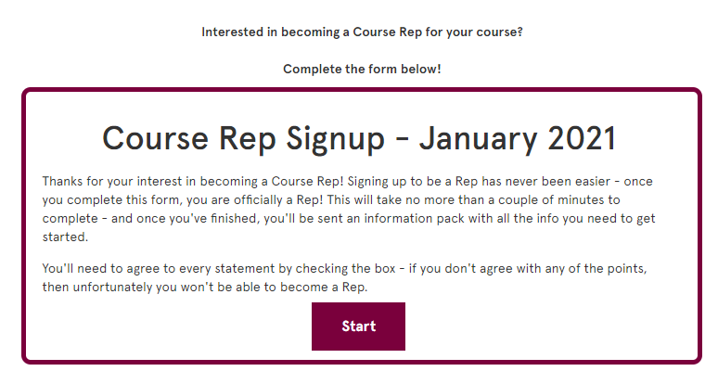

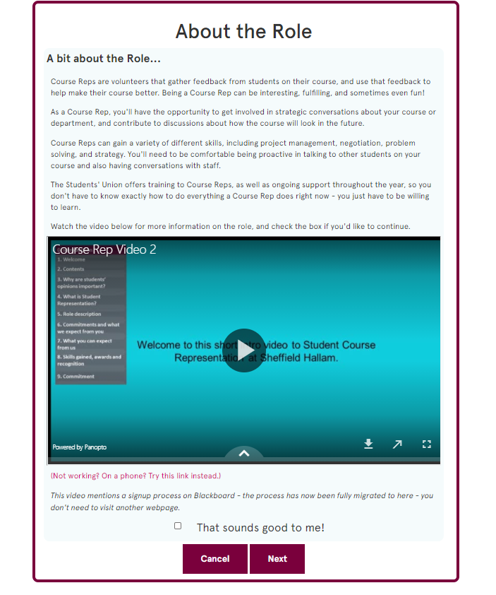
2)

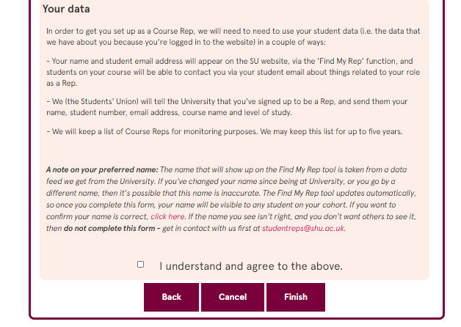
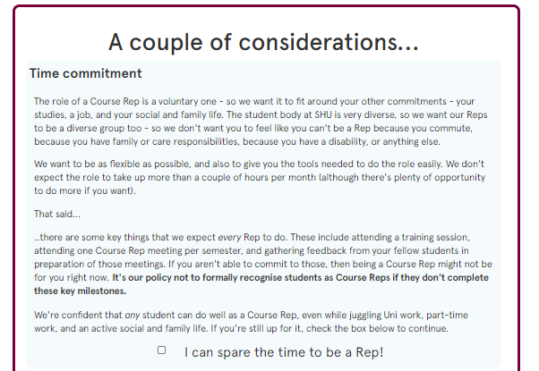

Course Rep Signup Confirmation Email
Hey!
Congratulations - you're on the way to being a Course Rep! We're really looking forward to working with you over the next year.
You'll receive more information from your Academic Department very soon - but in the meantime, here are some things you can do to get started as a Course Rep...

Sign up to a Training Session.
It's really important that you attend a training session - if you don't, then you won't be formally recognised as a Rep. This session will go over all of the key things you need to know about being a Course Rep, as well as going over some useful tips and tricks to help you get started, and some advice about avoiding common Course Rep mistakes.
You can attend any of the Core Training sessions listed on the SU website.
Click here to view the schedule - you only need to attend one session.

Read the Course Rep Handbook.
We've put together some of the important information you'll need as a Course Rep into a handy document that you can refer back to over the year if you're ever unsure about anything. We've made one for each College:
If you're in the College of Business, Technology & Engineering, click here.
If you're in the College of Health, Wellbeing & Life Sciences, click here.
If you're in the College of Social Sciences & Arts, click here.

Say hi to your Course Leader.
As a Course Rep, you will be a key contact for things relating to the student experience on your course. Building a positive working relationship with your Course Leader is an important part of that. If you've not already been in contact with them, you could send a short email to your Course Leader, letting them know that you've signed up as a Course Rep and introducing yourself. This is a great way to get the conversation started!
Due to the huge number of courses offered at Sheffield Hallam, we aren't able to tell you here who your Course Leader is, but you should already be aware of who this is. If you're unsure, get in contact with someone in your Department.
That's it for now - if you take those three small steps then you're well on your way to being an outstanding Course Rep.
If you have any questions, feel free to reply to this email and someone will get back to you as soon as possible.
Kind regards,
the Representation Team at Sheffield Hallam Students' Union.

