A Guide for Students

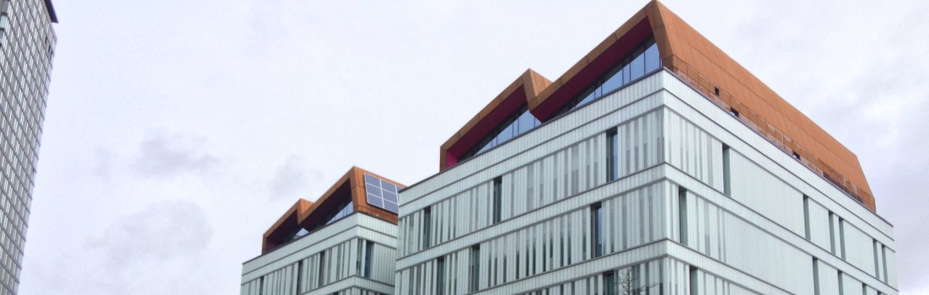

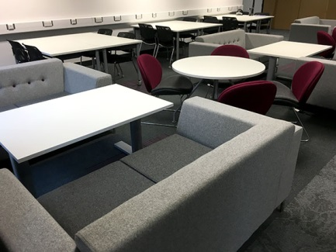


Using the Charles Street building to support and enhance your learning

Why do I need a guide?
The Charles Street building is SHU's most recent development and its design has been strongly influenced by feedback from staff and students about how they currently work and, more importantly, how they want to work in the future. As a result, there may be aspects of the building that you aren't as familiar with from your experience in other parts of the campus, and this guide will give you a brief summary of the main features of the space.

Informal and breakout areas
We frequently hear that you want more spaces to sit in groups to chat and work before, after and between your classes, as well as places to go and work quietly on your own. In response to this, a greater percentage of the floor space in Charles Street has been dedicated to these types of areas than in any of SHU's other buildings. Every floor has at least two large areas for you to work in, each with a variety of different types of furniture to help you work how you want to work. In particular, some areas have booths for individuals and pairs to work with some privacy and other areas have large booths for bigger groups.

The mobile building
Students increasingly tell us that you have mobile technology, such as smartphones, tablets and laptops, that you want to use as part of your studies. The Charles Street building has been designed from the outset to make it as easy as possible for you to use the technology that you are already familiar and comfortable with. There is high-capacity Wi-Fi throughout the building to allow you to move easily between the classrooms and breakout areas and electricity sockets are easily found in all of the informal spaces including in the sofas throughout the building. There are also lots of sockets available in the classrooms, including under the desk top in the lecture room.

The 'Turn and Learn' lecture theatre
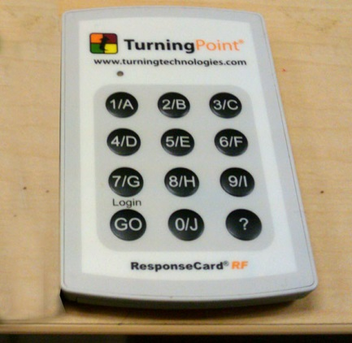

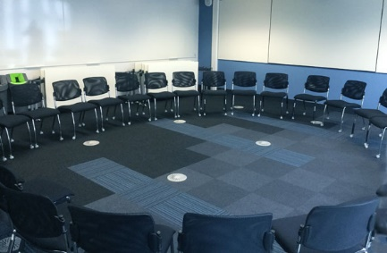

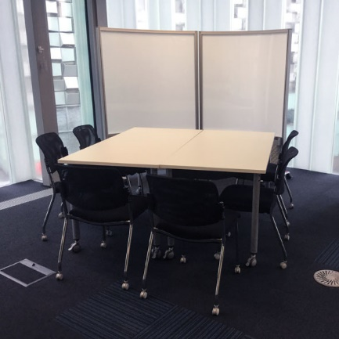
The new lecture theatre has some features not found elsewhere at SHU. The most obvious is the stadium-style screen at the front, which is clearly readable from anywhere in the room even with all of the lights on. Less obvious might be that the seats in every other row rotate, meaning that instead of just listening to your lecturer at the front you can have discussions with those around you much more easily than in other lecture theatres. The third aspect of the lecture theatre that might be new to you is the built-in voting pads that enable you to quickly respond to questions from your lecturer. All together, these changes are intended to move away from the lecture theatre being somewhere you just sit and listen and into somewhere you listen, discuss and do.

Flexible classrooms
The furniture in all classrooms is designed to be easy to move around and set up in different configurations to suit the type of activity taking place. While the default for the building is for small groups of four to six around a central table, all of the furniture is on wheels so it can be quickly repositioned. In addition, all of the chairs stack and the tables can be folded down and pushed out of the way. So if you are working in a room and think that a different room layout would be better, suggest it to your lecturer and see what they think - if they decide to try it, it won't take long to set up.

Whiteboards
All of the classrooms have plenty of whiteboards available for you to work on, and there are also movable whiteboards in some of the informal spaces that you can use to work on or to give extra privacy. Using whiteboards is a great way to come up with new ideas through brainstorming, connect existing ideas and knowledge by mind-mapping and concept-mapping, prototyping designs and processes, etc. They also encourage you to move around, which can be really useful when you have a mental block, and are much more dynamic than writing ideas on flipchart paper because you can easily rub bits out and rethink without having to start again.

Outdoor spaces
There are patio spaces available for you to use on several of the floors. These are for you to get some fresh air, chat in the sunshine, and take in the view over the city. They are not for eating and drinking on and smoking is strictly prohibited.

Produced by Ian Glover, LEAD

