Professional Services Capability Framework: Seeing the Bigger Picture

SWOT analysis: Use a SWOT analysis to explore new opportunities, manage and eliminate threats
SWOT analysis is a useful technique for understanding your business area's strengths and weaknesses, and for identifying both the opportunities open to us and the threats we face.
SWOT Analysis in your business area
A SWOT analysis can help us to uncover opportunities. By understanding the weaknesses of and challenges to your business area, you can also manage and eliminate threats that would otherwise catch you unawares. More than this, by looking at yourself a using the SWOT framework, you can start to build a strategy that helps us distinguish ourselves from our competitors.

How to Do a SWOT Analysis
Originated by Albert S. Humphrey in the 1960s, the tool can be used in two ways – as a simple icebreaker helping people get together to "kick off" strategy formulation, or as a serious strategy tool. To help you to carry out your analysis, use the following structure:

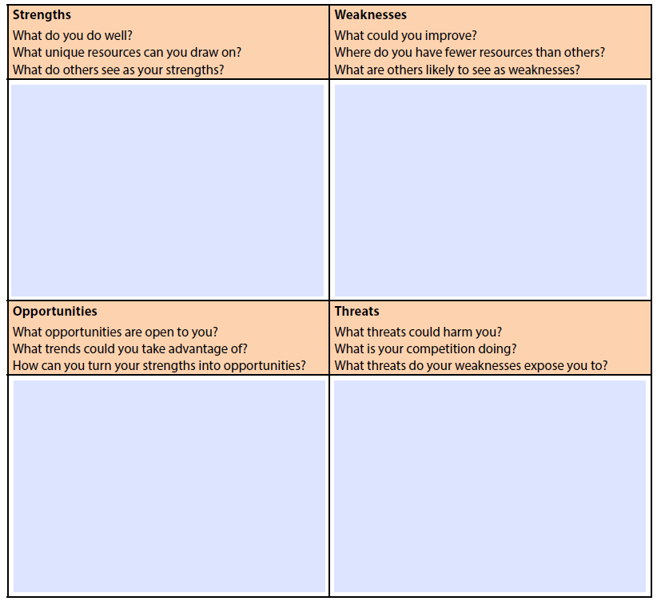

Consider some of the following questions

1. Strengths
- What advantages does your organisation have?
- What do you do better than anyone else?
- What unique or lowest-cost resources can you draw upon that others can't?
- What do people in your market see as your strengths?
- What is your team's unique selling point?
Consider your strengths from both an internal perspective, and from the point of view of our students and other customers and partners. Also, if you're having any difficulty identifying strengths, try writing down a list of the University's characteristics. Some of these will be strengths.
When looking at your strengths, think about them in relation to your competitors. For example, if all of your competitors provide high quality student services, then a high quality student service is not a strength in our market, it's a necessity.

2. Weaknesses
- What could you improve?
- What should you avoid?
- What are students likely to see as weaknesses in our services?
- What factors lose us students to other organisations?
Again, consider this from an internal and external perspective: do other people seem to perceive weaknesses that you don't see? Are your competitors doing any better than you? It's best to be realistic now, and manage future threats as soon as possible.

3. Opportunities
- What good opportunities can you spot?
- What interesting trends are you aware of?
Useful opportunities can come from such things as:
- Changes in technology and markets on both a broad and narrow scale.
- Changes in government policy related to your field.
- Changes in social patterns, population profiles, lifestyle changes, and so on.
- Local events.
A useful approach when looking at opportunities is to look at your strengths and ask yourself whether these open up any opportunities. Alternatively, look at your weaknesses and ask yourself whether you could open up opportunities by eliminating them.

Threats
- What obstacles do you face?
- What are your competitors doing?
- Are quality standards or specifications for your job, products or services changing?
- Is changing technology threatening your position?
- Do you have bad debt or cash-flow problems?
- Could any of your weaknesses seriously threaten your business?

Tip: When looking at opportunities and threats, PESTEL Analysis can help to ensure that you don't overlook external factors, such as new government regulations, or technological changes in your industry.

Conclusion
SWOT Analysis is a simple but useful framework for analysing your organisation's strengths and weaknesses, and the opportunities and threats that you face. It helps you focus on your strengths, minimize threats, and take the greatest possible advantage of opportunities available to you.
It can be used to "kick off" strategy formulation. You can also use it to get an understanding of your competitors, which can give you the insights you need to craft a coherent and successful competitive position.
When carrying out your analysis, be realistic and rigorous. Apply it at the right level, and supplement it with other option generation tools where appropriate.

