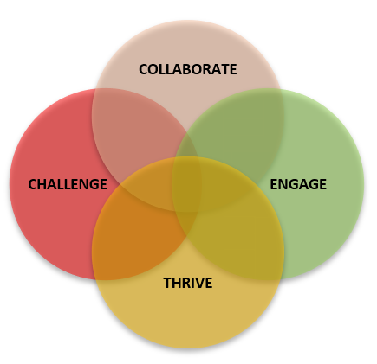The Hallam Model
Overview of the What, the Why and the How

What is the Hallam Model?
The Hallam Model sets out our collective commitment to a distinctive applied curriculum across the university at every level. From film studies to finance, midwifery to mechanical engineering, it aims to capture and showcase what is special about learning at Sheffield Hallam University, whilst also ensuring consistent high-quality in all our courses.
It is about the way we design our curriculum. It supports our academic community, subject and course teams to continuously update. It draws from innovative approaches and techniques across the university.
The Hallam Model is built around four simple and accessible principles as follows:
- Engage - Learning engages with the world beyond the University
- Challenge - Learning is intellectually stretching in applied contexts
- Collaborate - Learning with, from and alongside others
- Thrive - Learning enables students to thrive personally, culturally and professionally.
Why is this important?
Sheffield Hallam has a powerful commitment to shaping futures through intellectually challenging academic provision, embedded within a culture of support and community. We have a proud heritage of preparing students to be ready for life and work through courses which combine academic rigour and real-world engagement, alongside cross-disciplinary and diverse perspectives.
In order to realise this commitment, and to support subject and course teams on this journey, the Hallam Model offers a lens through which we can ensure that all our courses offer a consistently high-quality learning experience. It is aspirational, but realistic; conceptually clear and accessible. It empowers subject and course teams to innovate and try new approaches to teaching and learning.
How will the Hallam Model be realised?
As the project team have had conversations across campus over the past year, we know that there are already strong foundations on which to build the Hallam Model across our taught portfolio. Through this extensive consultation, the team have developed a mapping tool to help departments and course teams to apply the Hallam Model principles, and tailor to their own disciplinary context and structure.
We want to work with colleagues to capture and celebrate best practice across the university. We want to support subject and course teams to develop their own approach to the four principles. We want to embed the Hallam Model through existing quality assurance and course improvement processes across two academic cycles, with resources and support for Colleges and Departments on this journey.
We will do this through the Support and Resource group currently being established which will have membership from across the University including all three colleges.

