Social Model of Disability and what it means for us
When we first came together as the steering group for Spark! – Staff Disability Network we agreed quickly that our ethos is strongly aligned with the social model of disability. We also agreed to use the social model to guide us in how we believe SHU should be changing to ensure equal opportunity and treatment of disabled members of staff

But what is this social model that we are aligning ourselves with?
Traditionally ‘disability’ was seen as an individual problem; a deficit of the mind and/or body; something that needs to be cured by medics and other professionals. This tends to lead to disabled people being viewed as objects of pity, incapable, lacking autonomy, and a burden on society. Although it is recognised that some of these feelings/views can be internalised by disabled people I think that we would all agree that this is not the case at all, and that we can in fact contribute greatly to the University and to society, but sometimes we face barriers that non-disabled people don’t face and often don’t recognise.
These barriers are what Mike Oliver wrote about when he conceptualised the social model of disability in the 1980’s. This new way of understanding ‘disability’ turned traditional thinking on its head and shifted the ‘problem’ away from the individual who happens to have a medical condition, onto society which structures itself in such a way that does not facilitate the needs of disabled people. Essentially, society disables us not our bodies/minds.
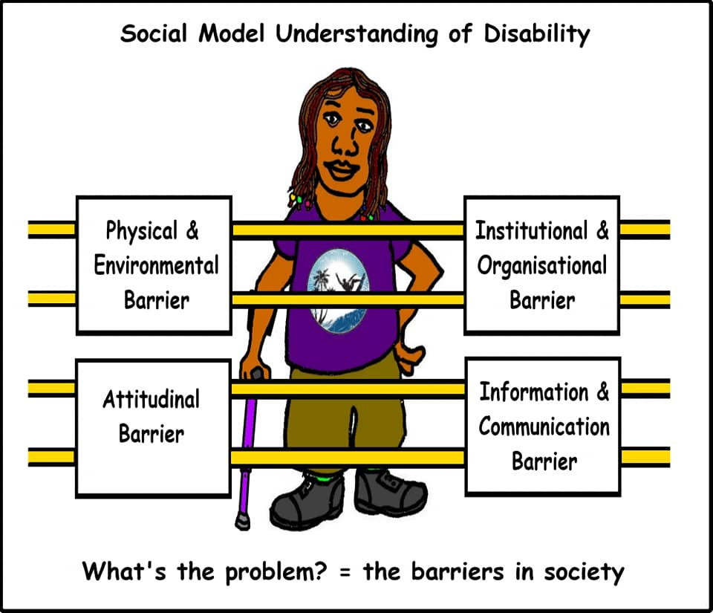
The picture above gives a lovely graphical illustration of just some of the barriers disabled people face daily. If society was constructed in such a way that buildings were all accessible (this goes beyond ramps, lifts, and accessible toilets), disabled people weren’t seen as a burden, as less productive and expensive members of society, if information was provided routinely in a variety of formats and if institutions like our own took a more flexible approach to their working policies or even assessment policies, disabled people wouldn’t be as disabled as they are.
Now I want to make clear that when I say we wouldn’t be as ‘disabled’ as we are I am not saying that by removing all these barriers our conditions will magically disappear and we will no longer experience pain, fatigue, or any of the other impairment effects that one may experience. I am talking about the stuff that we experience that has nothing to do with our condition. The experiences that we endure that put us at a disadvantage to our non-disabled peers purely because we don’t function in the ‘expected‘ way – the way in which society is structured to expect as the norm.
It is this kind of barrier deconstruction that we will aim to achieve as we help SHU truly lead the way in terms of being a ‘disability friendly’ employer. We want to push the institution not to look at ‘reasonable adjustments’ only as and when a disabled person tells a manger that there is a problem but to try to work in a flexible and accessible way for all members of staff and pre-empt as many issues as they can. As an example, with the new building works that are happening at city campus we want to ensure that consultation happens right from the start so that we can not only reinforce that the building needs ramps, easy or electric doors and accessible parking, but also that layout, colour, lighting, signage, texture, and atmosphere are all crucial elements for creating a truly inclusive environment.
We have all experienced buildings where disabled people are thought about after everything else has been completed but retro fitting doesn’t work. Equally, we shouldn’t have to rely on getting a ‘good manager’ who understands about disability and how important it is to let us work flexibly or to get the right equipment. We need to remove such attitudinal barriers and make sure that it is standard practice for managers to address potential alterations with all staff – making it the norm not the exception.
I would also quickly like to address disability terminology here. If you are a guest blogger we are not going to ‘police’ the language you use, and we understand that terminology is often deeply personal and a very complicated matter. However, posts from us as the steering group will probably utilise terms such as ‘disabled people’ instead of ‘people with disabilities. We accept and appreciate that person first language is important for some however for us, when we are talking about a person being disabled, we are not talking about a person’s medical condition. We are making a statement that they are disabled by society. If we want to refer to a person’s medical condition, we may use the word ‘condition’ or ‘impairment’. For me this separates the two issues more clearly. For example, if I say to you “I am a disabled person, and my disability is XXX” – the second part of the sentence is falling back onto old ways of thinking as I am referring to my medical condition as the disability. If I say “I am a disabled person, and my impairment/condition is XXX” there is a clear distinction.

