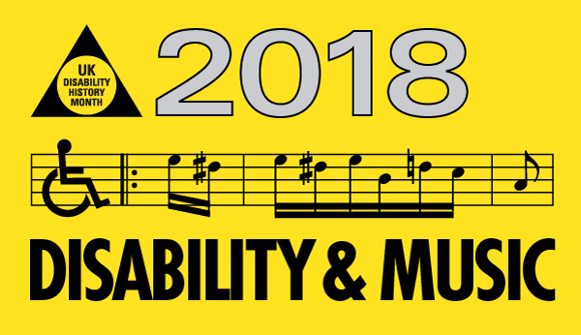
19th November to 22nd December
UKDHM 2018 will focus on Disability and Music. We want to explore the links between the experience of disablement in a world where the barriers faced by people with impairments can be overwhelming. Yet the creative impulse, urge for self expression and the need to connect to our fellow human beings often ‘trumps’ the oppression we as disabled people have faced, do face and will face in the future. Each culture and sub-culture creates identity and defines itself by its music. ‘Music is the language of the soul. To express ourselves we have to be vibrating, radiating human beings!’ Alasdair Fraser.

Born in Salford in 1952, polio survivor Alan Holdsworth goes by the stage name ‘Johnny Crescendo’. His music addresses civil rights, disability pride and social injustices, making him a crucial voice of the movement and one of the best-loved performers on the disability arts circuit. In 1990 and 1992, Alan co-organised Block Telethon, a high-profile media and community campaign which culminated in the demise of the televised fundraiser. His albums included Easy Money, Pride and Not Dead Yet, all of which celebrate disabled identity and critique disabling barriers and attitudes. He is best known for his song Choices and Rights, which became the anthem for the disabled people’s movement in Britain in the late 1980s and includes the powerful lyrics:
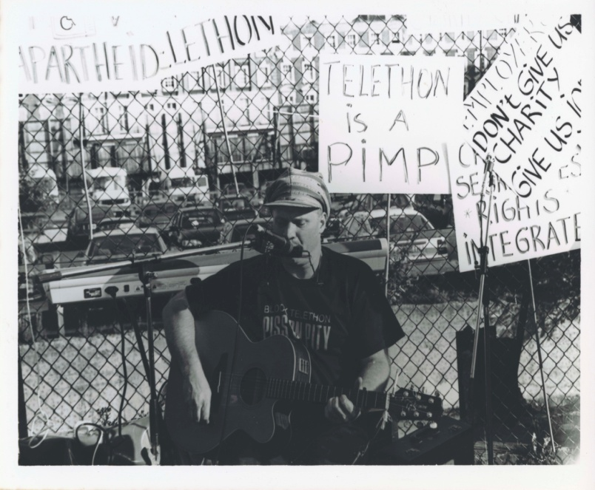
Choices and Right
That’s what we gotta fight for
Choices and rights in our lives
I don’t want your benefit
I want dignity from where I sit
I want choices and rights in our lives
I don’t want you to speak for me
I got my own autonomy
I want choices and rights in our lives
https://youtu.be/yU8344cQy5g?t=14

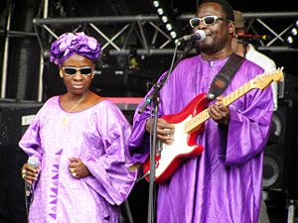
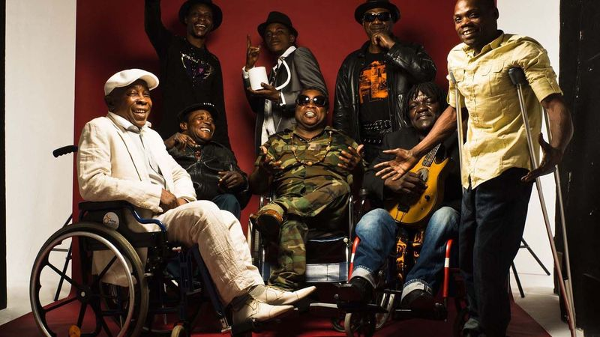
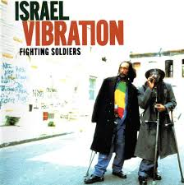
The polio virus attacked the nerves. The after affects of paralysis leading to hospitalisation, isolation, segregation and rehabilitation often involved playing an instrument. The sense you had to do better to be accepted, led to a number of polio survivors becoming professional musicians. Polio in temperate countries came in epidemics in the summer, as it was water borne. Until the late 1950s there was no effective vaccine. Musicians who contracted polio (Date in brackets is the year they caught polio):- Connie Boswell- singer, actress (USA,1910); Dinah Shore –singer, actress (USA, 1918); Brownie McGee-blues singer, guitarist (USA, 1919); Horace Parlan-jazz pianist (USA, 1931); Doc Pomus-rock and roll songwriter (USA,1931); Carl Perkins-bebop pianist (USA, 1930);CeDell Davis-blues slide guitarist (USA, 1936) Michael Flanders-music hall/radio singer (UK,1943); Ray Peterson-pop singer (USA, 1940);Walter Jackson-soul singer(USA,1940s); Judy Collins-folk singer (USA,1948); David Sanborn-jazz saxophonist (USA, 1948); Itzahak Perlman-violinist, conductor (Israel,1949;) Ian Dury-rock singer (UK,1949); Donovan-folk singer (UK,1949); Dave Liberman- jazz saxophonist (USA,1949); Neil Young-rock guitarist, singer (Canada,1951); Joni Mitchell singer, songwriter (Canada, 1951); Charlie Haden- jazz bassist (USA,1952);Steve Harley rock, pop singer (UK, 1953); Reggae group Israel Vibrations formed in the sanatorium (above right) 3 disabled members, (Jamaica,1950s-1960s); Staff Benda Belili formed as rough sleepers in Kinshasa (above left) 5 disabled members, (Congo, 1960s-1980s). In poorer and equatorial parts of the world polio was not eradicated. The 2008 Bank crisis disrupted the WHO vaccination programme so polio is still impairing people in Nigeria and Pakistan.
Amadou & Mariam

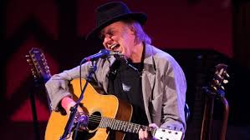
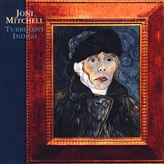
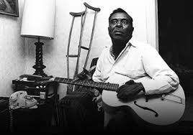
Many of these musicians had to adapt their performance. Joni Mitchell has explained her unusual guitar chord technique, hence her characteristic acoustic sound as the result of her attenuated muscularity “My left hand is somewhat clumsy because of polio, but I craved chordal movements that I couldn’t get out of standard tuning”. She drew on the blues of the past and helped shape the rock of the present by delving into jazz with 35 unique tunings. These were not seen as limitation, but a prized original sound. Carl Perkins had a crab like left hand position so his left arm was parallel to the piano. Horace Parlan developed his own style of playing using mainly his left hand. CeDell Davies (below left) had to rethink his approach “I was right handed but I couldn’t use my right hand so I turned the guitar round; I played left handed now.” He used his mother’s silver knifed handle to start with, making a unique tonal plasticity. Neil Young caught polio in Canada the same year as Joni Mitchell. The authorities placed those with the condition in isolation with chains across the door. This is reflected in his standard Helpless https://youtu.be/qOv9nwuC67Y?t=89 . Joni demonstrated solidarity with disabled people on Turbulent Indigo, showing herself as Vincent Van Gogh. She sung Helpless with Neil in the film the ‘Last Waltz’. Young also had epilepsy which he claimed contributed to his music.
“ There is a town in North Ontario.
With dream comfort memory to spare.
And in my mind I still need a place to go.
All my changes were there.
Blue. Blue windows behind the stars.
Yellow moon on the rise.
Big birds flying across the sky.
Throwing shadows on our eyes.
Helpless, helpless, helpless, helpless
Babe, can you hear me now?
The chains are locked and tied across the door
Baby, sing with me somehow.”
Neil Young “ Polio f**ked up my body a little bit. The left-hand side got a little screwed. Feels different from the right. If I close my eyes, my left side, I really don’t know where it is...”

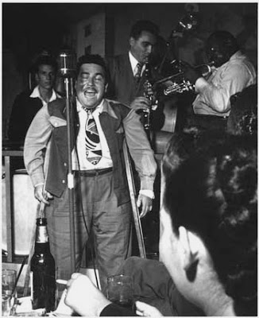
Brooklyn-born Jewish Jerome Felder reinvented himself first as a blues singer, renaming himself Doc Pomus (1925-1991), then emerged as one of the most brilliant songwriters of the early rock and roll era. His songs embody a greater emotional depth and dark pathos not heard in most of the work at the time :- Save the Last Dance for Me, This Magic Moment, A Teenager in Love, Viva Las Vegas, Lonely Avenue, Can’t Get Used to Losing You and dozens of other hits. For most of his life Doc used crutches and a wheelchair because of the polio he had as a child. He lived more during his 65 years than others could experience in several lifetimes. Now a film A.K.A. DOC POMUS brings to life Doc’s joyous, romantic, heartbreaking and extraordinarily eventful journey. Recalling his early days in the clubs of New York, “I walked slow and straight and never swung my legs fast and awkwardly like the rest of the ‘gimps’ who got around with braces and crutches. My main thing was to act and look cool - angry, and cool and sharp”.
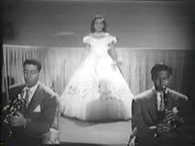
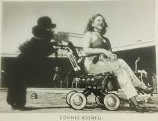
Connie Boswell (1907-76) was a white southern singer from New Orleans, first with two sisters in a close harmony trio as the Boswell Sisters in the 1930s becoming major radio stars across the US, then as a solo artist, and in an enduring set of duets with singer and film star Bing Crosby. Her deep voice, blues-inflected and sometimes scat-oriented singing style, unique arrangements and sense of vocal playfulness made her a ‘key figure … in the development of the voice as a carrier for jazz’. Boswell holds ‘a unique position as the only visibly disabled “A-list” female popular entertainer for most of the twentieth century’. Boswell was a wheelchair user as a result of contracting polio. She became a soloist coinciding with the shift from radio to film and television where her disability became more problematic. Decades later she remembered how ‘[p]roducers who knew me only from radio or recordings would call and ask me to audition for the show. I’d go over and as soon as they saw me in a wheelchair they’d freeze. It hurt. Really hurt”. “When for a time I wasn’t getting booked, I wanted to know why. I found out that the getting on and offstage was a pretty painful-looking procedure. People came to night clubs to enjoy themselves, to have fun. They wanted to get away from trouble. I could understand that well enough and that’s why I went to work to smooth out my entrances and exits... That’s how I dreamed up the skirt-covered wheelchair I use for my appearances.” This normalising of her impairment was similar to that of polio survivor President Franklin D Roosevelt, who never let the press or public know he used a wheelchair because of the stigma.
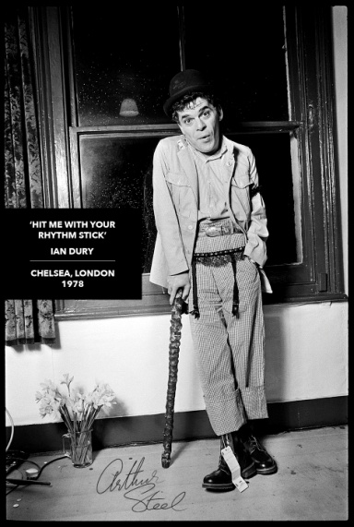
“Ian Dury (1942-2000), that 'flaw of the jungle', produced a remarkable and sustained body of work that explored issues of disability, in both personal and social contexts, institutionalisation, and to a lesser extent the pop cultural tradition of disability”, George McKay 2009. Ian contracted polio aged 7. After 6 weeks in a full plaster cast in Royal Cornwall Infirmary, Truro, he was moved to Black Notley Hospital, Braintree, Essex, where he spent a year and a half before going to Chailey Heritage Craft School, East Sussex in 1951. Chailey was also a hospital for disabled children, and believed in toughening them up, contributing to the observant and determined person Dury became. Chailey taught trades such as cobbling and printing but Dury's mother wanted him to be more academic, so his aunt Moll arranged for him to enter the Royal Grammar School, High Wycombe. He recounted being punished for misdemeanours by being made to learn long tracts of poetry until a housemaster found him sobbing and put a stop to it. Despite this he got 3 GCEs and went to Walthamstow Art College and the Royal College of Art. In 1970 he formed the band Kilburn and the High Roads. On the pub circuit he developed his music hall style and killer lyrics. In 1976 he formed the Blockheads, a punk band before punk. Ian could not hide his two legs with callipers and affected left arm, so his patter and songs projected a very cool sexy and off beat image that chimed with the times. Hits such as Sex and Drugs and Rock and Roll, Hit me with your Rhythm Stick and Reasons to be Cheerful were backed up by LPs such as New Boots and Panties, 1977 or What a Waste, 1978 https://youtu.be/beCMefqOi3w?t=29 Dury drew on his experience at Chailey to write Hey Hey Take Me Away covering the harsh life in institutions including sexual abuse and bullying. https://youtu.be/HmK8p-6Z3_A?t=2
Dury's 1981 song “Spasticus Autisticus” written to show his disdain for that year's International Year of the Disabled which he saw as patronising and counter-productive. This was one of the outstanding protest songs about the place of disabled people in what he called 'normal land'. The lyrics were uncompromising:
So place your hard-earned peanuts in my tin
And thank the Creator you're not in the state I'm in
So long have I been languished on the shelf
I must give all proceedings to myself
The song's refrain, "I'm spasticus, autisticus", was inspired by the response of the rebellious Roman gladiators in the film Spartacus, who, when instructed to identify their leader, all answered, "I am Spartacus", to protect him. Dury described the song as "a war cry" on Desert Island Discs. Although the song was at first banned from being broadcast by the BBC before 6 p.m. it was used at the opening of the London 2012 Paralympics. https://youtu.be/6isXNVdguI8?t=167
Punk A number of other disabled musicians made their way through the anti-establishment punk culture such as the ‘semi-hunchbacked’ Johnny Rotten of the Sex Pistols (both his eye and spine were permanently affected by child hood meningitis). In their album Never Mind the Bollocks (1977) is Bodies, in which Rotten tells us ‘I’m not an animal’. Bands called the Epileptics (UK) and the Cripples (USA) were briefly popular. Ian Curtis (with epilepsy) and his band Joy Division with their number She’s Lost Control was complemented by Curtis’s flailing dance style and glazed expression. Only in 1979 was Curtis diagnosed but he did not follow medical instruction as the band was taking off. By May 1980 Curtis was dead with a cocktail of drugs and depression led suicide. Robert Wyatt (born 1945) drummer from the band Soft Machine fell out of a 3rd floor window under the influence and broke his spine (1973). He has changed style as a wheelchair user and is still making music- jazz fusion and many other genre, though he had problems such as with the producer of Top of the Pops not wanting to film him in his wheelchair.

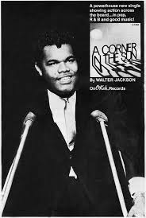
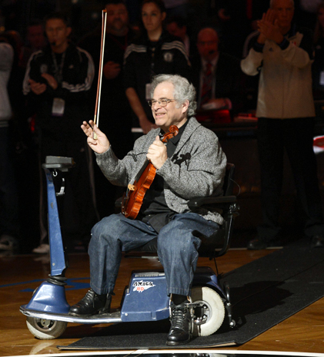
Itzhak Perlman World renowned classical violinist with 16 Grammy awards and now a biopic. https://www.itzhakthefilm.com/videos Perlman contracted polio aged 4 and has walked using leg braces and crutches since then. As of 2018, he uses crutches or an electric Amigo scooter and plays the violin while seated. “I didn’t like it when, early on in my career, the media invariably mentioned how I came on stage using crutches and played sitting down,” he confessed. “I wanted to be judged as a musician, to know if I was worthwhile as an artist. And eventually the stories stopped mentioning that. But once I was established I came full circle. I had no problem that people mentioned it. I just didn’t want the two things to be mixed up.” https://youtu.be/RYokqDoXQjU?t=59 He played the theme from Schindler’s List “Anti-Semitism is always there. Don’t ever forget. Always remember. When you see things happening, you see that nothing has changed really. I never deny who I am. I’m Jewish, I’m from Israel. That’s who I am but I don’t mind talking about it”. “When I first played in New York a journalist said did they give you a standing ovation because of the way you played or because you were sitting down? You always have to prove yourself.”
Walter Jackson
Classical Music and Disability
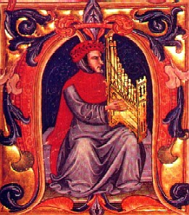
Classical Music and Disability There is a long association between blindness and music, in the classical and popular music of the West as well as in other parts of the world. Mostly blind musicians do not write music but improvise and perform, relying on others to notate. In early times blindness was associated with punishment (Oedipus or Samson) or as divine inspiration (Tiresias, Homer)-God/s compensated for lack of sight by inner vision. Francesco Landini (1325-1397) became the premier composer in Renaissance Florence and was described as ‘blind in his eyes, but illuminated in his soul’ or a ‘blind seerer’. He had become blind as a small boy following smallpox. Landini became devoted to music early in life, and mastered many instruments, including the lute, as well as the art of singing, writing poetry, and composition. He was employed as an organist at a Florentine monastery in 1361, and at the church of San Lorenzo from 1365. He was heavily involved in the political and religious controversies of his day, but remained in the good graces of the Florentine authorities. Numerous contemporary writers attest to his fame, as a composer, singer, poet, organist and philosopher. Writers noted "the sweetness of his melodies was such that hearts burst from their bosoms”. His blindness contributed to his virtuosity in his prodigious memory, improvisation on the organ and the portative organ( left). https://youtu.be/X1poFjPpa2s?t=4

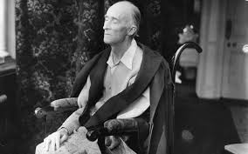
Some critics took a similar metaphysical approach to Frederick Delius (1865-1934) though others said they could find no difference in music composed before and after the onset of his blindness . In 1928, a young musician from Yorkshire, Eric Fenby, came to live in Grez with the Deliuses. Delius’s late music was made in close collaboration with Eric who enabled composition, as from 1922 Delius was blind and unable to use his hands due to syphilis. During his last years Delius completed by dictation a number of works, representing a later flowering. Songs of Farewell (1930) for double chorus and orchestra and the Idyll (salvaged from the one-act opera Margot-la-Rougeof 1902) were the largest in scale; others composed or completed with Fenby's help were A Song of Summer, Fantastic Dance, Cynara, A Late Lark, Irmelin Prelude, Caprice and Elegy for cello and small orchestra, Deux Aquarelles for strings, the 'Intermezzo' from Fennimore and Gerda, the Violin Sonata No.3 .These works have been heavily criticised as not Delius’s music or bad because of his disability. A preferred explanation is that Delius’s late music was liberated from the constraints of classical composition and benefitted from improvisation and collaboration. https://youtu.be/6DTShxT7XcM?t=43

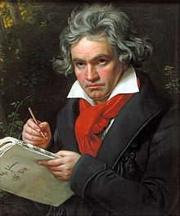
Beethoven (1770-1827) Buzzing noises started at around 1796, according to Doctor Marage, who has studied his letters. Deafness broke out in 1798 and Beethoven had lost 60% of his hearing by 1801. In 1816 he was completely deaf. Beethoven was appalled that he was losing what he relied on most, for his profession as a musical composer. He determined to continue and wrote some of the world’s most notable music as a deaf person. From 1803 to 1812, during his "middle" or "heroic" period, he composed an opera, 6 symphonies, 4 solo concerti, 5 string quartets, 6 string sonatas, 7 piano sonatas, 5 sets of piano variations, 4 overtures, 4 trios,2 sextets and 72 songs. The most famous were Symphonies No. 3-8, the Moonlight Sonata, the Kreutzer Violin Sonata and Fidelio, his only opera. With his output of superlatively complex, original and beautiful music, this period in Beethoven's life is unrivalled by any other composer in history. Beethoven revealed in a heart-wrenching letter (1801) to his friend Franz Wegeler, "I have ceased to attend any social functions, just because I find it impossible to say to people: I am deaf. If I had any other profession, I might be able to cope with my infirmity; but in my profession it is a terrible handicap." Beethoven described his despair in a long and poignant note, concealed his entire life. Dated October 6, 1802 and referred to as "The Heiligenstadt Testament," it reads in part, "O you men who think or say that I am malevolent, stubborn or misanthropic, how greatly do you wrong me. You do not know the secret cause which makes me seem that way to you and I would have ended my life — it was only my art that held me back. Ah, it seemed impossible to leave the world until I had brought forth all that I felt was within me." However, it has been argued that his music deals with the contradictions in sound or abnormality in the ‘tonal problem’. A note from outside the major scale threatens to destabilize the sense of key which takes over the piece to finally be resolved. This can be heard in Beethoven’s Eroica Symphony 3 https://youtu.be/zGEiJ44K3Oo?t=32 and Sympony No8 https://youtu.be/dV1zTM2P_LE?t=38 .

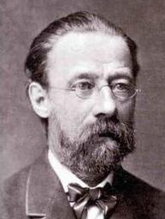
The Czech composer Smetana (1824-1884) went deaf suddenly as a result of syphilis, aged 50 at the height of his reputation. He was deeply affected, but continued to compose. String Quartet No1 draws on his experiences of deafness. “The long insistent note in the finale...is the fateful ringing in my ears of the high pitched tones which in 1874, announced the beginning of my deafness. I permitted myself this joke though it was disastrous to me”. His last published work String Quartet No 2 “depicts the turmoil of music in a person who has hearing loss” https://youtu.be/bXqq8b-Vkj0?t=6 https://youtu.be/AVOr71YBEJ4?t=271 Other classical composers with physical impairments include Gustav Holst (1874-1934), neuropathy and visual impairment, Maurice Ravel (1875-1937) speech, coordination and memory problems, Allan Pettersson (1911-1981), rheumatoid arthritis and Charles John Stanley (1712-1786), nearly blind for most of his life.

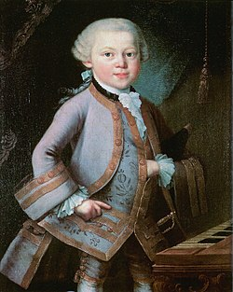
Madness and Music Attitudes and definitions have changed across history. The earliest conceptions involved possession by gods and demons. This was followed by identifying abnormalities in the person’s physiology. The medical model moved from seeing humours to categories of mental illness to psychiatric responses. In C19th madness was linked to creative genius. Today the diversity of human embodiments both physical and mental, is gradually being more accepted under the human rights rubric, madness beginning to be seen as part of the natural diversity of the human mind. Robert Schumann (1810-1856) His melancholia/depression first presented when he was 23 and continued episodically throughout his life and music. Listeners have responded in four ways to his music a) The composer is mad, therefore music is bad; b) the composer is mad, as is the music, therefore good; c) the composer is not all mad and it has had no impact on his music (the prevailing current view); d) the composer’s mental differences put him in the tradition of similar artists, his madness is ‘a dangerous gift’. This last fits more with the anti-psychiatry approach and would also include depressives Peter Tchaikovsky (1840-1893), Sergi Rachmaninoff (1873-1940), Rossini (1792-1868)-due to depression he did not compose an opera again after 1829 though he composed 32 before; Bipolar- Hector Berlioz (1803-1869), Neurodiverse - Wolfgang Amadeus Mozart (1756-1791), OCD- Anton Bruckner (1824-1896), Erik Satie (1866-1925), Arnold Schoenberg (1874-1951), Alcoholism-Modest Mussorgsky (1939-1881 ), Personality Disorder- Alexander Scriabin (1871-1915). Many of the most highly regarded composers being disabled through mental distress, lends weight to d) above.
Mozart aged 7

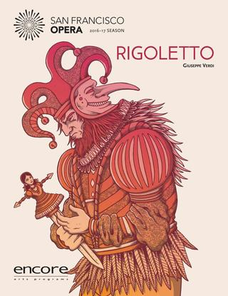
Opera Early views saw ‘disability’ as a mark of flawed character, inner evil or divine punishment as in Verdi’s opera Rigoletto (1852). Here the ‘hunchbacked’ (old word for ‘scoliosis’) court jester makes fun of himself and others to ingratiate himself with his master the Duke. He and the Duke are cursed by an old man seeking revenge for the Duke’s advances to his daughter. Through a complex plot Rigoletto’s daughter falls in love with the Duke, thinking him a poor student. Rigoletto schemes to kill the Duke but inadvertently his beautiful daughter gets killed instead confirming the ‘curse’. Verdi’s opera and its fine music such as La donna è mobile (Woman is fickle), reflect the sexist attitudes of the time. The music and opera became a popular hit.
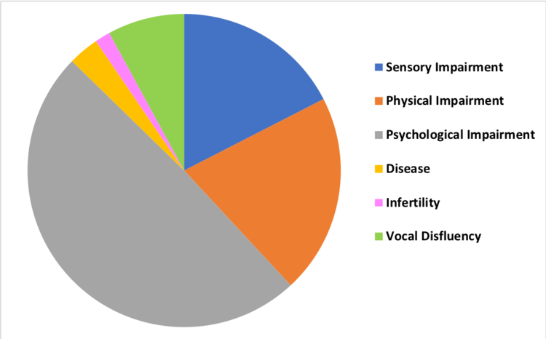
Chronic conditions such as tuberculosis, prevalent and a killer up until antibiotics in 1950s, feature as the drama in two favourite operas Verdi’s La Taviata (The fallen woman) and Puccini’s La Bohème. The inevitability of early mortality builds tension. The narratives of many operas involve disabled characters. Disability and the usual stereotypes abound. 7 Operas based on Victor Hugo’s The Hunchback of Notre Dame, Hamlet, Lear, Wagner’s Ring Cycle and Parsifal, Humperdinck’s Hazel and Gretel and many more, use disability stereotypes of the pitiful, asexual, evil, obsessive avenger, miracle cure/recovery.
Blake Howe categorised classical opera characters. Between 1700-1889, the database lists 63 representations of disability in opera. 30 (almost 48%) can be described as psychological impairments, followed by sensory. Only 13 (20%) are physical. The early C19th was the period in which the 'mad scene' developed to become an operatic staple. Think Elvira in Bellini’s Puritani (1835) and the title character in Donizetti’s Lucia di Lammermoor (1839). In the 1890-1930s the psychological is replaced by physical and visible impairment, with ‘hunchbacks’ and ‘dwarfs’ predominating. Classical Italian music notation has alla zoppa (a‘limping’style) more constrained, syncopated movement, the notes of which proceed in an irregular and awkward style. Opera and musicals rely quite heavily on stereotyped views of disabled people to develop their librettos and music.
Disability in opera (1700-1889) by type of impairment

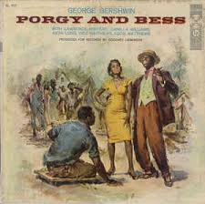
Musicals Porgy and Bess (1935) was the first modern musical/ opera to feature an entire black cast. Written by George Gershwin [1898-1937] and his brother Ira. It is set in South Carolina, the deep south of America just after the civil war. It is the story of life for the poor black communities who often lived in shanty like towns, well away from the white population. Porgy is a disabled man who lives in a shack, using a cart on wheels to get around. Bess is a fallen ‘angel’, beleaguered and oppressed by a violent low-life of a man, called Crown. When she tries to get away from him she seeks Porgy’s protection, who is respected in the community. He already loves her and as their friendship develops she comes to love him. Porgy treats her with respect which she is unused to. The community accept her but Crown seeks revenge. He cannot accept that Bess would leave him for someone he considers a useless ‘cripple’. With such standards as I love You Porgy and Summertime, the first all Black Musical to break through into the mainstream was an important show. The rock opera Tommy, 1969, composed by Pete Townshend of the ‘Who’ features Roger Daltrey a ‘deaf, dumb and blind’ boy traumatised by what he has witnessed and his eventual cure. Tommy has had many productions and a film,1975. https://youtu.be/iqXVZM9o6DU?t=161 Last year Ramps on the Moon,a disabled/non disabled drama collaboration toured their own production reclaiming this disabilist story. https://youtu.be/LIBSf5eexZE?t=79
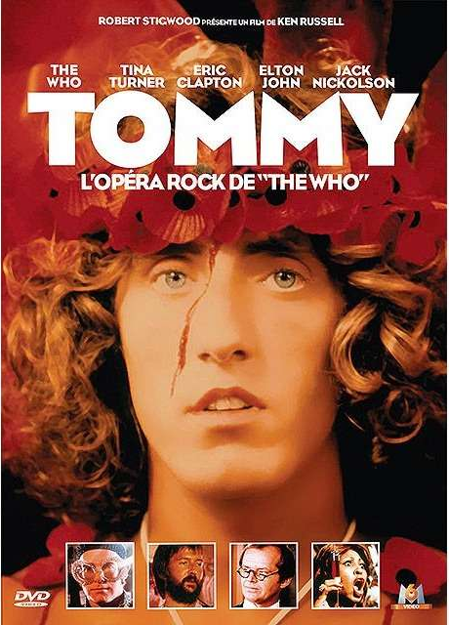
Ramps on the Moon https://youtu.be/rO_ErEi4k7k?t=131
Other popular musicals featuring disabled characters include Lloyd Webber’s Phantom of the Opera, 1986 (facial disfigurement), Jesus Christ Super Star,1971 (disabled outcasts in leper village), Mel Brooks Young Frankenstein, 2007 (hunchbacked Igor ) and Stephen Sondheim’s Into the Woods,1986,(Cinderella’s step sisters lose sight by crows attacking them).

Disabled Musicians
Playing an instrument or developing a concert singing voice is a complex, specialised form of development of body control. When disability is juxtaposed with ‘talent’ or extraordinary ability it contains the power to disrupt the socially developed and oppressive distinction between disability and ability. Examining a range of great disabled musicians should give pause for thought on such socially created prejudices. If you are a woman or black you experience even more prejudice.

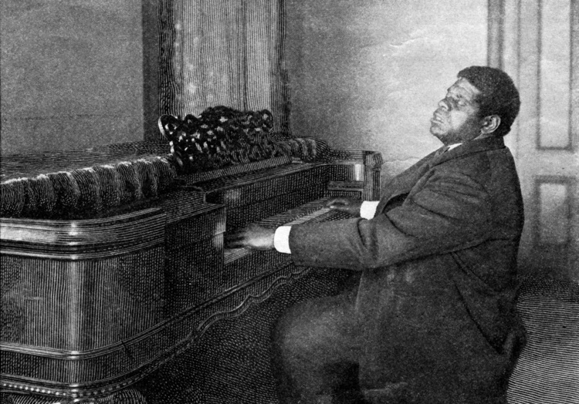
Musicians Tom Wiggins/Bethune (1849-1908) was born a slave in Georgia. Tom was blind and autistic. He grew up hearing his master’s children playing the piano. To everyone’s surprise Tom could play any tune. His master, General Bethune, took him round concerts and earned a good living. Tom travelled the world giving very popular concerts. He knew 700 tunes and composed 100 of his own. Tom was exploited by the people who controlled his life, though he was also happy. When asked how he had learned to play so well Tom said, ‘God taught me’.

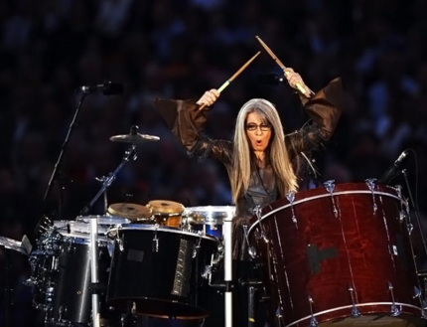
Evelyn Glennie (born 1965) is a Scottish virtuoso percussionist. She has been profoundly deaf since the age of 11. She regularly plays bare foot to feel the music better during both live performances touring the world and studio recordings. She hears the music with different parts of her body and describes thinking of different parts as different colours. When she went to the Royal College of Music she faced many barriers but prevailed. There was no such thing then as a solo percussionist. Evelyn made that a reality. https://youtu.be/YMZeBJJ5JJc?t=4 https://www.ted.com/talks/evelyn_glennie_shows_how_to_listen?language=en

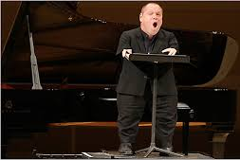
Thomas Quasthoff (born 1959) is a German bass-baritone. Quasthoff has a range of musical interests from the Baroque cantatas of Bach, to lieder and solo jazz improvisations. Born with severe birth impairments caused by thalidomide, Quasthoff is 1.34 m tall, with phocomelia. He was not accepted at the Conservatoire as he could not play piano. He had private lessons while doing a Law degree and was a TV announcer for 8 years before winning a music competition and his career took off. https://youtu.be/iJETtWr47PY?t=3

Alisa Weilerstein (born 1982) is an American classical cellist. https://youtu.be/zT5IUQynPkg?t=3 A leading classical soloist and mother, her career has been difficulties due to her hidden impairment. Coming from a musical family she was playing the cello proficiently by age 4. In 1991, aged 9, Weilerstein was diagnosed with type 1 diabetes. After she fell sick (she thought she’d done something wrong to feel so terrible) she might have worried for her future. However, she says “I was precocious in the sense that I knew what I wanted to do in my life.” Her strict diabetes management spilled over into her music. “I was forced to be so disciplined with the blood glucose control, and I think that extended to all parts of life.” Watching Weilerstein play the cello is like glimpsing a sailboat slicing through the water, effortless, the glide of her bow, fast movement of her fingers. Look closer and it’s clear: “Creating music is exercise. What I do is very physical,” Weilerstein says. “And physical exercise can often lower blood sugar.” Before performances, she remains ever aware of her blood glucose level, wearing a continuous glucose monitor .
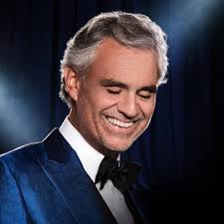
Andrea Bocelli (born 1965) is a renowned Italian opera singer, songwriter, and record producer. Bocelli has recorded 15 solo studio albums of pop and classical music, 3 greatest hits albums, and 9 complete operas, selling over 90 million records worldwide. He was born with poor eyesight and became completely blind aged 12, following a football accident. He won his first song competition, aged 14 with O sole mio, in Viareggio. He finished secondary school in 1980, then studied law at the University of Pisa. To earn money, he performed evenings in piano bars and it was there that he met his future wife Enrica in 1987. He completed law school and spent one year as a court-appointed lawyer. In 1994, he entered the main Sanremo Festival competition with Il mare calmo della sera, winning the newcomers’ section with a record score. Bocelli released his debut album of the same name 2 months later. It entered the Italian Top Ten, being certified platinum within weeks. The slow progress to success was because of the many barriers disabled performers face. https://youtu.be/hlBiL-WX2yI?t=23

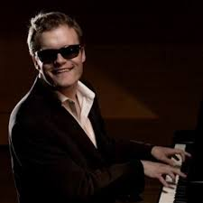
Derek Paravincini (born 1979) is blind and significantly impacted by his autism both caused by his premature birth at 25 weeks. He can play on the piano over 20,000 songs from memory. He has absolute pitch and can play any piece of music after hearing it once. He began playing the piano aged 2 when his nanny gave him an old keyboard. His inability to process language in his early years, coupled with his inability to ascribe functional meaning to everyday sounds, led to his heightened ability to process all sounds in a musical way. His parents arranged for him to attend a blind special school. On his introductory visit in the music room, he broke free from his parents heading straight for a piano, pushing the player, Adam Ockelford, aside to take over. Ockelford encouraged him, arranged lessons and still does. Derek has a blog site http://derekparavicinisblog.blogspot.com/2010/03/derek-on-cbs-60-minutes.html https://youtu.be/jsUIC68pLKg?t=129 .

Research is showing that music has particular significance for those who are Neurodiverse, particularly those on the autistic spectrum. People with dementia are stimulated and still recall music when other memory has gone. Music is valuable for the development of all, but its place in the school curriculum is being squeezed. In 2012/13, 84% of 13/14 year olds had music lessons by 2018 this was down to 47.5%. (Guardian 10.10.18)
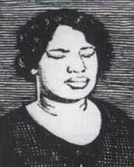
American Blind musicians have against the odds, made a significant contribution to American popular music. This is particularly true in blues, gospel, jazz, and other predominantly African American forms, because discrimination made it more difficult for black blind people to find other employment. John William Boone (1864-1927) ( "Blind Boone") was an important American pianist and composer of ragtime who was supported to get work by developing his piano skills. The first sanctified recorded gospel barrelhouse piano player, Arizona Juanita Dranes (1889-1963), was blind and she learned piano at Texas School for the Blind, https://youtu.be/MngzNKMiJHg?t=2 (right). Other blind musicians include Al Hibbler (1915-2001), Ray Charles (1930-2004) one of the most important figures in the creation of soul music, https://youtu.be/CzAkTrDiXxg?t=7 Art Tatum (1909-1956) commonly cited as the greatest jazz pianist of all time, was almost blind until his 20s then completely, https://youtu.be/fKb0Sc2lYVU?t=4 Stevie Wonder, blind from birth, recorded more than 30 U.S. top ten hits and won 22 Grammy Awards (the most ever won by a solo artist in history). “Music is a world within itself with a language we all understand with an equality of opportunity to sing, dance and clap hands”.

However, blind black musicians are still most strongly associated with the country blues Blind Lemon Jefferson (1893-1927) was the first successful male country blues performer, playing guitar, Blind Willie McTell (1898-1959) unusually had learned to read Braille and music at blind school, Blind Willie Johnson ((1897-1945), Sonny Terry ( 1911-1986) who started playing to farm horses to improve productivity after he went blind as a teenager, Blind Boy Fuller (1904-1941), Blind Blake (1896-1934), Reverend Gary Davis (1896-1972). Terry Rowden in Songs of Blind Folks (2009) analyses the Black American experience from slavery, poor sharecroppers to migrating northwards and the rise of the Civil Rights Movement. He links it to the changing position of blind black musicians.
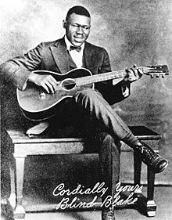
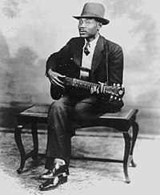
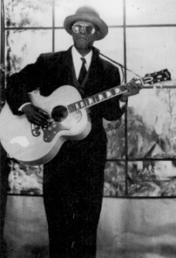
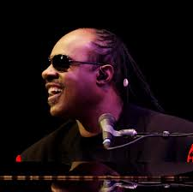
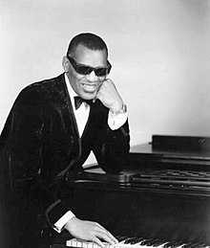
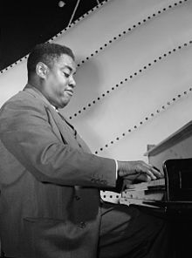
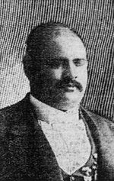
Left to Right: Blind Boone, Blind Boy Fuller, Blind Blake, Rev Gary Davis, Art Tatum, Ray Charles, Stevie Wonder
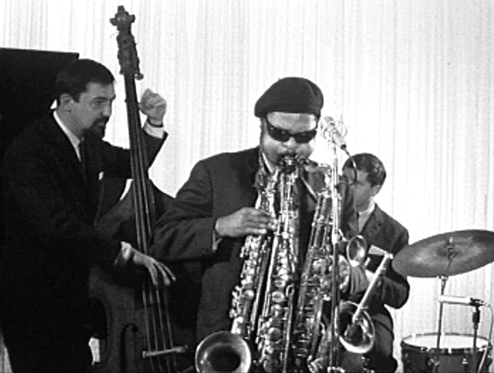
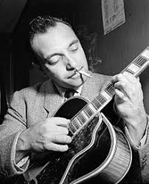
There were a wide range of disabled Jazz musicians. George Shearing (1919-2011) born blind to a working class Battersea family, learned piano at a special school, then played in pubs graduating to jazz bands. In 1947 he migrated to USA and continued a successful career. https://youtu.be/6sc7nlTucDA?t=14 Django Reinhardt (1910-1957) from a Belgian Roma background, had established himself as a formidable Jazz guitarist when in 1928 he was burned in a fire in his caravan and lost two fingers. He re-taught himself to play the guitar, perfecting an individual style. Teaming up with the jazz violinist Stephan Grappelli they formed the innovative Quintette du Hot Club de France, the first Jazz band with a lead guitar. Rahsaan Roland Kirk (1935-1977) was a blind American jazz multi-instrumentalist playing tenor saxophone, flute and many other instruments. He was renowned for his onstage virtuoso improvisation, accompanied by comic banter, political ranting, and the ability to play several instruments simultaneously. Inflated Tear (an autobiographical piece) shows his technique and variety of instrument, many made by him. (https://youtu.be/PQhTpgicdx4?t=256.

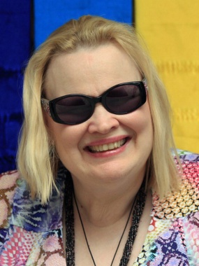
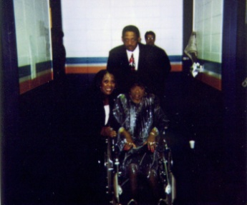
Sexism The overwhelming male dominance reflects the macho atmosphere of blues and jazz with women being written out. Blind Mamie Forehand (1895-1936) worked as a street musician in the 1920s with her musician husband. https://youtu.be/wkc23XCRCyA?t=21 Johnnie Mae Dunson was a drummer and singer, who in later years toured singing from her wheelchair. https://youtu.be/8SZjoLL-Y6s?t=2 La Vern Baker (1929-1999) was one of America’s most honoured soul singers
who had diabetes. After a double amputation in her later years she still performed from her wheelchair.
Diane ’Deedles’ Schuur (aged 65, left) is a blind jazz pianist and singer who has released 23 albums. She extended her jazz repertoire to include essences of Latin, gospel, pop and country music. Like many
La Vern Baker
musicians her career has not been without difficulties. She has had alcohol and drug problems and attempted suicide but is still performing. https://youtu.be/G8FFSIDYx8k?t=21
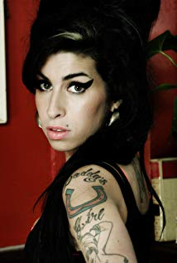
Amy Winehouse (1984-2011) Died at 27 from alcohol poisoning. She had had a history of alcohol abuse and drugs and was likely to have had bi-polar mental health issues. Going to Sylvia Young Theatre School, Amy made her own way into the Pop world which is an unsupportive industry to anyone with mental health issues. The press and fans did not see someone with difficulties, just someone living an outrageous life they could identify with. Her song Rehab is semi-biographical. https://youtu.be/KUmZp8pR1uc?t=45

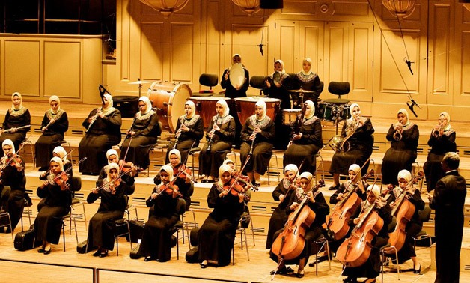
The Al-Nourwal Amal Orchestra in Cairo has only blind female musicians using Braille notation and memory to play high class western Symphony music and regularly tour the world. The Al Nour Wal Amal Association is a non-profit institution in Egypt that provides blind women with education, literacy programmes, and professional training. It is best known for its chamber orchestra. “I do not conduct them. I just help them memorise. Of course we know every composition by heart. We translate the score into Braille. Then each girl takes her part and memorises. I put sections together. On stage all I do is tell them which piece we are about to play.” Ali Osman (1958-2017), composer and conductor trained the musicians for many years. https://youtu.be/LiZGlj0JlYk?t=78

Amadou & Mariam are a musical duo from Mali, composed of the couple Amadou Bagayoko (1954) guitar and vocals, and Mariam Doumbia (1958) vocals. Their album Welcome To Mali (2008) was nominated for a Grammy Award for Best Contemporary World Music Album. They met at Mali's Institute for the Young Blind, where they both performed at the Institute’s Eclipse Orchestra, and found they shared an interest in music. In 1980 the couple married and by 1983 they began to play together while Amadou continued a successful solo career. https://youtu.be/i6uMoJOMpXc?t=18

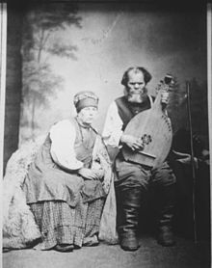
In many cultures around the world blind people have thrived with music. This is now backed by research, showing blind children's brains undergo radical changes in order to make better use of the sensory inputs they can gather. Court musician was a traditional profession for blind people in China, dating back to 200 BCE. In Japan, Heike Biwa, a form of narrative music, was invented and spread during the Kamakura period (1185–1333) by travelling musicians known as Biwa Hoshi, who were often blind. There is a strong tradition of blind minstrelsy in Ukraine known as Kobzarstvo. From 1800 to 1930 the majority of itinerant musicians in Ukraine were blind. In Ireland during the medieval and early modern eras, harpists, pipers, and other mostly blind musicians travelled around Ireland, providing music for dances and other occasions.
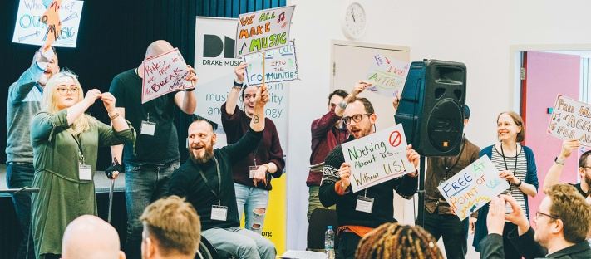
Drake Music are UK leaders in music, disability and technology. “We are innovators, educators, curators and advocates. We believe everyone has the right to express themselves creatively through music. We use new technologies and ideas to open up access to music for all. Our vision is a world where disabled and non-disabled musicians work together as equals”. http://www.drakemusic.org
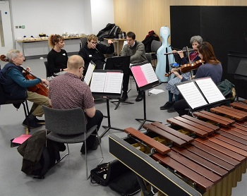
James Rose conducted Bournemouth Symphony Orchestra Resound at the Relaxed BBC Prom on 27 August 2018.They performed Alexander Campkin’s Hoping . Campkin has MS. James has cerebral palsy. “My interest in conducting was the idea of being able to influence the sound from an orchestra through movement.. The biggest barrier I faced was convincing people that I was serious.. I was met with lots of patronising smiles..In 2017, thanks to a bursary awarded by Arts Council England’s Change Makers’ fund, I began my 18 month traineeship with Bournemouth Symphony Orchestra .. A core part has been the curation of BSO Resound, the new disabled-led ensemble, which I am conducting and leading..I have been challenging the commonly held perceptions about the nature of conducting through using non-traditional methods to develop new ways of communicating with musicians. I’ve been working with Drake Music to develop my head baton since 2015. This provides me with dexterity and precision of movement. Working with BSO has turned my world upside-down. .I now work with a team who are not afraid to demand a lot from me and from the performers. In August, I made my BBC Proms debut conducting BSO Resound alongside the full Bournemouth Symphony Orchestra..I am extremely humbled to have had this debut ”. https://www.bbc.co.uk/programmes/p06klljb

Heart N Soul is an award-winning creative arts company and charity. They believe in the talents and power of people with learning disabilities, providing opportunities for people to discover, develop and share as widely as possible. www.heartnsoul.co.uk Starting in a Day Centre, 31 years ago , moving to the Albany, Heart n Soul have created productions, encouraging singers and musicians with learning difficulties such as Lizzie Emeh, https://lizzieemeh.bandcamp.com Afro punk group The Fish Police https://fishpolice.bandcamp.com and new groups such Electric Fire(above) and Too Hot For Candy.

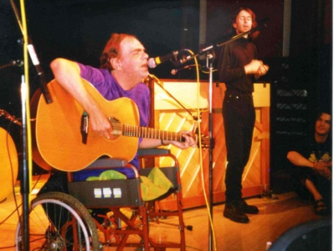
This year’s Disability History Month is being supported by National Disability Art Collection & Archive and their funders the Heritage Lottery Fund. The archive is unique because the Disability Arts Movement is not represented in any other archive in the country. Without a formal structure, the history of Disability Arts will be lost. Disabled people still experience inequality and discrimination. Disabled artists remain under-represented in the arts and cultural sector. The archive is a heritage story showing how a group of disabled people and their allies broke down social barriers. This effective arts protest movement starting in the 1970s, led to the passing of the 1995 Disability Discrimination Act. The Archive will encourage all disabled artists e.g. sharing the experiences of Johnny Crescendo (front page). In the Tragic but Brave show he worked with song writer and musician Ian Stanton. Audrey Stanton remembers her husband https://the-ndaca.org/video/audrey-stanton-remembers-her-husband-the-songwriter-activist-and-performer-ian-stanton/ Ian sadly died in 1998; his lasting memorial is his music and the final chorus of “Tragic but Brave” :
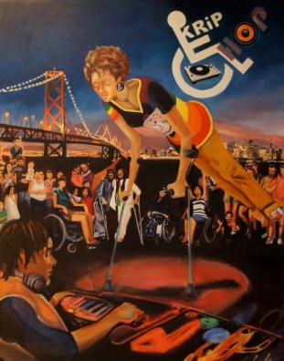
‘And she looks at the crowd on the TV News,
With their wheelchairs and sticks and their guides.
They are brandishing banners,
They are pissing on pity,
And they celebrate difference with pride.
Something stirs inside.’ https://youtu.be/2NSImzffEXA?t=29 https://youtu.be/_4r48B0x6qE?t=25

The spirit of disabled people making and enjoying music is everywhere.
Krip-Hop-Painting, New York, Carinea Lomeli
We should take heart in our struggle for equality from proms to hip hop!
P&P UKDHM 78, Mildmay Grove South, London N1 4PJ www.ukdhm.org rlrieser@gmail.com

Drawing heavily on Georg Mckay Shaking All Over : Popular Music and Disability Michigan, Ann Arbor, 2013
Stras, Laurie. 2008. ‘“Who told you that lie?” Picturing Connie Boswell.’ In Susan Shifrin, ed. Re-Framing Representations of Women:
These biographical details come from Joseph Strauss Extraordinary measures: Disability in Music, Oxford University Press, 2011
https://www.operaanddisability.com/home/disability-in-opera-the-numbers
https://petetownshend.net/musicals/tommy-musical
http://kriphopnation.com/storefront-street-corner-black-women-musicians-with-disabilities/

