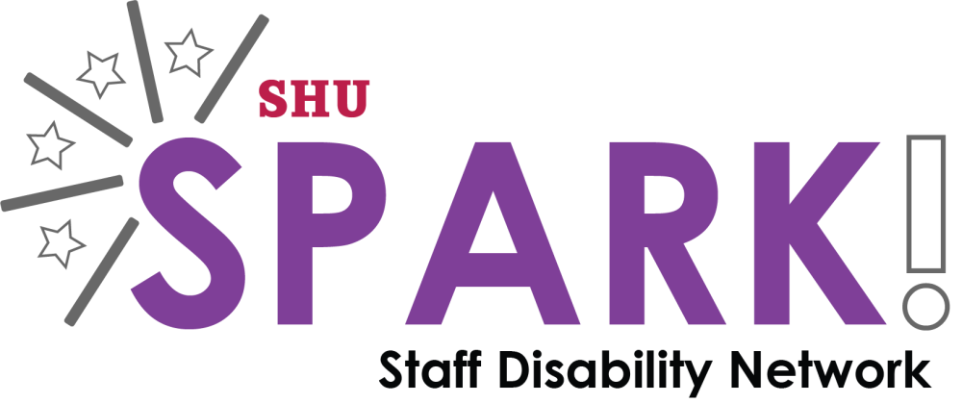
This document is produced by Spark! Staff Disability Network
It provides a framework for discussion about impacts of impairment and adjustments required for disabled members of staff at Sheffield Hallam University.
It’s aim is to support employees and line managers with filling in the employee’s Disability Passport, produced by Human Resources. Impacts and adjustments can be documented on the employee’s Disability Passport, page 8: ‘Summary of Discussions, Confirmation of Actions and Agreements’
Possible impacts of impairment/condition in the workplace

The following are broad areas that can act as starting points for discussion so you can think about the adjustments the employee may require.

Some areas may be very relevant and some may not be at all relevant. This will depend on the individual, their role, and the nature of their impairment/condition. It is also important to remember that two people with the same impairment/condition can be impacted in very different ways.

Organisation, planning and time management

Fatigue/pain

Medication

Writing/composing information

Research

Presenting/teaching

Note-taking

Multi-tasking

Concentration

Motivation

Communication/social interaction

Physical access/tasks

Sensory environment

Use of technology

Mobility/Travel

Other

Adjustments
The adjustments required will, as with the impact of impairment, vary from person to person. The following are, again, starting points for discussion but there are likely to be other adjustments that may be appropriate.
Changes to work pattern
Changes to responsibilities/allocated tasks
Support from other staff e.g. a work place mentor
Support workers provided by Access to Work
Changes to environment e.g. lighting. Contact Estates/speak to your Estates link to submit an Estates Development Request
Quiet work time in a different room
Allowed to wear headphones
Allowed own desk
Requires assistive equipment and software - may be through a Display Screen Equipment Assessment SHU Ergonomics or Access to Work
- Please be aware that there is some assistive software available on all networked SHU computers through AppsAnywhere.
- Some staff may benefit from using software called Texthelp: Read and Write – a literacy aid, and Mindview – for mindmapping.
- There is also a free version of Ginger – a grammar checker - available on the web.
Swap tasks with other staff members e.g. more reception work, less email work
Rest breaks
Able to sometimes work at home
Awareness raising of impact of impairment/condition
Other

If you have any ideas for additional information that could be added to this document please contact Spark! at diversity@shu.ac.uk

