HPO Floor Plan - Staff List

Third Floor

Room 16301 [Fashion Studio]

Room 16302 - Fashion Store
Lisa Batty
Nicole Cook
Alison Shankland

Room 16303
Nathan Jones
David Morrish
Jane Blohm
Lee Harding

Second Floor

Room 16201 [Graphic Design Studio - Level 5]

Room 16202 [Graphic Design Studio - Level 4]

Room 16203
Mel Levick Parkin
Patrick McEntaggert
John Dowling
Jonathon Wood

Room 16205
Matt Edgar
Lee Ford

Room 16206 [Graphic Design Studio - Level 6]

Room 16207 *Temporary Location for J&M until Summer 2016
Christopher Knight
Jenny Hutton
Jeff Durber
Alison Counsell

Room 16208
Frazer Hudson
Joanne Lee
Elizabeth Noble
Jenni Whitehead
Toby Lyons
Joanna Rucklidge

First Floor
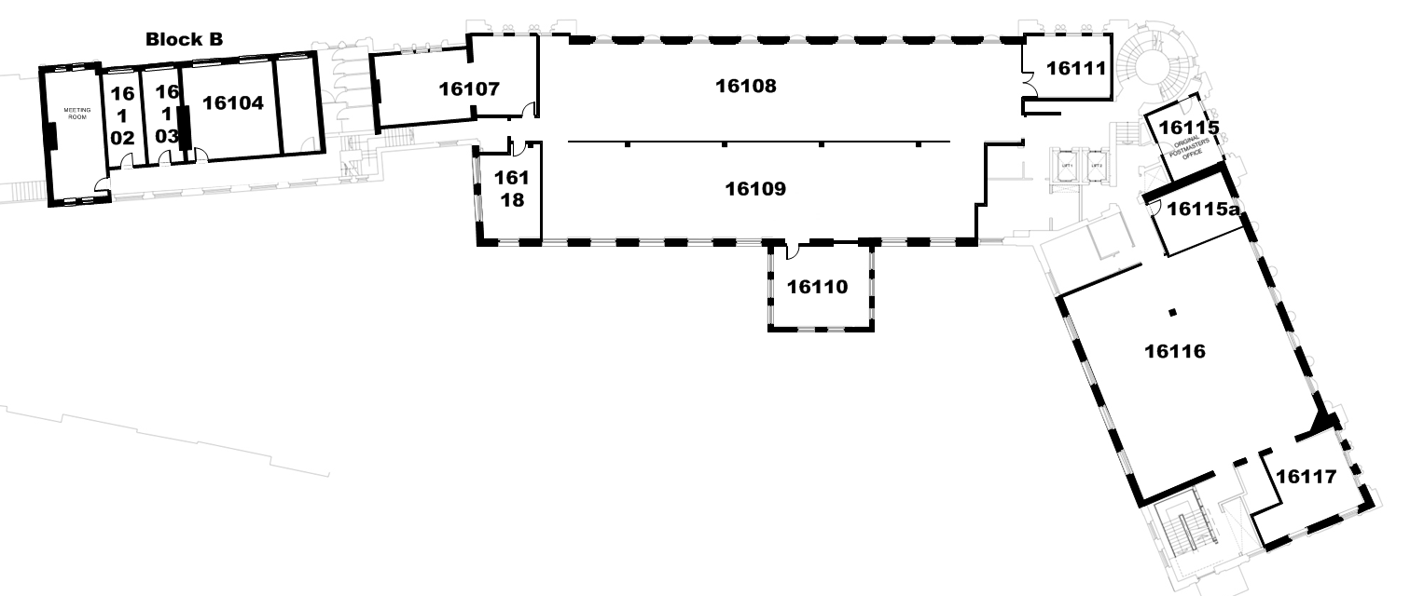

Room 16102 - Block B Available February 2016
Sally Wade

Room 16103 - Block B Available February 2016
Claire Lockwood

Room 16104 - Block B Available February 2016
Glyn Hawley
Roger Bateman
James Corazzo
Paul Heys
Gordon Young

Room 16107
Angela Burgin (replacing Susannah Turner on 4th Jan 2016)
Laura Galligan
Hilary Pye
Tim Machin

Room 16108 [Product Design Studio]

Room 16109 [Interior Design Studio]

Room 16110
Ranbir Barpagga
Steve Batty
Rachael Vallence
Eve Stirling
Sally Bilau

Room 16111
Peter Kaye
Mark Fisher
Jackie Leaver

Room 16115 *Temporary until 16102 & 16103 in Block B are available
Sally Wade
Claire Lockwood

Room 16115a
John Bairstow
Dean Stanford
Nigel Ball
Richard Evans

Room 16116 [MA Design Studio]

Room 16117 *Temporary office until Block B is available
Glyn Hawley
Roger Bateman
James Corazzo
Paul Heys
Gordon Young

Room 16118
Susan Dillon
Pam Bowman
David Swann
Mark Purcell

Ground Floor

Room 16001 - Block B FMC Studio Available February 2016

Room 16003 - Block B Available February 2016
Anthony Abebrese
Charlene Gallery

Room 16005 - Temporary Studio for J & M

Room 16007 - J & M Workshop

Room 16008 - Professional Services
Christine Billard
Sue Hall
Christy Bannister
Darren McCormack
Claire Rayner
David Culver

Room 16013 - Post Hall

Floor -1 (below Ground Floor)

Room 16-1 01 J & M Specialist Facilities

Room 16-1 02 Print Output

Room 16-1 03 Fabric Printer

Room 16-1 04 Flatbed Cutter

Room 16-1 05 Rapid Prototype

Room 16-1 06 Laser Cutting

Room 16-1 20 Photo Studio

Room 16-1 08 Workshop Area

Room 16-1 14 Framing

Room 16-1 15 Materials Store

Room 16-1 16 Technical Staff

Room 16-1 17 Ceramics / mould making

Room 16-1 18 J & M Hammer Room

