Race Equity through pedagogy conference

Sheffield Hallam University - 1st July 2019
The need to better conceptualise, confront and mitigate racism’s negative impacts is currently high on the HE agenda. An example of this is the call to ‘decolonise’ the curriculum which is gathering momentum, especially in relation to addressing the differentials in degree outcomes between students from Black, Asian and Minoritised Ethnic (BAME) backgrounds and white students. This is a persistent and systemic issue for the sector and sustained efforts to address inequalities in HE is an imperative.
Teaching anti-racism is, however, a political project. Anti-racist pedagogies require us to benefit and empower BAME students, to move beyond positioning BAME students as cultural experts or witnesses and help fostering anti-racist language. Using the curriculum to address the structures and practices of embedded racism and entrenched power relations can be challenging and generate resistance; consequently this requires us to think differently about our practices.
Against the backdrop of ongoing debates around the need to better conceptualise, confront and eradicate racism, there also is a need to provide a space for staff, students and indeed institutions to move beyond debates into action. Consequently, Sheffield Hallam University, in partnership with the University of Warwick and the Higher Education Race Action Group (HERAG), were pleased to host the Race Equity through Pedagogy Conference. Watch our conference video and reflect.
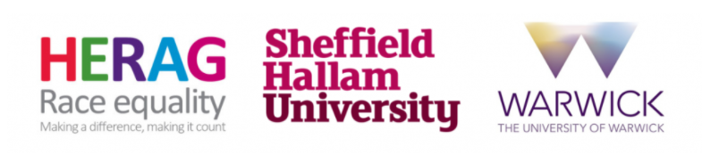

This one-day conference brought together those committed to eradicating racial inequality and inequitable outcomes in higher education through the provision of socially-just, anti-racist pedagogies. The aims of the conference were to:
- share effective practice in relation to, amongst others, anti-racist pedagogies; pedagogies for social justice and equity; pedagogies which challenge post-colonial white privilege;
- support the rejection of ‘toolkit teaching’ towards the development of reflexive, praxis-driven, pedagogies for social justice;
- help foster a community of scholars, academics, professional services staff, and students committed to enhancing racial and ethnic equality in higher education;
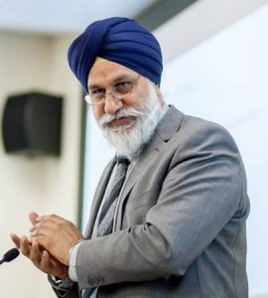
- The specific focus of the conference will be on reducing, and ultimately eradicating barriers to degree attainment and academic outcomes for students from Black, Asian and Minoritised Ethnic (BAME) backgrounds.

Key notes

Dr Gurnam Singh
Associate Professor of Social Work, Coventry University.
Dr Gurnam Singh is an Associate Professor of Social Work and Post Graduate Research Degrees Lead for the Faculty of Health and Life Sciences at Coventry University. He is also Visiting Professor of Social Work at the University of Chester and Visiting Fellow in Race and Education at the University of Arts, London. Before entering academia in 1993, he worked as a professional Social Worker in his home town of Bradford. Dr Singh completed his PhD from the University of Warwick in 2004 and in 2009 he was awarded a National Teaching Fellowship by the HEA for his work on Critical Pedagogy an Inclusion in Higher Education. More recently became a Fellow of the Royal Society of Arts (RSA). His main area of research is anti-racist theory and practice and critical pedagogy as it relates both to social work and higher education. He is seen as one of the leading thinkers on the issue of disparities in attainment in Higher Education and he has published over 50 peer review articles, book chapters and research reports and has presented over 150 papers conference papers across the world, many as invited keynote speaker. Dr Singh also has an extensive media and public profile and regularly offers commentary on policy developments. Later this year he will be publishing his 4th book which will be ‘Anti-Racist Social Work Practice: An International Perspective. Palgrave’.
Title: Intersectionality, Complexity and (BME) Student Attainment – the case for developing insurgent critical pedagogy.
Abstract: Over the past 10 years we have seen a number of local and sector wide initiatives seeking to address the challenge of race equality in Higher Education, with a specific focus on closing the ‘BME Attainment Gap’. Much of the statistical data suggests that factors beyond the control of universities, such as pre-entry educational experiences and family circumstance, have a significant impact on degree outcomes, but that is not the complete story. Indeed, though there are significant variations, there is evidence that universities are actually compounding the problem and widening the gaps! In this presentation I will argue that there are three fundamental problems with the current approach to ‘narrowing the gaps in HE’: framing the problem around a deficit modelling resulting in a perpetuation of colonial narratives of racial and cultural pathology; reducing identity to simplistic ethnic binaries, distorting the lived experience of students; failing to see the complex and dynamic nature of the production and reproduction of inequity. In this presentation I will argue that the only way we can understand and ‘solve’ the problem is if we see it as part of a complex dynamic evolving system which incorporates us all, i.e. we can’t simply treat the issue in objective terms that can be solved through neoliberal managerial logic. The presentation ends with some thoughts about developing ‘insurgent critical pedagogical strategies’ as the best way of resolving the paradox achieving equality in institutions that are historically established to promote privilege and elitism.
Dr Benjamin Blaisdell
Assistant Professor in the College of Education at East Carolina University (ECU)
Dr. Benjamin Blaisdell is an assistant professor in the College of Education at East Carolina University (ECU), where he teaches courses on diversity and the social foundations of education. His scholarship examines race and racism in education from a critical race theory (CRT) perspective and draws on critical and performance ethnography to highlight the interplay between structural racism and teacher practices. His goal is to use research as a means of engaged scholarship to promote teacher agency and racial literacy. His most recent publications specifically focus on an equity coaching—an approach to research and professional development that uses CRT analysis directly with teachers and administrators to collaboratively analyze and combat complicity in white supremacy. His work develops racial spatial analysis to examine schools as racial spaces—where white supremacy controls freedom and access but also where that oppression is hidden and normalized—and models how CRT research can be a form of insurgent practice to disrupt the racialization of school space. Dr. Blaisdell is also Treasurer of the Critical Race Studies in Education Association (CRSEA), co-chair of the College of Education Diversity Committee at ECU, and a member racial equity community groups such as the Chapel Hill-Carrboro NAACP and the Campaign for Racial Equity in Our Schools. As with his scholarship, he uses a critical, collaborative approach to working with fellow educators and community members to address issues of institutional and structural racism.
Title: Equity Coaching: A Collaborative Approach to Reenvision Racialized Educational Space
Abstract: U.S. schools and classrooms are racial spaces (Blaisdell 2016), where white supremacy—a system that perpetuates white dominance and non-white subordination on a daily basis via a wide range of cultural, economic, and political practices—affords white people greater freedom of expression and increased access to educational resources. Even in racially integrated schools, attempts to intervene in this system are often met with white discourse, a race-evasive discourse that uses a variety of rhetorical tools (e.g. appeals to discomfort) to support and legitimize white advantage. Based on 10 years of ethnographic work in integrated public schools, Dr. Blaisdell will share examples of complicity in white supremacy and of white discourse. He will also discuss how equity coaching, a collaborative approach to research and professional development rooted in critical race theory (CRT), can be used to challenge that complicity and discourse by raising schoolwide racial literacy. Equity coaching draws on CRT to uncover taken-for-granted school practices that continue to segregate students. It also centers the voices of teachers of colour in order to reframe dominant narratives (e.g. around discomfort) and disrupt the power of white discourse. Dr. Blaisdell will also discuss the implications of equity coaching for higher education settings by making connections to his experiences as co-chair of his college diversity committee and his current study of the experiences faculty of colour at predominantly white institutions (PWIs).

Programme
Take a look at the outline of our final conference programme.

