Elements Introduction
October 2018

This handout is a guide to the key things to do in Elements during the training session.
Everything you do is live and real and will be reflected in externally visible services. Please avoid creating test records or claiming identifiers or publications that aren't yours.
The publication list on your staff profile on the external website will be populated by your publications from Elements when the connection between the two systems goes live on the 3rd December 2018.

Login to Elements
- Go to: https://elements.shu.ac.uk
- Login with your usual SHU username and password

Navigating Elements - your Home page, Menu and Tasks
- Have a look at your Home page (Home tab) and at the Menu (Menu tab)
- Note that on the Home page there are tasks that you may wish to do under 'My Actions' (you don't need to do anything with all of these in this session, but they are useful reminders and shortcuts to tasks)
- There is also a 'My Summary' which is useful quick route to seeing your publications and provides links to more details about them.

View/Edit your profile
- From your 'Home' page, click on your photo or use the menus to navigate to your profile: Menu> My Account > Profile > View profile
- Click on the 'Edit profile' button. If you wish to do so, add some information to your profile - for example your Research interests or Education. Please don't spend too long on this during the training session, it can be completed later.

Check your claimed publications
- Go to your 'My Publications' from 'My Summary' on your Home page or by using the menus: Menu > Manage > Publications
- In your list of publications under the 'Mine' tab you will see publications which have already been identified as yours. These will have been found from SHURA, Academ or from external databases.

- Check that the list of publications under the 'Mine' tab are yours:
  - It may help to choose the 'Detailed view' option to see more details about each publication in the list
  - You can also click on the title of a publication to see the full publication details
  - You can reject any publications that have been incorrectly identified as yours

Adding publications and depositing manuscripts
This is the most common process you are likely to do in Elements.
However, you probably will not have anything you wish to add during the training session.
To help you after today's session, there are some instructions at the end of this handout for doing this.

Automatic claiming
- Have a look at the automatic claiming page: Menu > Manage > Publications > Automatic claiming
- Check that any identifiers already on the system for you are in fact yours. You can remove external profiles (identifiers) which are incorrectly assigned to you
- Claim any additional identifiers that you may wish to add - ORCID, Scopus ID
- If you have an ORCiD claimed, connect it to Elements (you will need to know your ORCiD username and password)
- Check your email address is correct
Check carefully that any identifiers/emails set up in automatic claiming are definitely yours. Publications linked to the identifiers will be automatically added to your Elements profile and to you profile on the SHU external web pages.

Claim and reject publications
- Go to your 'My Publications' page
- In your list of publications under the 'Pending' tab you will see publications which have been identified as possibly being yours. Elements has found these by searching external databases such as Scopus, for your name.
- Claim or reject these publications.
Check carefully before claiming publications. Claimed publications will automatically be added to your profiles.

Editing your publication search settings
You can use the search settings to make the search which adds publications to your 'Pending' list more accurate in finding publications that are yours.
- Go to your 'Search settings' using the menus:
Menu > Manage > Publications > Search settings
- Look under 'Name variants' and add any appropriate variations of your name ( you do not need to add variants with your full given names, the system works with initials only)
The accuracy of the search for your publications is improved by the addition of affiliation names in the 'Addresses' section of the search settings. This is particularly important if you have a name shared by researchers at other institutions.
- Add affiliations to your addresses section if they are not already there. A good address to include is 'Sheffield Hallam' (it works better without the 'University')
You can control which databases Elements searches for your publications:
- Look under ' Source-specific name-based search terms ' and tick / untick appropriate databases
When you have finished making changes to your settings click the SAVE button at the bottom of the page.

Use the 'Explore' options
- Have a look at the search options which are available: Menu > Explore
- Simple or advanced search
- Search for recently claimed publications for the whole university or by faculties, departments and institutes/centres
- Save and retrieve searches

Managing your claimed publications
Go to your 'My Publications' page
Click on the 'Mine' tab to see publications which have been claimed as yours. Below the details of each publication is a row of icons enabling you to do a variety of tasks. Try the functions below:
- 'Hide' icon (crossed out eye).
Hidden publications do not appear on your Elements profile or your profile on the external web pages (they can however still be found by searching Elements)
- 'Favourite' icon (heart).
Favourites appear under the Favourite publications tab on your Elements profile and will appear at the top of your list of publications on your staff profile on the external web pages

Key things to do in Elements
- Check the publications under 'Mine' are all actually yours
- Make sure your identifiers (ORCID, Scopus and Researcher IDs) are correct and add any that are missing. This will make sure that automatic claiming correctly finds your outputs
- Make sure your search settings are updated so that your 'pending' items will be as accurately identified as possible
- Respond to emails received from Elements – these will tell you about some of the actions you need to login and do (claim and reject, deposit)
- Add your new publications/outputs
- Don't forget to deposit on acceptance!

Depositing journal articles and conference papers on acceptance
Please deposit your new journal articles and conference papers as soon as they are accepted for publication.
You will need to know details of the publication you wish to deposit and have a file of the final peer reviewed manuscript saved. This is the version of the manuscript with all changes made in response to peer review but before publisher typesetting and copyediting. Knowing the acceptance date is also helpful.
In addition to making your deposit, you will need to forward the email from your journal editor notifying you that your work was accepted for publication to: elements@shu.ac.uk

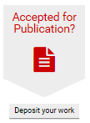
To deposit your journal article or conference paper:
- On your Elements Home page, click on the 'Accepted for publication?' button
- In the box that opens, choose whether to add a 'Conference paper' or a 'Journal article' by clicking on the appropriate button

- Elements can help you find the details of publications which you wish to add. However, when you are entering publications that have only just been accepted, it is unlikely to be able to find the details from elsewhere.
You can try searching for the title or DOI of your publication if you wish to do so.

If the search finds your article or paper you can claim it, but make sure you are certain that it is your article. Claiming it instantly adds it to your list of publications.

- If the search does not find your publication, you will need to enter the details manually. You can do this as follows:
- click on the 'Skip' link below the Title or DOI search box
- on the next screen, enter the details of the journal article or conference paper - the fields with a red star are mandatory
- you can fill in 'Additional information' if you wish to do so
- click on the 'Save' button

- Respond to the prompt to link the publication to a grant as appropriate.

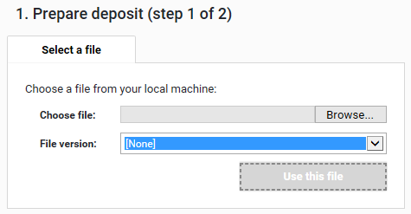
- The next step is to deposit your full text manuscript. You must do this for your publication to appear on SHURA and for your deposit to be eligible for the REF.
To select a file to deposit, click on the 'Browse' button and find your saved file.
Choose the file version 'Accepted', 'Published', 'Submitted' or 'Supporting information'.
Click on the 'Use this file' button.

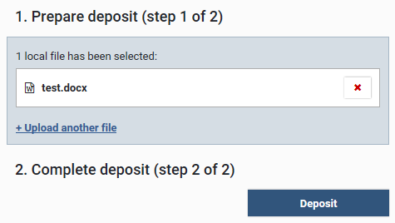
- You can 'Upload another file' if required, for example if you have a separate file of tables/figures.
- Complete the deposit by clicking on the 'Deposit' button.
You will see a page confirming the deposit status of your publication (on the 'Thank you' screen).

Depositing a new publication of any other type

The 'Add a new publication' option allows you to add the details of new publications and research outputs of any type. It also enables you to deposit a manuscript and create a SHURA record (this is strongly recommended).

- From your Home page, click on the '+ add' link in the 'My Summary' box. Alternatively, there is an 'Add a new publication' button on the 'My Publications' page.
- Choose the type of publication or output that you would like to deposit.
- Elements will prompt you to search (usually by title) for your publication or other research output.

Enter the title of your publication or output and click on the 'Search' button.
If Elements finds a matching output, click on the 'Claim' button next to it.
If Elements does not find a match, click on the 'Skip' link below the search box to go to the page where you can enter the details.
- Enter the details of the publication or output - fields with a red star are required.
- You can fill in 'Additional information' if you wish to do so.
- Click on the 'Save' button.
- Respond to the prompt to link the publication or output to a grant as appropriate.

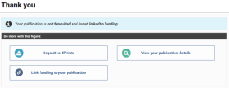
The record is now saved in Elements (you will see a Thank you screen confirming this).
If you want your publication or output to appear on SHURA, you will now need to deposit a file of the full text manuscript or other appropriate file (PDF of a poster, image of artefact, a film, etc.).

- Click on the 'Deposit to SHURA' button on the 'Thank you' screen.
- To select a file to deposit, click on the 'Browse' button and find the file where it is saved on your drives. Then click on the 'Use this file' button. You can Upload another file if appropriate.
- Complete the deposit by clicking on the 'Deposit' button.

Depositing a manuscript for an existing Elements record

You may have publications in your publications list in Elements that do not have the manuscript deposited in SHURA. You can deposit the manuscript as follows:

- View the full details of the publication

- Scroll to the section called 'Full text'
For publications with no SHURA record, you will see a 'Deposit' button.

For publications where there is a record on SHURA you will see a 'View' button.

Click on whichever of these buttons is available and you will see the page where you can deposit the manuscript for that publication.

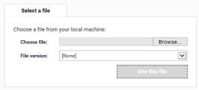
- To select a file to deposit, click on the 'Browse' button and find the file where it is saved on your drives. Then click on the 'Use this file' button
- You can Upload another file if required (for example if you have a separate file of tables/figures)
- Complete the deposit by clicking on the 'Deposit' button.

Feedback about the training session and about this handout are very welcome.

If you have any questions about Elements or if you need help, please contact the Library Research Support Team
- Email: elements@shu.ac.uk
- Call: (0114) 225 3852
- Elements help pages: http://bit.ly/elementsSHU

