How to Login to TurningPoint on a PC
Launch TurningPoint
- The first time you launch TurningPoint you will need to change the region.  select  Europe/Africa/Middle East/Russia  and Click connect | 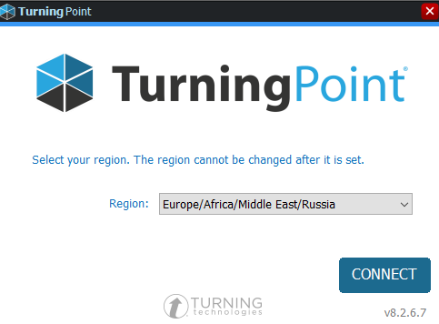
- A sign in box will now appear click sign in | 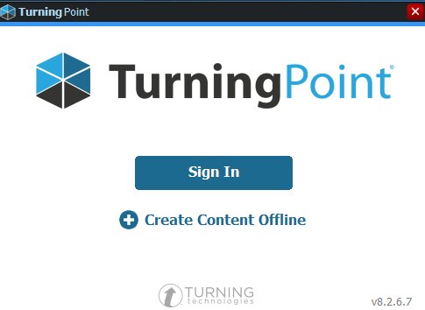
- Sign in using your SHU email and the password you created for your TurningPoint account (separate to your normal SHU password) | 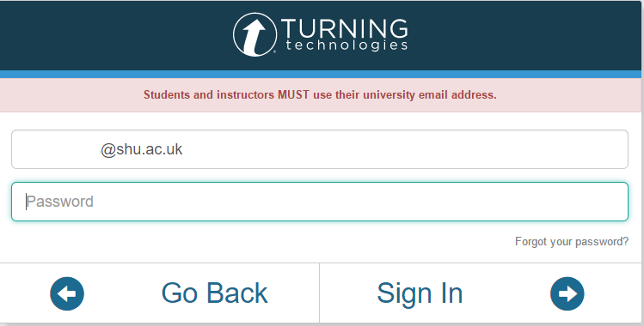
4 You will now see the appearance of the Turning Point software has been updated however the layout and functionality is the same

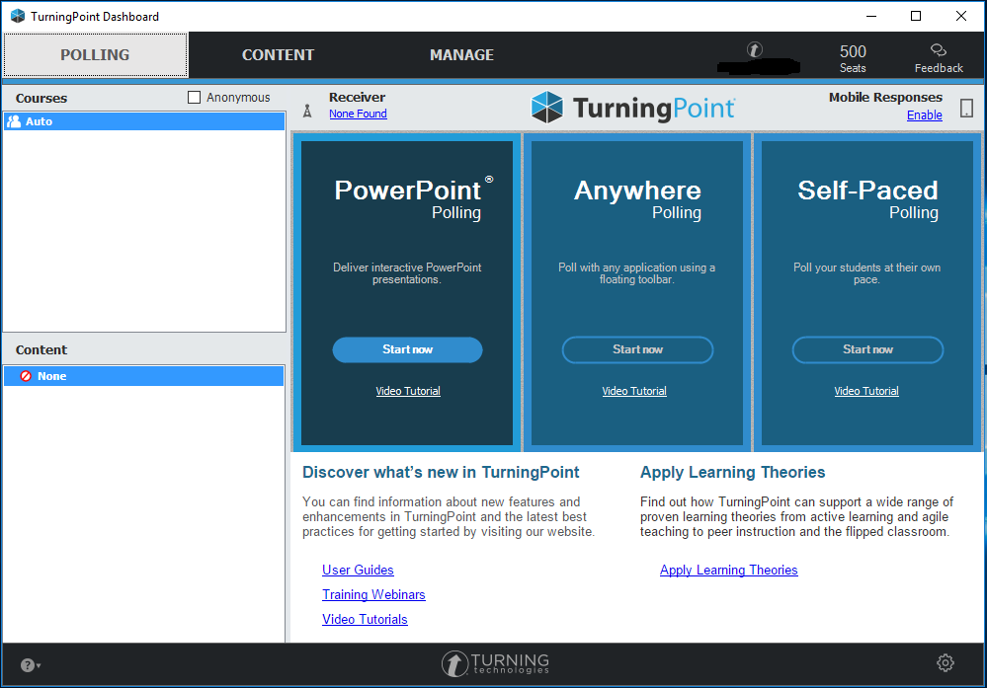

Checking PowerPoint Content Created in TurningPoint Version 5
The animated charts used in our current version of TurningPoint Version 5 will not function in the new version. This is because some of the charts used Flash to create the charts and the new version of TurningPoint no longer supports Flash content. The charts which will need to be changed are:-
- 3D column - animated chart
- 2D column - animated chart
- 3D pie - animated chart
- 2D pie - animated chart
- 3D doughnut - animated chart
- 2D doughnut - animated chart
- 2D bar - animated chart
These charts will need to be changed to ensure they appear and do not cause your PowerPoint presentation to crash.

Testing Your Previous TurningPoint PowerPoint presentations

You can test to see if your PowerPoint presentation will work OK before using it live in class and without having clickers or respondents by using the “Simulated Polling” setting, which generates 30 random responses to your questions.
1 Log into TurningPoint
Select PowerPoint Polling and click start now and open the existing Presentation you wish to check.
2 Click on the TurningPoint Tab in PowerPoint
3 In the polling section on the ribbon from Click the dropdown arrow from live to Simulated polling

4 You can now run through and test your presentation TurningPoint questions are working as expected.

5 Once you have finished you can remove the simulated responses by going to the session section and clicking on Reset option for session.
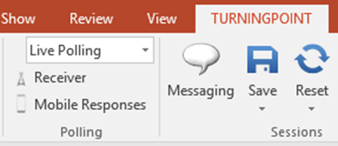

Please Note
This will ensure any responses will not be carried over when using the presentation in class and will not affect any other content in the presentation.

How to Change TurningPoint Chart Types

If you have checked your presentation and found charts which are not working correctly, you can change the chart to another type following the steps below:-
1 Log into TurningPoint
Select PowerPoint Polling and click start now and open the existing Presentation you wish to change the chart for
2 Click on the TurningPoint Tab in PowerPoint
3 Select Objects menu and charts and change to a different chart type.
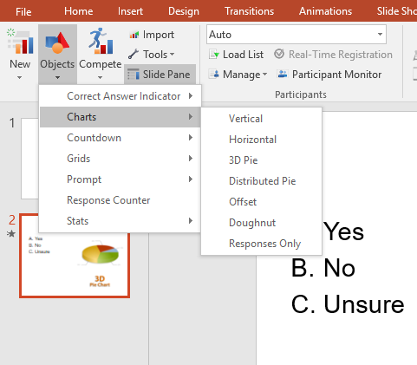
4 Once you have changed and saved the presentation we advise you test it again using simulated polling to ensure it is working correctly before using in class.

