How to check and change your server on the TurningPoint desktop application

- LAUNCH TURNINGPOINT ON YOUR DESKTOP WORKSTATION

- IN THE UPPER RIGHT OF THE MAIN WINDOW, CLICK ON “CLICK TO CONNECT” UNDER RESPONSEWARE | 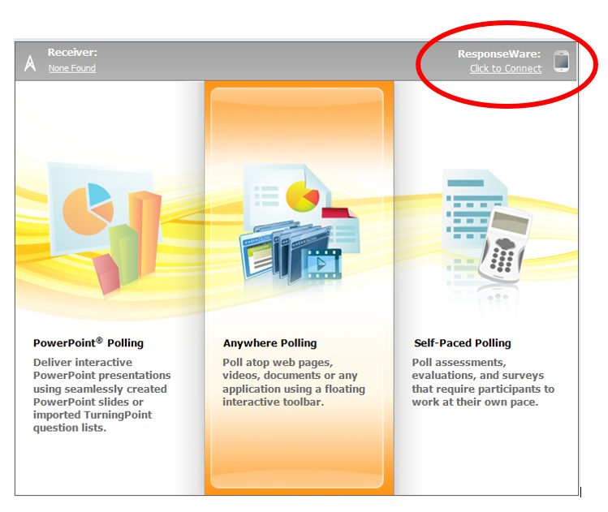
- FOR THE FIRST OPTION “SERVER URL”, YOU SHOULD SEE THE EU SERVER:

https://responseware.turningtechnologies.eu/responseware/

IF YOU SEE THE US SERVER ADDRESS (PICTURED RIGHT), YOU MUST CHANGE IT

- TYPE YOUR RESPONSEWARE USERNAME (EMAIL) AND PASSWORD

- CHOOSE YOUR PARTICIPANT OPTIONS

- CLICK LOGIN

