How to change the server on the “TurningPoint” / “ResponseWare” mobile app

THE MOBILE APP USED TO BE CALLED “RESPONSEWARE”, BUT HAS NOW BEEN REBRANDED TO “TURNINGPOINT”. DEPENDING ON WHICH VERSION YOU HAVE, THE NAME MAY BE DIFFERENT, BUT THE INSTRUCTIONS ARE THE SAME

- OPEN THE “RESPONSEWARE”/”TURNINGPOINT” APP ON YOUR DEVICE
- ACCESS THE SETTINGS MENU | 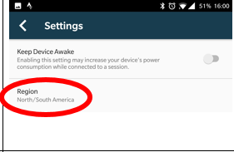
- CHOOSE THE EUROPEAN REGION SERVER | 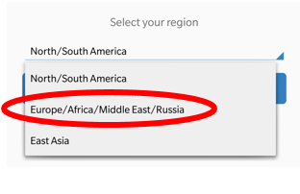
 | 