HOW TO UNINSTALL RESPONSEWARE APP ON APPLE |  | HOW TO INSTALL TURNINGPOINT ON APPLE
- FIND THE RESPONSEWARE APP AND LIGHTLY TOUCH THE APP ICON UNTIL IT JIGGLES. |  | - GO TO THE APP STORE. SEARCH APPS FOR TURNING POINT AND INSTALL BY PRESSING 'GET' | 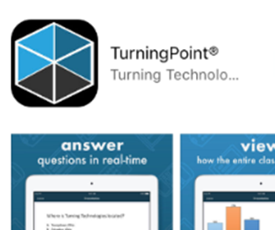
- TAP X IN THE UPPER-LEFT CORNER OF THE APP. |  | - OPEN THE APP AND SELECT YOUR REGION EUROPE/AFRICA/MIDDLE EAST/RUSSIA | 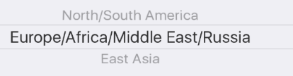
- A BOX LIKE THE ONE OPPOSITE WILL APPEAR. TAP DELETE TO REMOVE THE APP. | 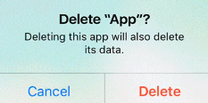 | - SIGN IN USING YOUR SHU EMAIL ADDRESS AND PASSWORD FOR YOUR TURNINGPOINT ACCOUNT | 