HOW TO UNINSTALL RESPONSEWARE APP ON ANDROID |  | HOW TO INSTALL TURNINGPOINT ON ANDROID
- GO TO THE PLAY STORE |  | - GO TO THE PLAY STORE  SEARCH APPS FOR TURNINGPOINT AND INSTALL | 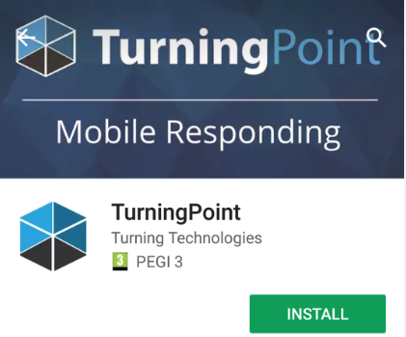
- GO TO THE MENU AND SELECT MY APPS & GAMES | 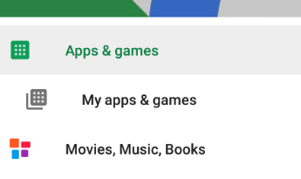 | - OPEN THE APP AND SELECT YOUR REGION EUROPE/AFRICA/MIDDLE EAST/RUSSIA | 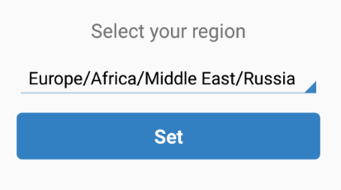
- GO TO INSTALLED APPLICATIONS. SCROLL DOWN THE LIST OF APPLICATIONS AND FIND RESPONSEWARE |  | - SIGN IN USING YOUR SHU EMAIL ADDRESS AND PASSWORD FOR YOUR TURNINGPOINT ACCOUNT | 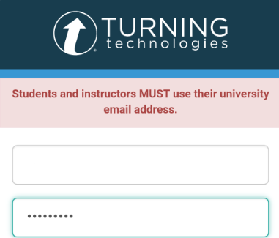
- CLICK ON RESPONSEWARE AND UNINSTALL THE APP

