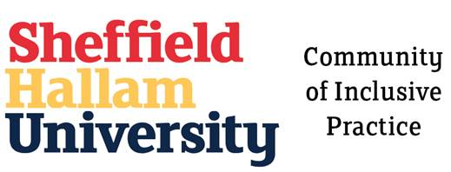

Community of Inclusive Practice
Hallam Guild - Themed Week - 24th June - 28th June 2019

Inclusive Group work
Helen Kay and Marissa Hill
This workshop allowed delegates an opportunity to discuss some of the challenges of group work and an exploration of ideas for to support access and participation to enhance a sense of belonging and community. Here are some of the discussion points and suggested next steps:
Group Teaching and Learning
Helen Kay has created a resource called group teaching and learning, which provides information, guidance and resources for both staff and students at Hallam. We'd love to have your feedback on the existing content and ideas to develop new content and share best practice.
We are currently working on a project to join up all group work content across all teaching and assessment essentials sites - for more details please contact teachingessentials@shu.ac.uk
The Skills Centre
Nick Russell
Have a range of generic group work resources which can provide a start to understanding and delivering group work activities for both students and staff
Next steps - add to and share existing resources under Teaching and Assessment Essentials
Learning Contracts
Liz Escadale
Are currently undertaking a project to review how Learning Contracts are created for the individual student and to links to a wide range of guidance and information for both students and staff. They are expecting to roll-out the new style Learning Contracts wef September 2019.

Next steps - add to and share existing resources under Teaching and Assessment Essentials

Communicate to staff networks:
  - Course Leaders
  - Module Leaders
  - Student Administration support staff

Using Technology to facilitate group work
The Assistive Technology Service which includes AppsAnywhere and Mindview
Google Apps - facility to share 1 document for group contributions
Socretive App which includes Interactive analytic skills
Trello Boards
Blackboard - take a look at the TEL Help site for group work guidance

ACTIVITY - thoughts on group work?

The delegates discussed the positive and negative aspects to group work and assessment and gave some ideas on how to integrate into teaching and learning:

Challenges | Ideas and suggestions
Handling difficult conversations  Challenging assumptions from the students | Writing inclusive group work guidelines  Being made available on Blackboard beforehand
English as a second language  Understanding regional dialects | Supporting peer mentors in group work
How to support deaf students in group work:  Consider anxiety and wellbeing issues | Small group activities in formative assessment (not summative)
Expectations of behaviour based on:  Different cultures  Age group dynamics  Structure of social groups | Teaching and Learning  Active learning approach  Peer learning - ideas and conversations
Making assumptions | Feeding back facilitation
How to engage students at different levels  More at L4 then phase out by L6?  Isolated groups | Setting expectations early as possible!  Timelines  Group work and assessment  Learning Engagement  Students in the decision making process  Split up 'cliques' in the module group  Learning Spaces - consider classroom set up and environment
Course Design:  Setting expectations in course and module leaders and tutor groups  Adaptations for group work  Planning  Normalising group work strategies  Conversations across all module teams | Skills - areas of:  Employability  Raising standards and aspirations  Scale-up  Social practices in a group environment  Providing strategies for the students  Transferable skills
Understanding the needs of the group
Normalising the language used
Developing 'contracts of behaviour' for students
Linked to student induction

