Supporting students with disabilities and other protected characteristics to access work experience and placements
The Equality Act 2010 sets out the responsibilities of HE institutions in relation to students with protected characteristics*. This document sets out how the Student and Graduate Employability Service can support students with protected characteristics access work experience and placements, and some points for course teams and departments to consider.
Provision for students with protected characteristics
- Employability Advisers are trained in professional interviewing skills and are experienced in supporting students with protected characteristics and a variety of additional needs. Students can be supported with decision-making and transition into work experience, placement, employment or further education.
- Identification of potential barriers and personal strengths can be facilitated via guidance interviews. This can help students form an action plan to achieve work experience and or placement.
- Employability Advisers can help students identify positive and inclusive employers, and access specialised openings for people with protected characteristics.

Students can book appointments via UniHub, at Careers Connect or Heart of the Campus, or 225 3752

On-line information

The Employability Service's website Careers Connect (formerly Careers Central) provides specialist information (: https://careersconnect.shu.ac.uk/students-and-graduates/equality-and-diversity

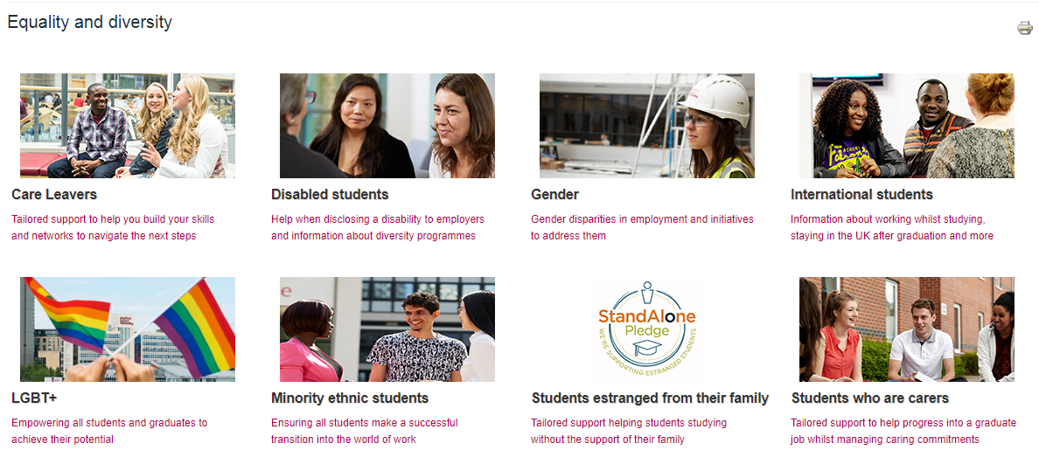

Student-support triangle

- Agreed referral processes between the Academic Adviser, Students Adviser and Employability Adviser could help to give a co-ordinated approach to meeting possible complex needs.

Course teams

- A PDP tool (e.g. Pebble pad) from L4 to L6 to facilitate documenting experiences, advice, reflection and career planning is likely to be of benefit to all students, but especially those with additional needs.
- Some students may benefit from work experience 'in-house' or supported environments. This expressed need should come from the student's self- assessment, and not be 'presumed' by a member of staff.

Karen Allan, Employability Adviser, Lead for Equality and Diversity Priorities

*Protected characteristics:
Age, disability, gender reassignment, race, religion or belief, sex, sexual orientation, marriage and civil partnership, pregnancy and maternity

