Airway / CPR

Adult Tracheostomy Manikin | 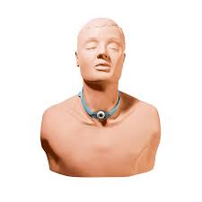
Techniques which can practised include suctioning, proper cuff inflation, dressing changes and cleansing and maintenance of the tracheal site

 | 3 x Available

Adult Airway Management Trainer | 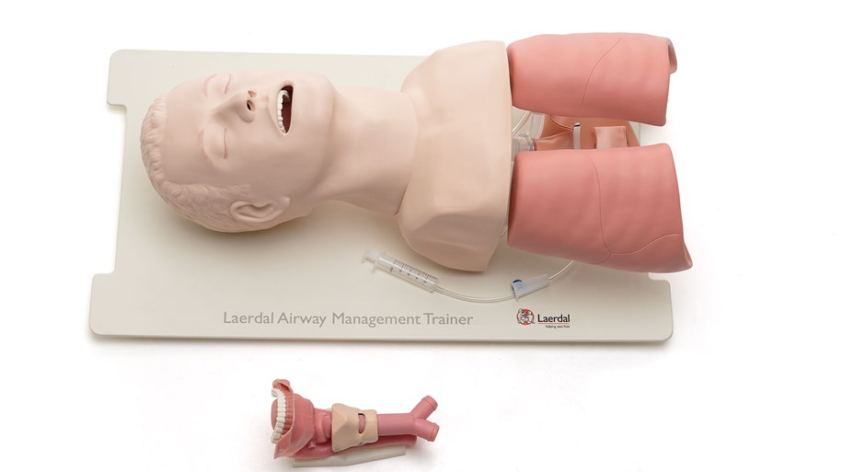
This simulates an adult airway, and the lifelike upper torso and head can be used to practice intubation, ventilation and suction techniques

10 x Available
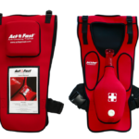
Adult
Anti-Choking Vests

This vest is worn by students in CPR class to learn the Abdominal Thrust Manoeuvre and when performed correctly, a foam plug shoots into the air, this trainer also has a foam Back Slap Pad for practising choking rescue protocols

 | 18 x Available

Child Airway Management Trainer | 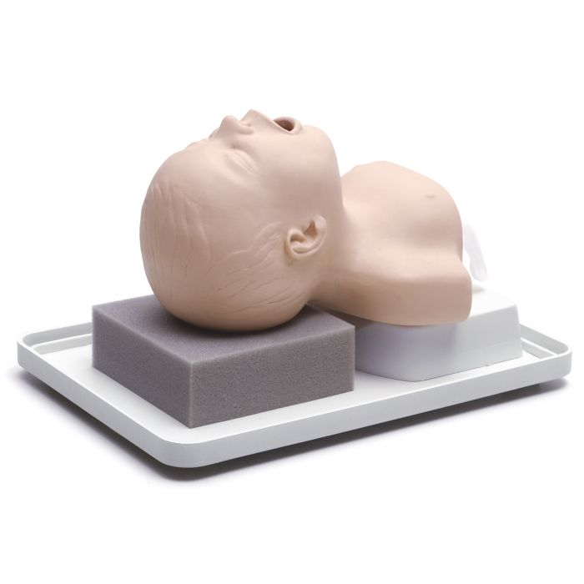
With realistic anatomy and head positioning, it allows practice on intubation, clearing an obstructed airway and suctioning

 | 2 x Available

Child Tracheostomy Manikin | 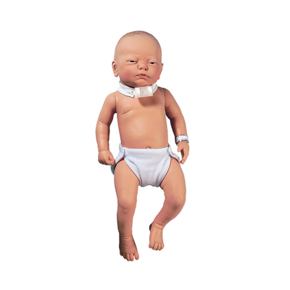
Perfect for practising basic tracheostomy care skills on children such as suctioning, cuff inflation, dressing changes and cleansing of the tracheal site

 | 1 x Available

BLS Baby | 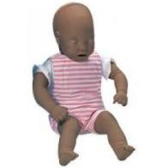
This baby is designed for skills training in neo-natal resuscitation with realistic anatomical landmarks simulating a full-term female new-born

 | 12 x Available
Child Anti-Choking Rescue Trainer | 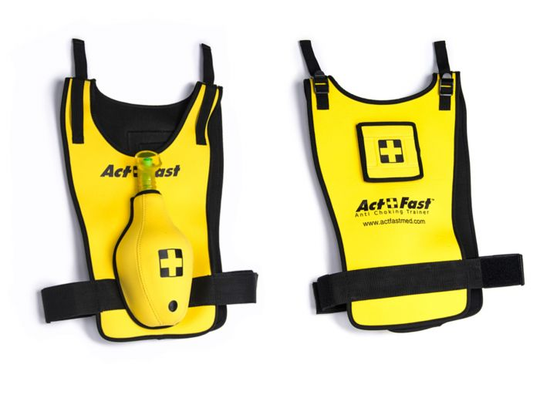
These child vests can be used to practice the Abdominal Thrust Manoeuvre, if performed correctly, a foam plug shoots into the air. It also includes a foam ‘back slap’ for practising choking rescue protocols

 | 3 x Available

Resusci Baby QCPR | 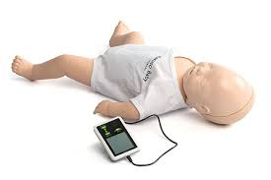
This baby has realistic chest stiffness, censored touch and a skills reporter app for CPR feedback, it gives the learner a new level of precision training for treating babies in cardiac arrest

 | 6 x Available

Little Junior QCPR | 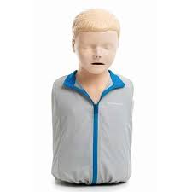
This gives real time feedback on compressions and ventilations, details on compression release, depth and rate, ventilation volume and number of compressions, ventilations and cycles

 | 12 x Available

Little Anne QCPR | 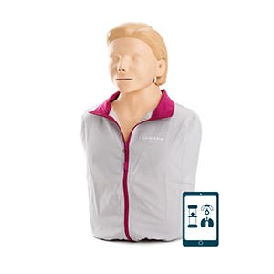
This gives real time feedback on compressions and ventilations, details on compression release, depth and rate, ventilation volume and number of compressions, ventilations and cycles

 | 30 x Available

Breathing

Lung Sound Auscultation Trainer | 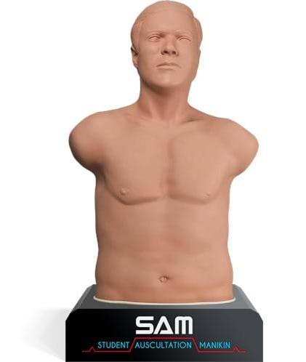
This manikin has listening points at the correct anatomical locations and allows users to use their own stethoscope to identify an extensive range of lifelike heart, breath, and bruit sounds.
It also allows a palpitation of a thrill and includes ECG waveform, case videos, ECGs and a real library of sounds

 | 2 x Available

Pneumothorax Trainer | 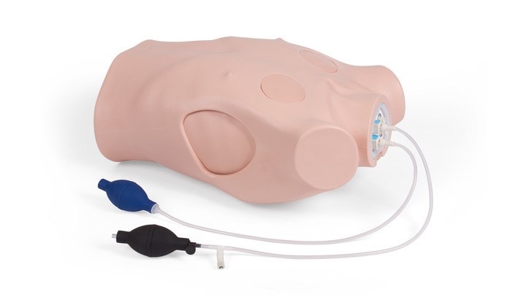
This trainer has bilateral tension pneumothoraxes and decompression portals in each axilla and subclavian region, it has anatomical landmarks and sites available for decompression

7 x Available

Cricothyrotomy Simulator | 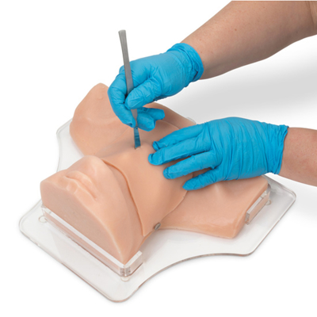
This trainer is ideal for learners to practice the techniques necessary to perform needle or surgical cricothyrotomy procedures

6 x Available

Cricoid Pressure Trainer | 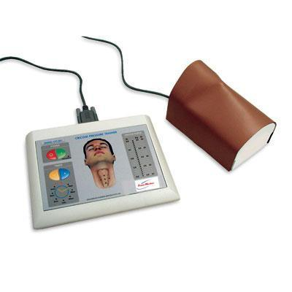
This has a realistic throat region with landmarks such as the thyroid, cricoid cartilages and trachea, it provides real time graphical feedback to the user

3 x Available

Catheterisation
Male & Female Task Trainer | 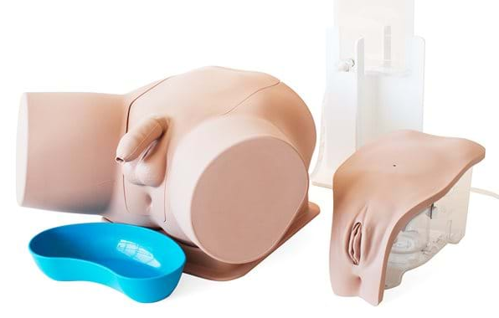
These male & female catheterisation trainers have a single pelvic shell which is compatible with both the female and female units. It allows the users to learn urinary and suprapubic catheterisation techniques

 | 8 x Available

Male & Female Catheter Models | 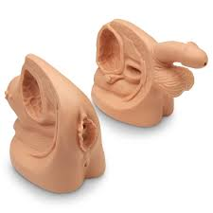
These realistic catheterisation models can be used to practice the proper insertion of a lubricated catheter and for teaching anatomy and sterile cleansing techniques before, during and after insertion

 | 4 of each available
Circulation
Injection, Venepuncture, Cannulation & Infusion Arm | 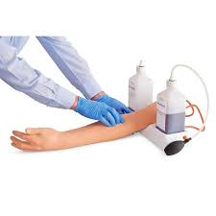
This realistic arm trainer features a flexible wrist and pronounced veins in the antecubital fossa region of the forearm and on the back of the hand. It can be used for administering IV injections and infusions.

Practice in setting up and monitoring infusions including application of dressings to secure a cannula in place and withdrawal of blood using a syringe or vacutainer

 | 10 x Available

Venepuncture Arm | 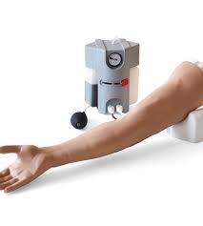
This advanced arm utilises a pressurised pump and unique locking system to accurately simulate venepuncture training

 | 6 x Available

Blood Pressure Arm | 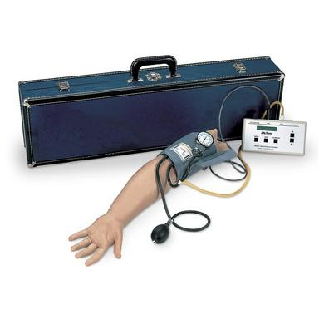
This blood pressure simulator is ideal for teaching physical assessment, it helps resolve the uncertainties common in teaching students to take blood pressure readings. It has a palpable radial pulse, and you can select systolic and diastolic settings
 | 8 x Available
Intraosseous Paediatric Trainer |  | 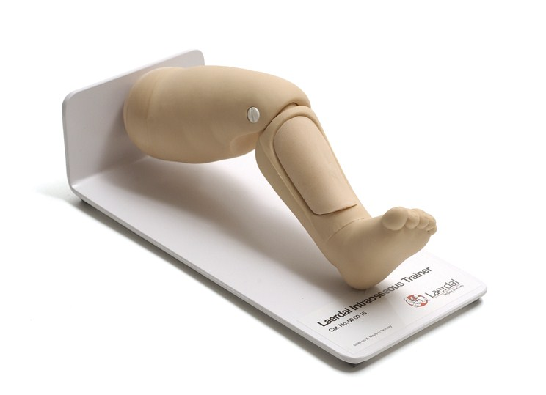
This Intraosseous trainer is designed for training in infant infusion techniques by intraosseous needle insertion with aspiration of simulated bone marrow

 |  | 10 x Available

Three Vein Venepuncture Pad | 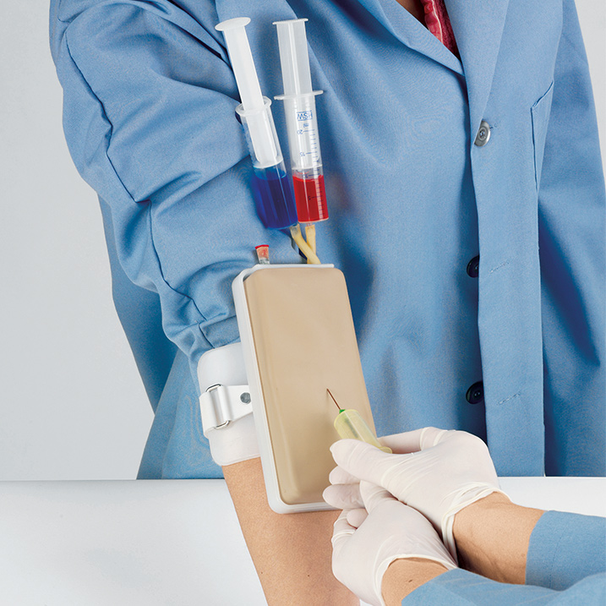
This IV pad can be attached to a student’s arm to practice venepuncture techniques and correct positioning on a live subject, without the risks associated with living tissue, there is an arterial vessel present for blood gas simulation

 | 12 x Available
Virtual IV Simulator | 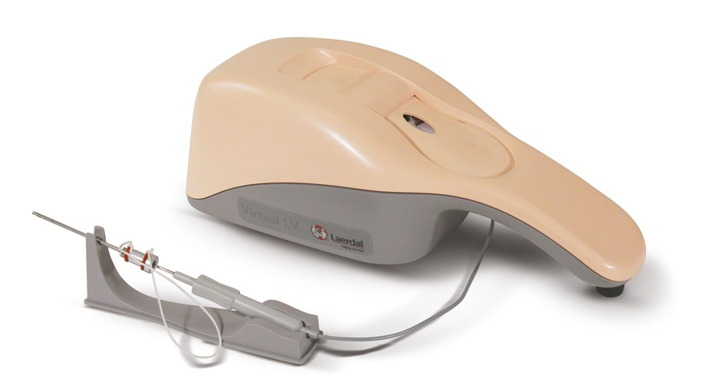
This virtual IV simulator is a comprehensive and fully interactive self-directed learning system which helps learners to improve their skills and knowledge.
3D graphics on the screen provide realism and feedback

 | 1 x Available

ABG Arm |  | 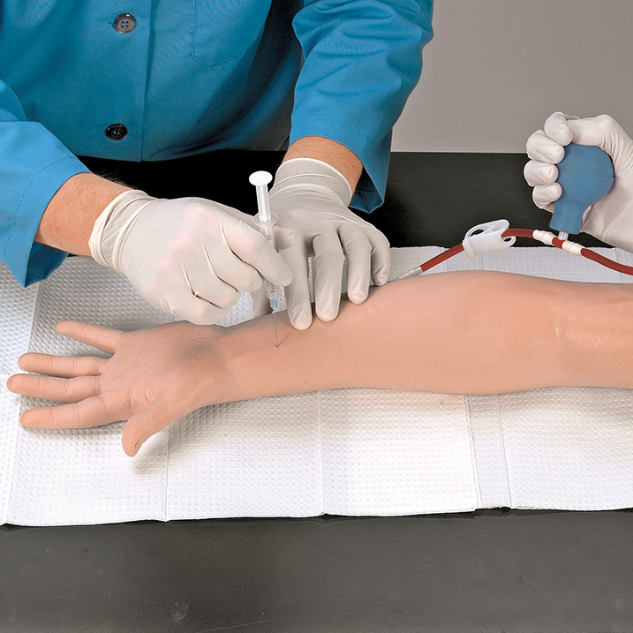
This realistic arm model is ideal for practising and demonstrating drawing arterial blood samples for monitoring blood gases. Learners can identify puncture locations through palpation of the pulse at either the radial or brachial sites

 |  | 3 x Available
Paediatric Multi-Venous IV Arm | 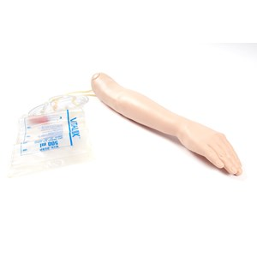
This trainer has a multi-vein system designed for peripheral intravenous therapy. Venepuncture can be done in the antecubital fossa or dorsum of the hand, palpable veins enable site selection and preparation

 | 4 x Available

Baby Arti | 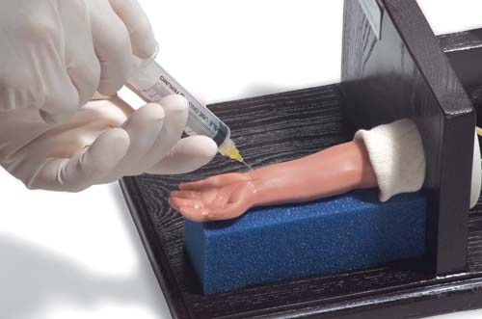
This virtual IV simulator is a comprehensive and fully interactive self-directed learning system which helps learners to improve their skills and knowledge.
3D graphics on the screen provide realism and feedback

 | 1 x Available

IV / IM Injection Buttock | 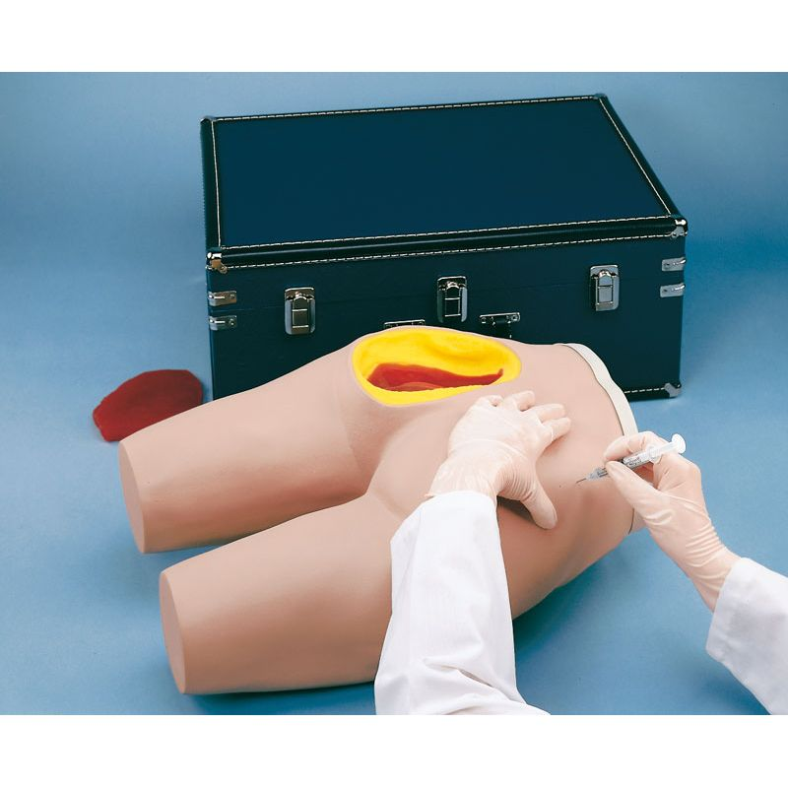
This trainer allows three intramuscular injections to be practiced, a bony structure provides palpable anatomical landmarks so the learner can identify proper injection sites

 | 12 x Available

Injection Trainer | 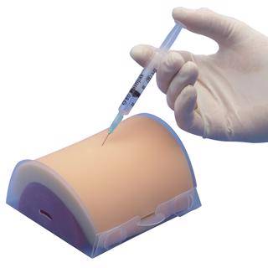
This soft tissue injection pad is designed for practising subcutaneous and intramuscular tissue injection techniques, it has multiple tissue layers representing the epidermis, fat and muscle and be easily attached to an arm or thigh

 | 30 x Available

ENT

Ear Examination Trainer | 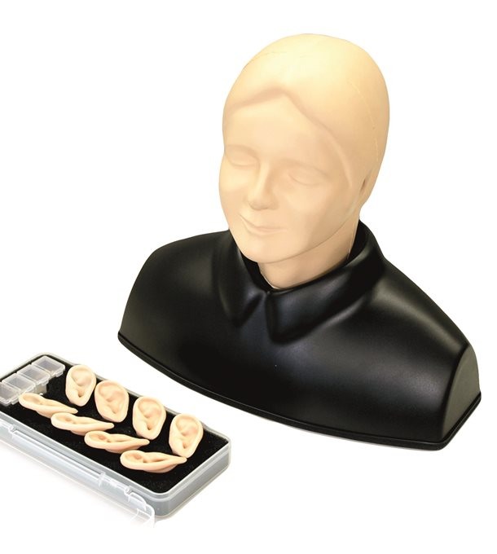
This has a life-size model of the ear including acoustic meatus and tympanic membrane for training in examination with an otoscope and foreign body removal. The model warns against painful insertion in the ear by beeping and indicates when the tip of the otoscope reaches the bony part of the ear canal or touches the eardrum

 | 4 x Available

Eye Examination Trainer | 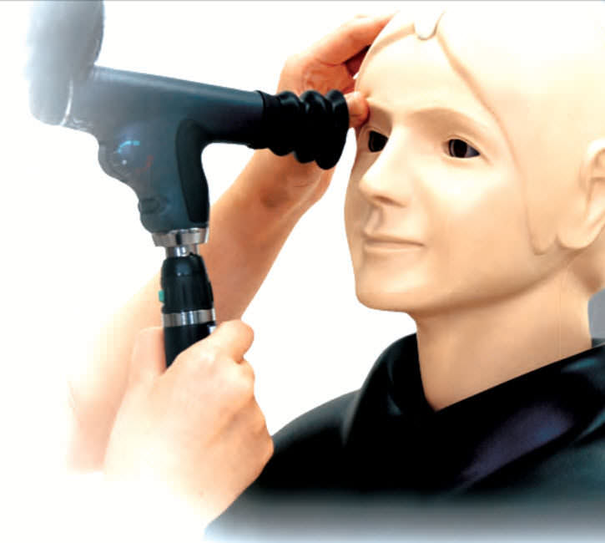
This eye trainer uses a combination of slides to demonstrate different conditions affecting the eye such as hypertensive retinopathy, papilledema, glaucomatous optic atrophy and age-related macular degeneration and subretinal haemorrhage

 | 4 x Available

Gastro

Hungry Manikin | 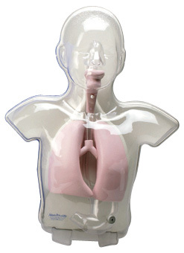
This trainer enables users the chance to practice the technique for insertion of nasogastric and gastrostomy tubes, this model features a movable epiglottis. It helps train you to visualise the correct positioning of the tube

 | 6 x Available

Nasogastric Intubation Model | 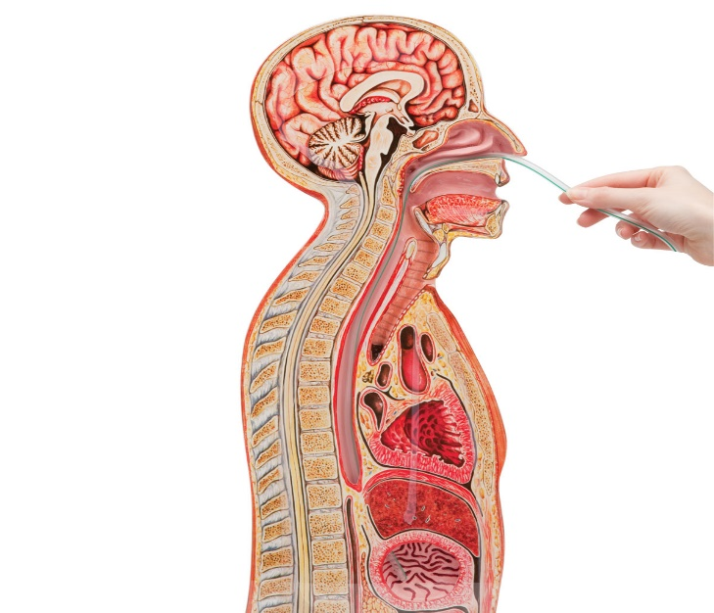
This instructional model shows a median section through nose, mouth, pharynx, trachea, oesophagus and stomach. The plastic feeding tubes, or catheters may be passed through the nose or mouth into the oesophagus and stomach.
A tracheostomy has been added to demonstrate endotracheal aspiration

 | 4 x Available

Maternity
Newborn Anne | 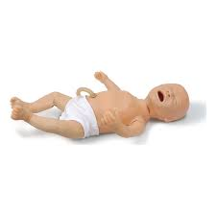
This new-born baby is designed to focus on the critical, resuscitation skills required in the first ten minutes of a new-borns life

 | 6 x Available
& Congenital Anomaly Kit | 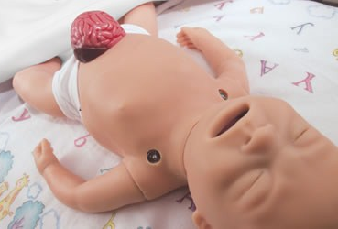
This Congenital Anomaly set includes the following head skins, forceps laceration, cleft lip, cystic hygroma and two polycystic kidney modules

 | 1 x Available
Prompt Birthing Trainer  (With legs) |  | 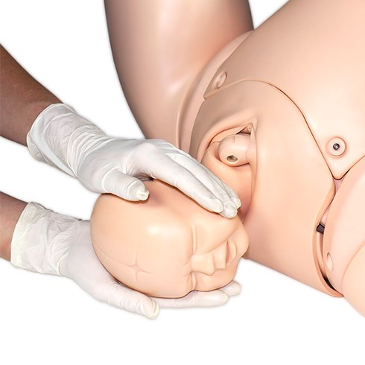
This trainer has anatomical accuracy and features, which include a cervix and birth canal, it provides the ideal training solution for all skills relating to routine and difficult births

 |  | 4 x Available

Cervical Dilation & Effacement Module | 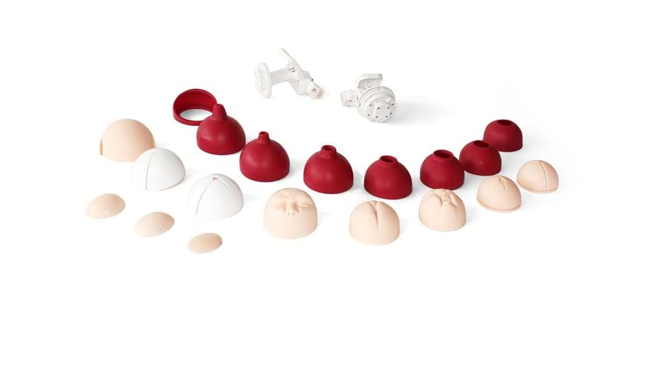
This module can be used as an add on to the prompt birthing trainer, it allows for training in assessment of both the latent and active first stages of labour.
It has numerous inserts including flexed, deflexed, brow, face and breech

 | 2 x Available
Mama Natalie |  | 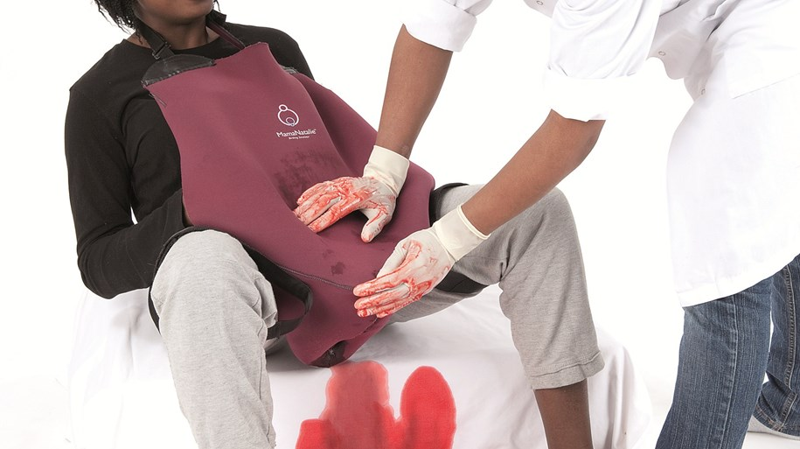
This trainer is realistic for training control of postpartum haemorrhage, it features realistic bleeding, positioning and delivering of the baby, delivery of the placenta, foetal heart sounds, cervix landmark and uterine massage

 |  | 4 x Available

Maternity Simulation Jacket |  | 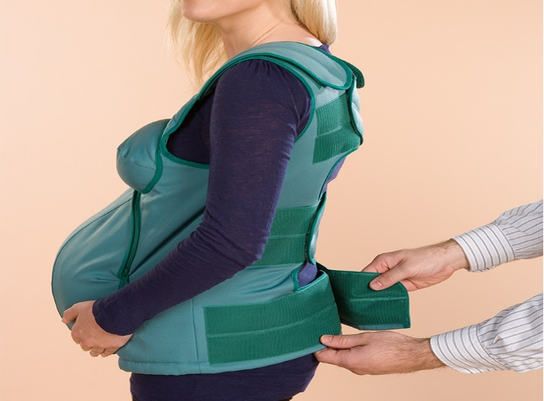
This jacket is ideal to experience being pregnant, the jacket is filled with silicone gel and bags containing weights which can be adjusted to simulate the different
Stages of pregnancy

 |  | 2 x Available
Breast Milk Expression Trainer |  | 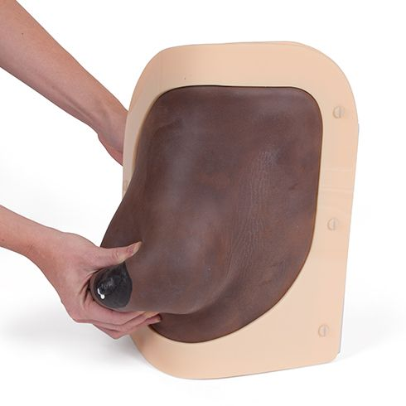
This model can be used in two ways, freestanding or held against the body, the soft foam breast is realistic in shape, texture and proportion and is warm to the touch. It incorporates four ‘milk’ reservoirs which mimic the sinuses of the breast

 |  | 1 x Available
Cervical Dilation Models | 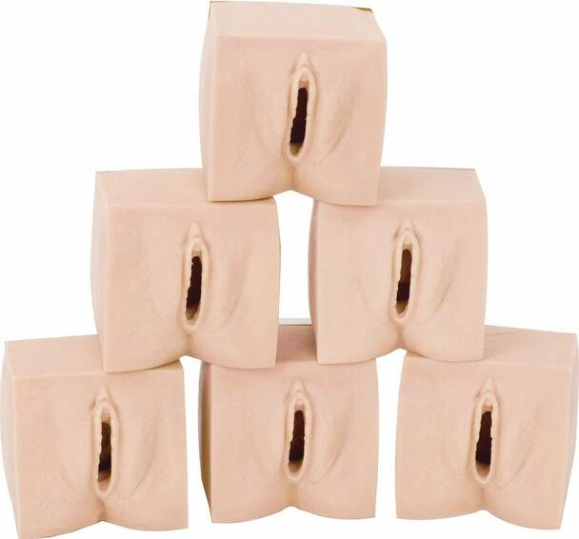
These models show the six stages of a prenatal cervix, the user can gain skills in examination and assessment on the changes of the cervix through centimetres dilation

 | 8 x Available

Episiotomy Trainer |  | 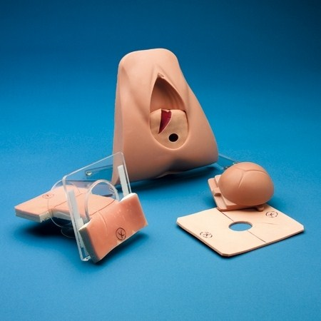
This is ideal for teaching the three stages of episiotomy and second degree tears

1 x Keele & Staff Episiotomy &
20 x Perineal Suture Repair Pads

Maternity Model | 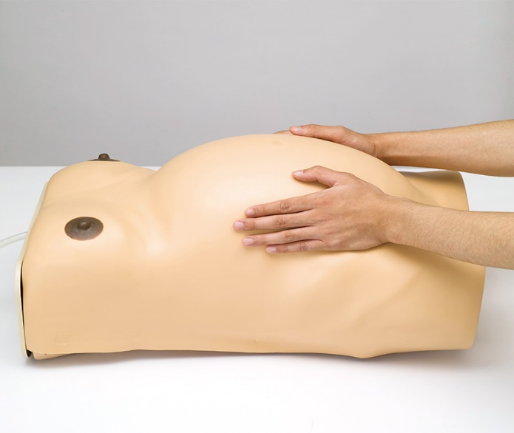
This realistic trainer feels very much like human skin, inflation, and adjustment of air volume inside the uterus enables a lifelike sensation of both mother and baby.
Inside is a skeletal structure which enables practice of pelvimetry and abdominal measurement.

 | 8 x Available

Baby Hippy | 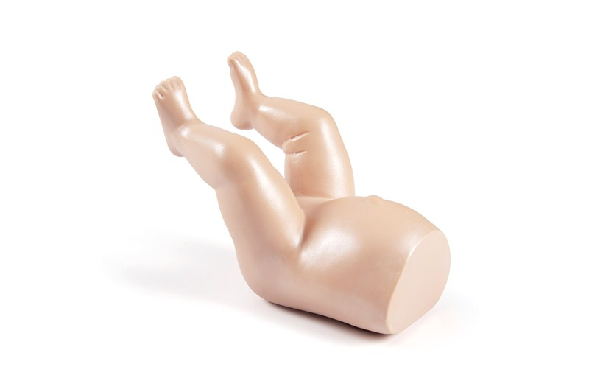
This is a model of the lower torso and limbs of a seven-pound female new-born which helps the user diagnose both congenital hip dislocation and hip dislocatability

 | 5 x Available
Ready or Not Tot | 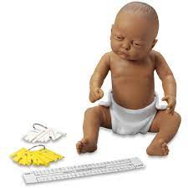
This is a crying baby simulator that teaches students about the demands of parenting as well as being ideal for demonstrating baby handling and care

 | 3 x Available

Men’s Health
Male Pelvic Trainer | 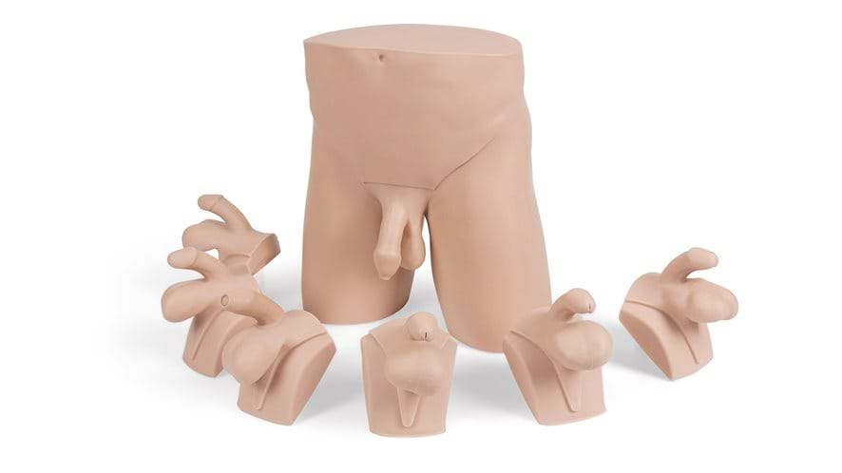
This trainer is an ideal platform for teaching and learning ‘hands on’ male pelvic examination and diagnosis. It has clear anatomic landmarks and a range of pathologies

 | 2 x Available

Advanced Rectal Examination Trainer | 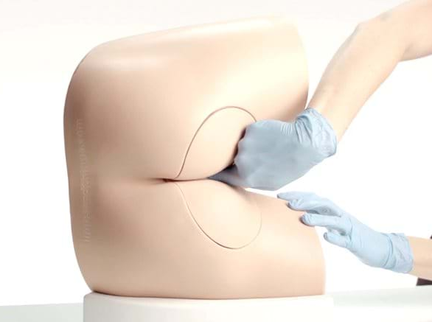
This trainer offers realistic, repeatable training in the core skill of rectal examination, it has interchangeable prostates, left lateral positioning and an illustration pack of nine external anal conditions
 | 4 x Available
Buttocks  Examination Model |  | 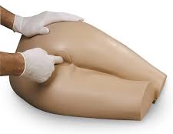
This buttocks model allows learners to practice performing rectal examinations to assess the amount and consistency of stools in the rectum

 |  | 2 x Available

Other
Skin Suture Trainer | 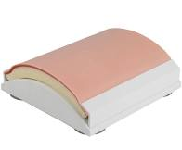
This trainer allows you to practice surgical suturing, the suturing resistance of the artificial skin is almost like real skin

 | 20 x Available

Suture Practice Arm | 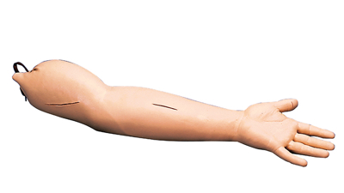
These model arms contain wounds which may be sutured repeatedly, the skin is tough enough to ensure that sutures will not pull out when tightened
 | 3 x Available
Hand & Wrist Injection Trainer |  | 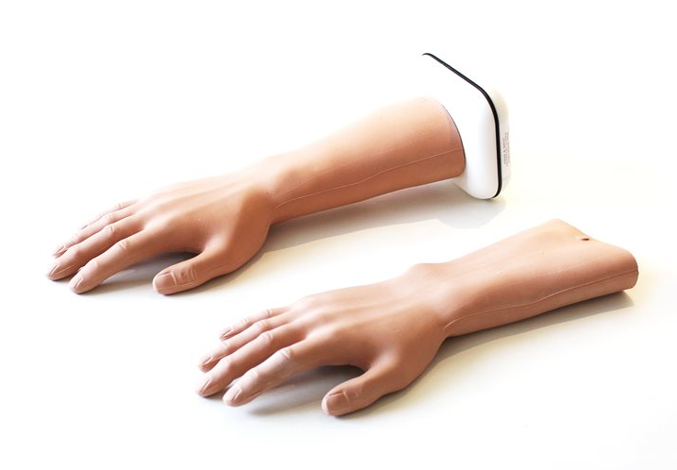
This anatomically correct trainer has landmarks and underlying structures, it allows users to practice injections in five different locations within the hand and wrist

 |  | 1 x Available

Foot & Ankle for Joint Injection | 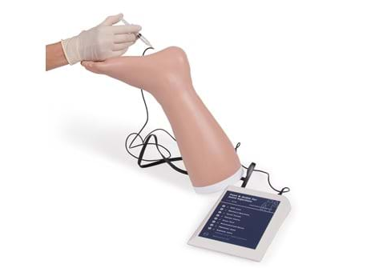
This foot & ankle trainer is designed for practising soft tissue injection for the treatment of injuries and arthritis, it represents normal anatomy as required for palpation purposes

 | 1 x Available

Shoulder Injection Trainer | 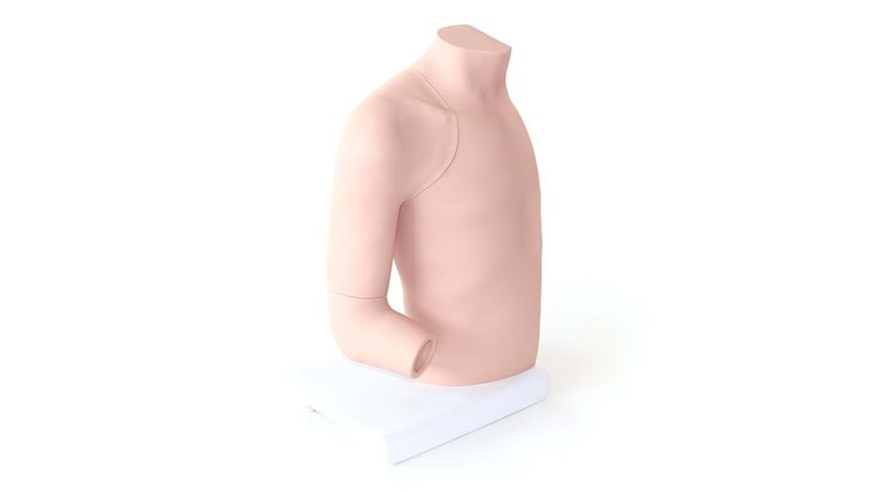
This palpation guided injection trainer offers an ideal way to learn the skills needed for injections in four of the most common shoulder sites

 | 1 x Available

Knee Aspiration & Injection Trainer | 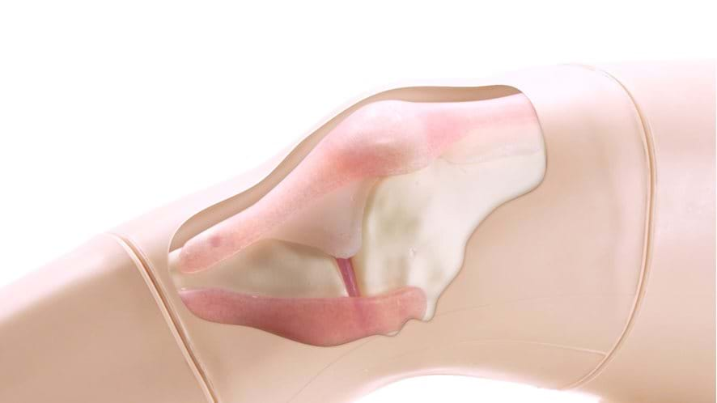
An anatomically accurate adult knee model for injection and aspiration of fluid from the knee joint, from both the lateral and medial aspects using palpation

 | 1 x Available

Age Simulation Set | 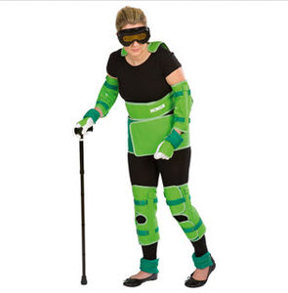
This age suit is a teaching material intended to demonstrate the inconveniences felt by the aged due to the musculoskeletal, visual and auditory changes that occur with age
 | 3 x Available

Bariatric  Suit | 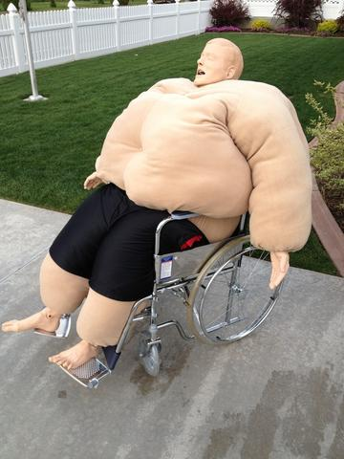
This obesity suit can be worn by the learner or fitted onto an adult manikin, it is weighted with deep skin folds. Learning how to move obese patients is critical to both the safety of the patient and the carer

 | 4 x Available

Abdominal Trainer | 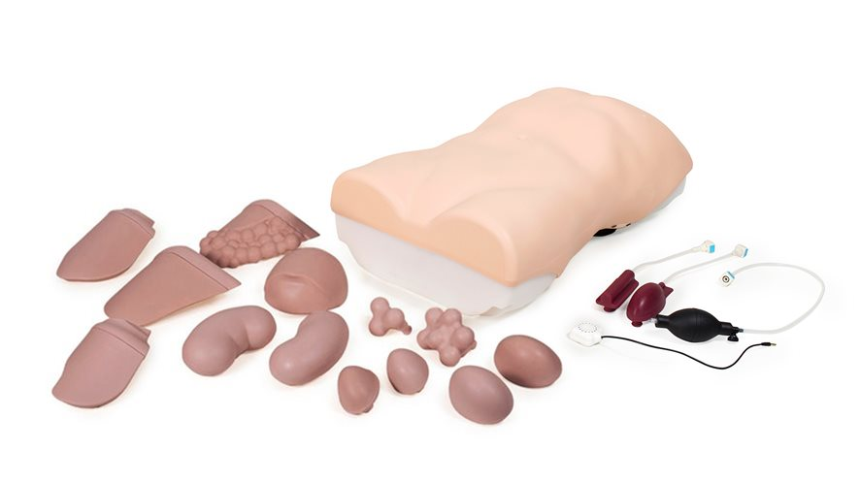
This is an anatomically accurate adult torso used to teach and practice the palpation, auscultation and percussion elements of abdominal or gastrointestinal examination

 | 3 x Available

Women’s Health
Female Pelvic Trainer | 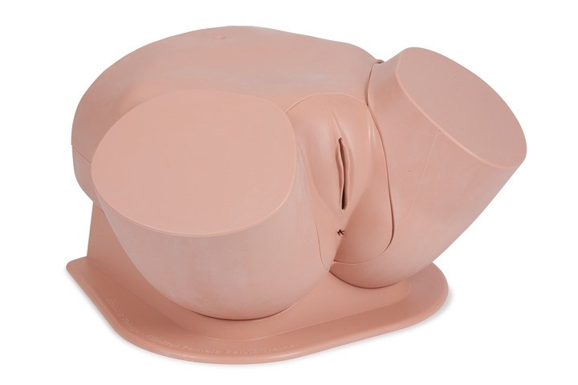
This trainer is an accurate and tactile representation of the female pelvis. It is the ideal platform for ‘hands on’ examination as well as diagnosis of pathologies and abnormalities

 | 4 x Available
Breast  Examination Trainer |  | 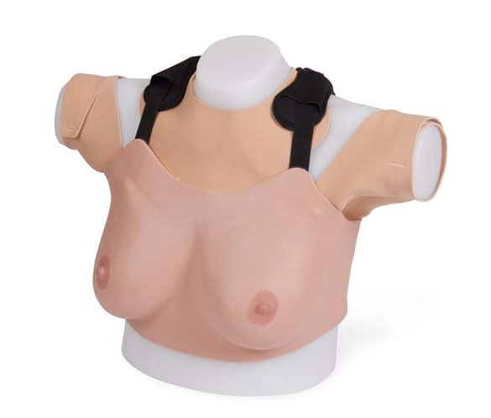
This trainer provides a highly realistic learning platform for acquiring the skills required to perform self-breast and clinical breast examination
 |  | 2 x Available

