Our Adult Family

HAL
HAL is our most advanced full-bodied manikin with physiology and functionality for unlimited training possibilities

Click for more capabilities | 3 x Available

SimMan 3G
SimMan 3G is a patient simulator created for high-quality simulation training in a multitude of different medical procedures and patient cases

Click for more capabilities | 1 x Available
SimMan
SimMan Essential offers learners a risk-free way to build teamwork and enhance individual skills in airway, breathing, cardiac and circulation management

Click for more capabilities | 7 x Available

Resusci Anne Simulator
Resusci Anne Simulator has been designed for the unique training needs of emergency care in both pre-hospital and in-hospital environments

Click for more capabilities | 3 x Available

Nursing Anne
Nursing Anne is a manikin designed for scenario-based training from the care and management of basic patient handling skills to advanced nursing skills

Click for more capabilities | 6 x Available

Resusci Anne Advanced Skills
Resusci Anne Advanced Skills is a lightweight manikin designed to deliver high quality skills training in a wide range of ALS scenarios

Click for more capabilities |  | 9 x Available
Vivien
This Elderly Female manikin 'Vivien' is a highly accurate 82-year-old with lifelike features such as veins, underlying structures and includes an articulated mouth for airway management

Click for more capabilities | 1 x Available

Sam
This Adult Male manikin 'Sam' is based on a 50-year-old who is highly accurate and lifelike, he features lifelike details including replication of veins and underlying structures, hair and a precise anatomical mouth and airway

Click for more capabilities | 1 x Available
Jack | 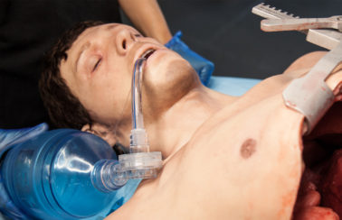
This Adult Male manikin 'Jack' is based on a 30 - 40-year-old who has highly accurate and lifelike features, he has a detachable lower leg and foot for an amputated upper limb

Click for more capabilities | 1 x Available

Mavel |  | 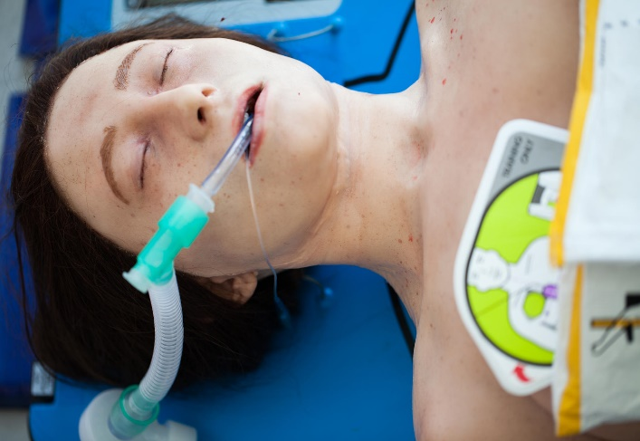
This Adult Female 'Mavel' is based on a 20 - 30-year-old who has highly accurate and anatomically realistic features, she has a detachable lower arm and hand for an amputated upper limb

Click for more capabilities |  | 1 x Available
Mac
'Mac' is based on a 50-year-old male with a realistic upper airway and lungs enabling bag/valve/mask and ET tube intubation

Click for more capabilities | 1 x Available

Rani
‘Rani’ is a based on an 82-year-old with the weight and height of an average senior which encourages a more natural handling, bringing a new level of realism

Click for more capabilities | 1 x Available
Popeye & Dave |  | 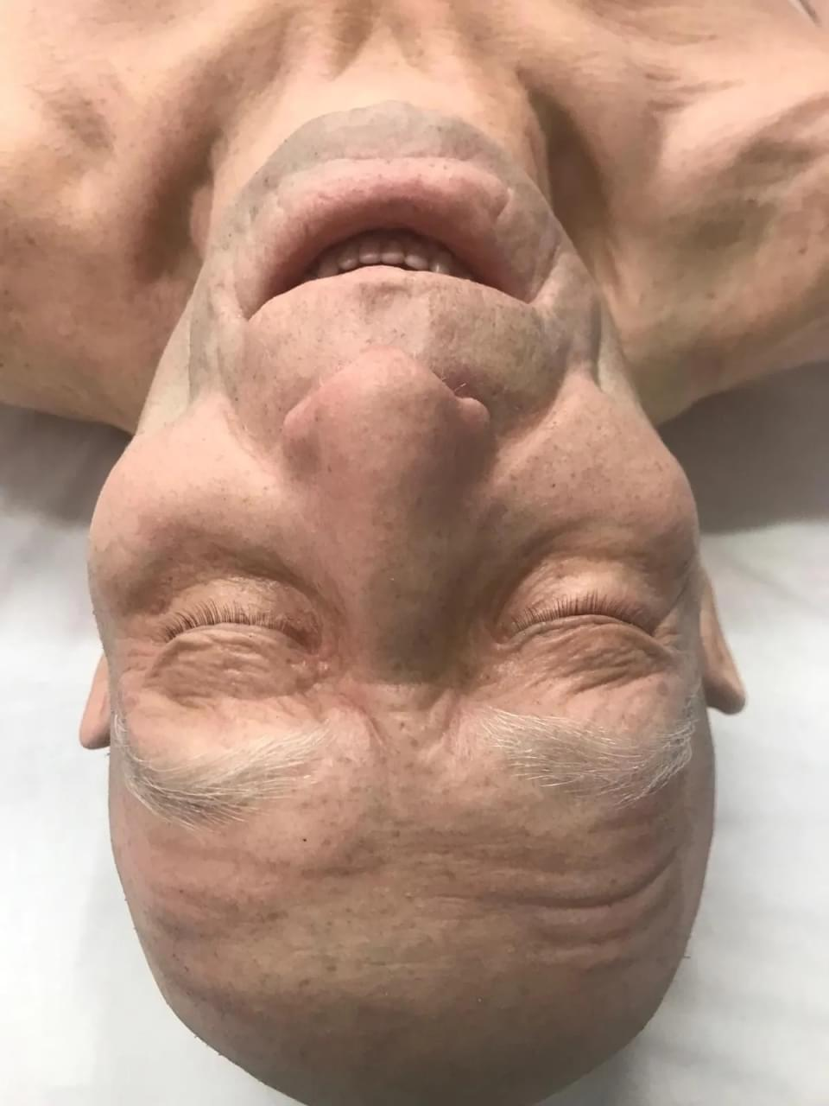
These are both based on a 82-year-old male with lifelike fine details and the weight and height of an average senior

Click for more capabilities |  | 2 x Available

The Kids

Premature Anne
Premature Anne is a realistically proportioned 25-week pre-term manikin and is designed to help train users in the correct care and resuscitation of preterm infants

Click for more capabilities | 1 x Available

Idris, Isiah & Tallulah
These are a realistic 'full term' baby with lifelike features such as a cannulatable umbilical cord and visible veins

Click for more capabilities | 3 x Available
Sim NewB | 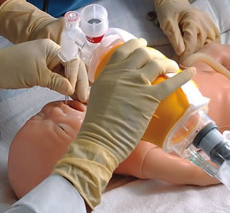
Sim NewB is a neonatal tetherless simulator designed to improve neonatal resuscitation and meet the critical learning objectives of the resuscitation protocol

Click for more capabilities | 1 x Available

ALS Baby | 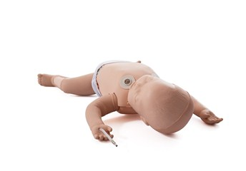
This baby is based on a 3-month-old infant, it offers the opportunity to practice advanced resuscitation skills, CPR, vascular access and 4 lead ECG monitoring

Click for more capabilities | 3 x Available

Newborn Anne | 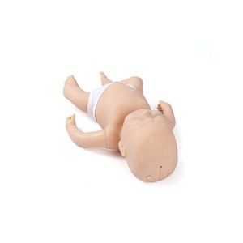
This new-born baby is designed to focus on the critical, resuscitation skills required in the first ten minutes of a new-borns life

Click for more capabilities | 6 x Available

Sim Baby
The SimBaby simulator represents a 9-month-old which is designed to help learners recognise and respond to an unwell paediatric patient

Click for more capabilities | 2 x Available

Felicity
Felicity is a lifelike manikin and is based on a 3-year-old girl, she has visible veins and underlying structures

Click for more capabilities | 1 x Available

Todd
Todd is highly accurate and lifelike and is based on a 3-year-old boy, he has a precise anatomical mouth and airway

Click for more capabilities | 1 x Available

Sim Junior
Sim Junior is a 6-year-old boy that simulates a wide range of conditions from a healthy child to an unresponsive critical patient

Click for more capabilities | 1 x Available
Megacode Kid
Megacode Kid is a realistic manikin which can be used for paediatric training and emergency skills including CPR, trauma, first aid and child abuse awareness

Click for more capabilities | 8 x Available

Chucky
Chucky is a full-body manikin which represents a 4/5-year-old child designed for skill and scenario based training

Click for more capabilities | 2 x Available

Nursing Kid
Nursing kid is ideal for clinical training of common and uncommon in-hospital paediatric patients

Click for more capabilities | 2 x Available

Lily & Amira | 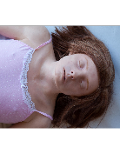
Both are highly accurate of a 9–10-year-old with the look and feel of real skin and can be intubated and ventilated, she has a detachable lower leg and foot for an amputated upper limb

Click for more capabilities | 2 x Available

