

The Essentials of Leadership and Management
Session 8 - Leading Teams
Managers in the Faculty of Science, Technology and Arts

- You ensure your people understand what is expected of them
- You manage tools and resources effectively to help your people meet expectations
- You ensure your people have the right level of autonomy
- You ensure your people feel treated with dignity and respect
- You ensure your people feel listened to and supported
- You help your people develop their career
- You ensure your people have adequate access to you when they need you and you respond appropriately
- You manage unacceptable performance and behaviour in a fair and equitable manner
- You take responsibility to resolve problems within your remit
- You are prepared to make and implement difficult or unpopular decisions

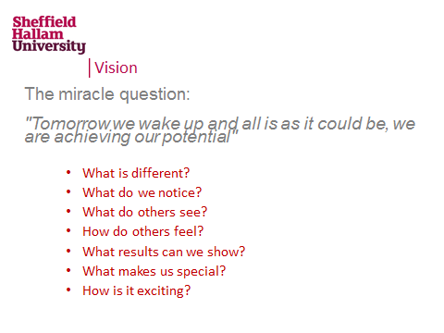
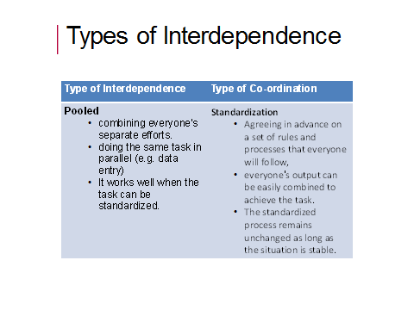

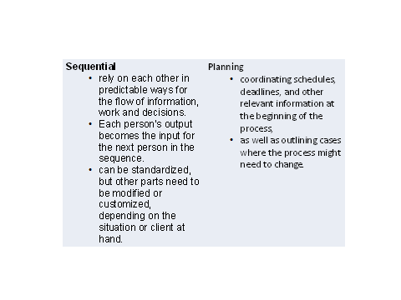
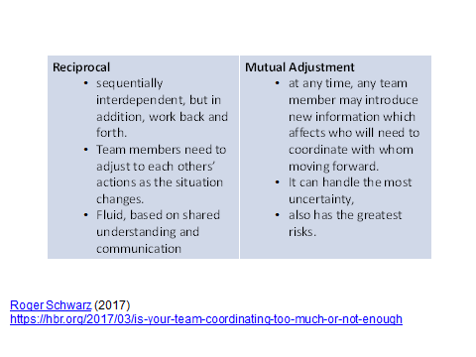
Notes

Development Plan
Goals (linked to Core Expectations) | Planned action | Success measures  (how will I and others know?)
Learning Record
What happened | What I learned | Evidence of Success

