

The Essentials of Leadership and Management
Session 3 – Health & Safety
Managers in the faculty of Science, Technology and Arts

- You ensure your people understand what is expected of them
- You manage tools and resources effectively to help your people meet expectations
- You ensure your people have the right level of autonomy
- You ensure your people feel treated with dignity and respect
- You ensure your people feel listened to and supported
- You help your people develop their career
- You ensure your people have adequate access to you when they need you and you respond appropriately
- You manage unacceptable performance and behaviour in a fair and equitable manner
- You take responsibility to resolve problems within your remit
- You are prepared to make and implement difficult or unpopular decisions

Notes

Key slides and models
Course objectives

We will therefore aim to help you understand:
1.Why Health and safety is important.
2.What we mean by sensible and effective safety management.
3.How to achieve high standards of Health and Safety management.
4.Where to get information and support.
5.What to do next?

Extract from STA Health and Safety Policy:

Academic, Technical & Professional Services Managers are responsible for implementation of the policy at operational level, including:
- assessment of risks, implementation and maintenance of effective control measures;
- competence with regard to the health and safety risks encountered at work;
- provision of information to all staff, students, visitors, partners and contractors within the manager’s influence or control;
- effective monitoring processes are in place including inspections, so that the workplace remains safe; and
- effective arrangements for foreseeable emergencies.

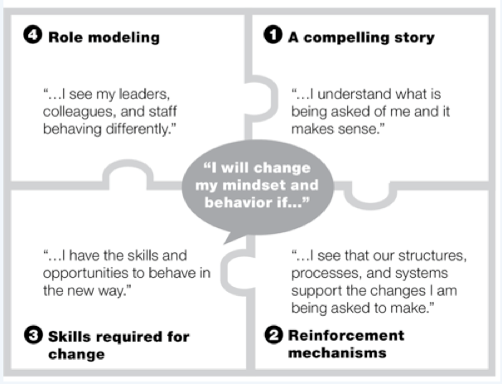
McKinseys model of influence.

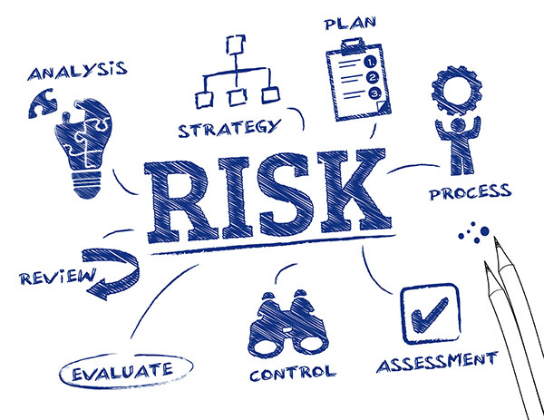
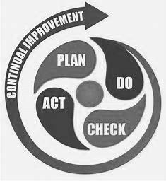
Notes

