Date & Time
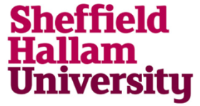
Hallam Leaders' Community
Events Calendar 2018
Our leadership community events are being hosted by a mixture of internal leaders from across the university and external hosts. Each leader has designed a workshop based core leadership skills and will involve a mixture of theory, discussion and a chance to share experiences of leadership approaches.

Getting Things Done (GTD): Taster Session  Miles Seecharan  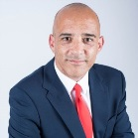  Miles Seecharan is a trainer and coach specialising in the Getting Things Done (GTD®) methodology, a way of managing your workflow which enables you to get more things done with a lot less stress.  Event Details:  This session introduces the principles of GTD and the 5 phases of GTD workflow. | The Listening Leader: transforming relationships through deep listening  Annabel Park  Annabel Park is an Executive Coach, Facilitator and Groupwork Practitioner who spends some of her time running Leadership and People Management programmes for Medecins Sans Frontieres (MSF) staff in Africa, Asia and Latin America.  Event Details  This is a workshop for leaders and managers who want to improve their listening skills.
Managing conflict in the workplace: Causes, consequences and options available to the manager  Tony Bennett  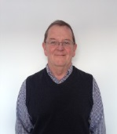  Tony is a senior lecturer and researcher in the Business School. He has spent many years researching the causes and consequences of workplace conflict and, crucially, the options available for its resolution.  Event Details:  The workshop critically considers why conflict in the workplace occur, What are the consequences and what options are open to managers to help resolve workplace conflict | Authentic Leadership  Mike Bramhall & Colin Beard  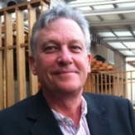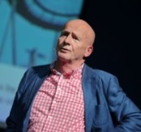  Professor Colin Beard, Principal Lecturer, SBS  Colin runs a learning and development consultancy working with clients across the globe.  Professor Mike Bramhall, Emeritus Professor, ACES  Mike is an Emeritus Professor of Sheffield Hallam, having previously been the Assistant Dean Academic Development in ACES.  Event Details:  In what way is leadership different from managing? This session will provide experiences that engender leadership characteristics that you can reflect upon and further develop.
What's my purpose?
Mark Swales & Lynda Hinxman
Mark Q. Swales, MSc. FInstLM
Director of Estates and Facilities at Sheffield Hallam University
Lynda Hinxman, Assistant Dean for Employer Engagement, SBS

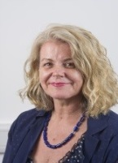
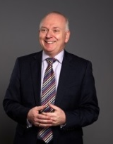
Event Details: In this interactive session we will encourage you to think about your purpose and how the answer to this question drives your behaviours? We'll be considering our own purpose and behaviours from a whole person perspective, not just that which exists in a work place setting.

