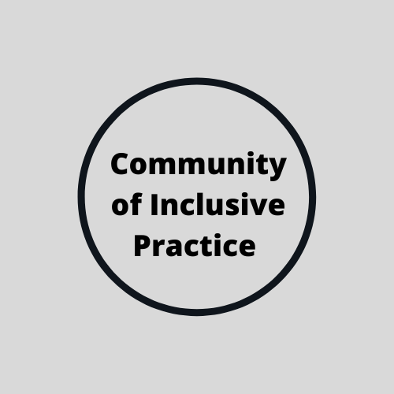

Community of Inclusive Practice

Vision

Our vision is to build a community that is both informed and inspired to implement and promote inclusive practices and behaviours to enhance belonging, support teaching excellence and deliver an excellent experience for staff and students. We will achieve our vision by working as a community and in partnership with students and practitioners delivering space for conversation, sharing, signposting and developing resources.

Mission
The mission of the Community of Inclusive Practice is to create a space where we can facilitate participation and build networks of experts in inclusive practice, through face-to-face and online experiences, fostering trust, respect, positive communication, commitment, competence, and equality to enable us to work in partnership in order to synthesize the best available research, student experience, and professional insight for the ultimate benefit of the staff and student experience. Evidence based- action from our community will also feed into impacting policy to increase the likelihood that policy will provide systemic enhancements in inclusion and belonging.

Principles

1. Trust: Trust is the foundation of our community. We are part of a community to support each other and our core ambition for a more inclusive university.
2. Respect: Community members respect opinions, values, and beliefs of other members.
3. Communication: Community members engage in clear, honest, and respectful communication.
4. Commitment: To the shared goals and common interests of inclusion and belonging to enhancing teaching excellence and an excellent experience for staff and students.
5. Competence: Community members have a commitment to identify and share effective and relevant practices to support our aims.
6. Equality: All members of the community are equally important and make equally significant contributions to our community.

Goals

1. Provide a safe, respectful, and positive environment for members to exchange ideas and problem solve barriers to inclusion. Building a network of experts in inclusive practice.
2. Create a space for practitioners to reflect and develop practice enabling innovative transformational practice.
3. Collect real, experience-based stories from students and staff about barriers to inclusion and share practice and resources to support and promote inclusive practice.
4. Create smaller working communities around specific areas such as communication and campus facilities to support a holistic approach to inclusive practices.
5. Build a base of evidence connecting support, use of toolkits and resources to improve student outcomes.
6. Produce annual reports on activities, best practice and toolkits with recommendations to further develop the overall experience of inclusion and belonging in the Hallam community.

