INDUCTION PLANS-ENTRY/FULL TIME PATHWAY TRAINEES

Date | Activity | Location
21/9/22 | Welcome, Introduction to the course, Play and statutory frameworks-9.00 am | 12.2.14 ( Charles Street,S1 2NE)
22/9/22 | Tour round research nursery,observation and assessment and Initial needs assessment and placement preparation 9.30 am | Early Years Community Research Centre  SHU Nursery - The Meadows  S5 8XJ
23/9/22 | Getting to know you day 9.30 am | Grindleford Woods  Meet at the Station Café near to Grindleford Train Station, Derbyshire, S32 2JA
30/9/22 | Hallam Welcome 9.00 am | 12.2.14

INDUCTION PLANS-EMPLOYMENT/PART TIME PATHWAY TRAINEES

Date | Activity | Location
23/9/22 | Getting to know you day  9.30 am | Grindleford Woods  Meet at the Station Café at 9.30 am near to Grindleford Train Station, Derbyshire, S32 2JA
30/9/22 | Hallam Welcome 9.00 am start | 12.2.14
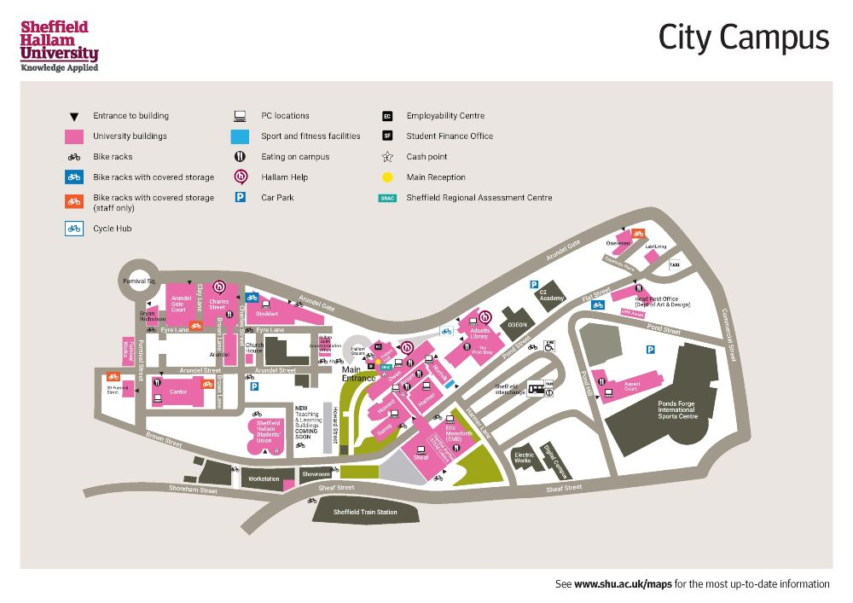
Charles Street 12.2.14 ( 2nd floor room 14)

