Three Minute Thesis (3MT®) Competition 2020

HEATS
Thursday 23 April 2020, 10.00 - 12.00 pm at Collegiate Campus, D005 Main Building
Wednesday 29 April 2020, 10.00 - 12.00 pm at City Campus, The Void

FINAL
Tuesday 9 June 2020 at City Campus
Part of the SHU Creating Knowledge Conference 2020
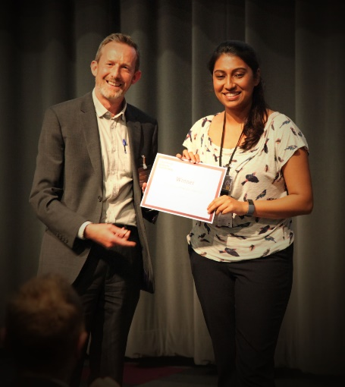
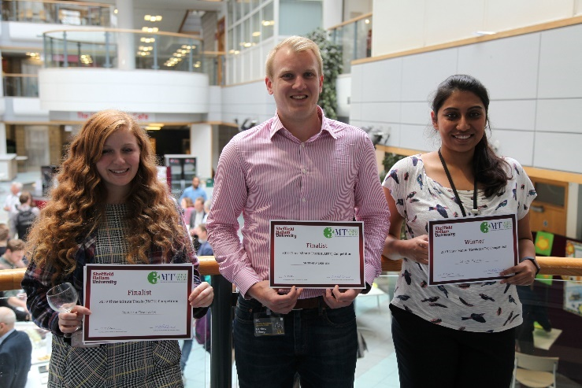

3 of our SHU 3MT 2019 finalists Shruti Mandhani, SHU 3MT 2019 winner

Three Minute Thesis (3MT®) is a competition developed by the University of Queensland which challenges doctoral students to deliver a compelling spoken presentation on their research topic and its significance, in just three minutes.

Sheffield Hallam will be holding its 2020 3MT® competition on Tuesday 9 June 2020 as part of the SHU Creating Knowledge conference. As well as winning a prize of £250 towards attending an academic conference of their choice, the winner will be put forward as SHU's entry to the UK national competition.

All you have to do is present your doctoral research topic to a mixed-disciplinary audience, using one slide and in no more than three minutes.

We will be holding 3MT® heats at both campuses, and you are welcome to participate in either heat regardless of where you are usually based. The three strongest presenters from each heat, plus the two highest-scoring runners up, will go through to the SHU final on 9 June.

Eligibility

All Sheffield Hallam doctoral students who will not have had their viva by 9 June 2020 are invited to enter. Only those doctoral students who have passed their Confirmation of Doctorate (RF2 or equivalent) by the date of their first 3MT® presentation will be eligible to proceed to the national competition. Those earlier on in their doctoral studies are still encouraged to take part in 3MT® as a developmental activity. You must be able to attend one of the heats taking place on Thursday 23 April or Wednesday 29 April and the final on Tuesday 9 June.

How to enter

Please email doctoralschool@shu.ac.uk by Thursday 9 April 2020 to express an interest in participating, stating your name, college, thesis title and preferred heat.

What happens then?

You will then receive further guidance on preparing your 3MT® presentation, and the format of the heats and final.

Why enter?

3MT® is an excellent opportunity for doctoral researchers to develop their communication skills. It is also a unique chance for you to share your research and your passion for it with the broader research community, and raise your profile as a researcher both within and beyond the University.

Our previous competitions saw some excellent presentations given by researchers from across the University. You can watch the SHU finalists via the links on the Doctoral School site:
2016 SHU 3MT finalists, 2015 SHU 3MT finalists

The winner of SHU's 2019 competition, Shruti Mandhani, won the UK national finals. You can watch Shruti's final presentation, along with those of the other national finalists, on the Vitae website https://www.vitae.ac.uk/events/three-minute-thesis-competition/3mt-2019/3mt-finalists-2019

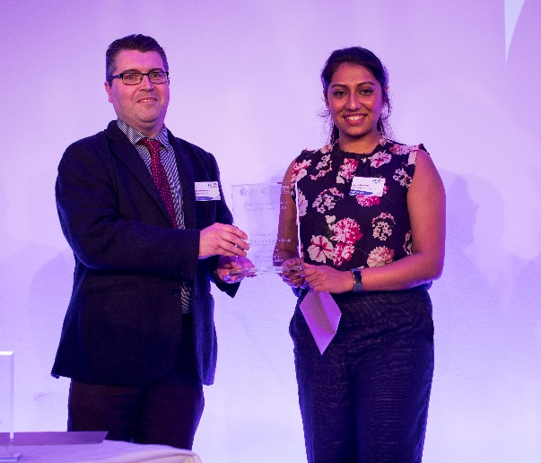
Shruti Mandhani – Vitae 3MT national winner 2019

Competition Rules

- A single static PowerPoint slide is permitted. No slide transitions, animations or 'movement' of any description are allowed. The slide is to be presented from the beginning of the oration
- No additional electronic media (eg sound and video files) are permitted
- No additional props (eg costumes, musical instruments, laboratory equipment) are permitted
- Presentations are limited to 3 minutes maximum and competitors exceeding 3 minutes are disqualified
- Presentations are to be spoken word (eg no poems, raps or songs)
- Presentations are to commence from the stage
- Presentations are considered to have commenced when a presenter starts their presentation through either movement or speech
- The decision of the adjudicating panel is final
Judging Criteria

Comprehension & Content
- Did the presentation provide an understanding of the background and significance to the research question being addressed while explaining terminology and avoiding jargon?
- Did the presentation clearly describe the impact and/or results of the research, including conclusions and outcomes?
- Did the presentation follow a clear and logical sequence?
- Was the thesis topic, research significance, results/impact and outcomes communicated in language appropriate to a non-specialist audience?
- Did the presenter spend adequate time on each element of their presentation - or did they elaborate for too long on one aspect or was the presentation rushed?

Engagement
- Did the oration make the audience want to know more?
- Was the presenter careful not to trivialise or generalise their research?
- Did the presenter convey enthusiasm for their research?
- Did the presenter capture and maintain their audience's attention?
- Did the speaker have sufficient stage presence, eye contact and vocal range; maintain a steady pace, and have a confident stance?
- Did the PowerPoint slide enhance the presentation - was it clear, legible, and concise?

Related Terms and Conditions

- The institutional final will be filmed.
- Other entrants and invited guests will also be in attendance.
- The winner's film will be submitted to the national online semi-finals, taking place during July and August.
- If our entry to the national semi-finals is successful, the winner will be expected to attend the live UK final in Birmingham on 14 September 2020. The University will cover travel costs.
- Individual doctoral students and Sheffield Hallam University will jointly own the resulting films from the institutional final. Both may freely use the films on websites/social media, but must reference the other and the 3MT competition where it is displayed. Students may veto the University using their film if they have any particular concerns.
- The £250 prize must be utilised to attend an academic conference or equivalent before 31 July 2021. It may be used towards delegate fee, accommodation and travel costs only. The award is up to £250 and underspend cannot be paid directly to individuals. The sum may be spent on more than one conference during the stated period.

