Accessing Online Research courses

The University has decided to change the process of accessing the Epigeum 'Research' online courses. They will now be available via an external website hosted by Oxford University Press (the owners of Epigeum), rather than via the Academic CPD Blackboard organisation site as previously.

SHU has paid for an institutional subscription to the modules which is available to staff and doctoral researchers. In order to access the modules, you will need to set up an account on the system using your SHU email address (please do not use a personal email address as this will not link you to the SHU subscription).

The steps to complete this are:

o Go to: https://learningtechnologies.epigeum.com
(You are advised to use a Chrome browser rather than Internet Explorer, as some of the content cannot be viewed using IE)

o Click on Create an account and complete the form -
Your username must be your email address.
IMPORTANT - users can register with any of these email domains: @shu.ac.uk; @student.shu.ac.uk; @my.shu.ac.uk; @exchange.shu.ac.uk

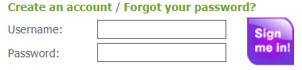

o You will receive an email inviting you to complete your registration on the site. If you don't receive the email within a few minutes, please check your spam/junk folder as it may have been held there.

o Once registration is complete, users can login. They will then see the front page containing all the training modules available via the SHU subscription. 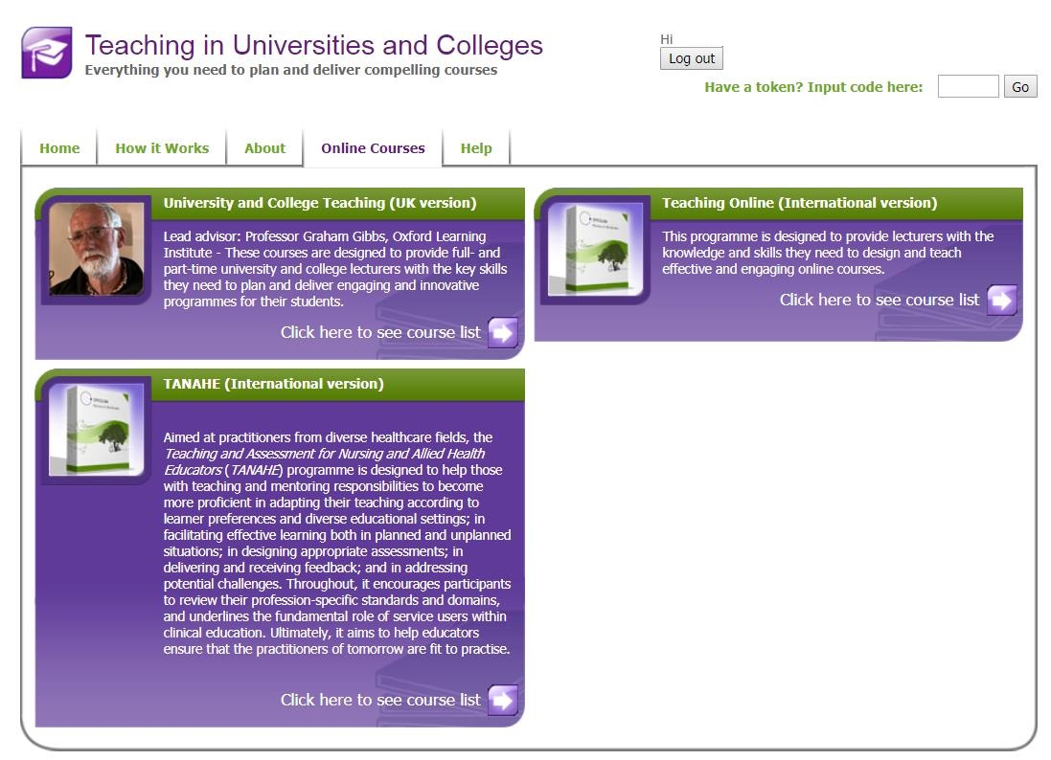

The full suite of online training modules available via the SHU subscription are shown below:

Included modules will show "Provided by Sheffield Hallam University" in the Access column.

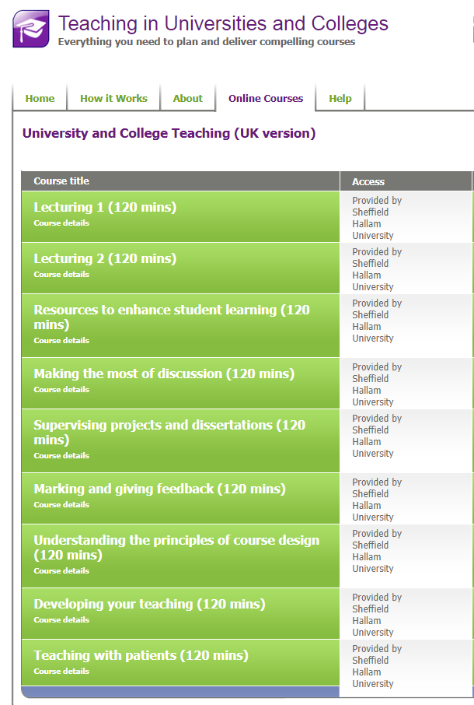

If you have accessed the site without registering and then click on the training modules, you will see the view below:

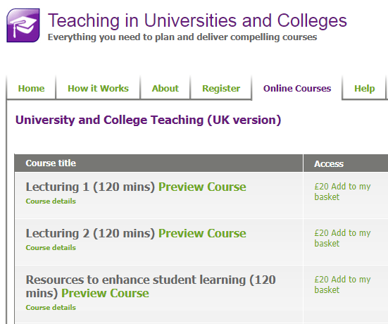
Please don't proceed any further. You should return to the home page and complete your registration. Please don't make any payments for modules, as these are included in the SHU subscription and Epigeum will not refund any payments made in error by individuals.

You will need a device (PC/tablet/mobile) which can play audio/video, and if you work in a shared space it would be best to use headphones when accessing the module

Each module has downloadable resources for you to complete and record your progress through the module.

Once you have completed the test at the end of the module, you will see your grade and will be able to download a certificate to confirm completion of the module if you achieved the pass standard.

The Course Feedback button takes you to a survey about your experience of the course.

