ESRC Sheffield Festival of Social Science 2017
Proposal Details and Materials Form

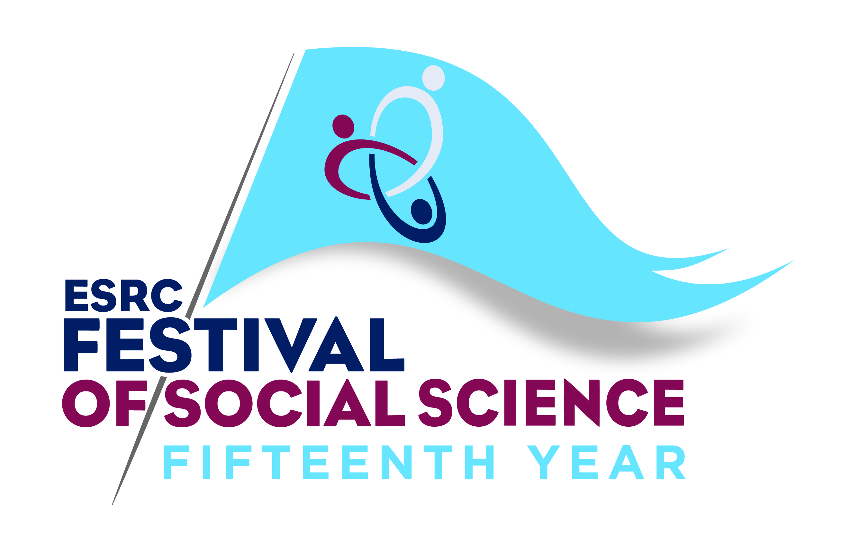
Please email this form to your UOA Coordinator (see below) and cc Camilla Prince c.prince@shu.ac.uk by Friday 5th May.

The Unit of Assessment Coordinators are:
16: Peter Wells for Architecture, Built Environment and Planning (p.wells@shu.ac.uk)
19: Bradley Barnes for Business and Management (b.r.barnes@shu.ac.uk)
22: David Best for Social Work and Social policy (d.best@shu.ac.uk)
25: Jacqueline Stevenson for Education (jacqueline.stevenson@shu.ac.uk)

1. Organiser and contact information
Organiser Name(s)
Telephone
Email
Website for event (if any)
Organised by (e.g. Research Centre / department name)

2. Event name, date and venue
Event title (max 7 words)
Date of event(s)
Event start time (in 24h clock - 00:00)
Event finish time (as above)
Venue
Venue address, incl. city and postcode
(N.B. ESRC prefer events to be held off campus)

3. Contributors, partners and external support

If you have received tentative agreement or secured additional financial support from organisations, including in kind support from your HEI. If you aren't sure please estimate.
Name of partner/contributor
Type of support (tick all that apply):
- Staff time
- Venue hire
- Refreshments/catering
- Cash sum
- Printing, stationary, publicity or advertising
- AV/Technical support, recording
- Other (please specify)
Approximate value of support
Does your event have any links with the University of Sheffield? If so, please specify.

4. Target audience
The Festival programme is targeted at four audience types to help attendees find events which are relevant to them. Select one of the following broad audience types:
- 50% of events aimed at young people aged 14-18 and the general public
• 30% of events aimed at business, policy makers and the third sector
• 30% of events involve interdisciplinary and /or cross-departmental working

- Young people (aged under 14)
- Young people (aged 14-18)
- Suitable for a general audience (no background of topic required)
- For those with a specific interest or some knowledge of the topic
- For professionals as part of their work (business, policy makers and third sector)
What is your expected audience size?

5. Event description (to appear in the online programme and on the website)
Max 150 words
• Festival events are to reach new audiences and event organisers are seeking and exploiting opportunities to take events outside the city centre (ESRC prefer events to be held off campus)
• Event organisers are developing skills for dissemination of and engagement with research through their involvement with the Festival
- Interdisciplinary and /or cross-departmental working

6. Awareness and media support
To help us raise awareness of your event, for example via the media, please give the following details: (maximum 100 words in each)
- What do you hope the audience will gain from your event?
- What makes your event exciting/interesting?
c. How will you promote your event? Mailing lists, Eventbrite, WordPress, Social Media, other? Will people have to sign up to your event to attend?

7. Materials
The ESRC will produce and supply Festival flyers, promotional material, audience evaluation forms, and pull-up banners for all events.

Would you like a Festival poster(s)? If so, how many?
What format would you prefer your audience evaluation form in? Print, online or on an iPad?

