Filtering & Reporting in Converis

Document Title and Version: | Filtering (3.2)

Contents
Filtering 3
Filtering Options 4
Project Applications 4
Project Application 4
Users 6
Principal Investigators 6
Co-Investigators 6
Support contacts 6
Organisations & Funders 7
Internal Organisations 7
External Partner Organisations 7
Funders 7
Guidance on using dates (e.g. Academic Year) - utilising the Third Column 8
How to use multiple filters 9
Saving Filters 10
Example: Project ID 10
Using Saved Filters 11
Deleting Saved Filters 11
Clearing Filters 11
Reporting Using Filters 12
Reporting 13
Running a Report 14
Filtering when Reporting 15
Notes 16

Filtering
Filters can be used to tailor the results shown in the Project Application List View e.g. by Principal Investigator, Workflow Status or Centre.
- To access the filter, click on Projects.

- Select Project Applications.
- You will be presented with a list of all the application that you have access to.

At the top of this list you will see the Functions Bar - select the Filter icon.
You will be presented with the filtering options:

The selection made in the first column will determine what information you can filter on. The table below contains information on the filtering options available in the First and Second Columns.

Filtering Options

Project Applications
First Column | Second Column
Project Application  This allows you to filter by attributes within the Project Application. | Abstract
 | Activity Type
 | Actual End Date
 | Actual Start Date
 | Admin Area
 | Another UK HEI being the lead partner
 | Application stage
 | Are any staff assigned to the project on a temporary or fixed-term contract that will need to be extended to cover the project duration?
 | Awarded but Transferred
 | Awarded Sponsor Costs
 | Call deadline
 | Call Title
 | Contract and Grant Terms and Conditions Review
 | Contract Terms and Conditions
 | Corporation Tax
 | Corporation Tax Comments
 | Customer Credit Validation
 | Date Awarded
 | Date Rejected
 | E5 Number
 | European Procurement Regulations / Subcontracts
 | Expected date result will be known
 | Expected end date
 | Expected start date
 | Financial Comments
 | Funder's Reference
 | HR & Employment Issues
 | Human participants (including tissue or personal data)
 | Insurance
 | Intellectual Property
 | Is a collaboration agreement required Post Award?
 | Is a sub-contract required Post Award?
 | Joint Faculty Proposal?
 | Notes
 | Potential ethical issues
 | Potentially vulnerable participants
 | Project ID
 | Project Intellectual Property
 | Proposal Tracking No
 | Proposal Type
 | Purchase Order Number
 | Reason application not proceeding
 | Reason for Rejection
 | REF 2014 Unit of Assessment
 | Resource Requirements
 | Risk Assessment
 | Short Project Title
 | Short Title
 | SHU Involvement
 | Strategic Fit
 | Submitted Date
 | Title
 | Total Actual Contribution to Overheads
 | Total Expected Income (Excludes VAT on price)
 | Total Full economic cost
 | Type of project application
 | VAT Comments
 | VAT Type
 | Will any fixed-term research staff exceed 4 years of service as a result of this project?
 | Will new staff need to be recruited to the project?
 | Will redundancy costs or redeployment need to be considered?
 | Would the Project go through The NHS, Social Care or the Criminal Justice System Ethical Approval Processes
 | Updated on
 | Status
 | Created on

Users
First Column | Second Column
Principal Investigators  This allows you to filter by the PI assigned to application(s). | related
 | number related
 | First name
 | Last name
 | Status
Co-Investigators  This allows you to filter by the Co-I(s) assigned to application(s). | related
 | number related
 | First name
 | Last name
 | Status
Support contacts  This allows you to filter by the Support contact(s) assigned to application(s). | related
 | number related
 | First name
 | Last name
 | Status

Organisations & Funders
First Column | Second Column
Internal Organisations  This allows you to filter internally by:  - Faculty  - Institute  - Research Centre  - Department  When searching for Internal Organisations, it is best to use the Tree View finder to locate the area you are searching for: | Related
External Partner Organisations  This allows you to filter by the External Partner Organisations assigned to application(s). | related
 | number related
 | Acronym
 | Alternative Name
 | Name
 | Type of organisation
 | Previous Name of Organisation
 | Status
Funders  This allows you to filter by the Funders assigned to application(s). | related
 | number related
 | Acronym
 | Alternative Name
 | Name
 | Type of organisation
 | Previous Name of Organisation
 | Status

Guidance on using dates (e.g. Academic Year) - utilising the Third Column

When on Project Application (First Column), the options for dates (Second Column) are:
- Call deadline
- Expected end date
- Expected start date
- Submitted Date
- Date Rejected
- Actual Start Date
- Actual End Date
- Expected date result will be known
- Date Awarded
- Updated on
- Created on

In the Third Column, you are presented with a dropdown list, and the options can include:
- Equals - if you are looking for applications on a specific date.
- Before - if you are looking for applications before a specific date.
- After - if you are looking for applications after a specific date.
- Between - if you are looking for applications between specific dates (e.g. Academic Year - example in screenshot below)
- Is empty
Use the calendars to select specific dates.

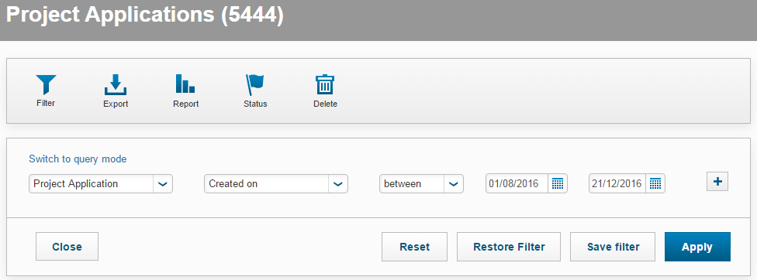

How to use multiple filters
It is possible to apply multiple filters to tailor your results, but care must be taken to avoid applying conflicting requests. Where conflicting filters are applied, '0' applications will be found. This is because the filters are to match one criteria AND another, not one criteria OR another.

For example, you can apply a filter that returns all applications for a particular academic that are in 'Awarded' status. However, you cannot apply a filter that returns all applications in 'Awarded' or 'Unsuccessful' status.

To apply a multiple filter, use the to the right of the Search Box. This will bring in a new row below your initial filter(s).

To remove a row, use the

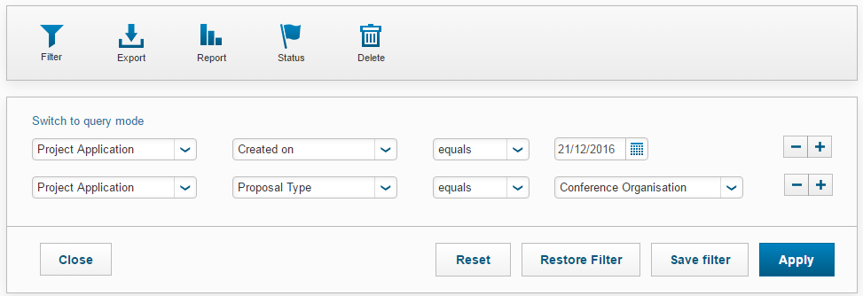

Saving Filters
You can save regularly used filters in order to bypass the problem of having a large list of attributes to search through.

Example: Project ID

In order to locate applications in Status 1 (In Preparation) using their Project ID number, you will need to use filters rather than the search bar. If you do this regularly, you can save a filter which enables you to quickly search using Project ID numbers.

On your Dashboard, click Projects > Project Applications.

Click on to open the filtering options.

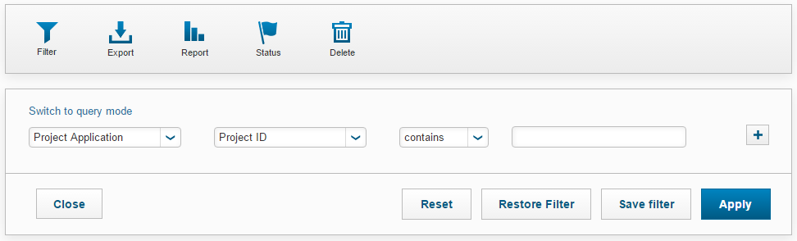

- First Column: Project Application
- Second Column: Project ID
- Third Column: contains

Leave the Search Box blank and click 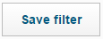

A 'Save filter settings' box will appear. Write Project ID in the box and click

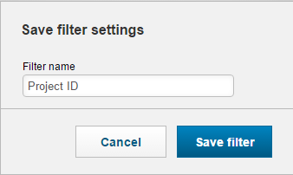

Using Saved Filters
On your Dashboard, click Projects > Project Applications.

Click Restore Filter.
This will open a new window. The filter you used most recently will show up. | 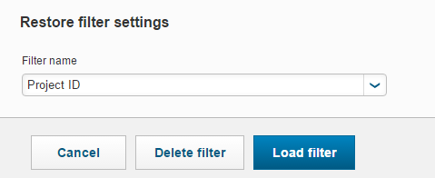
From the dropdown list select your chosen filter.
Click Load filter.

Deleting Saved Filters
To delete saved filters, follow the steps above until you get to the last step, and then
click 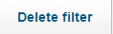

Clearing Filters
When you wish to remove a filter and return to the full overview of all Project Applications in your area, Click 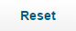 to clear the filters.

Reporting Using Filters
Filters can be really useful to help users tailor reports before running them in Converis.

For example, if you wanted to produce an Excel report of all the 'Awarded' applications funded by The British Academy, before you ran the report you could apply the following Filter Criteria:

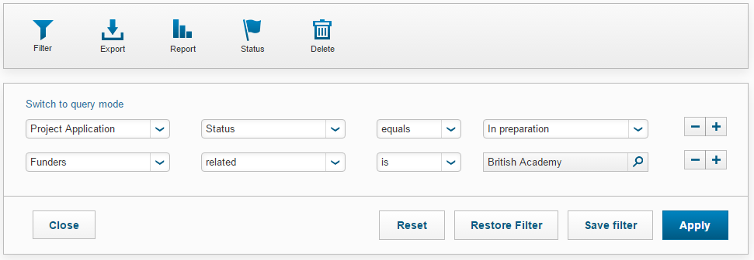

When you have selected the appropriate filters, click 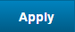

You would then be able to run the report on the filtered data. More information on reporting can be found in the Reporting section of the guide.

Reporting
Currently, there are six available reports in Converis.

- Project Application_All Attributes Report - applications in this report will have multiple lines of data if they have two or more of any of these attributes:
  - Co-Investigators
  - Joint Faculties
  - External Partner Organisations
  - Funding Organisations
  - Support Contacts

- Project Application_All Attributes Report (Concatenated) - there will be one row per application. If any application has two or more of any of these attributes, the data will be displayed in a single cell and separated with a comma:
  - Co-Investigators
  - Joint Faculties
  - External Partner Organisations
  - Funding Organisations
  - Support Contacts

- Project Application Awarded Applications Report - applications in this report will have multiple lines of data if they have two or more of any of these attributes:
  - Co-Investigators
  - Joint Faculties
  - External Partner Organisations
  - Funding Organisations
  - Support Contacts

- Project Application Awarded Applications Report Concatenated - there will be one row per application. If any application has two or more of any of these attributes, the data will be displayed in a single cell and separated with a comma:
  - Co-Investigators
  - Joint Faculties
  - External Partner Organisations
  - Funding Organisations
  - Support Contacts

- Project Application Submitted Applications Report - applications in this report will have multiple lines of data if they have two or more of any of these attributes:
  - Co-Investigators
  - Joint Faculties
  - Funding Organisations

- Project Application Submitted Applications Report Concatenated - there will be one row per application. If any application has two or more of any of these attributes, the data will be displayed in a single cell and separated with a comma:
  - Co-Investigators
  - Joint Faculties
  - External Partner Organisations
  - Funding Organisations
  - Support Contacts

Finding the Reports
The Reports can be accessed from the Project Application List View.
- When you are logged into Converis, on the left-hand side, click on Projects.

- Select Project Applications.
- You will be presented with a list of all the application that you have access to.

Running a Report
To run a report, click on the Report tab at the top of the Project Applications list view.

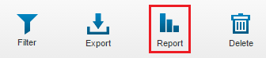

- Choose either Report for selected items or Report for all listed items.
Note: If you select Report for selected items, you must tick the applications from the list you wish to be included on the report.

- Select your report. The selected report will be dark grey (Application Benchmark in the example below).
- Select
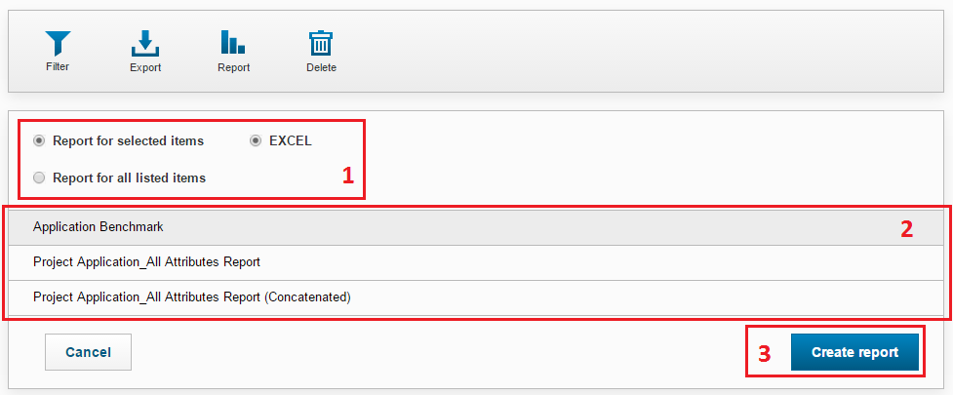
Depending on the number of applications being reported on, the report can take a few minutes to run. After clicking to create the report, you will know the report is being generated as the page icon revolves (located on the browser tab in the top left hand corner of your screen). The report will open as a Microsoft Excel file.

Filtering when Reporting
You can use filters to specify which applications are pulled into the report. Guidance on filtering can be found in the Filtering section of the guide.

If you have a filter selected when running a report, the Filter icon will turn orange:

Notes

