**CREATING DESKTOP SHORTCUTS & BOOK MARKING FAVOURITES**

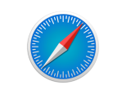  

Choose your browser by clicking on the icon above

**Chrome**

Creating a desktop shortcut

1. Open Chrome
2. Type the website address into the address bar at the top of the screen

<https://shu.converis.clarivate.com/converis/secure/login>

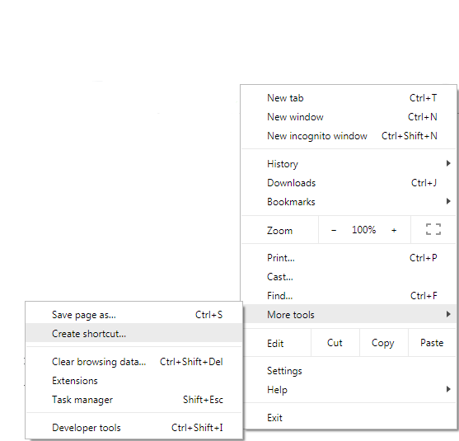

1. Click on the ellipsis menu in the top right
2. Hover over **More tools**
3. Select **Create shortcut**
4. Give the shortcut a name and click **create**

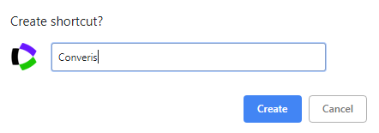

1. Double click on the icon to open Converis in Chrome

Bookmarking a favourite in Chrome

1. Open Chrome
2. Type the website address into the address bar at the top of the screen

<https://shu.converis.clarivate.com/converis/secure/login>

1. Click on the ellipsis menu in the upper right hand side
2. Hover over **Bookmarks**
3. 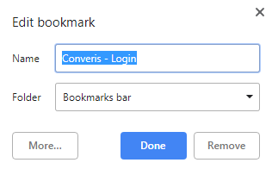Click on **Bookmark this page**
4. Give the bookmark a name, choose a folder and click done
5. Your bookmark will appear under the address bar if selected
6. Your bookmark will also appear in the drop down list

**Mac - Safari**

Creating a desktop shortcut

1. Open Safari
2. Type the website address into the address bar at the top of the screen

<https://shu.converis.clarivate.com/converis/secure/login>

1. Resize your browser so that you can also see your desktop
2. Highlight the address in the address bar and using your cursor drag and drop the address onto your desktop
3. This will create a desktop icon



1. Click on the icon to open Converis in Safari

Bookmarking a favourite in Safari

1. Open Safari
2. Type the website address into the address bar at the top of the screen

<https://shu.converis.clarivate.com/converis/secure/login>

1. Click on the **Bookmarks** menu
2. Click on **Add Bookmark**
3. Give the bookmark a name
4. Click **Add**



1. To access the bookmark, click on **Bookmarks**
2. Click on **Favourites**
3. The Converis link will be here

**Internet Explorer**

Creating a desktop shortcut

1. Open Internet Explorer
2. Type the website address into the address bar at the top of the screen

<https://shu.converis.clarivate.com/converis/secure/login>

1. Right click on any blank space on the web page
2. From the context menu which pops up, select **Create shortcut**

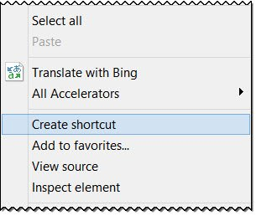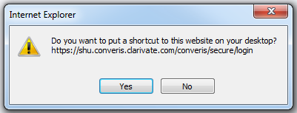

1. Alternatively you can click on the "favicon" to the left of the URL on the address bar
2. Hold the mouse button down, drag and drop onto your desktop (make sure your desktop is visible first)
3. Double click on the desktop icon to open Converis in Internet Explorer

Bookmarking a favourite in Internet Explorer

1. Open Internet Explorer
2. Type the website address into the address bar at the top of the screen

<https://shu.converis.clarivate.com/converis/secure/login>

1. On the left hand side of the favourites bar click on the **gold star** **with a green arrow**
2. The URL is automatically added to the favourites bar

1. Alternatively click on the **gold star** icon in the upper right hand corner
2. Click on **Add to favorites**
3. Name to your preference, choose a folder to create in and click **Add**

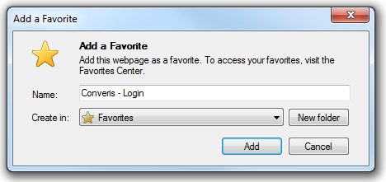

**Firefox**

Creating a desktop shortcut

1. Open Firefox
2. Type the website address into the address bar at the top of the screen

<https://shu.converis.clarivate.com/converis/secure/login>

1. Resize the firefox window so you can see the desktop
2. Click the icon on the left of the **address bar**
3. Hold the mouse button down, drag and drop onto your desktop



1. Alternatively you can drag and drop bookmarks listed in the Bookmarks menu onto your desktop
2. Double click on the icon to open Converis in Firefox

Bookmarking a favourite in Firefox

1. Open Firefox
2. Type the website address into the address bar at the top of the screen

<https://shu.converis.clarivate.com/converis/secure/login>

1. On the right hand side of the address bar click on the **Star** 

1. The star will turn blue when the page is bookmarked and a window will pop up so you can name, more or tag your bookmark

