

Converis

Ethics Review

Faculty Ethics Administrator

User Guide

Contents

1. Introduction 4

1.1. What is Converis? 4

1.2. Ethics Review in Converis 4

1.3. Responsibilities 4

1.4. Timescales 4

2. Accessing the system 5

3. Accessing help 6

3.1. Technical Help 6

3.2. Ethics Policy and Procedure Queries 6

4. Faculty Ethics Admin Emails and Dashboard 6

5. Overview of Ethics Reviews in Converis 8

5.1. Ethics Review Templates 8

5.2. Differences in process for Staff Researchers and Doctoral 8

Students 8

5.3. Being notified of Applications which require processing 9

5.4. Switching Roles 10

6. Faculty Ethics Admin Checklist & Assigning Reviewers 11

6.1. The Admin checklist 11

6.2. Assigning Ethics Reviewers 17

6.3. Moving on the application to the next stage of the process 18

6.4. Receiving confirmation that a decision has been made 19

6.5. Decision Emails 20

6.6. If a reviewer declines to Review 22

7. Resubmission Process 23

8. Post Approval Amendments 24

8.1. For applications which have previously undergone review 24

8.2. For applications which have not previously undergone review 24

9. Converis Email Notifications 25

10. Ethics Review Overseer 27

10.1 Health and Safety Team 28

10.2 Insurance Team 28

10.3 Library Team 28

11. Ethics Reporting 29

Running the Ethics Reports 29

Filters 31

Hints and Tips 32

2.10. Requests for new users to be setup in Converis 33

# Introduction

## What is Converis?

Converis is the University's Research Management System and is used to record Pre-Award Funding Applications and Ethics Reviews.

## Ethics Review in Converis

The Ethics Review module replaced the SHUREC 1 and 2 forms for all staff and doctoral research in September 2017.

The SHU [Research Ethics Policy](http://www.shu.ac.uk/research/ethics/procedures.html) should be consulted before completing the Ethics Review application in Converis.

Completing the Ethics Review application in Converis enables the University and Faculty to keep a record confirming that research conducted has been subjected to ethical scrutiny.

## Responsibilities

Collecting data without ethical approval or ethical scrutiny constitutes research misconduct under the University policy. Studies can only begin once ethics approval has been received.

The final responsibility for ensuring that ethical research practices are followed rests with the supervisor for student research and with the Principal Investigator for staff research projects.

Note that students and staff are responsible for making suitable arrangements for keeping data secure and, if relevant, for keeping the identity of participants anonymous. They are also responsible for following SHU guidelines about data encryption and research data management.

|  |  |
| --- | --- |
| **Converis Role** | **Responsible for** |
| Staff Researcher/Student | Creating the application in Converis |
| Director of Study | Signing off Students' application as ready for review |
| Ethics Reviewer | Undertaking ethical review of applications and making recommendation. Lead Reviewer responsible for making overall approval decision or escalating to FREC. |
| FREC | Making overall approval decision |

## Timescales

The target for completing Ethics Reviews is 2 weeks.

# Accessing the system

Converis can be accessed by clicking on this link:

<https://shu.converis.thomsonreuters.com/converis/secure/login>

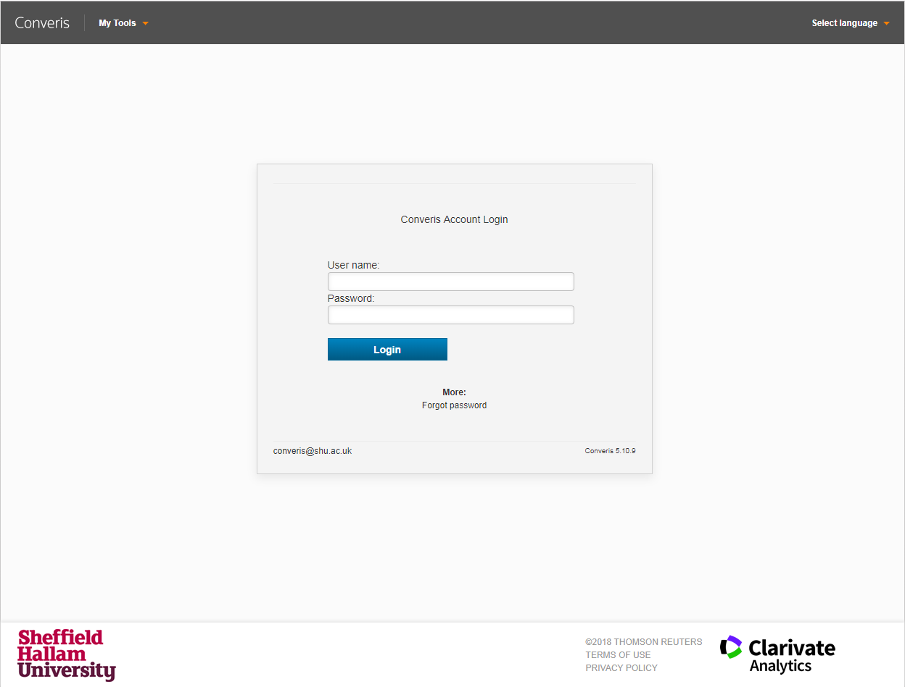

|  |  |
| --- | --- |
| **User name** | Your username is your normal SHU network login.  Students this will be your student number beginning with a letter e.g. B999999 |
| **Password** | Existing users can use current Converis password.  New Users - you will be emailed a password when you request an account.  If you have not received an email or want to change your password, you can reset your password by clicking on the **Forgot password** link from the login page. |
|  |  |
| **How to request an account** |

# Accessing help

## Technical Help

|  |  |
| --- | --- |
| Converis Support Team | [converis@shu.ac.uk](mailto:converis@shu.ac.uk) |

## Ethics Policy and Procedure Queries

|  |  |
| --- | --- |
| Research and Innovation Office | [ethicssupport@shu.ac.uk](mailto:ethicssupport@shu.ac.uk) |

# Faculty Ethics Admin Emails and Dashboard

Emails will be sent to individual Faculty Ethics Administrators and to shared Faculty Ethics email inboxes:

HWB: [hwbethics@shu.ac.uk](mailto:hwbethics@shu.ac.uk)

STA: [STAfrec@shu.ac.uk](mailto:STAfrec@shu.ac.uk)

SBS: sbsethics@shu.ac.uk

SSH: [SSH-ResearchEthics@shu.ac.uk](mailto:SSH-ResearchEthics@shu.ac.uk)

You can view and search through all Ethics Reviews within your area by clicking on Ethics Reviews on the left hand sidebar.

If you have multiple roles in the system, ensure you are in your *Faculty Ethics Admin* role.

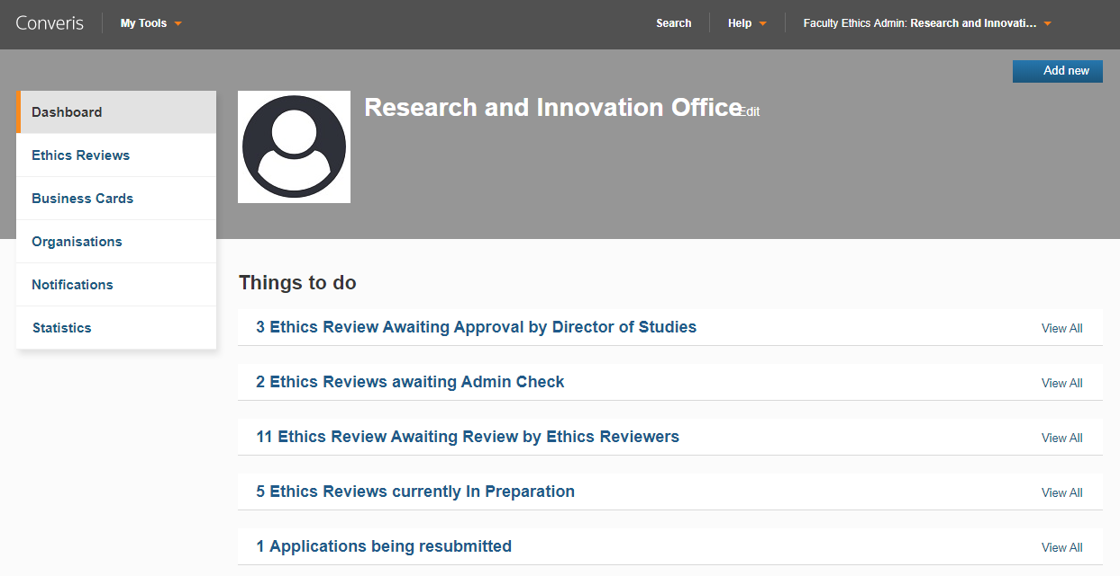

**Things to do:**

In this section, you can view applications in a variety of statuses:

* **Ethics Review Awaiting Approval by Director of Studies**

PhD applications currently awaiting approval by a Director of Study.

* **Ethics Reviews awaiting Admin Check**

Applications which require action by the Faculty Ethics Administrator.

* **Ethics Review Awaiting Review by Ethics Reviewers**

Applications currently out for Review.

* **Ethics Reviews currently in Preparation**

Applications being worked on by the applicant.

* **Ethics Reviews currently being resubmitted**

Applications being worked on by the applicant prior to resubmission.

# Overview of Ethics Reviews in Converis

## Ethics Review Templates

When a new Ethics Review is created, there are five templates that can be chosen from, each reflecting the level of risk associated with the research.

|  |  |
| --- | --- |
| **Template** | **Description/to be used for** |
| No human participants, human tissue or personal data | * Desk based reviews * Analysis of anonymised data * No interaction with human participants * Typically only in areas such as humanities, engineering and physical sciences; although not all research in those areas has no participants |
| Very low risk human participants studies | * Participants not vulnerable * No foreseeable risk of physical or emotional harm * No potential pain * Not a sensitive topic * All participants giving informed consent * No covert observation * No drugs, food substances or invasive procedures being administered |
| All other research with human participants | This is the standard ethics proforma and includes:   * Bioscience * Food science * Sport science * And most social science research |
| IRAS – projects requiring NHS or HMPPS ethics | Project is being submitted to NHS or HMPPS (prisons and probation) ethics through IRAS |
| Approval given elsewhere - another UK HEI | In the case of collaborations reviewed under another UK university's approval process. |

## Differences in process for Staff Researchers and Doctoral

## Students

The process which the Ethics Review application will follow differs slightly for **Doctoral Students** and **Staff Researchers.**

Applications for **Doctoral Students** will be approved by the Director of Studies before progressing to Admin Check. Other than this additional step, the process remains the same.

## Being notified of Applications which require processing

It is the Researchers' responsibility to create and then complete an Ethics Review on the system.

For Doctoral Researchers, once they have completed the required fields, they should change the status of the application to: **Send for Director of Studies Approval**.

The Faculty Ethics Admin will be notified by email that there is an application for them to check. The email (similar to the screenshot below) will provide details of:

* Title of the Ethics Review
* Researchers Name
* Researchers Faculty, Research Centre/Department
* ID number for the Ethics Review (note all IDs are prefixed with **ER** - so can be distinguished from Pre-Award Project Applications which are prefixed with **AA**)
* Whether the applicant is staff/doctoral Researcher

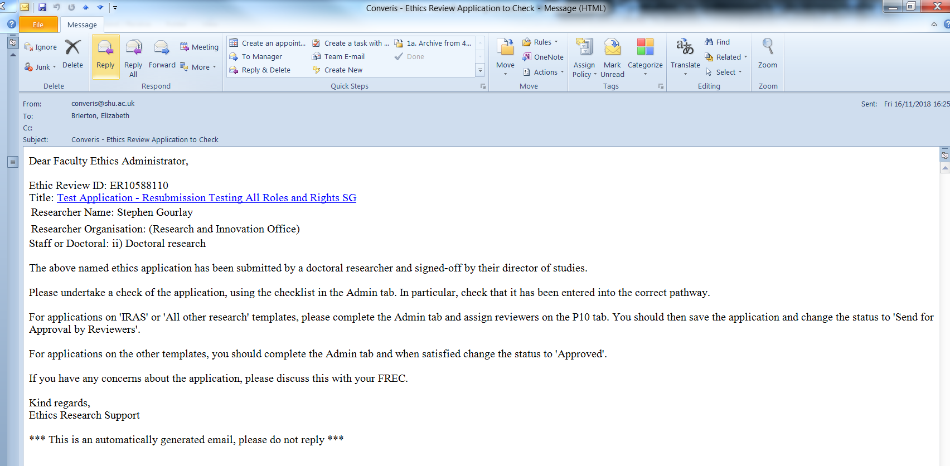

The Title of Ethics Review is hyperlinked. If you click on this, Converis will open and when you login, you will enter the application in question *if* your primary role in the system is Faculty Ethics Admin.

If your primary role is something else, you will see an '**Access Denied'** message. You will need to switch your role to Faculty Ethics Admin to be able to access the application, which you can do so via your Dashboard.

## Switching Roles

|  |  |
| --- | --- |
| Log into Converis and click on the orange arrow  next to your user role in the top right section of the screen.  Select N:\RIOStaff\Shared Folders\InfoEd replacement\11. Training\SHU\Training Guide\Complete Training Guide\Screenshots\Switching Roles #2.jpg |  |
|  |  |
| This will show all the roles which have been assigned to your user profile. Select the new role. |  |
|  |  |
| Your new roles will be shown where the orange dropdown menu is located on your Dashboard at the top right corner of the screen. |  |
|  |  |
| Every time you login you will always automatically be logged in in your standard role.  So using the example above, the role was originally **Head of Research Centre**, but was changed to **Assistant Dean**. If the user logged out at that point and logged back in, they would log in as a **Head of Research Centre** and so would need to actively switch roles again if it was required. | |
|  |  |

# Faculty Ethics Admin Checklist & Assigning Reviewers

Once you have accessed the application in the Edit Template, there are three tasks that you need to complete:

1. Undertake a check by completing the Admin checklist
2. Assign reviewers to applications that require review
3. Move the status of the application onto the next stage

## The Admin checklist

The Admin Checklist needs to be completed for *all* Ethics Review applications. It is the final tab on each template, although the number of checks that are required vary depending on which template the application is using.

There are a series of questions, which will require you to navigate to different sections of the application to check how applicants have responded to particular questions.

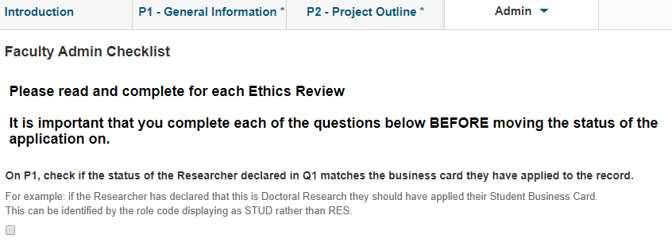

Navigate to "P1 - General Information". Look in the Role Code for the Principal Investigator and then at the response to Q1.

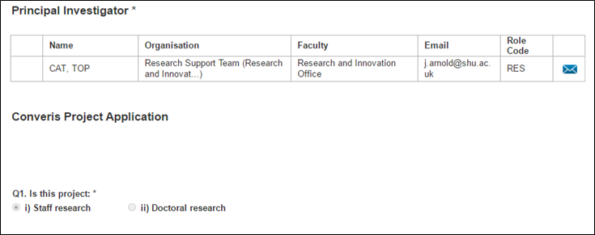

The following responses should have been given:

|  |  |
| --- | --- |
| **Role Code** | **Response to Q1** |
| RES | i) Staff research |
| STUD | ii) Doctoral research |

If the Researcher has picked the correct role code but answered Q1 wrongly, this doesn't need to be corrected.

However, if the Researcher has selected a RES role code, but has said theirs is Doctoral Research, the following information needs to be determined:

1. Is the Doctoral Research being completed at SHU? If so, follow the instructions for **Scenario a)** below.
2. Is the Doctoral Research being completed at another University? If so, follow the instructions on the **Hints and Tips** section, **page 21**.

**Scenario a)** Doctoral Research is being completed at SHU. The Researcher's Business Card needs to be corrected as the Director of Studies won't have seen, nor approved, the application (this can be checked on "P9 - Adherence to SHU Policy and Procedures"). The Director of Studies approval boxes should have been completed for all Doctoral Research being undertaken internally before the application comes for Admin check.

To correct this, follow these steps:

1. On the Admin Tab, there is a free text box **"Returning to In Preparation because"**.



1. In this box, write instructions to the Principal Investigator for swapping their Business Cards on "**P1 - General Information**".
2. Save and Close the application and change the status to: "**Record as Incorrect Pathway**".
3. Open the application again
4. Save and Close the application and change the status to: "I**n Preparation**".
5. This will generate an email to the Researcher with the instructions entered in the free text box: **"Returning to In Preparation because"**.

***See box below for steps Researcher will need to complete***

1. Once the Researcher has made the corrections they should then move the status of the Application to Send for Director of Studies Approval.

|  |
| --- |
| They will need to follow these steps:   * + 1. Switch their role to their Student Role (if they don't have a Student Role in the system, please get in touch with [converis@shu.ac.uk](mailto:converis@shu.ac.uk) to arrange that). They have to be in their Student Role in order to move their application on to Status 2: **Send for Director of Studies Approval**      * 1. At the top of P1, they will need to delete the RES Business Card off the record and add their STUD Business Card.      * 1. They should then move the application onto Status 2: "**Send for Director of Studies Approval**" |

If/when the correct business card is on the application, proceed to the next questions.

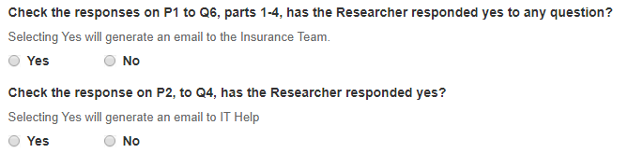

**Applications requiring a change in template**

There may be occasions when the incorrect template has been chosen by the applicant. Rather than starting the application again, it is possible to change the template, and information they have filled in will carry over to the new template (where relevant).

One particular example may be if the applicant has chosen the *Very low risk* template, but the research may involve vulnerable participants. This can be checked on P2: Q1 & Q2 and P3: Q2.

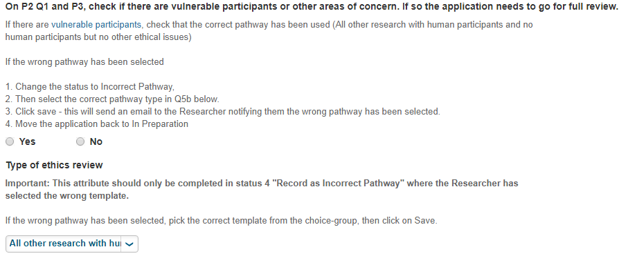

After reading the definition of vulnerable participants, check if the correct template has been used.

* 1. If the template has been wrongly selected - follow the steps below:

If the wrong pathway has been selected:

1. Click Save and Close and change the status to "**Incorrect Pathway**"
2. Open the application again. Go to the Admin Tab.
3. Select the correct pathway type.

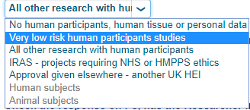

1. On the Admin Tab, there is a free text box: **"Returning to In Preparation because"**.



In this box, write instructions to the Researcher about why the application has been returned to them.

1. Click Save - then click on Save and Close.
2. Move the application back to In Preparation.
3. This will send an email to the Researcher notifying them the wrong pathway has been selected.
   1. If the template is correct = do nothing and continue with the admin checklist.

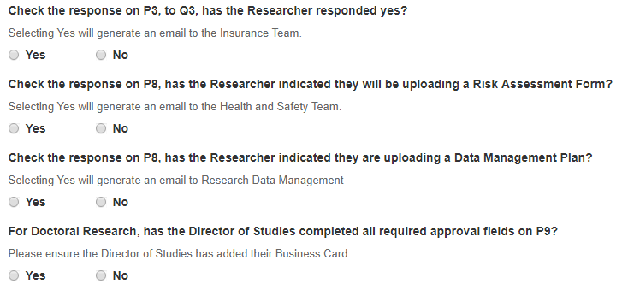

Complete the date that you have undertaken the check:

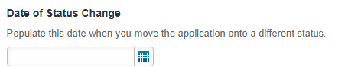

**When you have completed the check:**

1. If the application needs to be sent for Review, proceed to 6.2. If not, proceed to 6.3.

## Assigning Ethics Reviewers

The following pathways/templates will require review:

* **All other research with human participants**
* **IRAS - projects requiring NHS or HMPPS ethics**

To assign the Reviewers:

1. Navigate to the tab: "P1 - General Information"
2. Check the responses the Researcher has given to Q11 and Q12.

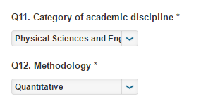

1. Next, navigate to the tab called "P10 - Review".
2. Use your faculty spreadsheet to inform your choice of reviewer.
   * There is a spreadsheet uploaded to P10 which contains STA & SSH Reviewers
3. Once you have identified the most suitable reviewers, their names need to be assigned to the Converis record:
   1. Click on the blue plus underneath the appropriate reviewer: **Lead Reviewer, Reviewer 2 and Reviewer 3:**
   2. Type in the reviewers surname and click on the magnifying glass icon

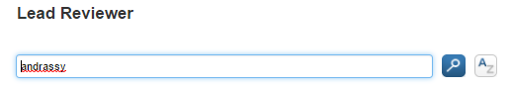

* 1. You will be presented with a list of reviewers that match your search criteria

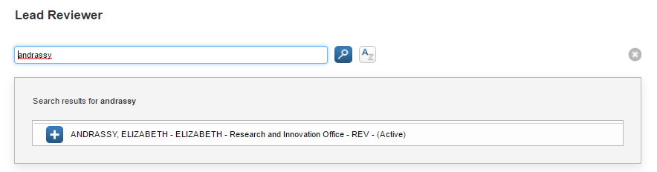

* 1. 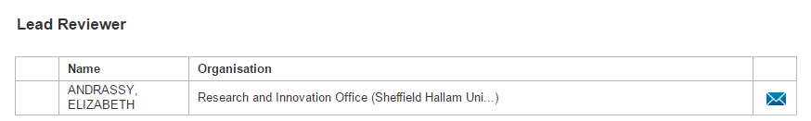Click on the blue plus icon next to the correct Reviewer to add them to the record

Once you have assigned the Reviewer's business card and pressed save, an email will be sent to notify them there is an application to review. Please remember Reviewers cannot access when the application is still in Send for Admin Check.

## Moving on the application to the next stage of the process

The template type selected by the Researcher determines the workflow step that the Ethics Review application should be moved to.

The following table indicates the route each template type should follow:

|  |  |  |
| --- | --- | --- |
| **Template** | **Move to this Workflow Status** | **What happens next** |
| No human participants, human tissue or personal data | Application Approved | Researcher is notified by email of the Awarded outcome |
| Very low risk human participants studies | Application Approved | Researcher is notified by email of the Awarded outcome |
| All other research with human participants | Send for Approval by Reviewers | Reviewers are notified by email |
| IRAS - projects requiring NHS or HMPPS ethics | Send for Approval by Reviewers | Reviewers are notified by email |
| Approval given elsewhere - another UK HEI | Application Approved | Researcher is notified by email of the Awarded outcome |

To move the workflow status on, click on the **Save & Close** button at the bottom right of the Converis screen.

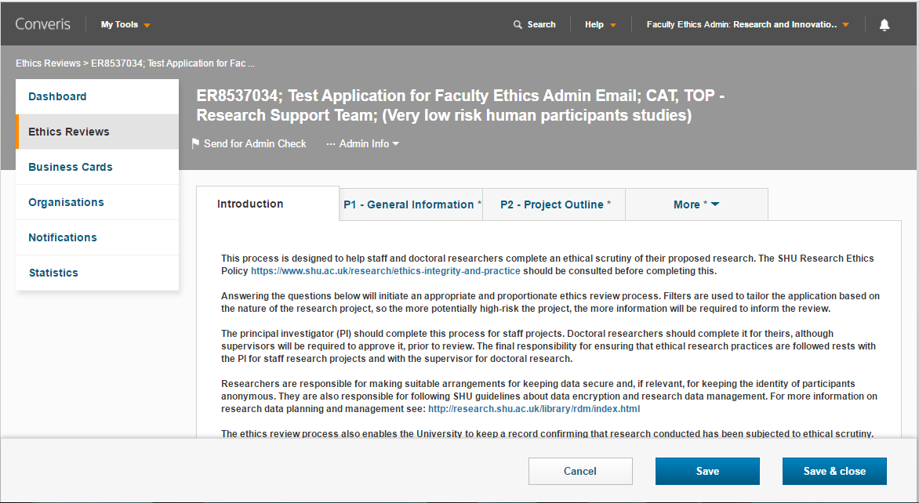

Then choose the required workflow status from the Set status box and click: **Done**.

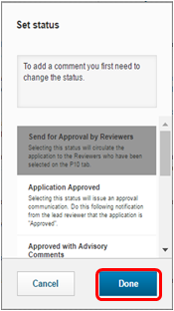

## Receiving confirmation that a decision has been made

Once you have set the status of the Ethics Review to **Send for Approval by Reviewers:**

1. The Reviewers having already received a notification will complete their individual reviews with a decision, adding comments below this decision if appropriate.
2. When the three reviews are completed, the **Lead Reviewer** should compile the comments and set the final decision at the bottom of the P10 tab.

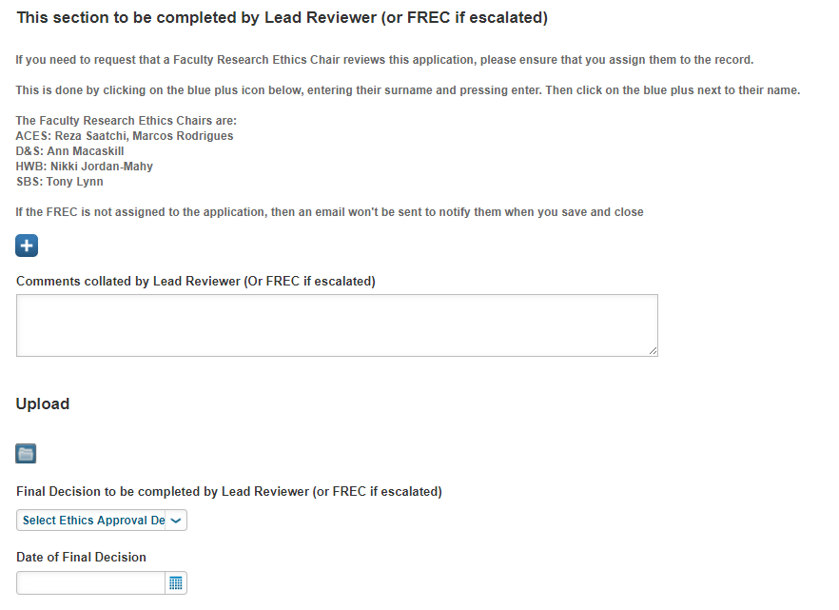

If a consensus can't be reached between the three Reviewers, the Lead Reviewer can either make a decision, or escalate the Ethics Review to the Faculty Research Ethics Chair for them to arbitrate.

The Faculty Ethics Admin will receive an email notifying them of the decision.

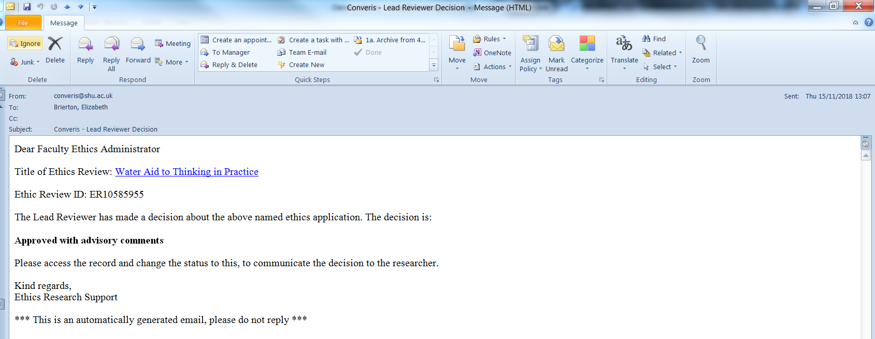

1. The administrators then enter the application and change the status so it matches the final decision

## Decision Emails

The following are examples of the emails applicants will receive when a decision is made on their application.

**Application Approved**

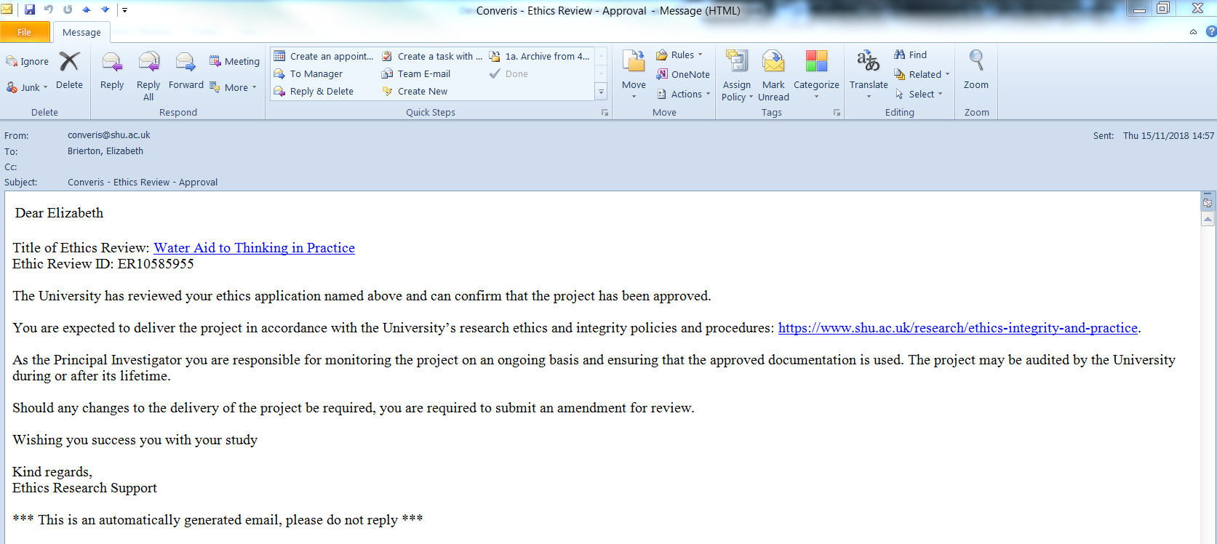

**Application Approved with Advisory Comments**

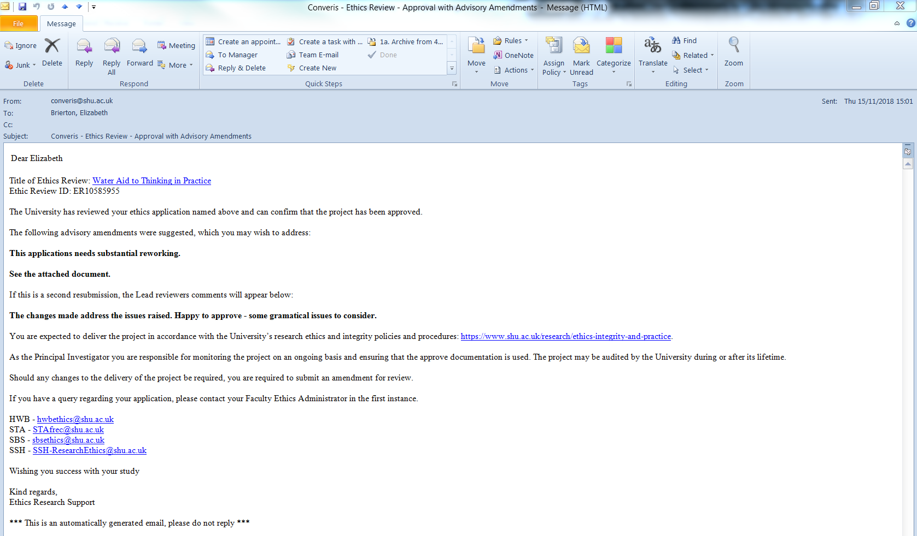

**Application Requires Resubmission**

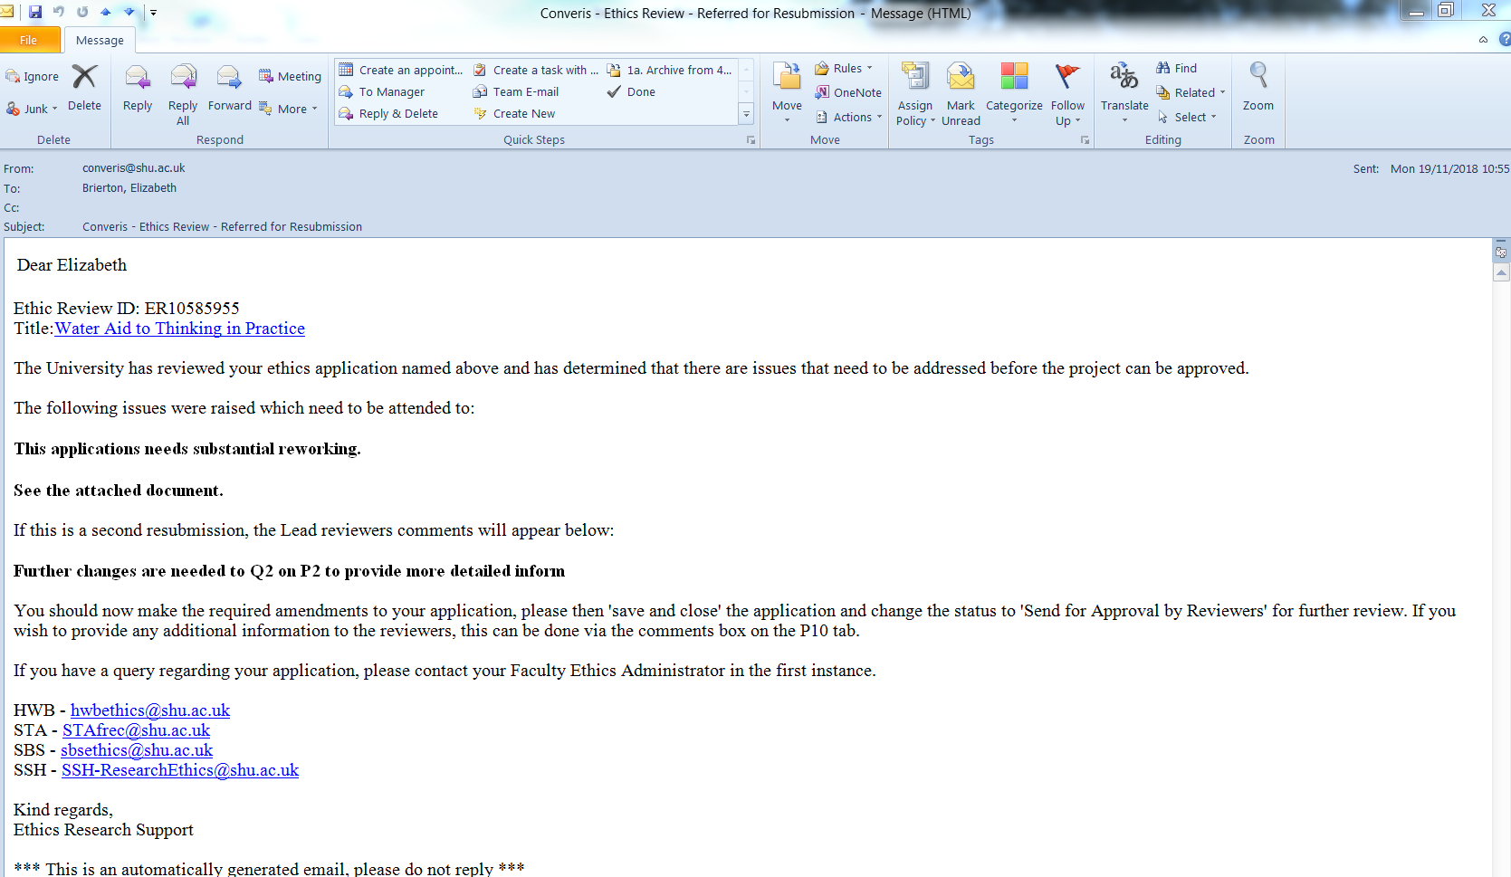

**Application Not Approved**

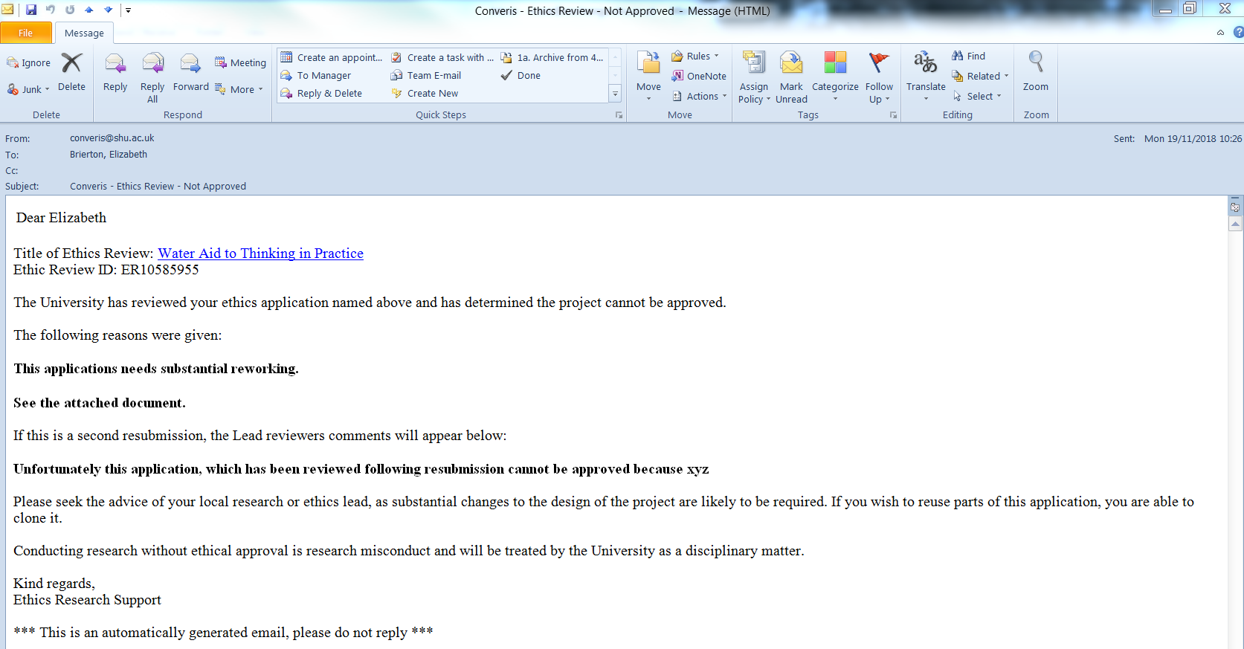

## If a reviewer declines to Review

If a Reviewer is unable to undertake an Ethics Review they are asked to complete the tick box and provide a reason why they are declining to review the application.

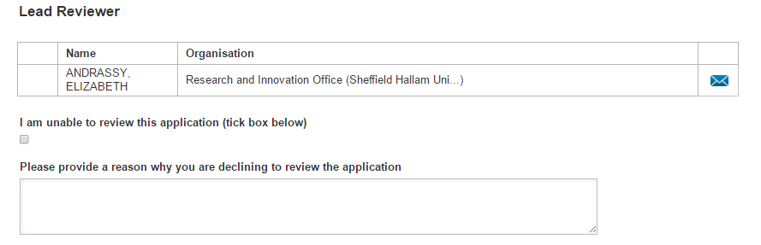

The Faculty Ethics Admin will then receive an email notification advising them which Reviewer has declined and the reason why:

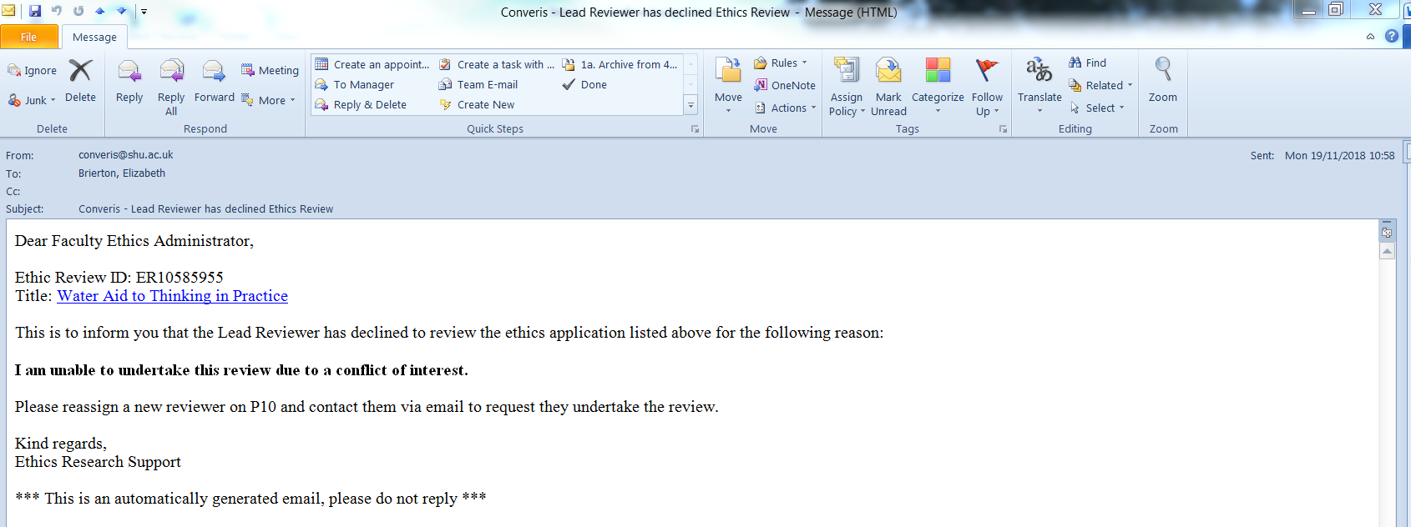

Follow these steps:

1. Delete the Reviewer in question and add a new one.
2. Remove the tick-box and comments in the decline box as shown below.

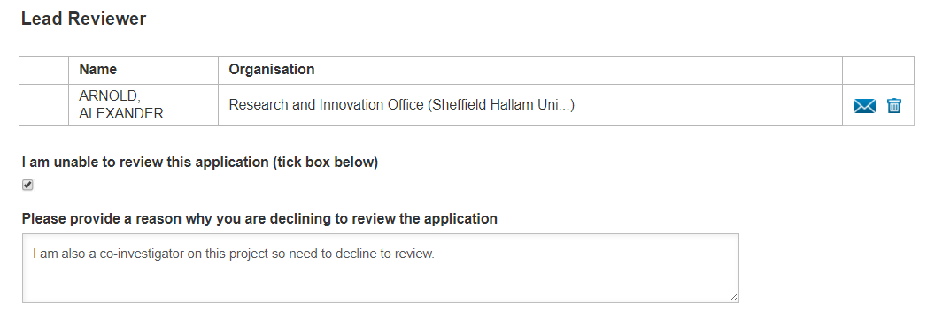

# Resubmission Process

When you receive email notification that the Lead Reviewer/FREC has made the decision that Resubmission is required:

* Change the workflow status to "Application Referred back for Resubmission".

This will send a notification email to the applicant and will contain the reasons given by the Lead Reviewer/FREC (from the Collated Comments box on the P10 tab).

The applicant can now edit the application whilst it is in "Application Referred back for Resubmission" status. This is new – previously the application had to be returned to “In Preparation” status for it to be edited.

There is a new field at the bottom of the P10 tab called “Applicants Comments to Reviewers (following resubmission)” which the applicant can use to communicate with the Lead Reviewer/FREC i.e. provide additional information.

Once the applicant is ready to resubmit, they can do this by changing the workflow status to “Send for Approval by Reviewers”. This will email the Lead Reviewer/FREC only. This is a change to the previous process where all reviewers were notified. The application won’t be sent to the Director of Study or the Faculty Ethics Administrator again for checking.

The Lead Reviewer/FREC will review the application again, and complete the "Lead Reviewers Comments Following Resubmission” box and the “Final Decision” choice-group for the second time. There is a new option in the choice-group “Second Submission Required” if further revisions are necessary. New: Now when Lead Reviewer/FREC change the choice-group for the second time, FEA will receive an email, previously this had to be checked manually.

Once FEA receive the email notification, informing them of the decision, FEA should change the status of the workflow as advised by Lead Reviewer/FREC. If second submission is required, FEA should change the workflow status to "Referred for Resubmission" as previously.

As well as the applicant, the named Director of Study and the three Reviewers will now receive an email notifying them of the outcome of the application. This has been developed in response to requests from academics for notification.



# Post Approval Amendments

When a researcher advises that they need to make minor amendments to their application after it has been approved, the following process should be followed.



# Converis Email Notifications

The following are a list of the email notifications that can be generated during the Ethics Review Process in Converis.

| **Email ID** | **Who gets the email notification** | **When is the email received?** |
| --- | --- | --- |
| 1 | PI (PhD Student) | When an applications status is changed from: Status 1 (**In Preparation**) to Status 2 (**Send for Director of Studies Approval**) |
| 2 | Director of Studies (DoS) | When a Director of Studies is listed on an application and the status is changed from: Status 1 (**In Preparation**) to Status 2 (**Send for Director of Studies Approval**) |
| 3 | PI (Staff Researcher) | When an applications status is changed from: Status 1 (**In Preparation**) to Status 3 (**Send for Admin Check**) |
| 4 | Faculty Ethics Admin | When a Staff Researcher moves an application from:  Status 1 (**In Preparation**) to Status 3 (**Send for Admin Check**) |
| 5 | PI (PhD Student) | When an applications status is changed from: Status 2 (**Send for Director of Studies Approval**) to Status 1 (**In Preparation**) |
| 6 | Faculty Ethics Admin | When a Director of Studies moves an application from:  Status 2 (**Send for Director of Studies Approval**) to Status 3 (**Send for Admin Check**) |
| 7 | PI (Staff Researcher / PhD Student) | When an application is moved from: Status 4 (**Record as Incorrect Pathway**) to Status 1 (**In Preparation**) |
| 8 | Ethics Reviewers | When a Reviewer is added to an application in status: Status 3 (**Send for Admin Check**) or  Status 5 (**Send for Approval by Reviewers**) |
| 9 | Faculty Ethics Admin | When a Reviewer declines to Review an application, they tick the box on P10, enter their reason and Save the record in Status 5 **(Send for Approval by Reviewers)**. This sends an email to the Faculty Ethics Admin. |
| 10 | Faculty Research Ethics Chair | When an application is in Status 5 (**Send for Approval by Reviewers**) and the Lead Reviewer assigns the Faculty Research Ethics Chair to the application and saves the record. |

| **Email ID** | **Who gets the email notification** | **When is the email received?** |
| --- | --- | --- |
| 11 | Faculty Ethics Admin | When a Lead Overall Decision is made on P10, either by the Lead Reviewer or the FREC. When they make that decision and save the application in Status 5 **(Send for Approval by Reviewers)**, this sends an email to the Faculty Ethics Admin. |
| 12 | PI (Staff Researcher / PhD Student) / DoS / Ethics Reviewers | When an application is moved from: Status 3 (**Send for Admin Check**) or Status 5 (**Send for Approval by Reviewers**) to  Status 6 (**Application Approved**) |
| 13 | PI (Staff Researcher / PhD Student) / DoS / Ethics Reviewers | When an application is moved from: Status 3 (**Send for Admin Check**) or Status 5 (**Send for Approval by Reviewers**) to  Status 7 (**Approved with Advisory Comments**) |
| 14 | PI (Staff Researcher / PhD Student) / DoS / Ethics Reviewers | When an application is moved from: Status 5 (**Send for Approval by Reviewers**) to  Status 8 (**Application Referred back for Resubmission**) |
| 15 | Lead Reviewer / FREC | When an application is moved from:  Status 8 (**Application Referred back for Resubmission**) to  Status 5 (**Send for Approval by Reviewers**) |
| 16 | PI (Staff Researcher / PhD Student) / DoS / Ethics Reviewers | When an application is moved from: Status 5 (**Send for Approval by Reviewers**) to  Status 9 (**Application Not Approved**) |
| 17 | Insurance | If Question 3 on the Admin Tab is Ticked **Yes**, the Insurance Team will receive an email when the application is Saved in Status 3 (**Send for Admin Check**) |
| 18 | Secure Storage | If Question 4 on the Admin Tab is Ticked **Yes**, the IT Help Team will receive an email when the application is Saved in Status 3 (**Send for Admin Check**) |
| 19 | Clinical Trials | If Question 6 on the Admin Tab is Ticked **Yes**, the Insurance Team will receive an email when the application is Saved in Status 3 (**Send for Admin Check**) |
| 20 | Health and Safety | If Question 7 on the Admin Tab is Ticked **Yes**, the Health and Safety Team will receive an email when the application is Saved in Status 3 (**Send for Admin Check**) |
| 21 | Data Management | If Question 8 on the Admin Tab is Ticked **Yes**, the Research Data Management Team will receive an email when the application is Saved in Status 3 (**Send for Admin Check**) |

# Ethics Review Overseer

If you are a member of the following: the Health and Safety, Insurance and Library Teams, you will be notified by the system for the reasons listed on the next page.

To access applications which you are notified about in Converis, please follow these steps:

1. In the email you receive, take note of the Ethics Review ID. Click on the link in the email - this will open Converis and take you to the Browse Template for the application.
2. Click on Ethics Reviews on the menu to the left of the Browse Template:

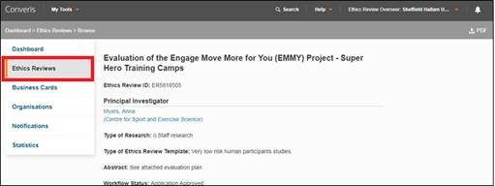

1. This will take you to the list of Ethics Reviews in the system:

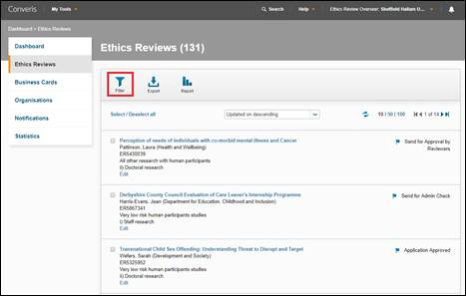

1. This will bring up some different filtering options. The first one you see is the one you want: Ethics Review ID. Put in the ID of the application in question and click apply:

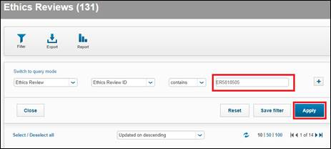

1. This will bring up the application in question. Click on the ‘Edit’ button underneath the application. This will take you into the application and you can navigate to ‘P8 – Attachments’, where the Risk Assessment has been uploaded:

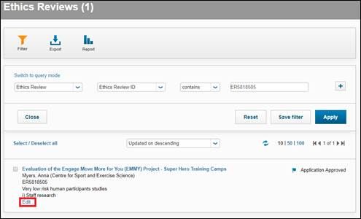

## 10.1 Health and Safety Team

For members of the Health and Safety Team, you will be notified if an applicant has uploaded a Health and Safety plan on P8 of their application.

## 10.2 Insurance Team

For members of the Insurance Team, you will be notified if a project involves at least one of these:

* Participants under the age of 5
* Participants who are pregnant Women
* 5000 or more participants
* Research being conducted in an overseas country
* Clinical trial

## 10.3 Library Team

For members of the Library Team, you will be notified if an applicant has uploaded a Data Management plan on P8 of their application.

# Ethics Reporting

There are three Ethics reports available for users to run in Converis

## 11.1 Running the Ethics Reports

When you login to Converis, ensure you are in the appropriate role to view Ethics applications. You can do this via the **Switch Roles** function in the top right corner of the screen:

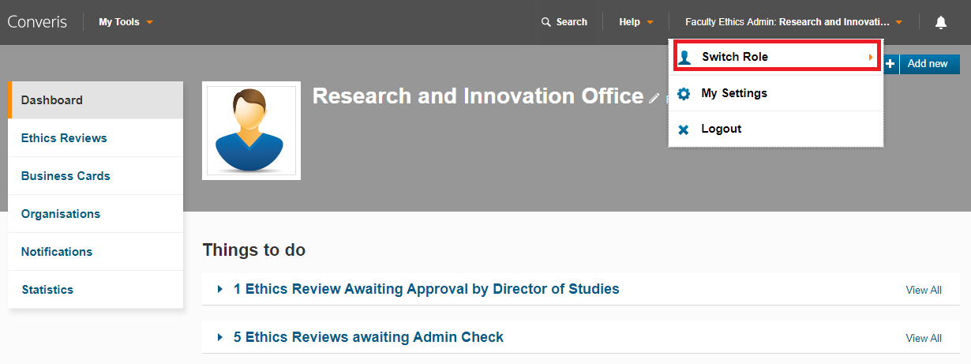

Click on **Ethics Reviews** on the left-hand side of the screen - this will take you to the List View of Ethics Review applications that you can view.

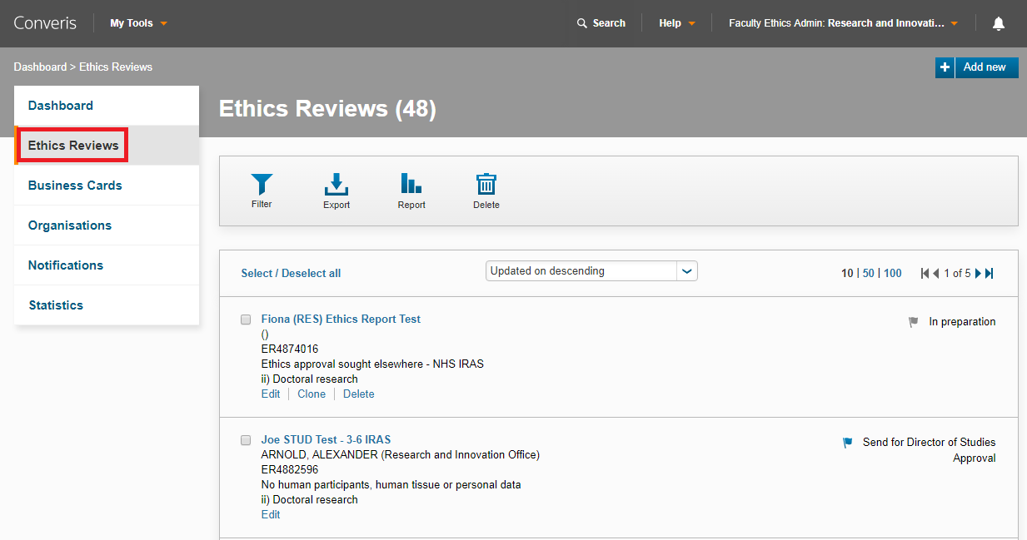

Click on the **Report** button. The reports will appear below.

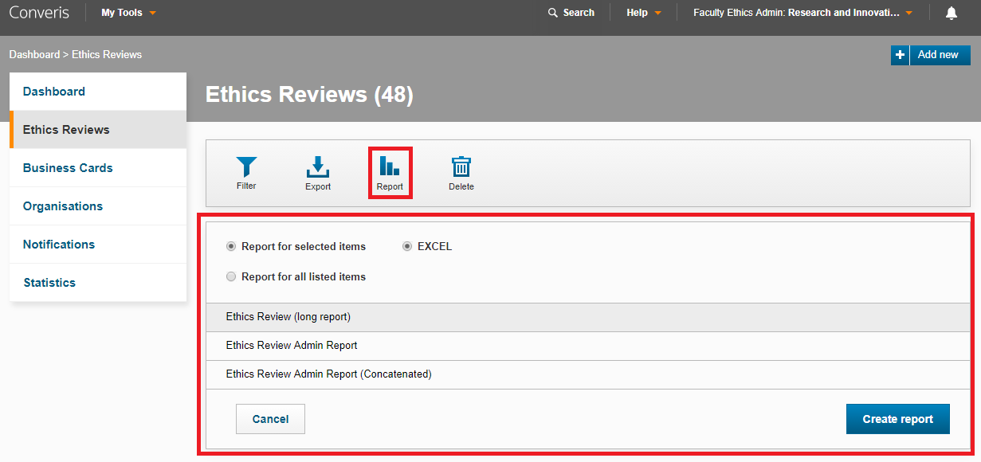

The three Ethics Review reports available are:

* **Ethics Review (long report)** - Ethics Review applications in this report will have multiple lines of data if they have two or more of any of these attributes:
  + Converis Project Applications
  + Co-Investigators
  + Funders
* **Ethics Review Admin Report** - Ethics Review applications in this report will have multiple lines of data if they have two or more of any of these attributes:
  + Converis Project Applications
  + Co-Investigators
  + Funders
* **Ethics Review Admin Report (Concatenated)** - Ethics Review applications in this report will have multiple lines of data if they have two or more of any of these attributes:
  + Converis Project Applications
  + Co-Investigators
  + Funders

Once you have selected the report you wish to run, you must select one of the following options:

* **Report for selected items** - if you select this option, you must manually tick all the Ethics Review applications you wish to be included in the report.
* **Report for all listed items** - if you select this option, all the ethics review applications you can view will be included in the report.

Click on  to run report. It will open as a Microsoft Excel file.

## 11.2 Filters

You can use filters to specify which applications are included in the report.

Click on **Ethics Reviews** on the left-hand side of the screen - this will take you to the List View of Ethics Review applications that you can view.



Click on the **Filter** button. The filtering options will appear below. When you have finished selecting your filters, click **Apply**.

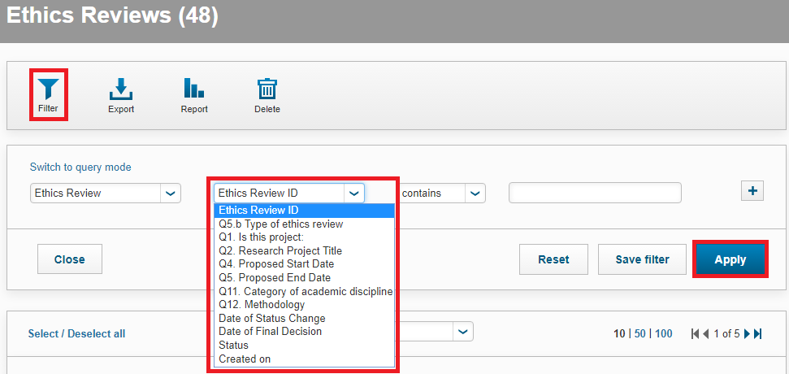

If you have a filter selected, the Filter icon will turn orange when running a report:



## 11.3 Hints and Tips

|  |  |
| --- | --- |
| When Faculty Ethics Admin clicks on the link in the notification email they get an access denied error message. | This is likely due to your account defaulting to your Pre-Award Management role.  See the guidance on page 7 about how to work around this issue.  If you continue to experience problems, please email [converis@shu.ac.uk](mailto:converis@shu.ac.uk) |
| Issues copying data from e.g. word into a Converis field e.g. abstract. | This is most likely a browser issue.  Always remember to use **Google Chrome** or **Firefox**, not **Internet Explorer**. |
| Faculty Ethics Admin isn't receiving any email notifications. | Navigate to the orange drop down on the functions menu.    Click on My Settings.   * Ensure there is a tick against **Email** and not CONVERIS Inbox. * Click Save. |
| What happens if an application is created In Preparation and is no longer needed | The Faculty Ethics Admin can delete the application from the list view page. |
| What happens when a SHU Staff Researcher is completing their PhD at another University? | 1. The Researcher should add their STUD Business Card to the record. 2. Select Doctoral Research for Q1 on tab P1. 3. They don't need to add their Director of Studies to the Record. 4. They then need to email [converis@shu.ac.uk](mailto:converis@shu.ac.uk) to move the application on. |

## 11.4 Requests for new users to be setup in Converis

|  |  |  |
| --- | --- | --- |
| **Issue** | **Who to contact** | **What information will be needed from you?** |
| A new member of staff needs to be set-up as a Faculty Ethics Admin | [converis@shu.ac.uk](mailto:converis@shu.ac.uk) | First name  Last name  Job Title  Role that they need  Which Faculty? |
| A new reviewer needs to be set-up | [converis@shu.ac.uk](mailto:converis@shu.ac.uk) | Professional Title  First name  Last name  Job Title  Role that they need  Which Faculty?  Email address  Are they internal or external to SHU? |
| A new Director of Study needs to be set-up | [converis@shu.ac.uk](mailto:converis@shu.ac.uk) | Professional Title  First name  Last name  Job Title  Role that they need  Which Faculty?  Email address |
| A new staff researcher needs to be set-up | [converis@shu.ac.uk](mailto:converis@shu.ac.uk) | Professional Title  First name  Last name  Job Title  Role that they need  Which Research Centre or Department?  Email address |
| A new doctoral student needs to be set-up | [converis@shu.ac.uk](mailto:converis@shu.ac.uk) | First name  Last name  Role that they need  Which Faculty?  Email address |