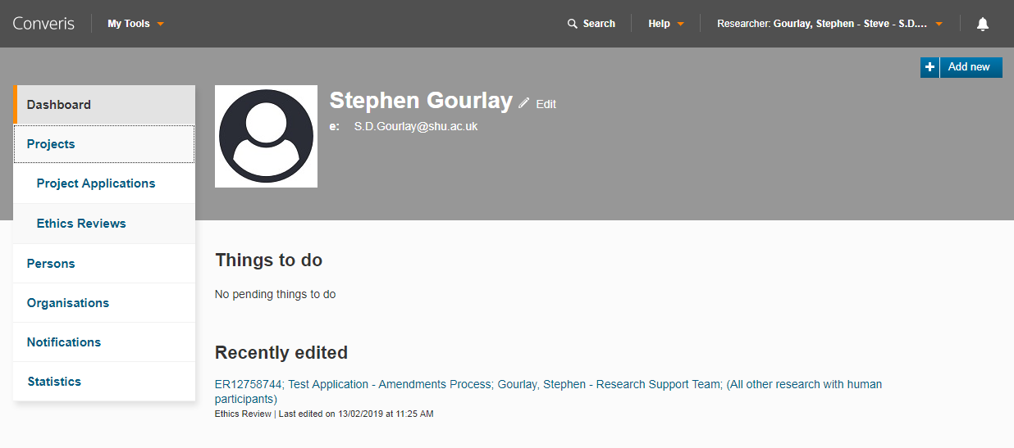
Browse Template Instructions
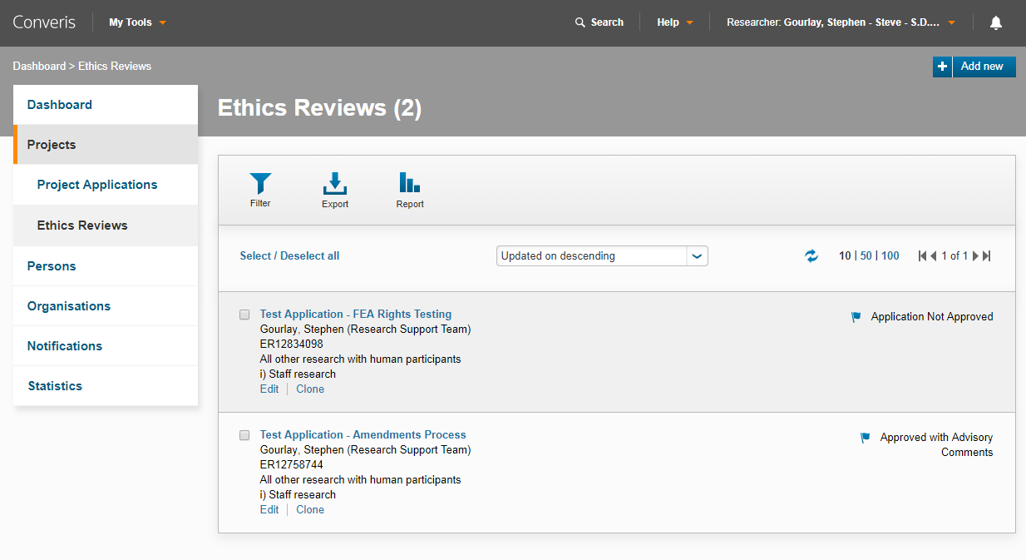
- Login or switch role to Researcher/Student
- Click on Projects
- Click on Ethics Reviews

- You will see all the Ethics Reviews you are PI or CoI for. (if required you can increase number of records to 50/100 or use the filter)
- Find the Ethics Review you would like to PDF
- Hover anywhere over the light grey box of that application
- The colour will change to a darker grey
- Click on Mouse
- Allow a few seconds for the Browse Template to load
- On the new window select PDF in the top right

