Converis User Guide

Document Title and Version: | User Guide (2.11.9)

Contents
Introduction to Converis 4
Approval to apply for external funding income 5
Comparison of regulated and non-regulated funders 6
Process for seeking approval to apply for Research Grants (Regulated funding) 7
Process for seeking approval to apply for Research Tenders and Consultancy (Unregulated Funding) 8
Converis Responsibilities 9
Accessing and Navigating Converis 10
Accessing Converis 10
Which Browser(s) to use? 10
Creating a desktop shortcut to Converis 10
Logging into Converis 12
Logging into Converis for the First Time 12
Forgotten Password 13
Password Rules 13
Navigating Converis 14
Project Application List View 15
Browse Template 15
Edit View 15
Search for existing content in Converis 16
Finding existing applications 16
Recently edited list 16
Search 16
Filtering 17
Filtering Options 18
Guidance on using dates (e.g. Academic Year) - utilising the Third Column 22
How to use multiple filters 23
Saving Filters 24
Using Saved Filters 25
Clearing Filters 25
Reporting Using Filters 26
Creating a new record in Converis 27
About the template 28
Help Completing the Template 29
Adding information to a new record in the system 30
Tab: Applicants 30
Adding New External Partner Organisations 36
Tab: Proposal Details * 38
Adding New Funders 40
Tab: Management Info * 44
Tab: Management Info (Fields to be completed by Support Contact) * 47
Tab: Financial Information * 48
Tab: Documents * 51
Opening Documents 51
Converis Document Requirements - Regulated (Research Grants) 52
Converis Document Requirements - Unregulated (Contract Research/Consultancy) 52
Moving applications through workflow - Converis Statuses 53
How to change the status of an application (using workflow) 53
Applications requiring approval - up to £100,000 54
Applications requiring approval - above £100,000 54
Authorising an application 55
Head of Research Centre, Head of Department, Director of Research Institute, Head of Faculty Finance, Assistant Dean 55
Pro Vice-Chancellor (Faculty) 59
Browse Template 59
Edit View 60
Director of Finance 63
Browse Template 63
Edit View 64
Vice Chancellor 67
Browse Template 67
Edit View 68
Updating the Workflow Status to Financial Summary Approved/Not Approved. 71
Updating Workflow Status to Submitted 72
Tab: Application Outcome 73
Awarded Grants that are transferred into the University 76
Process where activity doesn't require a Financial Summary 77
Process for Revised costings 78
Process for Recording Internal Funding 79
Two stage applications 80
Adding a Related Application 81
Non-Contractually Binding Expressions of Interest 82
Reporting 84
Benchmark Report 84
Filtering when Reporting 84
Trouble Shooting 85
Changing your password 85
Delegating Access 86
Switching roles 87
Switching on Email Notifications 88
Timing Out 88
RST - Minimum Data Entry Requirements (In Preparation Status) 89
Receiving Help from the Converis Support Team 90
Who we are 90
How to get in touch with us 90
Once your call has been closed 91
Links 91
Appendix 1: 92
Reference Guide for Gaining Approval to Apply for External Income 92
Notes 93

Introduction to Converis

Converis is a Research Management life-cycle system supplied by Clarivate Analytics.

The Pre-Award Management module has been used since February 2015 to record Research and Knowledge Transfer activity at the University.

Further information about the system can be found on the Converis Intranet page:
https://staff.shu.ac.uk/enterprise/research/converis.asp

Approval to apply for external funding income

Internal approval must be sought before applying for external income from Research Grants and Tenders/Contract Research in accordance with the University's Financial Regulations, the latest version of which is available at:
https://portal.shu.ac.uk/departments/finance/Pages/Home.aspx

Previously, the RBD1 Form was used in the University internal process for authorising Research and Knowledge Exchange activity. However, after extensive consultation with stakeholder groups, a number of fields have been incorporated into the Converis system to reduce duplication and re-keying of data, and the RBD1 form has been re-developed as a Financial Summary Form.

These changes will make the process more efficient for Academics, Support Contacts and Approvers of research proposals, and will support the review and approval of research activity within the University.

The Financial Summary Form should be used for both regulated funding (Grants) and unregulated activity (Tenders/Contract Research and Consultancy).
The form, along with guidance on how to complete it, can be found at:
https://portal.shu.ac.uk/departments/finance/Costing/Pages/Unregulated%20and%20Regulated%20Financial%20Summary.aspx

Comparison of regulated and non-regulated funders

 | Regulated | Non-Regulated
Award | Grant | Contract
Research Idea | Researcher initiated | Funder initiated (often via tender)
Research Activity | Fundamental or applied | Applied or evaluative
VAT | Grant funded research falls directly within the charitable status of the University and is typically outside the scope of VAT | Will not always fall within the definition of the charitable status of the University and may be subject to VAT
Regulations | Mandatory requirements regarding institutional and individual researcher eligibility and financial regulations | Mandatory requirements regarding Institutional eligibility only; may have to be on a preferred supplier list.
Finance | Cost-based in accordance with strict funder rules | Price-based in accordance with University pricing strategy
Intellectual Property | Owned by the University | Usually owned by the funder but can be owned by the University
Publication | Ability to publish as per usual academic practice | Publication can be restricted and is usually subject to funder approval
Outputs | No outputs guaranteed due to the speculative nature of the work but quality publications and dissemination in the public domain expected | Outputs must be delivered in accordance with tender specification and contract; dissemination is usually at the funder's discretion
Peer Review | Externally peer reviewed | Will not always be externally peer reviewed
Award holder | Usually awarded to the Principal researcher and will transfer with the lead if they move institutions | Awarded to the University who will have to provide suitable alternative staff if the principal researcher moves institutions

Process for seeking approval to apply for Research Grants (Regulated funding)

For regulated funding applications the Regulated Financial Summary (RFS) Form should be used and the following process followed.

Process for seeking approval to apply for Research Tenders and Consultancy (Unregulated Funding)

For unregulated income the Unregulated Financial Summary (UFS) Form should be used following the principles of the process below. It is acknowledged that MA/Admin responsibility for creating and uploading the UFS varies in each Faculty so local arrangements should be followed.

Converis Responsibilities

Table detailing the responsibilities of all stakeholders for both Regulated and Unregulated activity:
 | Regulated Research  Grants | Unregulated Research  Tenders/Consultancy
Create Financial Summary | Research and Innovation Office | Faculty Support Contact **
Create Record on Converis | Research and Innovation Office * | Academic
Upload Financial Summary to Converis | Research and Innovation Office | Faculty Support Contact
Circulate for approval | Faculty Support Contact | Faculty Support Contact
Faculty Authorisations  Update Status of Application from For Approval to Financial Summary Approved or Financial Summary Not Approved. | Faculty Support Contact | Faculty Support Contact
Regulated Applications where Director of Finance/Vice Chancellor Approval required  Update Status of Application from For Approval to Financial Summary Approved or Financial Summary Not Approved. | Research and Innovation Office | n/a
Unregulated Applications where Director of Finance/Vice Chancellor Approval required  Update Status of Application from For Approval to Financial Summary Approved or Financial Summary Not Approved. | n/a | Faculty Support Contact
Maintain and update Converis record post approval decision including updating workflow statuses (Submitted, Awarded/Unsuccessful) | Research and Innovation Office | Faculty Support Contact

* | RIO may request that the Academic completes some fields in Converis and will advise the Academic of the actions to take at the point of initiating the application.
** | This may be Management Accountant or Administrator - local Faculty arrangements apply.

Accessing and Navigating Converis

Accessing Converis
Converis is a web-based system, which can be accessed using this link:

https://shu.converis.thomsonreuters.com/converis/secure/login

Which Browser(s) to use?
Converis should be used in Google Chrome or Mozilla Firefox. It does not work as well in Internet Explorer, and problems have been seen when used in Safari.

Creating a desktop shortcut to Converis
Regular users of Converis may prefer to create a shortcut to the system on their desktop.
- Right Click on your desktop.  - Select New.  - Select Shortcut. |  | 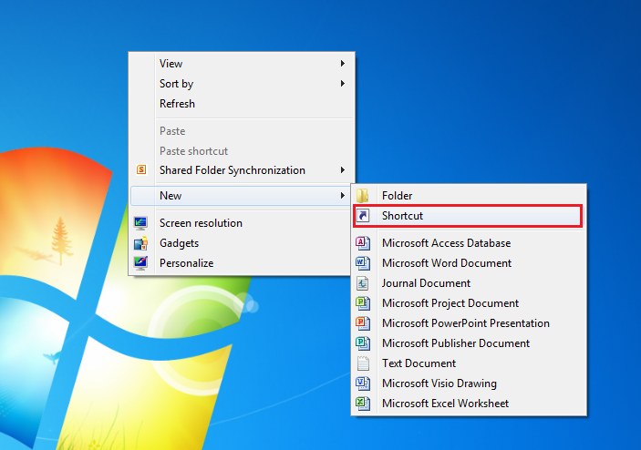
- Enter the Converis link into the "Type the location of the item" box:  https://shu.converis.thomsonreuters.com/converis/secure/login  - Click Next. |  | 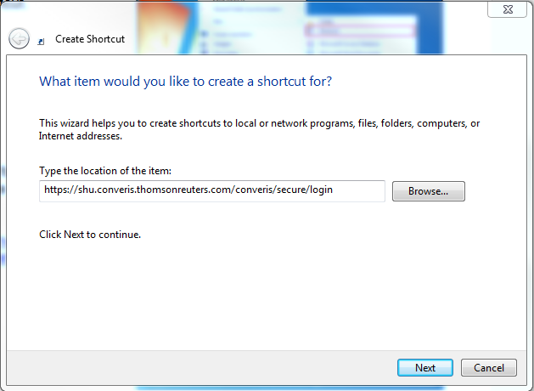
- In the 'Type a name for this shortcut' box, enter:  Converis Live.  - Click Finish. |  | 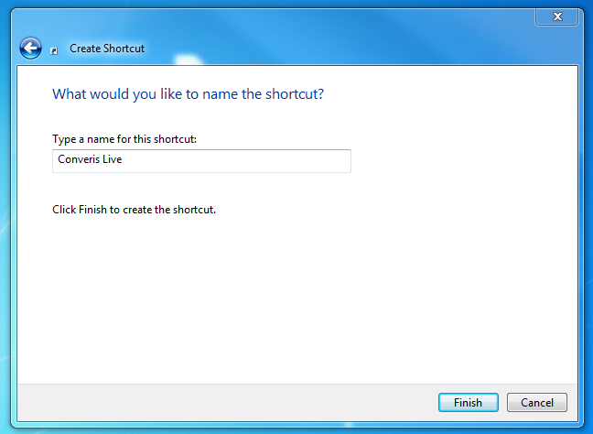
You will now have an Icon for Converis Live on your desktop.

Logging into Converis
Double click on the desktop icon to open the login screen.  Your username is your normal SHU login, for example: rbdph, Slsyyx etc…  Note: If any part of your SHU Username is capitalised, then you should copy it exactly when trying to login to Converis.  Passwords will be provided and should be changed on first login. Details of how to change your password can be found in the Changing your Password section of this guide.  Note: When logging in, click rather than pressing Enter on your keyboard. | 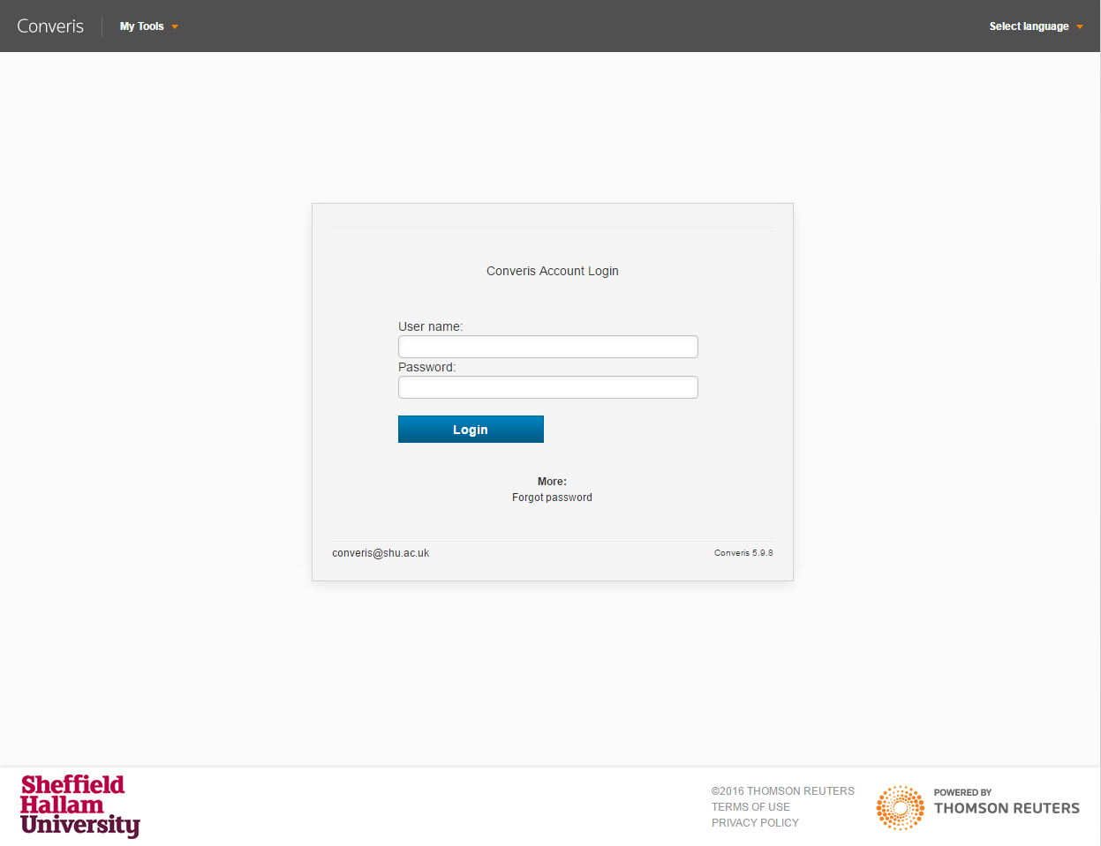

Logging into Converis for the First Time
The first time you log into Converis, you will be asked to change your password.  Enter the old password you first received via email for logging into Converis, and then enter your chosen password twice.  Click | 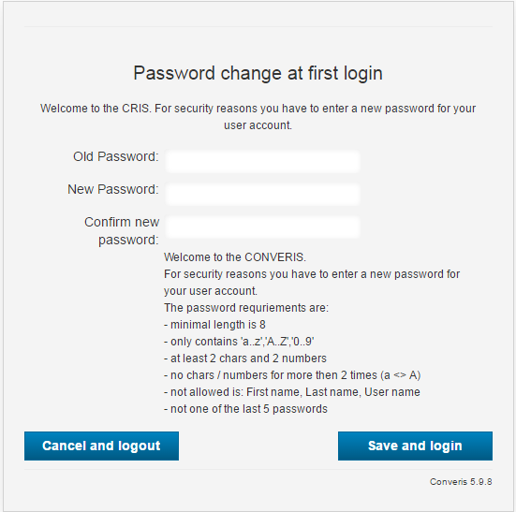

Forgotten Password
If you forget your password, click on the Forgot password link below the Login button.
Enter your username and click on
You will see the following message and should receive an email containing your new password. | 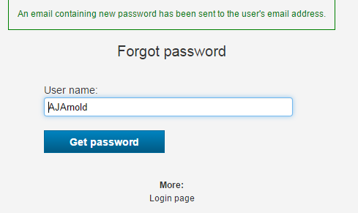
If you continue to have trouble logging in, please email: converis@shu.ac.uk

Password Rules
You will be prompted to change your password when you first log in or when you click the 'Forgot password' link as described above.

When creating a new password, it must comply with the following rules:
- Must be at least 8 characters long.
- Must contain at least two numbers.
- Must not contain any special characters (eg %^&*).
- Must not have three consecutive digits which are the same (eg aaa or 999).
- Must not use your First name, Last Name or User name.
- Must not use the word 'password'.
- Must not be one of the five previously used passwords.

Navigating Converis
After logging into Converis you will see the dashboard, similar to the screenshot below. From here, you can access all the system functions that you have rights to.

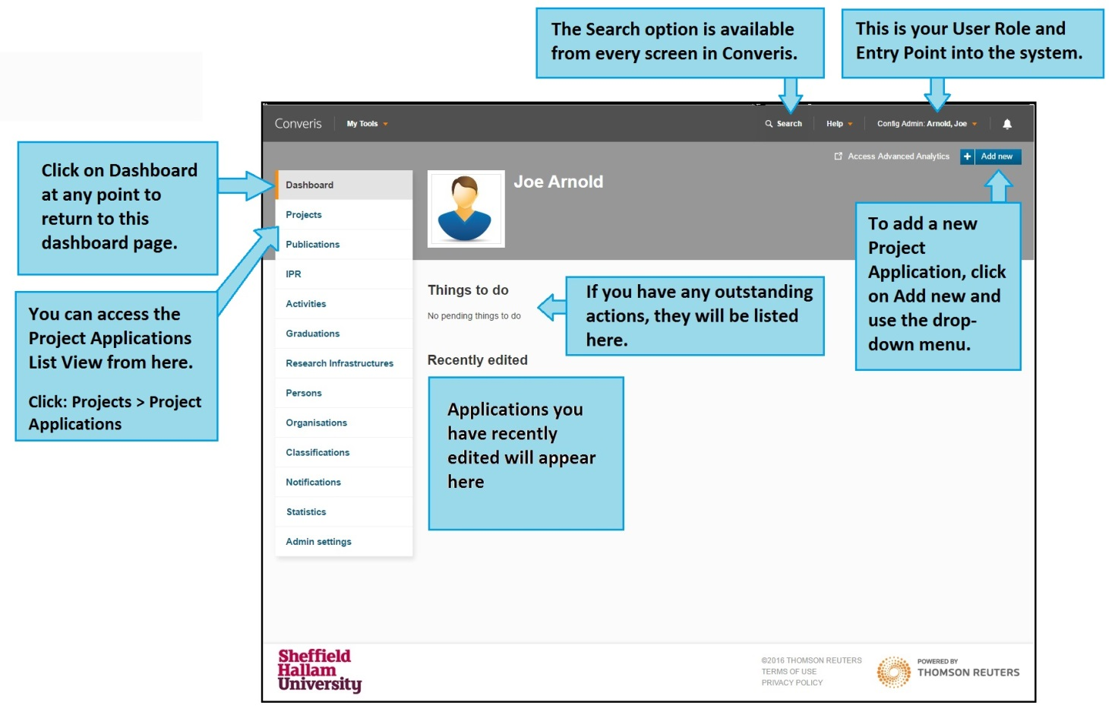

Project Application List View
To access the Project Application List View, click:
- Projects
- Project Applications.

This will bring you to a list of all the applications you can view with your role.
If you click on the title of the application, this will take you into the Browse Template of the application.

If you click on the Edit button, this will take you into the Edit View of the application.
Browse Template  The Browse Template is an overview the application. Only data which has been completed on the application will show on the Browse Template.  Click to create a PDF of the Browse Template.  Click to enter the Edit View. | 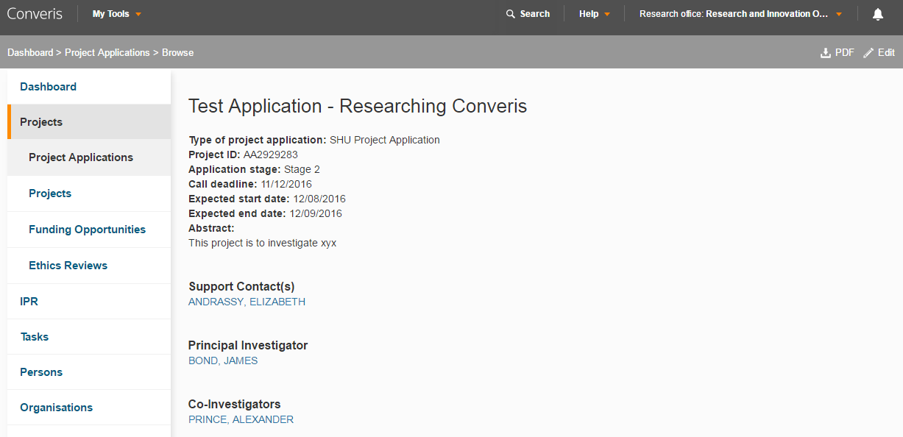
Edit View  When you are in the Edit View, you can view and update the fields within the application. | 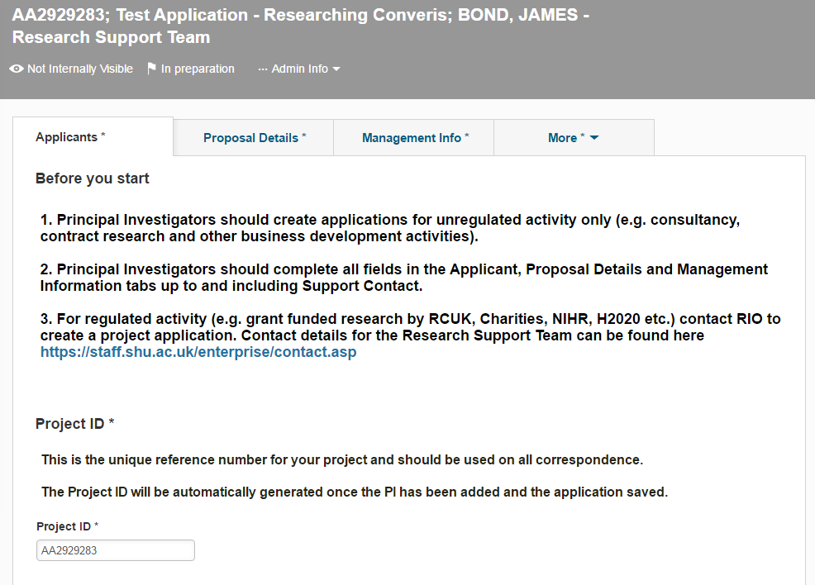

Search for existing content in Converis

Finding existing applications
There are a number of methods to find applications in Converis. The method you use depends on how much detail you know about the application.

Recently edited list
This method is useful for someone who is regularly working on a small number of applications.
The list of applications you have recently edited appears on the dashboard. This is a convenient way to quickly access content you have recently been working on.  The list contains hyperlinks (blue text). Clicking anywhere on these hyperlinks will take you directly to that application. | 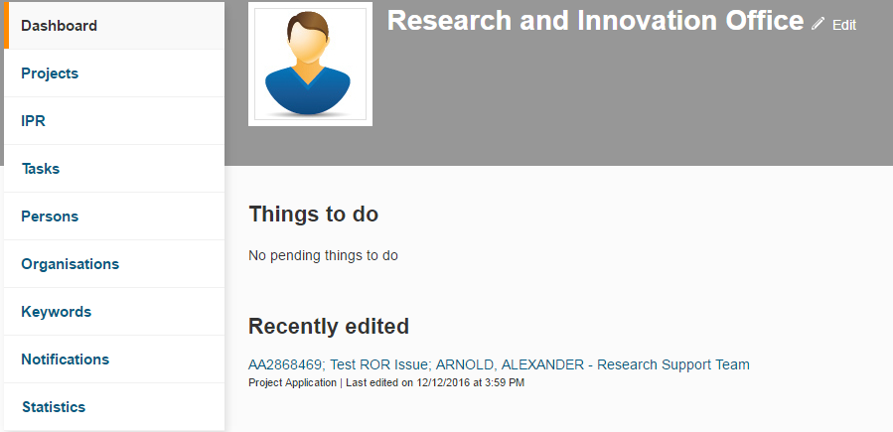

Search
Converis has a search tool which is always accessible at the top of any page.
This method is useful when you know one of the key pieces of information about an application, for example: Project ID or Title.

You can use the search box to find any application using one of the following:
- Converis ID
- InfoEd number
- Title

Note: this method cannot be used for Project Applications in Status 1: In Preparation
Click to expand the search box.
Note: where the search returns more than one record, you will be presented with a list to choose from.

Filtering
Filters can be used to tailor the results shown in the Project Application List View e.g. by Principal Investigator, Workflow Status or Centre.
- To access the filter, click on Projects.

- Select Project Applications.
- You will be presented with a list of all the application that you have access to.

At the top of this list you will see the Functions Bar - select the Filter icon.
You will be presented with the filtering options:

The selection made in the first column will determine what information you can filter on. The table below contains information on the filtering options available in the First and Second Columns.

Filtering Options

Project Applications
First Column | Second Column
Project Application  This allows you to filter by attributes within the Project Application. | Abstract
 | Activity Type
 | Actual End Date
 | Actual Start Date
 | Admin Area
 | Another UK HEI being the lead partner
 | Application stage
 | Are any staff assigned to the project on a temporary or fixed-term contract that will need to be extended to cover the project duration?
 | Awarded but Transferred
 | Awarded Sponsor Costs
 | Call deadline
 | Call Title
 | Contract and Grant Terms and Conditions Review
 | Contract Terms and Conditions
 | Corporation Tax
 | Corporation Tax Comments
 | Customer Credit Validation
 | Date Awarded
 | Date Rejected
 | E5 Number
 | European Procurement Regulations / Subcontracts
 | Expected date result will be known
 | Expected end date
 | Expected start date
 | Financial Comments
 | Funder's Reference
 | HR & Employment Issues
 | Human participants (including tissue or personal data)
 | Insurance
 | Intellectual Property
 | Is a collaboration agreement required Post Award?
 | Is a sub-contract required Post Award?
 | Joint Faculty Proposal?
 | Notes
 | Potential ethical issues
 | Potentially vulnerable participants
 | Project ID
 | Project Intellectual Property
 | Proposal Tracking No
 | Proposal Type
 | Purchase Order Number
 | Reason application not proceeding
 | Reason for Rejection
 | REF 2014 Unit of Assessment
 | Resource Requirements
 | Risk Assessment
 | Short Project Title
 | Short Title
 | SHU Involvement
 | Strategic Fit
 | Submitted Date
 | Title
 | Total Actual Contribution to Overheads
 | Total Expected Income (Excludes VAT on price)
 | Total Full economic cost
 | Type of project application
 | VAT Comments
 | VAT Type
 | Will any fixed-term research staff exceed 4 years of service as a result of this project?
 | Will new staff need to be recruited to the project?
 | Will redundancy costs or redeployment need to be considered?
 | Would the Project go through The NHS, Social Care or the Criminal Justice System Ethical Approval Processes
 | Updated on
 | Status
 | Created on

Users
First Column | Second Column
Principal Investigators  This allows you to filter by the PI assigned to application(s). | related
 | number related
 | First name
 | Last name
 | Status
Co-Investigators  This allows you to filter by the Co-I(s) assigned to application(s). | related
 | number related
 | First name
 | Last name
 | Status
Support contacts  This allows you to filter by the Support contact(s) assigned to application(s). | related
 | number related
 | First name
 | Last name
 | Status

Organisations & Funders
First Column | Second Column
Internal Organisation  This allows you to filter internally by:  - Faculty  - Institute  - Research Centre  - Department  When searching for Internal Organisations, it is best to use the Tree View finder to locate the area you are searching for: | Related
External Partner Organisations  This allows you to filter by the External Partner Organisations assigned to application(s). | related
 | number related
 | Acronym
 | Alternative Name
 | Name
 | Type of organisation
 | Previous Name of Organisation
 | Status
Funders  This allows you to filter by the Funders assigned to application(s). | related
 | number related
 | Acronym
 | Alternative Name
 | Name
 | Type of organisation
 | Previous Name of Organisation
 | Status

Guidance on using dates (e.g. Academic Year) - utilising the Third Column

When on Project Application (First Column), the options for dates (Second Column) are:
- Call deadline
- Expected end date
- Expected start date
- Submitted Date
- Date Rejected
- Actual Start Date
- Actual End Date
- Expected date result will be known
- Date Awarded
- Updated on
- Created on

In the Third Column, you are presented with a dropdown list, and the options can include:
- Equals - if you are looking for applications on a specific date.
- Before - if you are looking for applications before a specific date.
- After - if you are looking for applications after a specific date.
- Between - if you are looking for applications between specific dates (e.g. Academic Year - example in screenshot below)
- Is empty
Use the calendars to select specific dates.

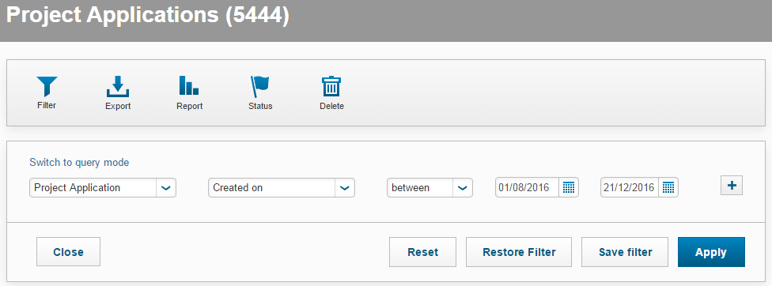

How to use multiple filters
It is possible to apply multiple filters to tailor your results, but care must be taken to avoid applying conflicting requests. Where conflicting filters are applied, '0' applications will be found. This is because the filters are to match one criteria AND another, not one criteria OR another.

For example, you can apply a filter that returns all applications for a particular academic that are in 'Awarded' status. However, you cannot apply a filter that returns all applications in 'Awarded' or 'Unsuccessful' status.

To apply a multiple filter, use the to the right of the Search Box. This will bring in a new row below your initial filter(s).

To remove a row, use the
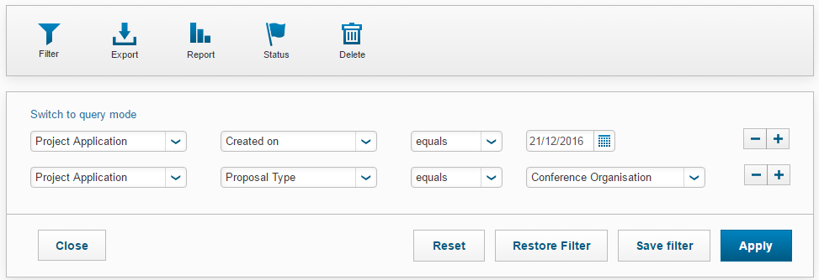

Saving Filters
You can save regularly used filters in order to bypass the problem of having a large list of attributes to search through.

Example: Project ID

In order to locate applications in Status 1 (In Preparation) using their Project ID number, you will need to use filters rather than the search bar. If you do this regularly, you can save a filter which enables you to quickly search using Project ID numbers.

On your Dashboard, click Projects > Project Applications.

Click on to open the filtering options.

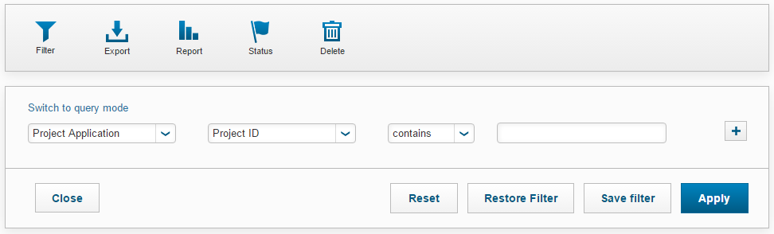

- First Column: Project Application
- Second Column: Project ID
- Third Column: contains

Leave the Search Box blank and click

A 'Save filter settings' box will appear. Write Project ID in the box and click

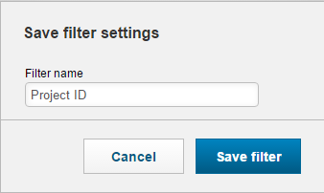

Using Saved Filters
On your Dashboard, click Projects > Project Applications.

Click Restore Filter.
This will open a new window. The filter you used most recently will show up. | 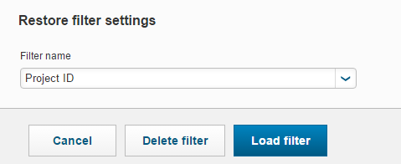
From the dropdown list select your chosen filter.
Click Load filter.

Deleting Saved Filters
To delete saved filters, click

Clearing Filters
When you wish to remove a filter and return to the full overview of all Project Applications in your area, Click to clear the filters.

Reporting Using Filters
A further use of the Filter function is to tailor data before you run a report.

For example, if you wanted to produce an Excel report of all the 'Awarded' applications funded by The British Academy, before you ran the report you could apply the following Filter Criteria:

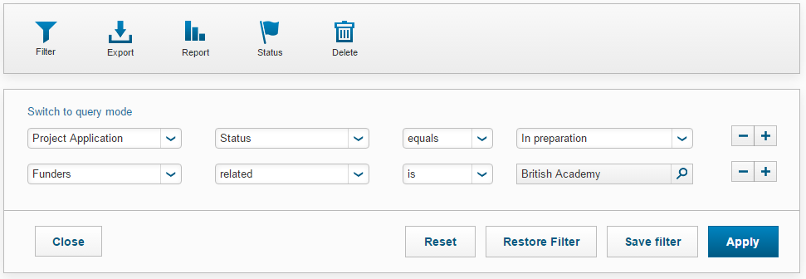

When you have selected the appropriate filters, click

You would then be able to run the report on the filtered data. More information on reporting, including how to run a Benchmark report, can be found in the Reporting section of the guide.

Creating a new record in Converis
- From the Dashboard, click on:
- Add new
- Projects
- Project Application

- You will be asked to select the Project Application type. Select:

Note: You should always select SHU Project Application for both internally and externally funded proposals and for all types of R&KT activity (including consultancy).

All other options are disabled, even if they are still displayed.

About the template

A blank project template will now be available for completion. The application template consists of 11 sections (tabs).
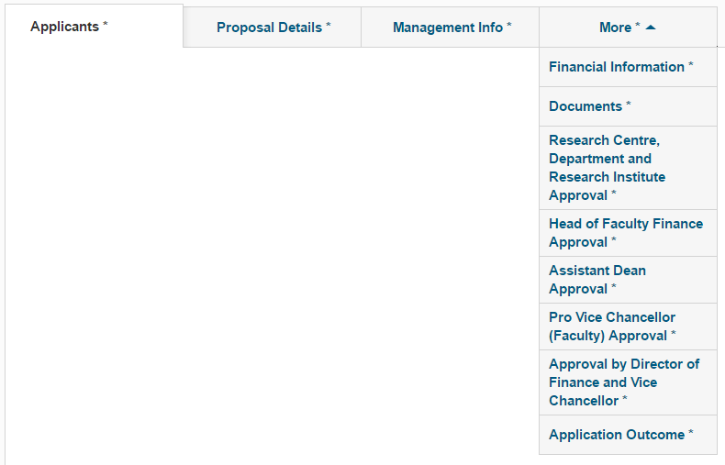
The Applicants, Proposal Details and Management Info tabs will always be visible at the top of the application. The fourth tab will can be changed by clicking on the small arrow and selecting a new tab. All authorisation tabs can be located this way.

To create an application and prepare it ready for approval, the following tabs must be completed:

- Applicants
- Proposal Details
- Management Info
- Financial Information
- Documents

Help Completing the Template
Hint Text  Some fields have hint text available (in italic font) to assist with completion. | 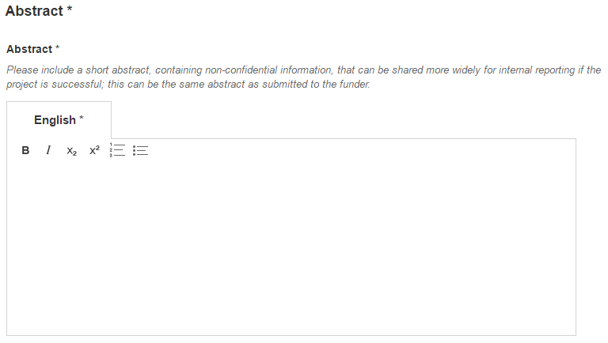
Help Text
Some sections have a which contains helpful information for completing that section.

To read the information, hover over the

If there is a link (see example) in the help text, you can select it by right-clicking your mouse while hovering over the. This will allow you to move the cursor across to the help text and click on the link; this will open it in a new tab.

You must click before opening links to documents or web pages that are found in the help text.
Mandatory Fields *
Mandatory Fields have an * next to them; this means they must be completed before the status of the application can be changed from 'In Preparation'.

Adding information to a new record in the system

Tab: Applicants
Please consider this text at the top of the Applicants tab before proceeding.

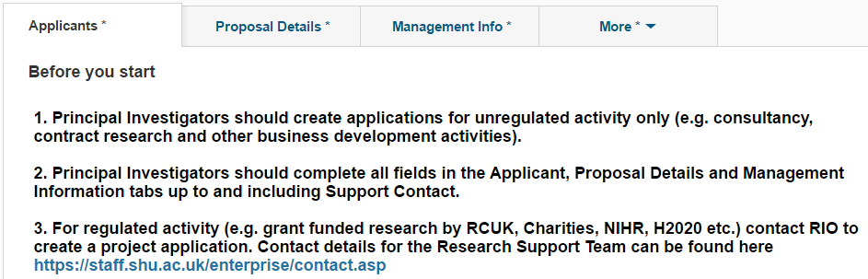
The Project ID is the unique identifier for the application in Converis. It will be automatically generated once the Principal Investigator (PI) has been added and the application saved.  This field appears at the top of each tab as you progress through the template. | 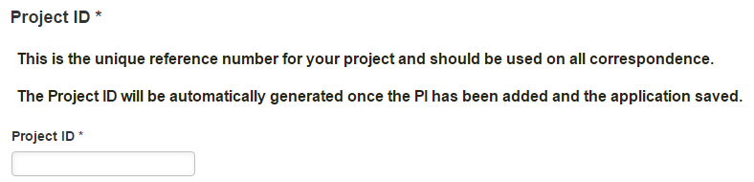
A Principal Investigator (PI) must be added before progressing.

If you have not saved an application before adding a PI, you will be presented with an error message and you will not be able to retrieve the application. However, a record will have been created, which may result in duplicate records and inaccurate reporting.

Note for KTPs: The Principal Investigator field should be used to record the Supervisor.
Note for Researchers: When you create a new application you will automatically be assigned as the Principle Investigator. | 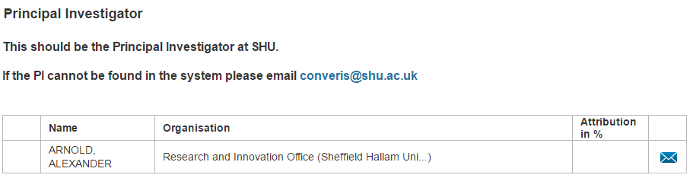
Note for Support Contacts: If you are creating an Application on behalf of someone else, please follow the steps on the next page.
To add the PI, click on the button.  There are two methods for finding the PI:  - Type their name into the search box using the following nomenclature:  Arnold, Alexander > Click on the magnifying glass icon to search.  - Search Alphabetically | 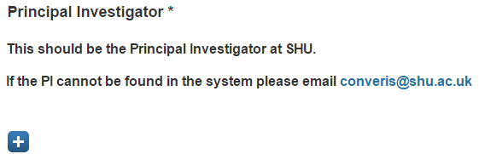
 | 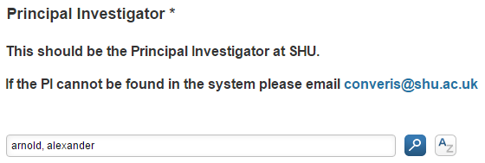
Once you have selected the PI, click on the to add the PI to the application. | 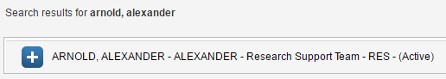
The PI will then be attached to the record. If an incorrect PI has been added, you can remove them by clicking: | 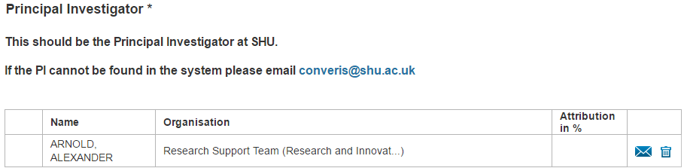
If the Principal Investigator cannot be found in the system, please email converis@shu.ac.uk with the following information:

- Professional Title (Professor / Dr)
- Official First Name
- Preferred First Name
- Last Name
- Job Title
- Research Centre / Department
It is recommended that after attaching the PI to the application, you save the record by clicking - this will generate the Project ID.
You can now move backwards and forwards between tabs. However, the information entered into the fields is not automatically saved. It is therefore recommended that you click on at regular intervals to avoid losing information.

The button does exactly what it says, and will close the record you are working on as well as saving the data that has been entered. You will have to confirm the status of the application when you click this button.

The following fields should be completed (as applicable).
Co-Investigators  If there are any Co-Investigators who are based at SHU, click the | 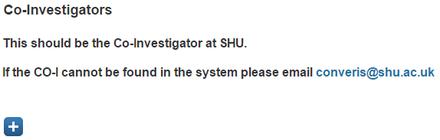
There are two methods for finding the Co-Investigator:  - Type their name into the search box using the following nomenclature:  Bond, James > Click on the magnifying glass icon to search.  - Search Alphabetically | 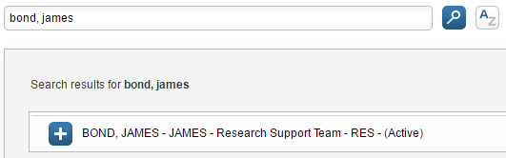
Once you have selected the Co-I, click on the to add them to the application.
The Co-I will then be attached to the record. If an incorrect Co-I has been added, you can remove them by clicking: | 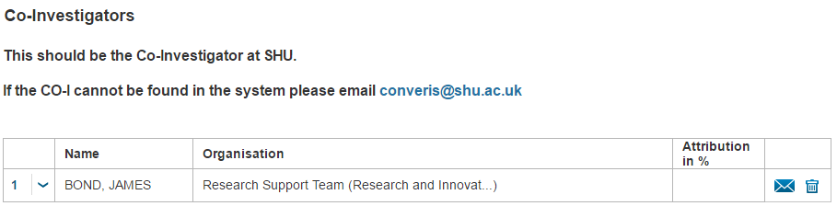
If the Co-Investigator(s) cannot be found in Converis, please email converis@shu.ac.uk with the following information:

- Professional Title (Professor / Dr)
- Official First Name
- Preferred First Name
- Last Name
- Job Title
- Research Centre / Department
PI's Unit of Assessment  REF2014 Unit of Assessment *  Select the PI's unit of assessment (UOA) using the drop down menu.  Help Text is available by hovering the cursor over the | 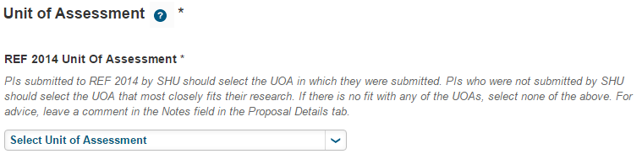
Joint Proposal *  Joint Faculty Proposal? *  If the proposal involves staff or resources from another Faculty, select 'Yes' from the drop down menu.  If 'Yes', click the | 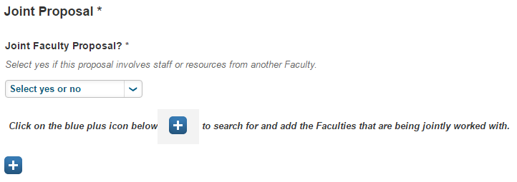
There are three methods for finding the correct Faculty.
a) Type the name into the
search box and then click
b) Search Alphabetically
c) Search through the faculties
using the
Ensure you click on the next to the Faculty name to add it to the bid.

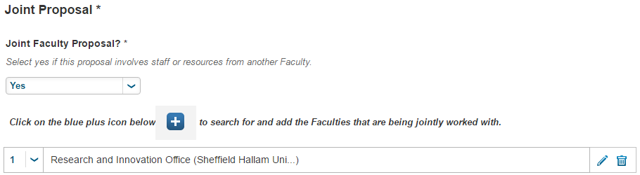

SHU Involvement *  Select how SHU are involved in the project using the dropdown list. | 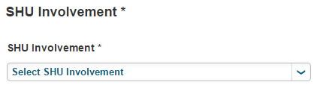

Lead Institution  If SHU is a partner on an application, you should list the institution which is leading the application here.  To add the Lead Institution, click the | 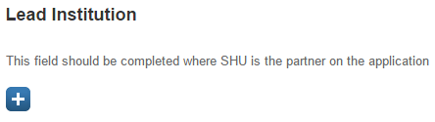
There are two methods for finding the correct External Partner Organisation.
a) Type the name into the
search box and then click
b) Search Alphabetically
Once you have located the organisation, click on the
If the organisation is not in the system, you can add new External Partner Organisations to Converis. Click the
Instructions on adding new organisations can be found on pages 36 and 37.

External Partner Organisations
In order to add an External Partner Organisation to the Application, click the

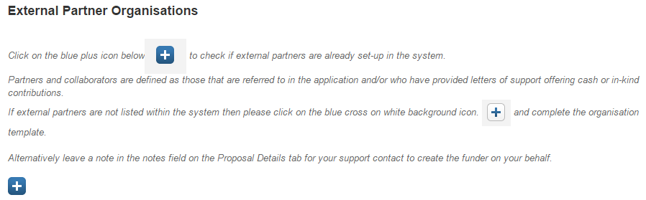
There are two methods for finding the correct External Partner Organisation.
a) Type the name into the
search box and then click
b) Search Alphabetically
Once you have located the organisation, click on the
If the organisation is not in the system, you can add new External Partner Organisations to Converis. Click the
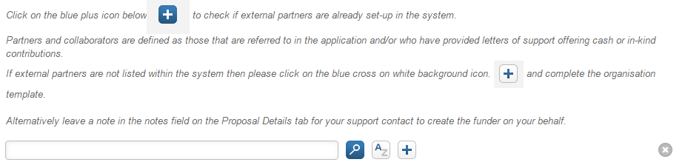
Before adding a new external organisation, please be certain that it doesn't already exist otherwise duplicate entries will be created resulting in inaccurate reporting.

Adding New External Partner Organisations
Name  Enter the legally registered name of the external partner. | 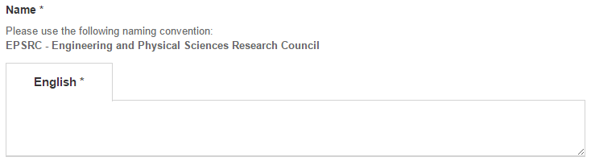
Acronym
Enter an Acronym if known (e.g. BBSRC)
URL
If the partner has an official URL, it must be entered in the following format:

http://www.organisation.org
Country
Select the country of location using the
Type in the search box the name of the Country and then click or
search alphabetically
Once you have located the country, click on the | 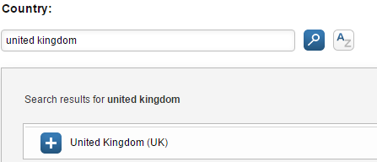
The Country will be added to the record.
Internal or external
Always select external.

Type of organisation
Select the most appropriate option from the choice group. If you do not know the type of organisation, please select Unknown.
Is selectable
Always select yes.
Is Funder
Always select yes.

This is to avoid duplicate records being created where an organisation is both an External Partner and a Funder.
When you have completed filling in the required information, click  The Set status box will open. Leave the status as Active and click  You will then be returned to the Project Application template. | 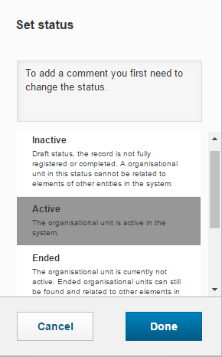

Tab: Proposal Details *
Information about the Project
Type of project application *
This is automatically set to 'SHU Project Application'. This cannot be changed.
Project ID *  This field will be automatically populated once the application is first saved.  Proposal Tracking No:  This relates to historic data and you do not need to complete this field. | 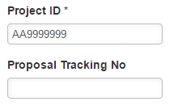
Title and Description
Title*
Add in the Title of the project in the text box provided. This should be the full project title as recorded on the funder application form.

Short Project Title *
Add the Short Project Title in the text box provided. This will be the name of the budget on E5 and must be 30 characters or less (including spaces).

Funders *
In order to add a Funder(s) to the Application, click the
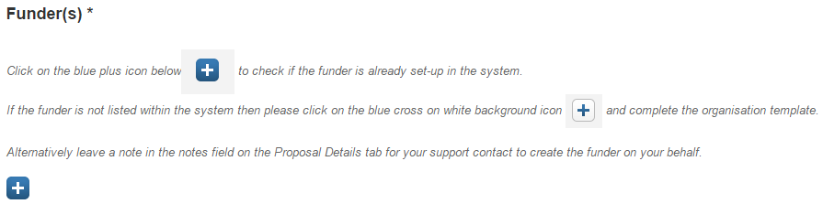
There are two methods for finding the correct Funder.
a) Type the name into the
search box and then click
b) Search Alphabetically

Once you have located the organisation, click on the
If you have mistakenly added a Funder, click the
If the organisation is not in the system, you can add new Funder Organisations to Converis. Click the

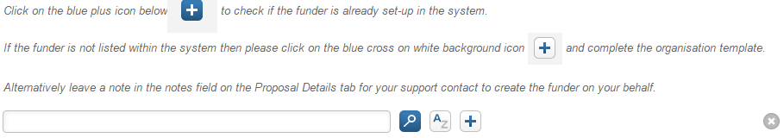
Before adding a new external organisation, please be certain that it doesn't already exist otherwise duplicate entries will be created resulting in inaccurate reporting.

Adding New Funders
Name
Enter the legally registered name of the Funder.

Acronym
Enter an Acronym if known (e.g. BBSRC)
URL
If the Funder has an official URL, it must be entered in the following format:

http://www.organisation.org
Country
Select the country of location using the
Type in the search box the name of the Country and then click or
search alphabetically
Once you have located the country, click on the
The Country will be added to the record.
Internal or external
Always select external.

Type of organisation
Select the most appropriate option from the choice group. If you do not know the type of organisation, please select Unknown.
Is selectable
Always select yes.
Is Funder
Always select yes.

This is to avoid duplicate records being created where an organisation is both an External Partner and a Funder.
When you have completed filling in the required information, click

The Set status box will open. Leave the status as Active and click

You will then be returned to the Project Application template.

Call Title
Insert the Call Title if applicable in the text box provided.
Dates
Dates are in the format DD/MM/YYYY, and can be free-typed or entered via the calendar.

If you are typing dates, as opposed to selecting from the calendar, please ensure that you use a forward slash (/) between DD/MM/YYYY; other forms of separator such as ‘-‘ are invalid and will not be recognised by the system.

Select dates for:  - Call deadline  - Expected date result will  be known *  - Expected start date *  - Expected end date *  - Date of First Contact | 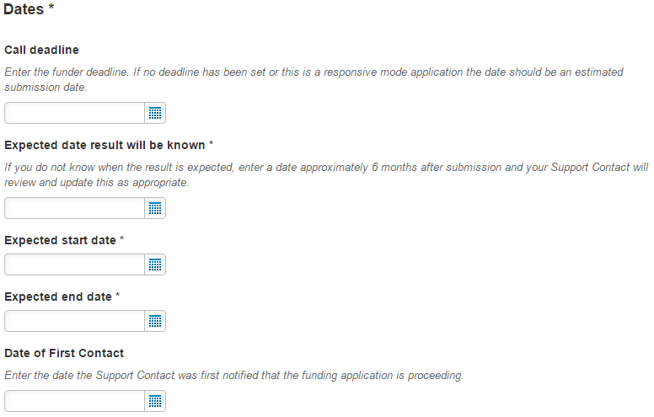
Abstract *
The abstract should be entered into the text box provided.

Note: Please ensure no confidential information is included in the Abstract.
Application stage *  You can select the Application stage using the dropdown list. | 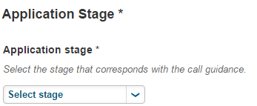
Related Application  If your application is linked to another project record in Converis, press the | 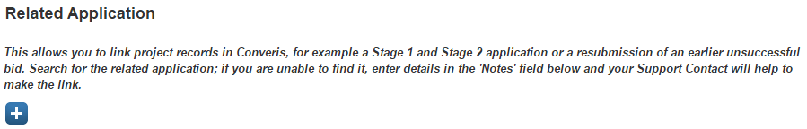
There are two methods for finding the correct Related Application:
- Type the Name or the Project ID into the search box and then click

- Search Alphabetically
Once you have located the Project, click on the to link it to the current application.
If you have mistakenly added an application, click the
Notes
Any notes to the Support Contact to assist with completing necessary fields and application support can be included in the text box provided.
Progress  This field can help to track the development of the application so the support teams are clear on tasks that have been completed and those in progress or outstanding. For example: draft costs with PI for review. | 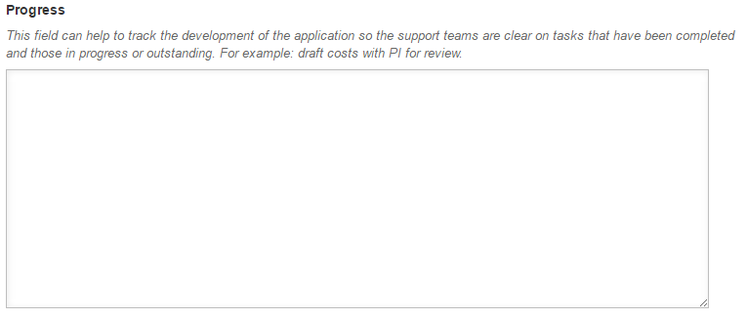
Comments for authorisers
Any notes to authorisers which could assist the authorisation process can be included in the text box provided.

Tab: Management Info *
Project ID *
This field will be automatically populated.
Strategic Fit *
The strategic fit of the work should be included in the text box provided.
Resource Requirements *
The resource requirements of the work should be included in the text box provided.
Risk Assessment *
The risk assessment of the work should be included in the text box provided.

Ethics *  Select either the Yes or No radio button for each question.  If you answer Yes for the question, "Other potential ethical issues" please include details in the text box provided.  Help Text is available by hovering the cursor over the  Detail any reputational risks, such as a topic of a particularly sensitive/contentious nature or a funder who may be considered controversial, which could potentially bring the University into disrepute. Methodological ethical issues should not be detailed here - they will be considered as part of the ethics review procedure. | 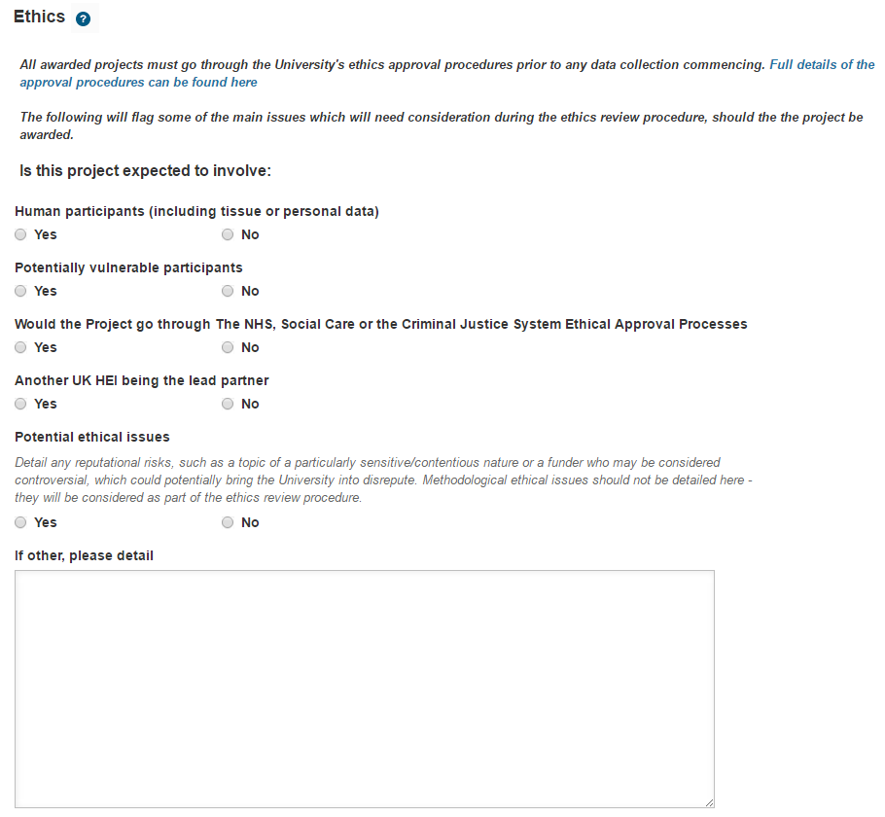
Human Resources *
Select either the Yes or No radio button for each question. If you answer Yes for any of the questions, please provide supporting information in the text box provided.

Help Text is available by hovering the cursor over the
Admin Area *  Select the Admin Area from the dropdown menu. | 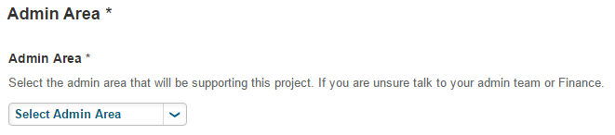

Support Contact(s) *
To add the Support Contact(s) for your project, click the
There are two methods for finding the PI:
- Type their name into the search box using the following nomenclature:

Arnold, Alexander > Click on the magnifying glass icon to search.

- Search Alphabetically

Once you have located the correct Support Contact, click on the to link them to the current application.
You can add multiple Support Contacts. If you mistakenly add an incorrect Support Contact to your application, you can remove them by clicking: | 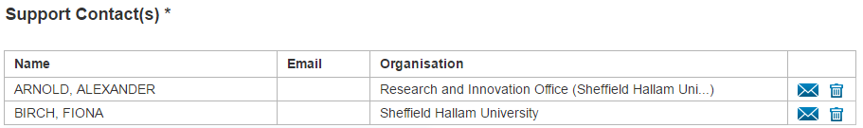

Academics should now email their Faculty Support Contact with the Project ID to notify them that the project application is ready for them to work on.

Tab: Management Info (Fields to be completed by Support Contact) *

Contract Terms and Conditions *
Select the Contract Terms and Conditions from the dropdown menu.

Use the radio buttons to answer the first two questions.

Further information on Contract and Grant Terms and Conditions Review should be entered into the text box provided.
Intellectual Property *
Select the Project Intellectual Property from the dropdown menu.

Further details should be entered into the text box provided.

Submitted Date
Input the submission date at the stage when the workflow status will be updated to Submitted.

Dates are in the format DD/MM/YYYY, and can be free-typed or entered via the calendar.

If you are typing dates, as opposed to selecting from the calendar, please ensure that you use a forward slash (/) between DD/MM/YYYY; other forms of separator such as ‘-‘ are invalid and will not be recognised by the system.

Tab: Financial Information *

The Financial Information * tab is the first option when you click on the fourth tab dropdown list.

Project ID *
This field will be automatically populated.
Proposal Type *
Select the Proposal Type from the dropdown menu.
Activity Type *  Select the Activity Type from the dropdown menu.  You can refer to the VAT Matrix available here:  https://portal.shu.ac.uk/departments/finance/Costing/Pages/RDB1-and-Authorisation.aspx. | 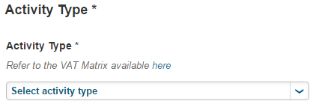
Costs *  All of the information for these fields should be copied from the Financial Summary into the boxes provided:  - Total Full economic cost  - Total Actual Contribution to Overheads  - Total Expected Income (Excludes VAT on price)  - Consortium Value Requested | 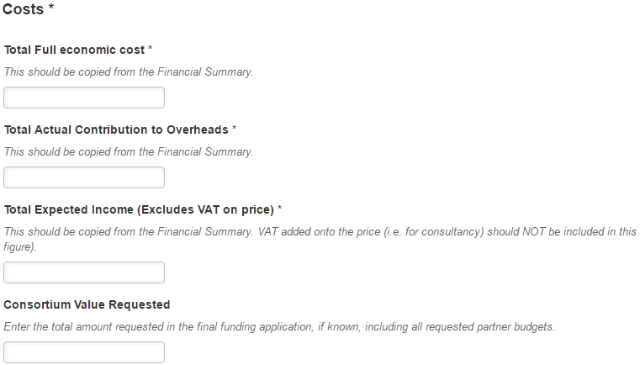
Customer Credit Validation *
This information should be included in the text box provided.

Help Text is available by hovering the cursor over the
VAT *
Select the VAT Type from the dropdown menu. You can refer to the VAT checklist available by clicking the link below:

https://portal.shu.ac.uk/departments/finance/Costing/Documents/Copy%20of%20SHU%20-%20VAT%20checklist%20-%20V4%2010-04-15.xlsx.

Associated comments can be included in the text box provided.

Help Text is available by hovering the cursor over the
Corporation Tax *
Select the Corporation Tax from the dropdown menu. You can refer to the Corporation Tax Decision Table available here:
https://portal.shu.ac.uk/departments/finance/Costing/Pages/RDB1-and-Authorisation.aspx.

Associated comments can be included in the text box provided.

Insurance *
Include information about Insurance in the text box provided.
European Procurement Regulations / Subcontracts *
Information relating to European Procurement Regulations / Subcontracts should be included in the text box provided.

Help Text is available by hovering the cursor over the
This process is managed by the Strategic Procurement Team who can be contacted by emailing the Strategic Procurement Team on: strategic@exchange.shu.ac.uk
Financial Comments
Any financial comments can be included into the text box provided.
Note: The Financial Comments field was previously known as "Management Accountants Comments" and should be utilised in the same way.

Tab: Documents *

The Documents * tab is the second option when you click on the fourth tab dropdown list.

Project ID *
This field will be automatically populated.
Official Documents
Clicking on the blue here will open up a Microsoft Word document detailing the documentation required for different types of applications. It also includes the types of documents supported by Converis. This information can also be found on the next page.

To upload documents, click on . Documents need to be selected one at a time. Once you have selected your chosen document, click Open.
You can select the Document Type from the dropdown menu.  Provide a description in the text box provided. | 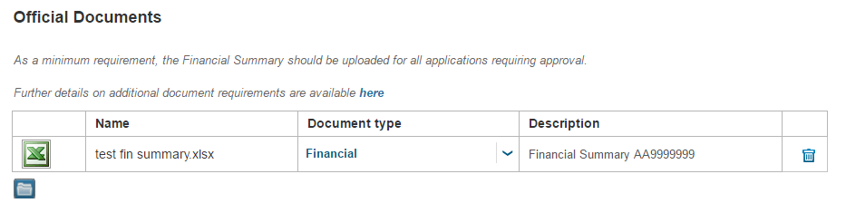
If you have mistakenly uploaded an incorrect document, click the to remove it.

Opening Documents
The way documents open depends on what type of document they are. For common document types uploaded to Converis:
- .xlsx - opens automatically.
- .xls - you have to save this document before opening it.
- .docx - opens automatically.
- .doc - you have to save this document before opening it.
- .pdf - you have to save this document before opening it.

Converis Document Requirements - Regulated (Research Grants)
Converis Status | Converis  Document Type | Minimum Document Requirements | Additional documents that can be uploaded to support the minimum documents requirements - this will be judged on a case by case basis and will be largely dependent on the funder and the application process
For Approval | Financial | Financial Summary | VAT Checklist | SHU cost | SHU income | Submission costs | Partner costs | Overall Project budget
Submitted | Scientific | Final application form submitted to funder & supporting documents | Application outline | Application second stage | Application resubmission | Application e-form | Case for support | Equipment quote | Finance forms | Academic CVs
 |  |  | Data Management/  technical plan | Justification of Resources | Impact plan | Visual material | Letter of support | Publications/  Bibliography | Gantt chart
Unsuccessful and Awarded | Administrative | Application outcome - letter from funder | Award letter | Rejection letter | Invitation to negotiation
Unsuccessful and Awarded | Administrative | Reviewer comments | Reviewer feedback | Evaluation report | Review summary | Response to review
Awarded | Legal | Grant terms and conditions | Grant special clauses | Grant preparation forms | Grant amendment | Grant transfer | Grant termination | Grant acceptance
Awarded | Legal | Collaboration Agreement (if project involves external partners to SHU) | Variation to collaboration Agreement | Partner accession/  withdrawal | Novation agreement
Awarded | Legal | Other agreements | Memorandum of Understanding | Materials Transfer Agreement | Confidentiality Agreement
Transferred | Administrative | Confirmation from funder that the grant can be transferred
Transferred | Administrative | Grant transfer letters from originating and accepting institutions
Transferred | Legal | Contract Amendments (if required)

Converis Document Requirements - Unregulated (Contract Research/Consultancy)
Converis Status | Converis  Document Type | Minimum Document Requirements | Additional documents that can be uploaded to support the minimum documents requirements - this will be judged on a case by case basis and will be largely dependent on the funder and the application process
For Approval | Financial | Financial Summary | VAT Checklist | Costings Template
For Approval | Administrative |  | Ethics Forms

File Types and Size
Converis supports the following file types:
- Document related - doc, docx, ppt, pptx, pdf, ps, rtf, txt, xls, xlsx
- Image related - gif, jpg, jpeg, png, tif.
  - Two common file types which are no longer supported by Converis are .xlsm files and .msg files. To upload .xlsm documents, resave them as .xls or .xlsx files. To upload .msg files (emails), resave them as .txt or copy and paste the email into a .doc or .docx file.

The system does not restrict the file size. However, files larger than 50 MBytes are not recommended.

Moving applications through workflow - Converis Statuses
Applications can only be moved from 'In Preparation' once all of the mandatory fields have been completed. If mandatory fields are incomplete, you will receive a warning message and will need to either complete the fields or leave the application as 'In preparation'.

Project Applications are assigned to one of 10 statuses in the system:
1 | In Preparation
2 | For Approval
3 | Financial Summary Approved
4 | Financial Summary not Approved
5 | Submitted
6 | Approved but not submitted
7 | Submitted but withdrawn from funder
8 | Awarded
9 | Unsuccessful
10 | Archived

Users can move applications between the different statuses depending on their role (and the associated rights) in the system.

How to change the status of an application (using workflow)
Once the details of an application have been captured in the Converis template and the record is saved - it is automatically assigned Status 1 - "In Preparation".

To push the application through for authorisation, the status of the record must be updated to Status 2 - "For Approval" (Note: this will generate the email notification to authorisers).
- Navigate to the Edit View of an application.
- Click
- Select For Approval from the choice-group and then click Done.

Applications requiring approval - up to £100,000
Once the status has been moved to 'For approval', an email containing a link to the application will automatically be sent to the following authorisers:
- Head of Research Centre/Head of Department
- Director of Research Institute (MERI only).
- Head of Faculty Finance
- Assistant Dean

Applications requiring approval - above £100,000
For applications greater than £100,000, or those requiring higher levels of authorisation for non-financial reasons, the support contact will need to email the additional authorisers as they will not be emailed automatically.

(FEC cost) | Signatory
Above £100,000 to £500,000 | Pro Vice-Chancellor (Faculty)
Above £500,000 to £2,000,000 | Director of Finance
Above £2,000,000 | Vice Chancellor

Note: When emailing these authorisers, the Support Contact will need to add a copy of a link to the application.

When copying the link:
- If you are in the Browse Template, the authoriser will arrive in the Browse Template of the application.
- If you are in the Edit View, the authoriser will arrive in the Edit View of the application.

A PDF of the Browse Template can be downloaded and attached to the email to the authoriser. When on the Browse Template, click

 | Authorising an application
 | Head of Research Centre, Head of Department, Director of Research Institute, Head of Faculty Finance, Assistant Dean
Once an application has been assigned a status of "For Approval" an email will be sent to the following authorisers:
- Head of Research Centre/Head of Department
- Director of Research Institute (MERI only)
- Head of Faculty Finance
- Assistant Dean

The email will contain the following information:
- The title of the application. This is also the link to the application.
- The funder(s)
- Details of the Type of Proposal e.g. Research Grant, Consultancy, Knowledge Transfer Partnership.
Note: Authorisers in SBS should review this information to determine who should authorise the application dependent on whether the application is research or other activities.
- The Support Contact.
Note: Authorisers should contact the listed Support Contact if they have any questions about the content of an application.
 | Click on the hyperlink title in the email to open the application in the Converis system.
 | The Converis login screen will then appear.  Your Username is your normal SHU login, e.g. rbdph.  Enter your User Name and Password and click |  | 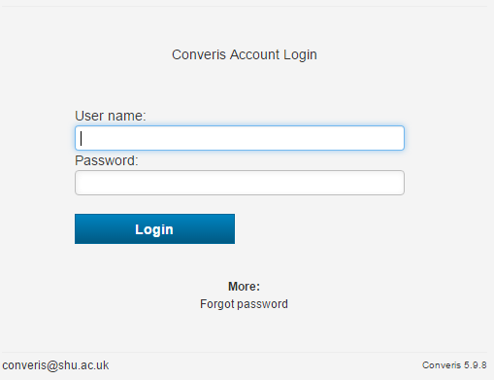
 | Note: If you have forgotten your password, you can reset it by following the steps described in the "Forgotten Password" section of this guide.
Once you have logged in, the browse template will appear. This provides an overview of all the information which has been filled in for the application. You can review all of the information in an application from here, and open any documents which have been uploaded.
To access the application, click on
The application will open in the Edit View. Information on the following tabs should be reviewed before proceeding to the approval tabs (if you have not read through the application information on the Browse Template):
- Applicants *
- Proposal Details *
- Management Info *
- Financial Information *
- Documents * (e.g. The Financial Summary can be downloaded from here)
There are two new fields to assist authorisation that Support Contacts may complete. The Comments for Authorisers and Financial Comments fields should be reviewed before proceeding to the approval tabs.
Comments for authorisers  At the bottom of the Proposal Details tab, there is a field which may contain information for authorisers to consider. |  | 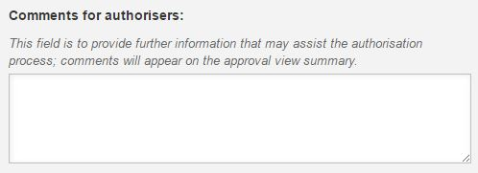

Financial Comments
At the bottom of the Financial Information tab, there is a field which may contain information for authorisers to consider.
The Financial Summary form will be uploaded as an attachment to the Documents tab. This is the second option when you click on the fourth tab dropdown list.

Click on the to open the document. |  | 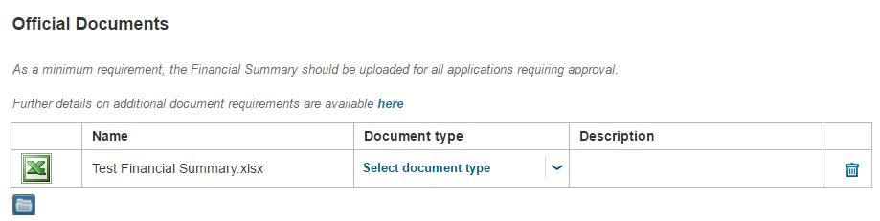
Review the Financial Summary Form.
Authorisers are required to complete the section relevant to their role. To authorise the application navigate to the tab relevant to your role (see table below). They are situated in the drop-down menu from the fourth tab at the top of the application.

Role | Approval Tab
- Head of Research Centre
- Director of Research Institute
- Head of Department
- Head of Faculty Finance
- Assistant Dean (R&I)

Select either the Yes or No radio button.  Some approval boxes have an escalation radio button; this is not being used at present and can be ignored.  Note: It is important to add your name to the approval.  Click on the and search for your surname. |  | 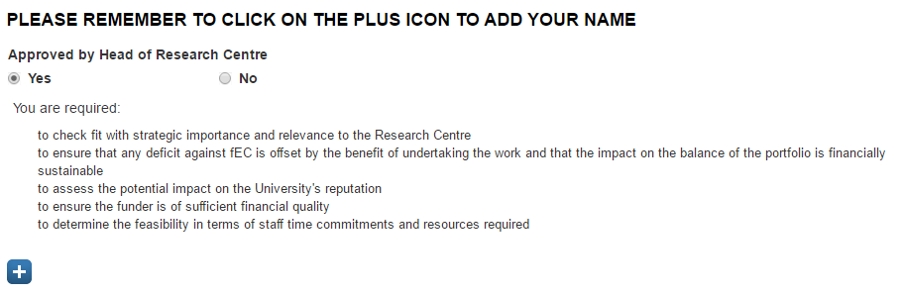
Press enter then click on the next to your Business Card to add it to the Application. |  | 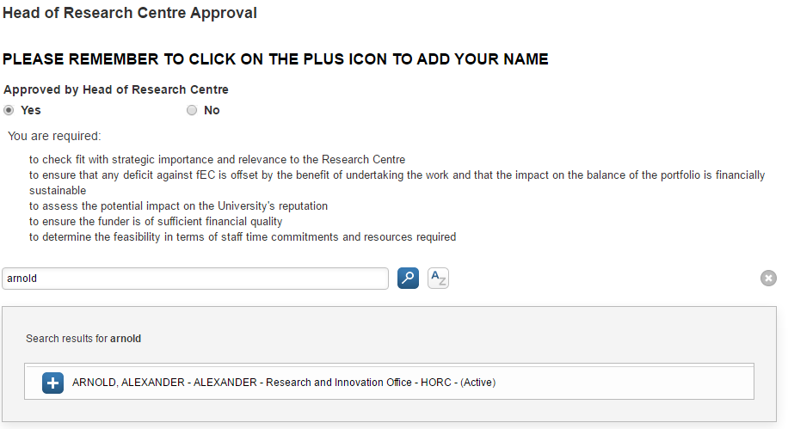
It will look like this when your Business Card has been added: |  | 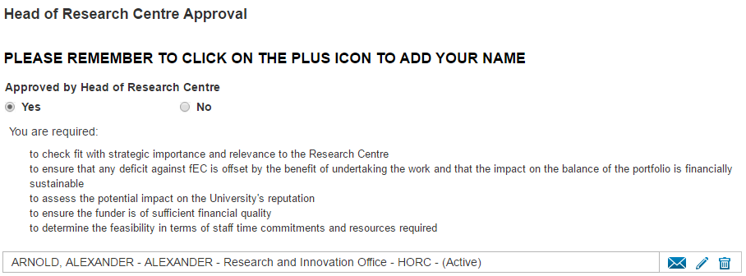
If you have approved an application, you can add comments in the text box provided.  If you have not approved an application, you can select a reason and provide comments in the text box provided. |  | 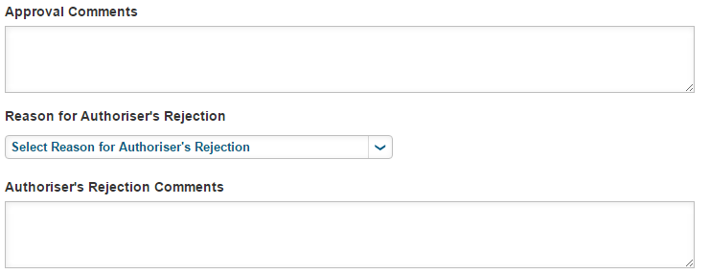
Once you have completed the authorisation, click  You will then see a Set Status box. For Approval will be the only option, so click on to complete the process. |  | 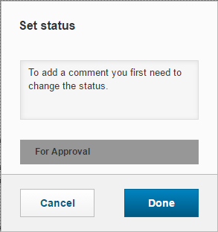
You can now exit Converis by selecting Logout from the drop down menu on the top right of the screen.

Pro Vice-Chancellor (Faculty)
For applications over £100,000, once the application has been approved by Head of Research Centre/Head of Department, Director of Research Institute (MERI only), Head of Faculty Finance and Assistant Dean, the Faculty Support Contacts should email the Pro Vice-Chancellor to request that they review and authorise the application.

The email should include a link to the application. Once the email has been received, the PVC should click on the link to open the application.
The Converis login screen will then appear.

Your username is your normal SHU login, for example, rbdph.

Enter your User Name and Password.

Click Login.
Note: If you have forgotten your password, you can reset it by following the steps described in the "Forgotten Password" section of this guide.
The application will either open on the Browse Template or in the Edit View.

Browse Template
If the link takes you to the Browse Template, you will see an overview of all the information which has been entered into the application:

Click to see a printable version of this overview.

When you have read through the information on the Browse Template, click to get to the Edit View.

Edit View
The application will open in the Edit View. Information completed on the application on the first four tabs should be reviewed before proceeding to the approval tabs.
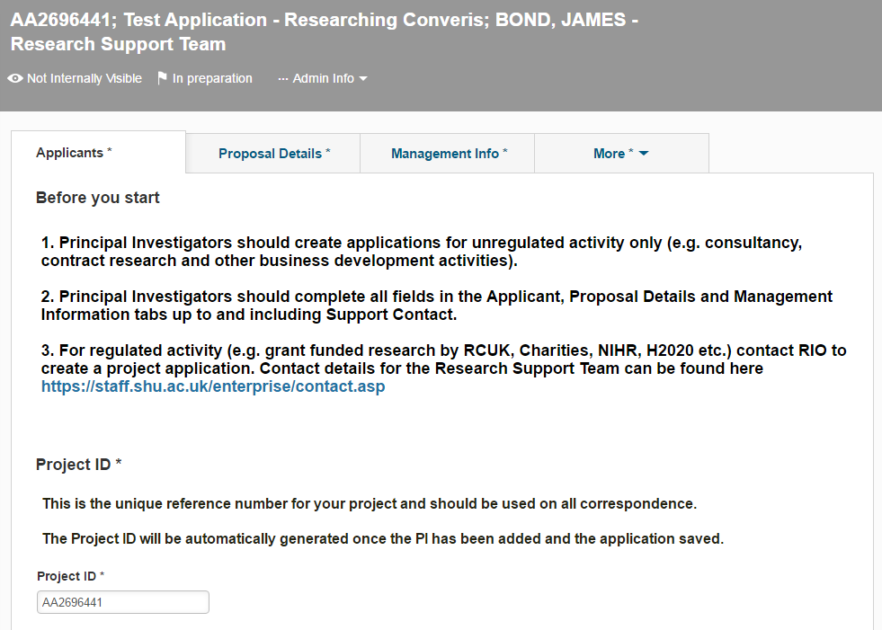
There are two fields to assist authorisation that Support Contacts may complete that should be reviewed before proceeding to the approval tabs:

Comments for Authorisers
To access the Comments for Authorisers field, click on the Proposal Details tab and scroll to the bottom of the screen.

Financial Comments
To access the Financial Comments field click the Financial Information tab and scroll to the bottom of the screen.
The Financial Summary form has been uploaded as an attachment to the Documents tab. This is the second option when you click on the fourth tab dropdown list.
Click on the to open the document.

Review the Financial Summary Form.
To authorise the application navigate to the Pro Vice Chancellor (Faculty) Approval * tab. This is situated in the drop-down menu from the fourth tab at the top of the application.

Select either the Yes or No radio button.  Some approval boxes have an escalation radio button; this is not being used at present and can be ignored.  Note: It is important to add your name to the approval.  Click on the and search for your surname. | 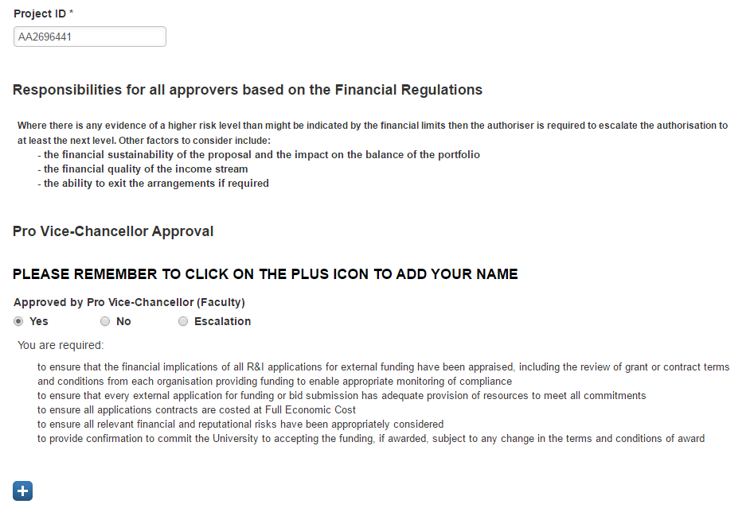
Press enter then click on the next to your name to add it to the Application. | 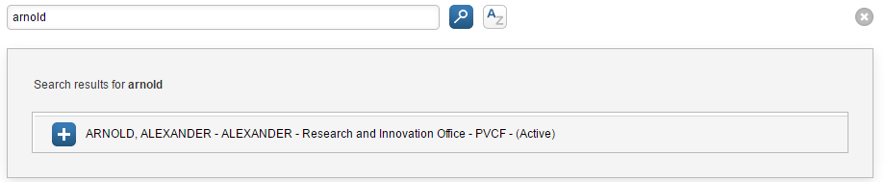
It will look like this when your name is added: | 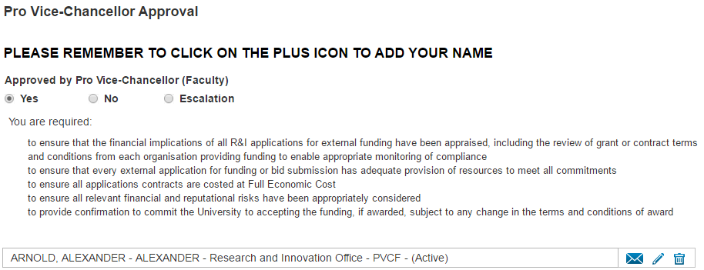
After approving or rejecting the application, you can provide a reason using the text boxes and drop down menu provided: | 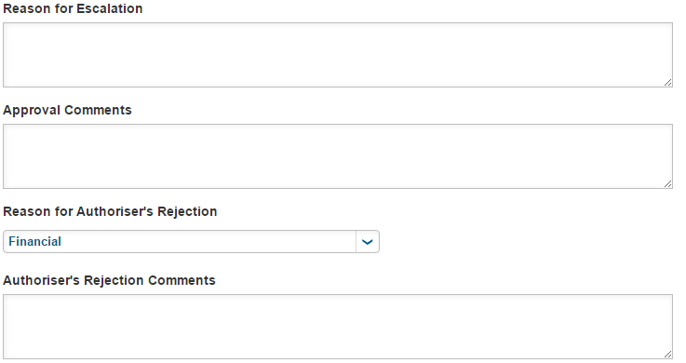
Once you have completed the authorisation, click

You will then see a Set Status box. For Approval will be the only option, so click on to complete the process.
You can now exit Converis by selecting Logout from the drop down menu on the top right of the screen.

Director of Finance
For applications over £500,000, once authorisation has been completed within Faculty, Support Contacts should email the Director of Finance to request that they review and authorise the application.

The email should include a link to the application. Once the email has been received, the Director of Finance should click on the link to open the application.
The Converis login screen will then appear.

Your username is your normal SHU login, for example, rbdph.

Enter your User Name and Password.

Click Login.
Note: If you have forgotten your password, you can reset it by following the steps described in the "Forgotten Password" section of this guide.
The application will either open on the Browse Template or in the Edit View.

Browse Template
If the link takes you to the Browse Template, you will see an overview of all the information which has been entered into the application:

Click to see a printable version of this overview.

When you have read through the information on the Browse Template, click to get to the Edit View.

Edit View
The application will open in the Edit View. Information completed on the application on the first four tabs should be reviewed before proceeding to the approval tabs.
There are two fields to assist authorisation that Support Contacts may complete that should be reviewed before proceeding to the approval tabs:

Comments for Authorisers
To access the Comments for Authorisers field, click on the Proposal Details tab and scroll to the bottom of the screen.

Financial Comments
To access the Financial Comments field click the Financial Information tab and scroll to the bottom of the screen.
The Financial Summary form has been uploaded as an attachment to the Documents tab. This is the second option when you click on the fourth tab dropdown list.
Click on the to open the document.

Review the Financial Summary Form.
To authorise the application navigate to the Approval by Director of Finance and Vice Chancellor * tab. This is situated in the drop-down menu from the fourth tab at the top of the application.

Select either the Yes or No radio button.  Some approval boxes have an escalation radio button; this is not being used at present and can be ignored.  Note: It is important to add your name to the approval.  Click on the and search for your surname. | 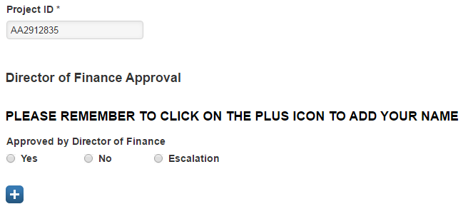
Press enter then click on the next to your name to add it to the Application. | 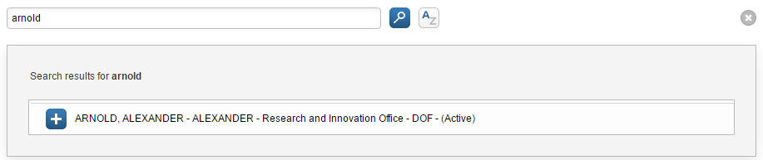
It will look like this when your Business Card has been added: | 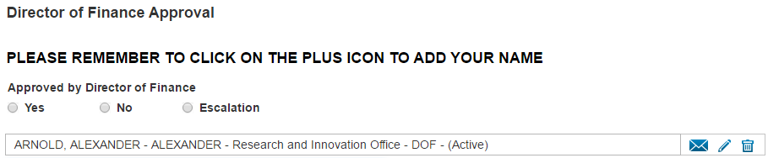
After approving or rejecting the application, you can provide a reason using the text boxes and drop down menu provided:
Once you have completed the authorisation, click

You will then see a Set Status box. For Approval will be the only option, so click on to complete the process.
You can now exit Converis by selecting Logout from the drop down menu on the top right of the screen.

Vice Chancellor
For applications over £2,000,000, once authorisation has been completed by Faculty and the Director of Finance, Support Contacts should email the Vice Chancellor to request that they review and authorise the application.

The email should include a link to the application. Once the email has been received, the Vice Chancellor should click on the link to open the application.
The Converis login screen will then appear.

Your username is your normal SHU login, for example, rbdph.

Enter your User Name and Password.

Click Login.
Note: If you have forgotten your password, you can reset it by following the steps described in the "Forgotten Password" section of this guide.
The application will either open on the Browse Template or in the Edit View.

Browse Template
If the link takes you to the Browse Template, you will see an overview of all the information which has been entered into the application:

Click to see a printable version of this overview.

When you have read through the information on the Browse Template, click to get to the Edit View.

Edit View
The application will open in the Edit View. Information completed on the application on the first four tabs should be reviewed before proceeding to the approval tabs.
There are two fields to assist authorisation that Support Contacts may complete that should be reviewed before proceeding to the approval tabs:

Comments for Authorisers
To access the Comments for Authorisers field, click on the Proposal Details tab and scroll to the bottom of the screen.

Financial Comments
To access the Financial Comments field click the Financial Information tab and scroll to the bottom of the screen.
The Financial Summary form has been uploaded as an attachment to the Documents tab. This is the second option when you click on the fourth tab dropdown list.
Click on the to open the document.

Review the Financial Summary Form.
To authorise the application navigate to the Approval by Director of Finance and Vice Chancellor * tab. This is situated in the drop-down menu from the fourth tab at the top of the application.

Select either the Yes or No radio button.

Some approval boxes have an escalation radio button; this is not being used at present and can be ignored.

Note: It is important to add your name to the approval.

Click on the and search for your surname.
Press enter then click on the next to your name to add it to the Application. | 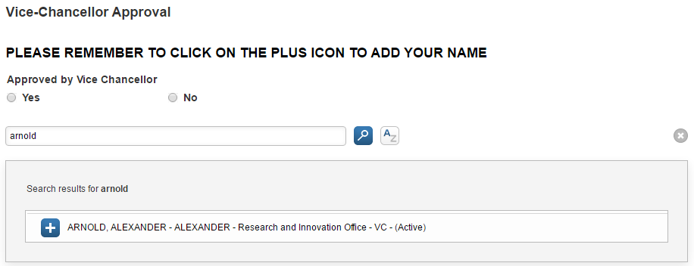
It will look like this when your Business Card has been added: | 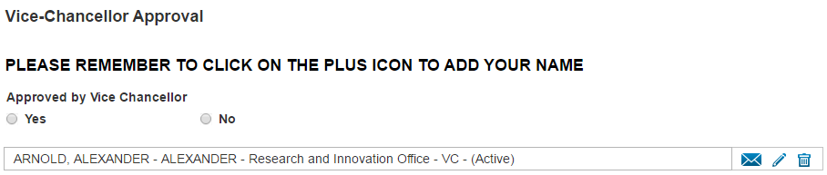
After approving or rejecting the application, you can provide a reason using the text boxes and drop down menu provided:
Once you have completed the authorisation, click

You will then see a Set Status box. For Approval will be the only option, so click on to complete the process.
You can now exit Converis by selecting Logout from the drop down menu on the top right of the screen.

Updating the Workflow Status to Financial Summary Approved/Not Approved.
Once the authorisers have completed their forms for an application, the Faculty Support Contact should move the status from For Approval on to either:  - 'Financial Summary Approved' when it has been approved.  - 'Financial Summary Not Approved' when it has not been approved.  For Regulated applications where authorisation is required by the Director of Finance/Vice Chancellor, the RIO Support Contact should move the status to 'Financial Summary Approved' after they have received notification that the required approval has been given.  After selecting 'Financial Summary Approved' or 'Financial Summary Not Approved' click | 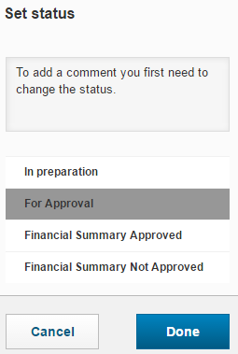

Updating Workflow Status to Submitted
Once the Financial Summary has been approved, and you have confirmation that the academic has submitted the proposal, Converis needs to be updated.

For applications supported by RIO - they should perform this step.
Complete the Submitted date on the Management Information tab.

If known, complete the Funder's Reference on the Application Outcome tab.

The final submitted version of the application form should now be uploaded to the Documents tab. | 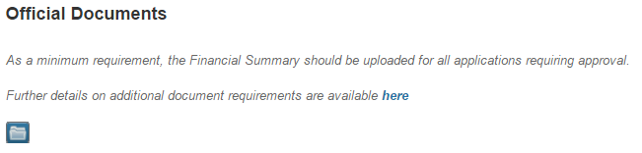
Click on

Now set the status of the workflow to 'Submitted' then click | 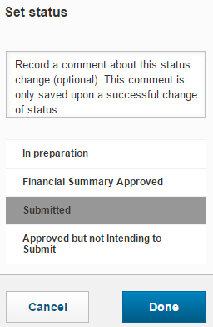

Tab: Application Outcome

This tab should be completed once the outcome of the application is known. This is the second option when you click on the fourth tab dropdown list.

Project ID *
This field will be automatically populated.
Funder's Reference
The funder's reference number should be included in the box provided.
Awarded  Complete the following dates:  - Actual Start Date  - Actual End Date  - Date Awarded  Dates are in the format DD/MM/YYYY, and can be free-typed or entered via the calendar.  If you are typing dates, as opposed to selecting from the calendar, please ensure that you use a forward slash (/) between DD/MM/YYYY; other forms of separator such as ‘-‘ are invalid and will not be recognised by the system.  The following should be input into the appropriate fields:  - Awarded Funder Costs  - Consortium Value Awarded  - E5 Number  - Purchase Order Number | 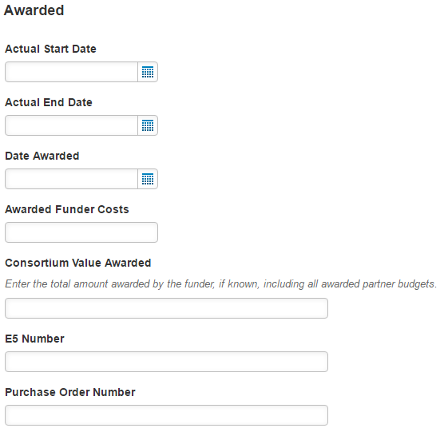
Unsuccessful
If the application was unsuccessful, please complete the following:
Enter the Date Rejected.

Dates are in the format DD/MM/YYYY, and can be free-typed or entered via the calendar.

If you are typing dates, as opposed to selecting from the calendar, please ensure that you use a forward slash (/) between DD/MM/YYYY; other forms of separator such as ‘-‘ are invalid and will not be recognised by the system.

The Reason for Rejection should be selected from the dropdown menu.

Comments referring to the Reason for Rejection Comments and Reason application not proceeding should be input into the appropriate text boxes.
Transferred  If an application has been awarded but transferred to another institution, you can select this using the dropdown menu.  To select the institution it has been Transferred To, click the | 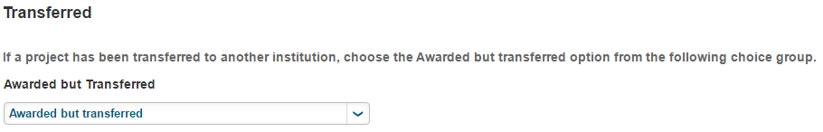
There are two methods for finding the institution:
a) Type their name into the
search box and then click
b) Search Alphabetically
Once you have selected the institution, click on the
The institute will be added to the application.
When you have completed filling out the Application Outcome tab, the appropriate status should be selected. Click on  Move the status on from Submitted to one of the following:  - Submitted but withdrawn from Funder  - Awarded  - Unsuccessful  When you have selected the appropriate status, click | 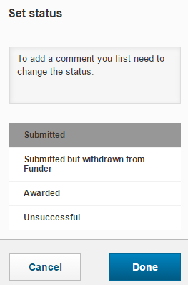

Awarded Grants that are transferred into the University
Where awarded grants are transferred into the University, the status of the workflow should be moved directly from In Preparation to Awarded.

If any difficulties are encountered with this please contact converis@shu.ac.uk for advice.

Process where activity doesn't require a Financial Summary
A Financial Summary Form is not required for Knowledge Transfer/Consultancy Projects under £2,000. The de minimis value is the greater of total income to be received or Full Economic Cost.

In specific exceptional circumstances, this can be raised to £10,000. Such circumstances will include where this is “pure” Knowledge Transfer/Consultancy with low levels of out of pocket cash expenditure (e.g. on non-pay costs). These instances need to be agreed with the Head of Faculty Finance (HOFF), who will document and share the rationale for raising the limit with the Deputy Director of Finance (DDoF).

All Knowledge Transfer/Consultancy Projects should be recorded on Converis, regardless of value, with the Management Info tab completed as evidence that any ethical, funder or strategic risks and fit have been considered.

Once the Application has been created on Converis, the status should be updated from 'In Preparation' to 'Submitted'.

Process for Revised costings
In the event of any changes being made to proposal costs once the authorisation process has begun or has been concluded, the nominated Faculty Support Contact should be informed of the changed costings and the cost headings affected.

Should the Faculty subsequently request a new Financial Summary to be circulated, the following process should be followed:

- The status of the record in Converis should be returned to In Preparation.
- Support Contact should make a comment in the Notes field detailing the changes that require reauthorisation.
- The revised Financial Summary should be uploaded into the Documents tab
- The status of the record should be changed to For Approval.

Emails will be generated to authorisers as usual.

Note: Any authorisations that have already (pre-changes) been made will remain in Converis. Therefore, it is advised that authorisers make a note in the "Approval Comments" box to confirm they are authorising the revised Financial Summary, for example:

Process for Recording Internal Funding
The Financial Regulations only make provision for external funding requests. Therefore a Financial Summary should not be completed where applications are being funded internally.

However, Converis can be used to record the funding.

Create a new application and assign “Internal Funding” in the Proposal Type Choice Group. This is extremely important as otherwise without clearly identifying that it is internal not external funding there is a risk that the income will be double counted.

For reporting purposes, internal funding should be removed from Income reports.

Two stage applications
It is increasingly common for an application process to consist of an outline/expression of interest/first stage, followed by an invited full or second stage.
In Converis, it is possible to record details for both stages of the application ensuring that costs and other information recorded at first stage are not overwritten.
When setting up your Converis record for a first stage application, on the Proposal Details * tab, select:

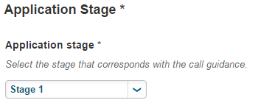
You will then follow the usual process.

This will only include authorisation of the Financial Summary if the application is contractually binding in its first stage. For non-contractually binding 'first stage' applications, authorisation by Assistant Dean is required - see the section on Non-Contractually Binding Expressions of Interest.
On notification that the first stage application has been successful, you will need to move the status of the application to 'Awarded'.
Return to your 'Project Applications' list view page. Click on the Clone button underneath the application description. This will replicate your project application record.
Change the Application Stage attribute on the Proposal Details tab to 'Stage 2':

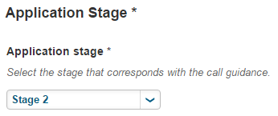
All the data that you entered at the first stage will be contained in the new record that opens.

Once you click on a new unique Project ID will be generated.

Adding a Related Application
The Related Applications field is located below the Application Stage field near the end of the Proposal Details tab.

In the 'Related Application' field, click on the . You need to use this field to link your first and second stage applications, as Converis will generate an identifier for each record.

Enter the Title or Project ID of the First Stage application in this field and click the search button:

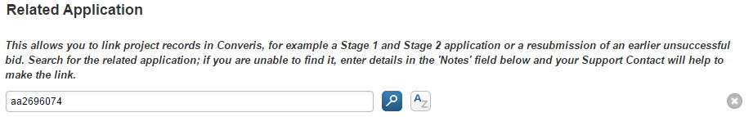

Select the correct record by pressing the button:

To save the link between the first and second stage applications, click
This field should also be used to link consultancy work.
Make sure the information you input is saved!

Non-Contractually Binding Expressions of Interest
Revisions to the Universities Financial Regulations were published in May 2015.
Section 22 of the Financial Regulations now states that:
- The financial implications of all external funding bids will be recorded along with a risk assessment using the standard University documentation (Financial Summary)
and
- Expressions of interest and other non-binding submissions to research and knowledge transfer funders do not need to follow the Financial Summary process. However, they should be assessed for their strategic fit, feasibility, financial viability and availability of resources.
As a result of this change, it has been agreed, with Finance and the Faculties that a Financial Summary will be produced for these schemes as usual but applications will be assessed only by the Assistant Dean, R&I, for strategic fit, feasibility, financial viability and availability of resource. Full approval of the Financial Summary form is not required at this application stage.

Our intention is that the assessment process for non-contractually binding EoIs will be built into Converis. However, until such time as this workflow is able to be made live in the system, it is requested that the process is as follows:
- Academic supported to complete a Financial Summary as per usual practice
- RIO create 'In preparation' record in Converis. 'Stage 1' should be selected from the drop down list in the 'Application stage' field ('Proposal Details' tab).
- RIO check that application is non-contractually binding at expression of interest/outline stage.
- If contractually binding, full Financial Summary approval is required.
- If non contractually binding, RIO upload the Financial Summary to Converis (in 'Documents' tab) and e-mail the appropriate Support Contact to ask for assessment of the Financial Summary (see draft e-mail text 1) by the Assistant Dean R&I. It is essential that the status of the application on Converis remains 'In Preparation' and is not moved to 'For approval' as this will generate emails to all authorisers.
- Assistant Deans R&I are asked to send an e-mail response to the appropriate Faculty Support Contact, indicating whether they have favourably assessed the Financial Summary, and submission to the funder is permitted.
- Faculty Support Contact email RIO Support Contact to notify them application has been favourably assessed.
- RIO Support Contact uploads the e-mail response to 'Documents' tab on Converis.
- RIO submit a status change request to converis@shu.ac.uk to move the application to "Financial Summary Approved" and include a comment in the notes box on the workflow status pop-up "EoI has been assessed by the Assistant Dean."
- RIO will move the status of application to 'Submitted' when it is known that the academic has submitted their proposal.
- Once the funder outcome is announced for the EoI/outline/stage 1 application, RIO will change the status on Converis to 'Unsuccessful' or 'Awarded'.
- If 'Awarded' (i.e. successful) at stage 1, the project details should be cloned by RIO in Converis and a stage 2 application will be created. The Financial Summary will then require full approval before submission at stage 2.
Example e-mail texts
1. RIO to Faculty Admin
Title: Proposal for Assessment

Dear [NAME Faculty administrator],

[NAME of academic] wishes to submit an Expression of Interest/Outline/First Stage (delete as appropriate) application to [NAME OF FUNDER]; deadline (DD-MM-YY).

RIO have ascertained that at this proposal stage, the application is non contractually binding, and as such requires assessment by your Assistant Dean, R&I, in line with the revised financial regulations.

The record of the application can be found at: [paste URL to page in Converis] and the Financial Summary uploaded on the documents tab. I would be grateful if you could forward the Converis link to your Assistant Dean [can substitute with name if prefer] and request they review the Financial Summary and confirm the outcome of their assessment in an e-mail to you.

Please let me know if you have any queries.

Kind regards

[NAME OF RIO staff]
2. Faculty Admin to Assistant Dean, R&I
Title: Proposal for Assessment

Dear [NAME OF ASSISTANT DEAN]

[NAME of academic] wishes to submit an Expression of Interest/Outline/First Stage (delete as appropriate) application to [NAME OF FUNDER]; deadline (DD-MM-YY).

RIO have ascertained that at this proposal stage, the application is non contractually binding, and as such requires assessment by you, as Assistant Dean, R&I, in line with the revised financial regulations.

The Financial Summary has been uploaded to Converis and the record of the application can be found at: [paste URL to page in Converis]. I would be grateful if you could review the Financial Summary and confirm the outcome of your assessment of the application in a return e-mail to me.

Please let me know if you have any queries.

Kind regards

[NAME OF Faculty Support Contact]

Reporting

Benchmark Report
To run a Benchmark report, click on the Report tab at the top of the Project Applications list view.
- Choose either Report for selected items or Report for all listed items
- Application Benchmark will be selected.
- Select
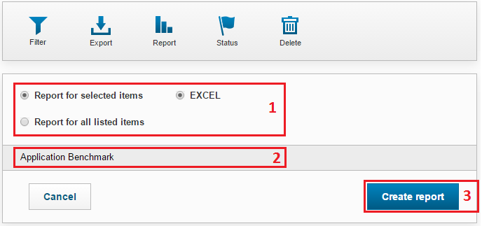
- Depending on the number of applications being reported on, the report can take a few minutes to run. After clicking to create the report, you will know the report is being generated as the page icon revolves (located on the browser tab in the top left hand corner of your screen). The report will open as a Microsoft Excel file.
Note: If projects have multiple investigators (e.g. a PI and a Co-I) and/or multiple funders/external partners, the data for that project application, separate lines will be created for those projects in the report for each multiple entry.

Filtering when Reporting
You can use filters to specify which applications are pulled into the report. Guidance on filtering can be found in the Filtering section of the guide.

If you have a filter selected when running a report, the Filter icon will turn orange:

Trouble Shooting

Changing your password
Log into Converis and click on the orange arrow next to your user role in the top right section of the screen.

Select
Scroll down to the Change Password setting.  Completed the three fields and click | 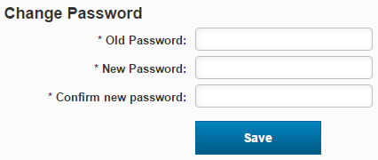
When creating a new password, it must comply with the following rules:
- Must be at least 8 characters long.
- Must contain at least two numbers.
- Must not contain any special characters (e.g. %^&*).
- Must not have three consecutive digits which are the same (e.g. aaa or 999).
- Must not use your First name, Last Name or User name.
- Must not use the word 'password'.
- Must not be one of the five previously used passwords.

Delegating Access
Log into Converis and click on the orange arrow next to your user role in the top right section of the screen.

Select
Scroll down to the User delegation section and click on
Type the delegates name into the search box and click

Click on the beside the delegates name.
Select to confirm the delegation.
Note: When you are 'back in the office', remove the delegation by clicking on the
Select to remove the delegate.
Email converis@shu.ac.uk if you are unable to find the name of the person you wish to delegate to.

Switching roles
Log into Converis and click on the orange arrow next to your user role in the top right section of the screen.

Select
This will show all the roles which have been assigned to your user profile. Select the new role.
Your new roles will be shown where the orange dropdown menu is located on your Dashboard at the top right corner of the screen.
Every time you login you will always automatically be logged in in your standard role.

So using the example above, the role was originally Head of Research Centre, but was changed to Assistant Dean. If the user logged out at that point and logged back in, they would log in as a Head of Research Centre and so would need to actively switch roles again if it was required.

Switching on Email Notifications
If you are receiving notifications in the system rather than emails to your inbox, you will need to change your Message Settings in the system.
Log into Converis and click on the orange arrow next to your user role in the top right section of the screen.

Select
Ensure Email is ticked and click

Timing Out
When you are logged into Converis, it is important to regularly save any changes you make to an application. If you are inactive for an extended period of time, you will be timed out of Converis and any unsaved changes will be lost. You will need to log back into the system and re-do any unsaved work.

RST - Minimum Data Entry Requirements (In Preparation Status)

Creating a research grant application record: role of RIO support teams

The Research Support Team and the Funding Development Team in RIO will create all research grant application records in Converis on behalf of the Principal Investigator.

As a minimum requirement the team will populate the following fields in Converis to ensure that a standard record for all grant applications is captured at the early concept stage. This may be used for reporting on proposals in development to aid forward work planning.

The Principal Investigator will be invited to contribute further information relating to the project as the application develops.

Status | Minimum Data Entry Requirements to create a research grant application record in Converis for RIO | Converis Tab
In Preparation | - Principal Investigator (select lead applicant at SHU)  - SHU involvement (select co-ordinator / partner / sole applicant / sub-contractor) | Applicants
 | - Short project title (enter short working title)  - Funder (select funder)  - Call title (enter scheme applied to as detailed in the call information or funder on-line system)  - Call deadline (select funder deadline - if the call is response, select the expected submission date or 01 January of the next calendar year if the date is unknown)  - Application stage (select stage 1 / stage 2 / single stage / as detailed in the call guidance or select re-submission without re-approval if this applies) | Proposal Details
 | - Admin area (select RIO)  - Support contact (select your name) | Management Info
 | - Proposal type (select research grant or research studentship)  - Activity type (select finance R activity code as recorded on the Regulated Financial Summary) | Financial Information

Receiving Help from the Converis Support Team

Who we are
Elizabeth Andrassy: Pre-Award Grants Systems Manager
Joe Arnold: Service Improvement Officer
Fiona Birch: Research Support Administrator

How to get in touch with us
The Converis Support Team (CST) use the Unidesk system to manage calls from users regarding Converis. If you have any query regarding Converis, for example how to access or navigate the system, please send your query to: converis@shu.ac.uk.
The subject heading of your email to us will show in your email, so it is a good idea to include succinct headings which give us a good indication about you query. In your emails, please include as much information as possible, and if relevant to your query, a screenshot of any issue you may be having.
Once you have emailed converis@shu.ac.uk you will receive an email similar to the one below to confirm your call has been logged in the system. Please keep this email because the logging number will be used as the work goes through the system and is allocated to a member of the team to deal with.
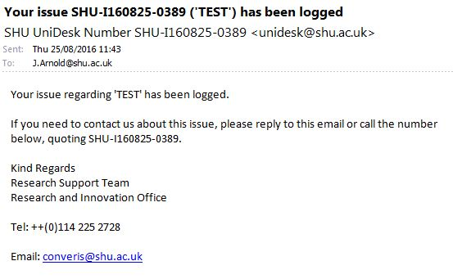
A member of the CST will get in touch via Unidesk. During email conversations about your query, please reply directly to the email you receive to ensure your response is listed within your original call. This is done via your SHU UniDesk Number (in this example SHU-I160825-0389).

Once your call has been closed
Once your call has been closed, you will likely receive an automatic email from the system 2 weeks after it has been closed to confirm the official closure of your call. Please only respond to this if you do not believe your call is complete. It will look something like this:
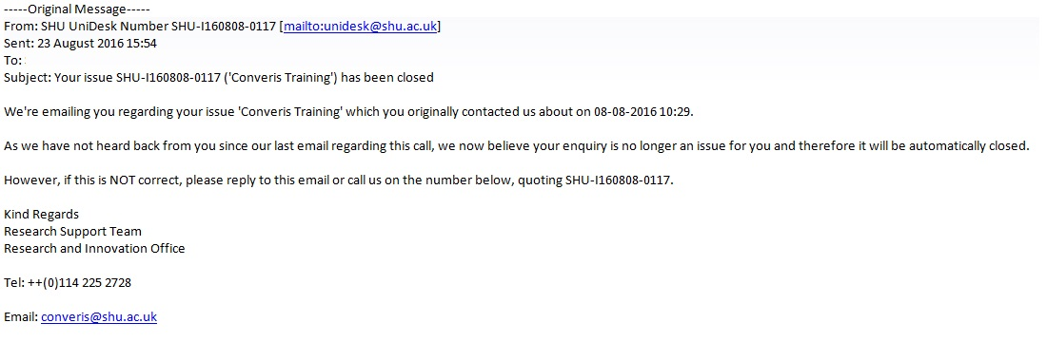

Links
Converis: | https://shu.converis.thomsonreuters.com/converis/secure/login
Converis Intranet Page: | https://staff.shu.ac.uk/enterprise/research/converis.asp

Appendix 1:

Reference Guide for Gaining Approval to Apply for External Income
For Unregulated Applications (Consultancy/Research Tender), please follow the instructions below.

Definitions of Regulated / Unregulated Applications can be found on page 6 of the Converis User Guide.

Create an Unregulated Financial Summary
1. Download a copy of the Unregulated Financial Summary Form by clicking here.
2. Complete this in conjunction with your Management Accountant / Faculty Support Contact.
Create a Project Application in Converis
1. You can access Converis at: https://shm.avedas.com/converis/secure/login
2. Login using your SHU username and your chosen password.

If you have forgotten your password, click the Forgot password link on the Converis login screen.

3. Create a new Project Application using the following steps (when on your Converis Dashboard):

Add new > Projects > Project Application > SHU Project Application.

4. Complete the following fields where applicable (fields marked with * are mandatory).
 | Tab | Fieldname
 | Applicants | Principal Investigator *  Co-Investigator  PI's Unit of Assessment *  Joint Proposal *  SHU Involvement *  External Partner Organisation *
 | Proposal Details | Title *  Short Project Title *  Funder(s) *  Call Title  Call Deadline  Expected date result will be known *  Expected start date  Expected end date  Abstract *  Application Stage *  Related Application  Notes  Comments for Authorisers
 | Management Info | Strategic Fit *  Resource Requirements *  Risk Assessment *  Ethics *  Human Resources *  Admin Area *  Support Contact(s) *
5. Save regularly. The first time you click save, this will generate your Project ID (e.g. AA9999999).
Email Support Contact
Once you have complete up to the Support Contacts field on the Management Info tab, email your Faculty Support Contact with the Converis Project ID (e.g. AA9999999) and inform them that the record is now ready for them to action.

Notes

