Sheffield Hallam University
Converis Ethics Reporting - Helpsheet

There are three Ethics reports available for users to run in Converis.
Running the Ethics Reports
When you login to Converis, ensure you are in the appropriate role to view Ethics applications. You can do this via the Switch Roles function in the top right corner of the screen:

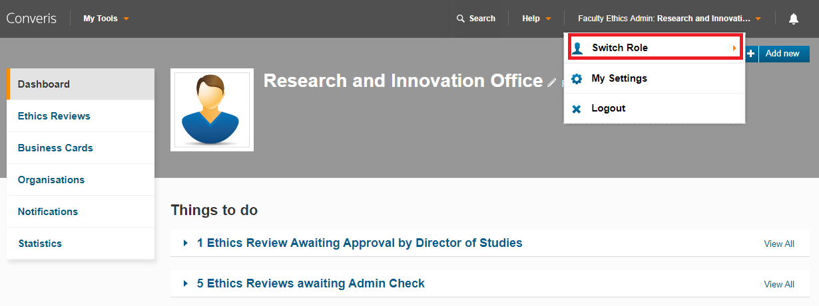

Click on Ethics Reviews on the left-hand side of the screen - this will take you to the List View of Ethics Review applications that you can view.

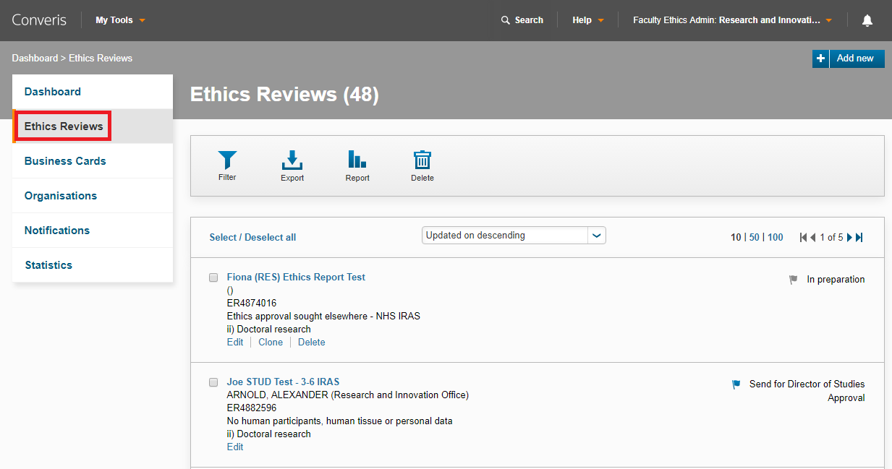

Click on the Report button. The reports will appear below.

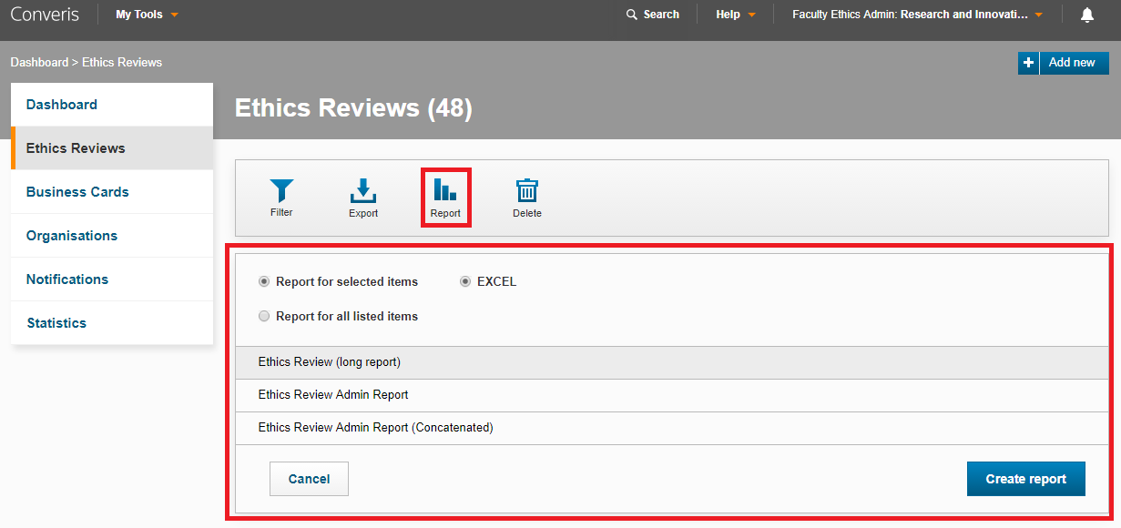

The three Ethics Review reports available are:
- Ethics Review (long report) - Ethics Review applications in this report will have multiple lines of data if they have two or more of any of these attributes:
  - Converis Project Applications
  - Co-Investigators
  - Funders

- Ethics Review Admin Report - Ethics Review applications in this report will have multiple lines of data if they have two or more of any of these attributes:
  - Converis Project Applications
  - Co-Investigators
  - Funders

- Ethics Review Admin Report (Concatenated) - Ethics Review applications in this report will have multiple lines of data if they have two or more of any of these attributes:
  - Converis Project Applications
  - Co-Investigators
  - Funders

Once you have selected the report you wish to run, you must select one of the following options:
- Report for selected items - if you select this option, you must manually tick all the Ethics Review applications you wish to be included in the report.
- Report for all listed items - if you select this option, all the ethics review applications you can view will be included in the report.

Click on to run report. It will open as a Microsoft Excel file.
Filters
You can use filters to specify which applications are included in the report.

Click on Ethics Reviews on the left-hand side of the screen - this will take you to the List View of Ethics Review applications that you can view.

Click on the Filter button. The filtering options will appear below. When you have finished selecting your filters, click Apply.

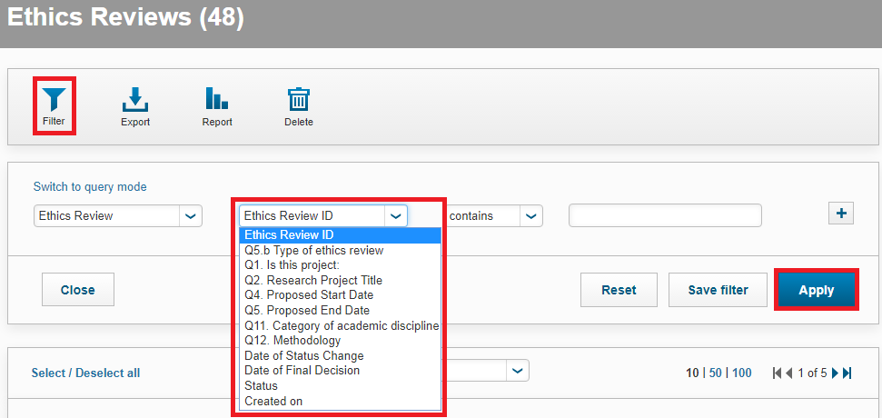

If you have a filter selected, the Filter icon will turn orange when running a report:
