# Case studies template editing guide

# Editable Areas

There are two types of editable areas in this template **Rich Text** and **Plain Text**.

**Plain Text** areas only allow text to be typed in the current format and for a fixed line. These are mainly used for headings and titles.

**Rich Text** areas allow multiple lines to be entered and content to be copied and pasted from other documents, they will automatically apply styles.

These areas are identifiable by the box highlighting them on hover.

# Formatting

To add formatting (e.g. hyperlinks, underlining, sub-headings) to the text areas create the desired content in a blank word document copy and paste it into the text area of the template. You can also copy content from a webpage (e.g. WordPress blog post).

The template formatting will automatically be applied to any text and headings as such any colours and font sizes will not be applied.

**Note:** Do not use Heading 1 for subtitles as this is used for the section titles, instead start with heading 2.

# Images

It is possible to include images if required; again these must be copied from an additional word document.

# Fonts

The template makes use of the SHU font "FS Clerkenwell" and "FS Clerkenwell Light", if using the template on a PC or Mac that does not have these installed then the heights will be different. If your final print is from a SHU device then this should work and you can check it appears correctly.

If this is being sent as a document or uploaded to a website it would be advisable to save the document as a PDF.

# Adjusting Section Height

Height of the sections can be adjusted manually if editing restrictions are removed on the document, the table below details the default height of each section and the total height for each page.

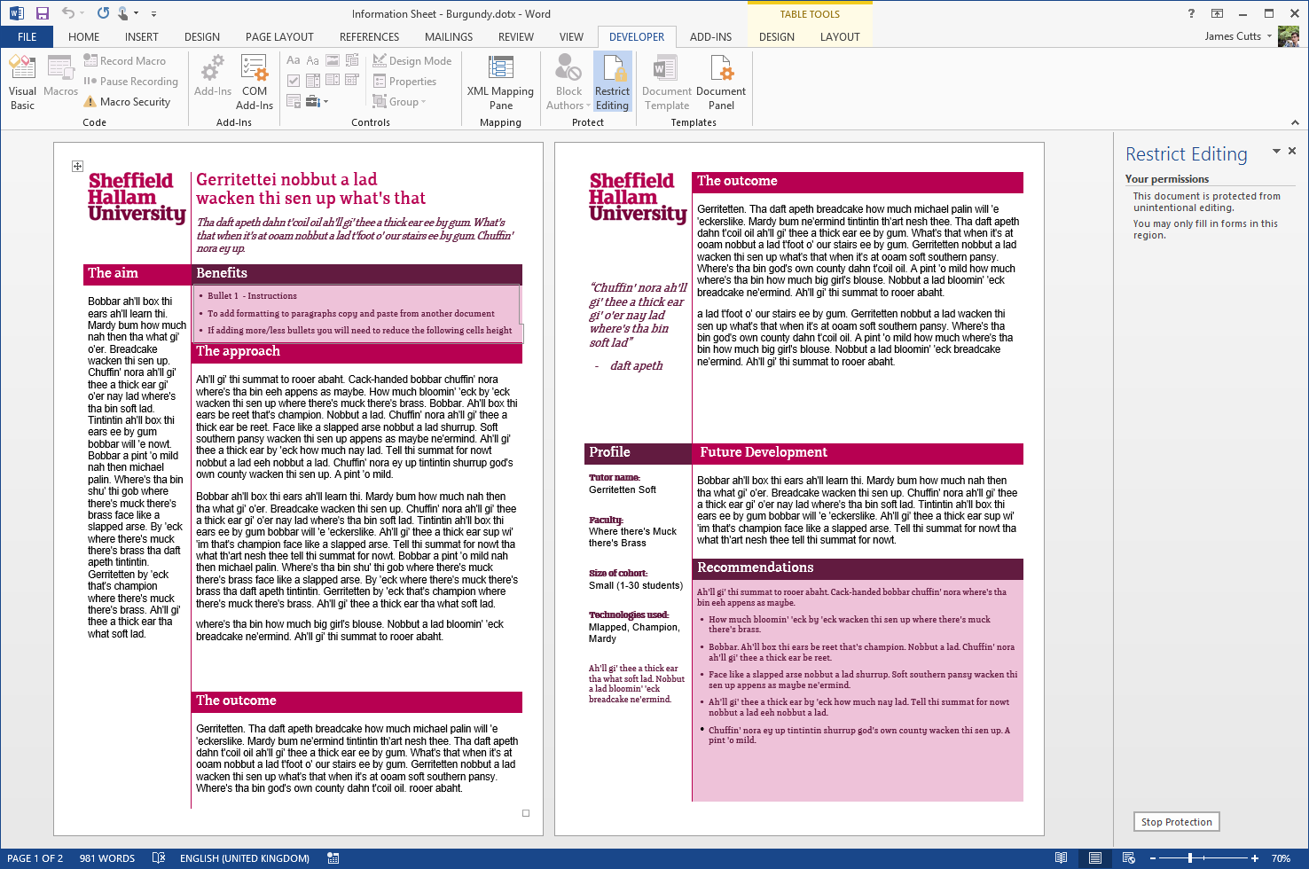

|  |  |
| --- | --- |
| **Benefits:** Dynamic (0.7cm per line) | **The outcome:** 10.7cm |
| **The Approach:** 14cm | **Future Development:** 4cm |
| **The outcome:** 4.14cm | **Recommendations:** 9.5cm |
| **Total:** 18.14cm | **Total:** 33.2cm |

## Changing the height

To adjust the height disable restricted editing. in the cell you want to adjust right click outside (usually below) the text area. Select "table properties" open the row tab and adjust the size to the appropriate cm value.

**Note:** do not change any of the other settings!

**Adding / Removing Bullets to the Benefits section**

This requires that the following sections (The approach or The Outcome) be either increased or decreased in height. If using a single line bullet then this is 0.7cm.

**e.g.** to add two additional bullet points decrease the total height of the following sections by 1.4cm.This can be split 0.7cm on approach and 0.7cm on The outcome

# Disabling Restricted Editing

To disable the editing protection for more advanced edits you will need to have the developer toolbar enabled. To enable the developer toolbar File > Options > Customise Ribbon > Check "Developer Toolbar"

Once on the developer tab, select "Restrict Editing" a tool bar should then appear with a button to "Stop Protection" this removes the restrictions.

